Analysis of Global Natural Resources: Consumption, Extraction, and Depletion Timeline
  - Created by: Uladzislau Mikhayevich <3xecvte@gmail.com> JA2-HR-23

CONTENTS
CONTENTS 2
PROJECT HIGHLIGHTS 6
Key stages of the project included: 6
Analytical tools and rationale: 7
Outcome: 7
PROJECT AIM 9
PROJECT MILESTONES 10
DESCRIPTIVE STATISTICS AND EXPLORATORY DATA ANALYSIS 10
Field Description 10
Basic Statistics 10
Data Dimensionality 11
Data Types 11
Counting Unique Values 11
Frequency Analysis of Categorical Features 11
Data Filtering 11
Visualization of Categorical Data 12
Correlation Analysis 12
Box Plots 12
Histograms 12
Group Summaries 12
Missing Value Analysis 13
VISUAL DATA ANALYSIS 14
Workflow 14
Analytical report on the energy consumption dataset 16
Analytical report on energy consumption data visualization 18
Report on testing statistical hypotheses in the energy sector 22
Multivariate data analysis: PCA and Clustering (K-Means) 36
Energy sustainability and depletion risk forecast 41

PROJECT HIGHLIGHTS
This project is devoted to the analysis of global natural resources, focusing on energy consumption, production, and depletion risks. The main objective is to evaluate the sustainability of the world’s energy systems, identify regions at risk of resource shortages, and demonstrate the application of descriptive statistics, exploratory data analysis (EDA), statistical hypothesis testing, and multivariate techniques.
The study covers the period 1900–2024 and is based on data from Our World in Data (OWID) and BP Energy Institute, including energy consumption, production, CO₂ emissions, and resource reserves for 217 countries across multiple regions. The analysis focuses on four key resources (Oil, Gas, Coal, CO₂) and three metrics (Production, Consumption, Emissions).

Key stages of the project included:
- Data collection and cleaning: integrated datasets from OWID and BP, standardized country names, filtered key resources and metrics, removed aggregated regions and historical countries, and ensured numerical formatting for analysis. Each country was assigned an ISO code and region for consistent merging.
- Exploratory Data Analysis (EDA): assessed distribution of observations by resource, metric, and region; analyzed historical trends; visualized distributions using boxplots and logarithmic scaling to account for extreme outliers and differences between leading countries and the global average.
- Statistical hypothesis testing: tested regional differences in production, consumption, and emissions using T-tests and p-values to evaluate whether observed gaps between leading countries (e.g., USA, China, Russia) were statistically significant. Key findings included regional determinism in all resource metrics and exceptional positions of global leaders.
- Multivariate analysis: applied Principal Component Analysis (PCA) to reduce dimensionality and K-Means clustering to segment countries by energy profile. Identified clusters ranged from energy giants (China, USA) to small economies, highlighting disparities in scale and structure of energy systems.
- Sustainability and depletion risk assessment: calculated the Depletion Risk Index (DRI) to evaluate the gap between consumption growth and production growth across regions. This analysis identified critical zones with high import dependence and accelerated resource depletion, notably in South Asia, the Middle East, and East Asia.

Analytical tools and rationale:
- Python was used for all analyses, including libraries such as pandas (data manipulation), numpy (numerical computation), matplotlib/seaborn (visualization), scipy.stats (hypothesis testing), and scikit-learn (PCA, clustering).
- EDA, hypothesis testing, and PCA were chosen to manage high variance, detect outliers, and extract patterns from large multivariate datasets spanning more than a century.

Outcome:
The project produced a structured analytical report and visualizations showing historical trends, regional disparities, and projections of resource depletion. The findings indicate that global energy systems are entering a phase of “transitional fragility,” with consumption growth outpacing production in several critical regions. This underscores the urgent need for improved energy efficiency, renewable energy adoption, and strategic policy planning to ensure long-term sustainability.

PROJECT AIM
The aim of this project is to conduct a comprehensive statistical, visual, and multivariate analysis of global energy resources in order to assess consumption, production, emissions, and depletion risks, as well as to identify regions and countries most vulnerable to energy shortages.
To achieve this objective, the following tasks were defined in the study:
- to select and justify datasets from reputable sources (Our World in Data, BP Energy Institute) covering historical and current energy metrics;
- to examine the dataset structure, feature types, missing values, and perform data cleaning and normalization;
- to perform descriptive and exploratory data analysis to identify trends in production, consumption, and emissions across regions and resources;
- to analyze historical patterns and highlight extreme values, outliers, and disparities among major global players;
- to formulate and test statistical hypotheses regarding regional and country-level differences in energy production, consumption, and emissions;
- to conduct multivariate analysis using PCA and clustering to segment countries based on energy profiles;
- to evaluate energy sustainability and depletion risks through the Depletion Risk Index (DRI) and long-term projections;
- to interpret the results from an economic, geopolitical, and environmental perspective;
- to present the analysis in a structured report and visual presentation;
- to formulate insights and recommendations for improving energy security, efficiency, and strategic resource planning globally.

DESCRIPTIVE STATISTICS AND EXPLORATORY DATA ANALYSIS
Within the project, a sequential stage of descriptive statistics and exploratory data analysis (EDA) was carried out, which serves as the foundation for subsequent visual, statistical, and multivariate analysis. This stage allowed for examination of dataset structure, feature characteristics, and identification of potential data quality issues.

Field Description
- All variables from the integrated OWID and BP datasets were examined, including their semantic meaning and role in the analysis.
- Special attention was given to key features such as resource type (Oil, Gas, Coal, CO₂) and metric (Production, Consumption, Emissions).
- This step was necessary to understand the data structure, ensure correct interpretation of results, and select appropriate analytical methods.

Basic Statistics
For numerical features, key statistical measures were calculated:
- mean,
- median,
- standard deviation,
- minimum and maximum values.
These measures allowed assessment of central tendencies, variability, and extreme values (outliers), which is critical for understanding the global distribution of energy resources and identifying leading countries.

Data Dimensionality
- The dataset includes 80,639 rows and 11 columns.
- Initial rows were displayed to visually check data loading, value formats, and presence of missing values.

Data Types
- For each column, the data type (numerical or categorical) was identified.
- This step ensured correct application of statistical and visualization methods and prevented processing errors.

Counting Unique Values
- For categorical features such as country, region, resource, and metric, the number of unique values was calculated.
- This helped assess data diversity and informed the selection of features for segmentation and multivariate analysis.

Frequency Analysis of Categorical Features
- Frequency distributions were constructed for resources, metrics, and regions.
- This step allowed identification of the most represented resources (Oil predominates) and regions (Europe & Central Asia), guiding subsequent analysis.

Data Filtering
- Filtering was applied to focus on key resources (Oil, Gas, Coal, CO₂) and metrics (Production, Consumption, Emissions).
- Filtering enabled analysis of resource-specific trends, country-level comparisons, and focused hypothesis testing.

Visualization of Categorical Data
- Graphical methods, including bar charts, were used to analyze categorical distributions.
- This highlighted imbalances in data representation across resources and regions.

Correlation Analysis
- A correlation matrix was calculated for numerical features (e.g., production vs. consumption).
- Results were visualized using a heatmap, allowing identification of strong and weak relationships between energy metrics.

Box Plots
- Boxplots were constructed for numerical features to:
  - assess distributions,
  - detect outliers,
  - compare values across regions and countries.

Histograms
- Histograms were created for resource metrics to assess distribution shapes.
- Skewed distributions and extreme values informed the selection of statistical tests and outlier considerations.

Group Summaries
- Aggregated statistics were calculated by region, country, and resource.
- This enabled comparison of energy characteristics between major global players (USA, China, Russia) and the rest of the world.

Missing Value Analysis
- Missing values were identified and quantified.
- Justified decisions were made to handle missing data, ensuring the correctness of subsequent statistical tests, visual analysis, and multivariate modeling.

VISUAL DATA ANALYSIS

Workflow

Raw data preparation
- Added Our World in Data as a submodule
- Added BP/Energy Institute — Statistical Review of World Energy
- Added EIA (US Energy Information Administration):
  - Coal and coke consumption and production
  - Dry natural gas consumption and production
  - Electricity consumption, capacity, and production
  - Emissions by fuel type
  - Total energy consumption and production

Data standardization
Table structure:
- country – country
- iso_code – ISO-3 code
- region – region
- year – year
- resource – Oil | Gas | Coal | Electricity | Energy | CO2
- metric – Consumption | Production | Reserves | Capacity | Emissions
- value – numerical value
- unit – unit of measurement
- source – OWID | BP | EIA

Rejection of EIA
During the normalization of datasets, I noticed that EIA datasets are mostly empty and do not contain particularly important information, so it was decided to reject this dataset.

New unified table in progress
Table structure:
- country – country
- iso_code – ISO-3 code
- region – region
- year – year
- resource – Oil | Gas | Coal | Electricity | Energy | CO2
- metric – Consumption | Production | Reserves | Emissions
- value – numerical value
- unit – unit of measurement
- source – OWID | BP

Progress in cleaning and standardizing energy data
During the project, source information was collected from two main sources: Our World in Data (OWID) and BP Energy Institute. To standardize the data, a table structure was developed, including the following columns:
country, iso_code, region, year, resource

Analytical report on the energy consumption dataset

General information
- The dataset contains 80,639 observations and 11 columns.
- There are missing values in iso_code (≈466–20,137) and region (466), the rest of the columns are filled in.
- There are duplicates: 20,811 rows. It is worth checking that these are not repeated measurements for the same country, resource, metric, and year.
- Negative values in value: 168. These may be measurement errors or data corrections (e.g., consumption/production rollbacks).

Resources and metrics
- Four resources are used: Oil, Gas, Coal, CO2.
- Metrics: Production, Consumption, Emissions.
- By number of observations:
  - Production — 47,406 rows (≈59%),
  - Consumption — 28,083 rows (≈35%),
  - Emissions — 5,150 rows (≈6%).
- The resource with the highest number of observations is Oil (26,214 rows), and the lowest is CO2 (5,150).

Geography and regions
- Data covers 217 countries, including regional aggregations.
- Main regions:
  - Europe & Central Asia — 26,803 observations
  - East Asia & Pacific — 13,875
  - Latin America & Caribbean — 13,157
  - Middle East & North Africa — 11,276
  - Sub-Saharan Africa — 9,269
  - South Asia — 3,797
  - North America — 1,996
- There are 466 countries without a specified region.

Time coverage
- Data by year: 1900–2024.
- This allows for long-term analysis of historical trends in consumption, production, and emissions.

Indicator values
- Average value: 198.54.
- High dispersion: standard deviation ≈ 925, indicating a wide range of data (including large countries with huge consumption/production).
- Minimum values may be negative (168 rows) — potentially errors or adjustments.
- Maximum values reach 26,245, probably large indicators for countries with large populations and energy consumption.

Initial conclusions
- The dataset is high quality.
- There are few CO2 observations — this should be taken into account when analyzing emissions.
- Most of the data is concentrated in Europe, Asia, and Latin America; North America is less represented.

Analytical report on energy consumption data visualization
At the current stage of data analysis, the distribution of observations across key categories has been assessed: resources, metrics, and regions.

1. Quantitative data review (EDA)
Resources and metrics: The main data set focuses on fossil fuels (Oil, Gas, Coal). The Production metric prevails in the data set, accounting for more than 59% of all records. Emissions data accounts for only 6%, which is a bottleneck for environmental analysis.
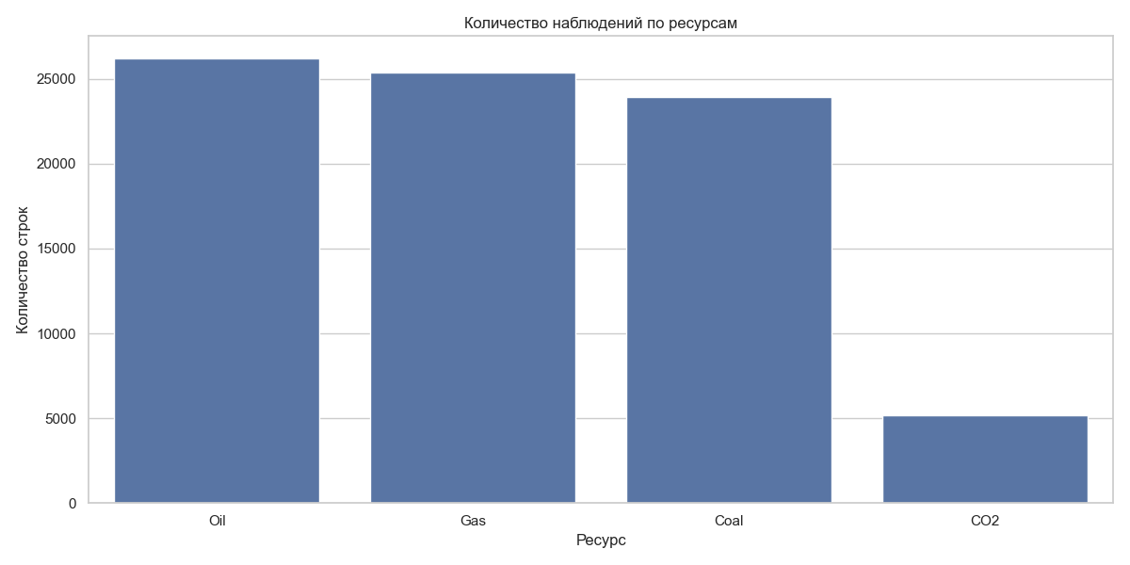
Picture 1 – Data review.
Geography: The highest data density is characteristic of the Europe & Central Asia region (more than 26,000 rows), while North America is represented minimally (about 2,000 rows), which is due to the small number of countries in the region.
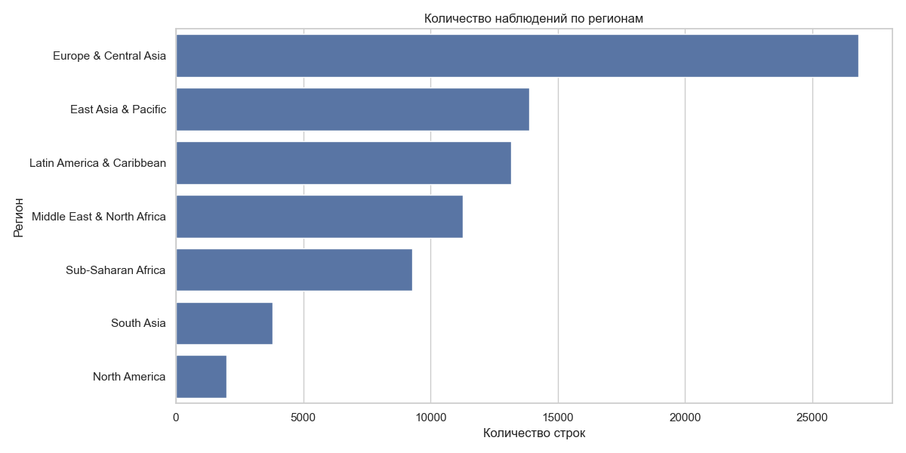

Picture 2 – all regional views.

2. Analysis of value distribution
To understand the scale of consumption and production, a boxplot method with a logarithmic scale was used.
- Dispersion: The average value of the indicator is 198.54, but the standard deviation exceeds 925, indicating an extreme difference between the leading countries and the rest of the world.
- Outliers: A large number of points outside the whiskers (in the region of 10^4) confirm that the global energy sector is heavily centered around a few major players.
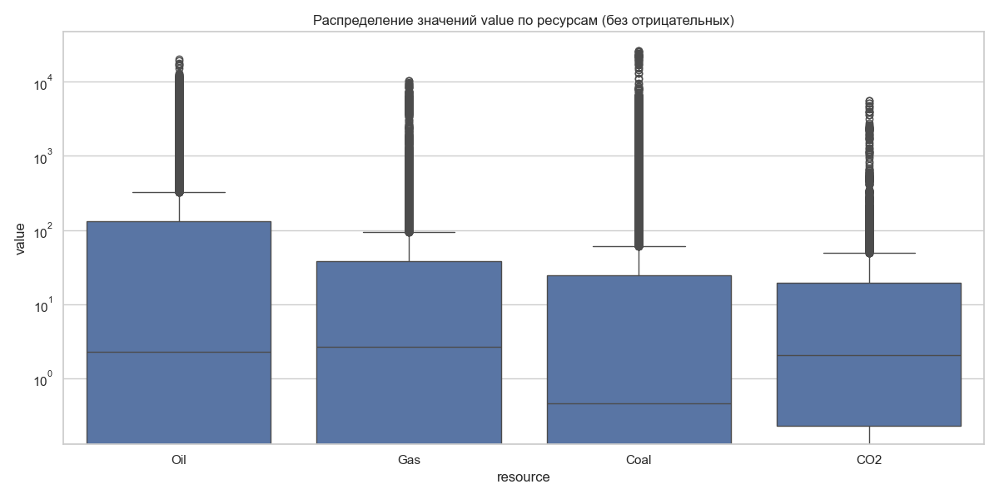
Picture 3 – Value Distribution.

3. Historical trends: Oil consumption (1965–2024)
An analysis of time series data on total oil consumption reveals key geopolitical and economic shifts:
- Change in leadership: The East Asia & Pacific region has shown aggressive growth since the 2000s, becoming the world's largest consumer.
- Western energy efficiency: North America and Europe are showing stagnation or a decline in consumption, which may be due to the transition to renewable sources and increased production efficiency.
- The 2020 crisis: The graph clearly shows a sharp “drop” in consumption in all regions caused by the COVID-19 pandemic, followed by a recovery.
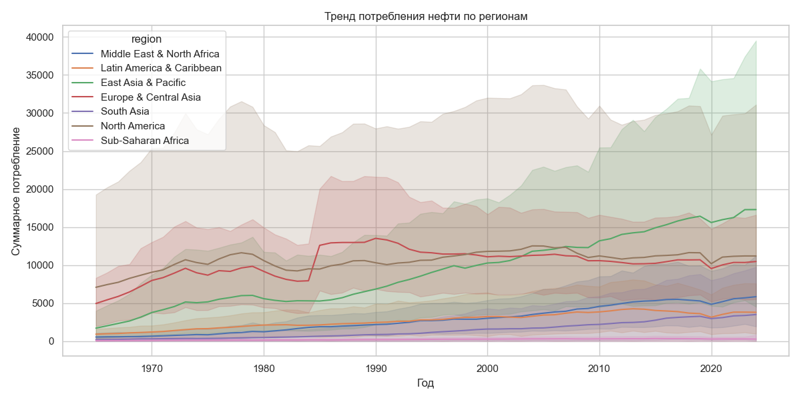
Picture 4 – Historical trends: Oil consumption.

Report on testing statistical hypotheses in the energy sector
This section presents the results of testing hypotheses about differences in resource production, consumption, and emissions between regions and key countries.

1. Regional differences (ANOVA)
For each resource, the null hypothesis was tested: “The average values of the indicator are the same for all geographic regions.” In all cases, the p-value = 0.000, which allows us to reject the null hypothesis.

Natural gas (Gas)
- Consumption: The North America region stands out with the highest median consumption and a significant number of large consumers (emissions on the graph).
- Production: The situation is similar to consumption — North America leads by a wide margin, confirming its status as the largest producer and consumer of gas.
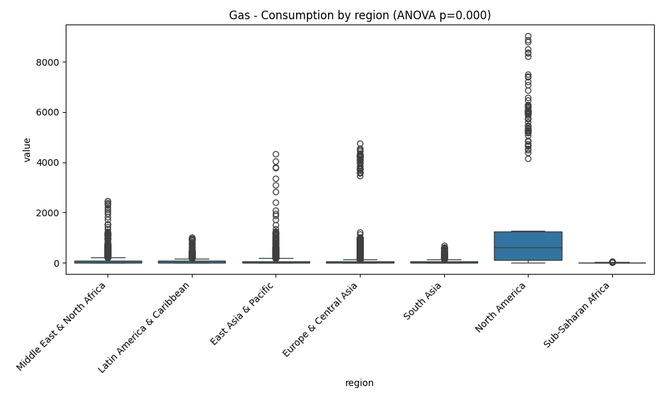
Picture 5 – Gas consumption by region.
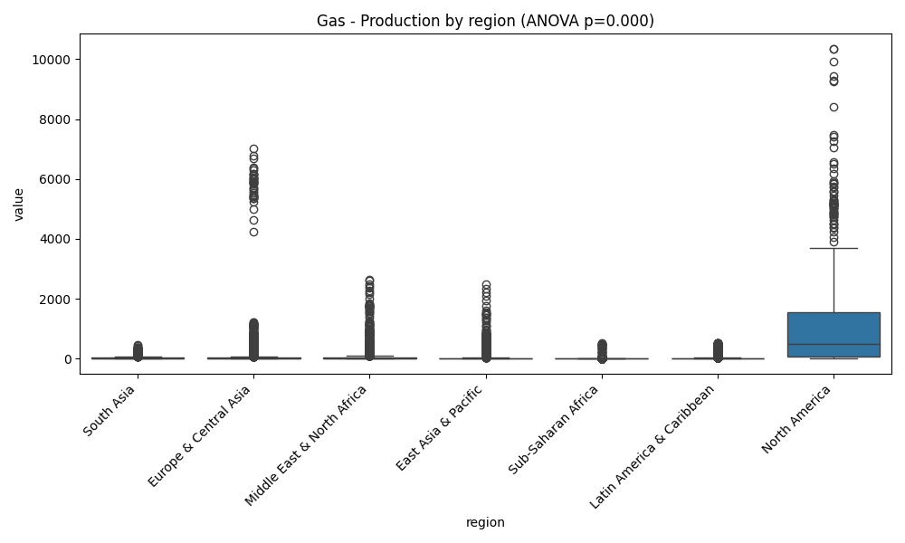
Picture 6 – Gas production by region.

Coal (Coal)
Consumption and production: The graphs clearly show the anomalous gap in the East Asia & Pacific region. The huge number of outliers in this region indicates that there are countries within it (probably China) whose scale of activity exceeds the global average by tens of times.
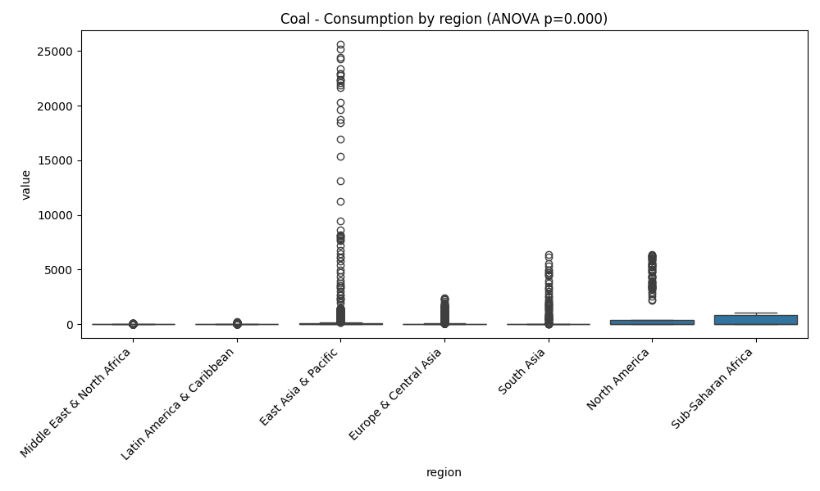
Picture 7 – Coal Consumption by region.
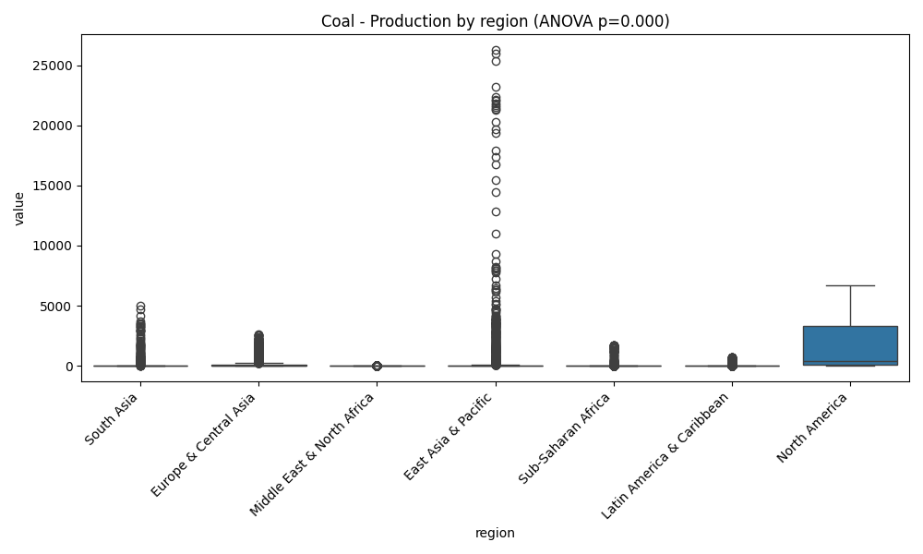
Picture 8 – Coal production by region.

CO2 emissions
The main concentration of emissions is recorded in East Asia & Pacific and North America. At the same time, the most extreme point values are observed in Asia.
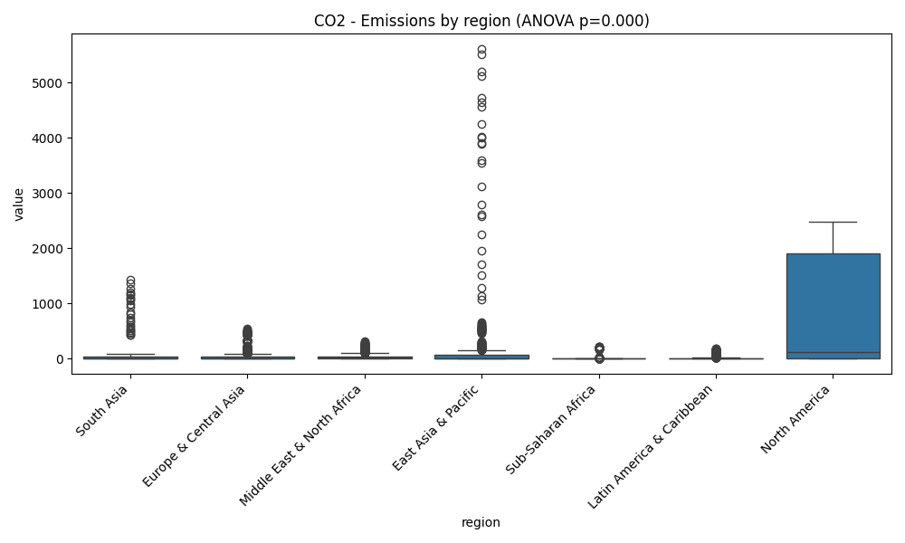
Picture 9 – CO2 emissions by region.

2. Comparison of market leaders (T-tests)
We compared the two largest countries in each category to see if the gap between them was statistically significant.

Coal industry (China vs. USA)
- Production: The difference between China and the USA is on the verge of statistical significance (p=0.054). This suggests that, historically, their production volumes have been comparable, although China is in the lead.
- Consumption: Here, the gap is critical (p=0.000). China consumes coal in volumes that exceed those of the US many times over.
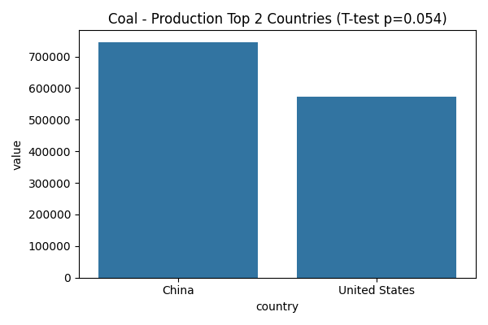
Picture 10 – Coal production top 2 countries.

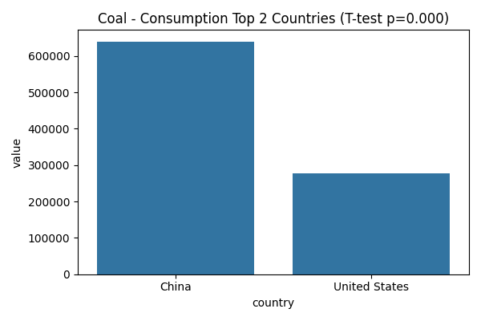
Picture 11 – Coal consumption top 2 countires.

Gas industry (Russia vs USA)
- Production: The T-test showed p=0.777. This is a crucial insight: there is no statistically significant difference in gas production volumes between Russia and the USA over the entire observation period. They are equal giants in the market.
- Consumption: Despite similar production levels, the USA consumes significantly more gas than Russia (p=0.000).
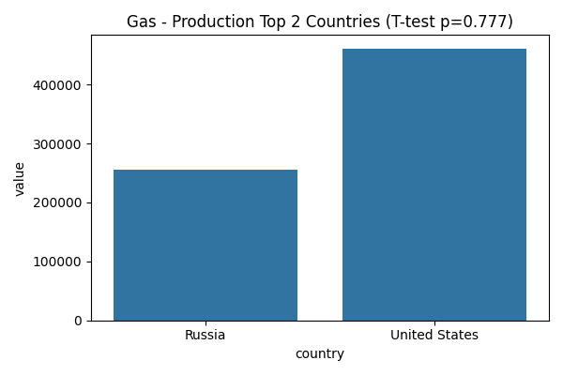
Picture 12 – Gas production top 2 countries.

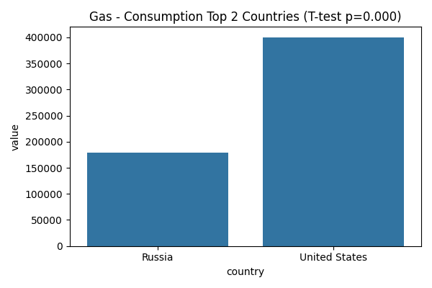
Picture 13 – Gas consumption top 2 countries.

Emissions (China vs USA)
China significantly exceeds the USA in total CO2 emissions (p=0.000), which directly correlates with abnormally high coal consumption in this region.
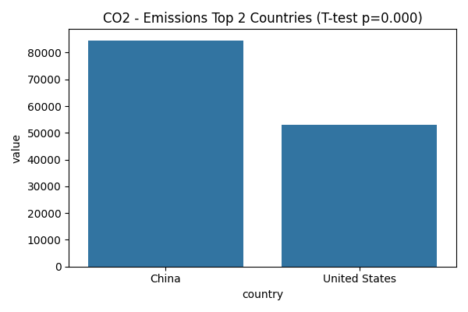
Picture 14 – CO2 emissions top 2 countries.

3. Oil industry

Regional differences (ANOVA)
As with other resources, the regional factor plays a decisive role (p-value = 0.000).
- Consumption: North America and Europe show the highest and most stable figures, while the Asia-Pacific region has the highest number of extreme values (emissions).
- Production: This is where the highest data variability is observed. The Middle East and North America are key centers of power in terms of production volumes.
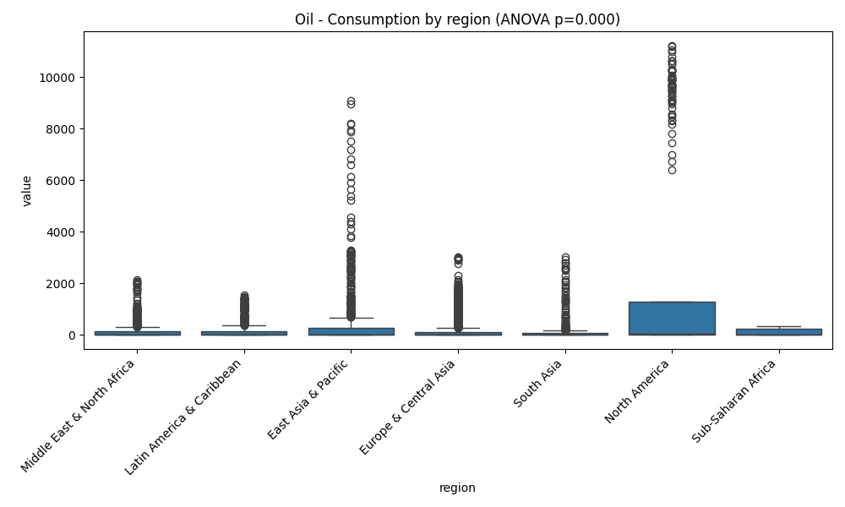
Picture 15 – Oil consumption by region.
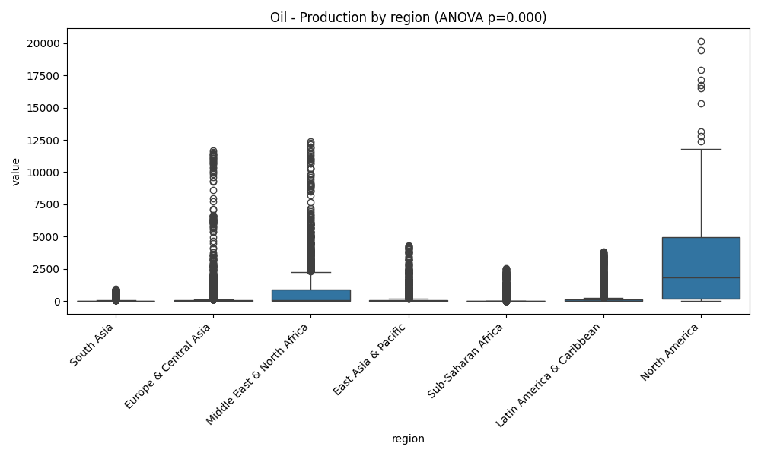
Picture 16 – Oil production by region.

Comparison of leaders (T-tests)
- Oil Production (USA vs Saudi Arabia): The difference in production volumes between the USA and Saudi Arabia is statistically significant (p = 0.0007). Despite the leadership of both countries, their production profiles differ significantly in the long term.
- Oil Consumption (USA vs China): The US remains a larger consumer of oil than China in historical terms, and this difference is statistically confirmed (p = 0.000).
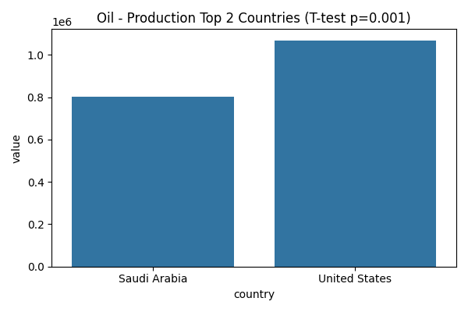
Picture 17 – Oil production top 2 countries.
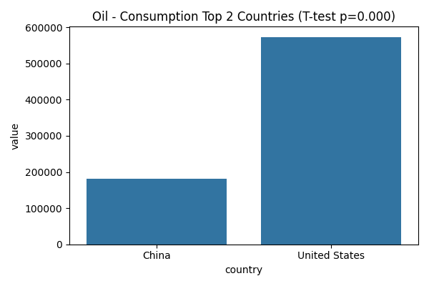
Picture 18 – Oil consumption top 2 countries.

4. Summary table of test results
The table below shows the key metrics for all tests. Recall that at α=0.05, the result is considered significant if p<0.05.
Table 1 – Summary of test results.
Resource | Metric | Test type | P-value | Significant?
Oil | Consumtion | ANOVA | 0.000 | Yes
Oil | Consumtion | T-test | 0.000 | Yes
Oil | Production | T-test | 0.0007 | Yes
Gas | Production | T-test | 0.777 | No
Coal | Production | T-test | 0.054 | No
CO2 | Emissions | ANOVA | 0.000 | Yes

Final conclusion on the hypotheses
- Geographical determinism: For all types of resources and metrics (production, consumption, emissions), the region is a critical factor. The hypothesis of regional equality is rejected in all cases.
- The only exception (Gas Production): The only test that did not show significant differences was the comparison of gas production in the US and Russia. This confirms their status as two comparable global leaders in the gas industry in terms of capacity.
- Coal uncertainty: The difference in coal production between China and the US is not statistically significant at the 5% level (p=0.054), indicating historical competition between these countries in the extraction of this resource until China's sharp breakaway in recent decades.

Multivariate data analysis: PCA and Clustering (K-Means)
In this section, we move from analyzing individual resources to a comprehensive comparison of countries' energy profiles. We used principal component analysis (PCA) to reduce the dimensionality and the K-Means algorithm to segment countries.

1. Principal Component Analysis (PCA)
For the analysis, a summary table was created where all metrics (Production, Consumption, Emissions) for all resource types were aggregated for each country.
- Explained variance: The first two principal components (PC1 and PC2) explain the vast majority of the data variability.
- PC1 (Scale axis): Probably responsible for the overall scale of a country's energy system (the higher the production and consumption of any resource, the higher the value).
- PC2 (Structure axis): Probably reflects specialization (e.g., the predominance of production over consumption or an emphasis on a specific fuel type, such as coal).

The majority of countries
For a detailed study of most countries, we selected a group up to the 95th percentile to avoid distortion of the scale by giants.
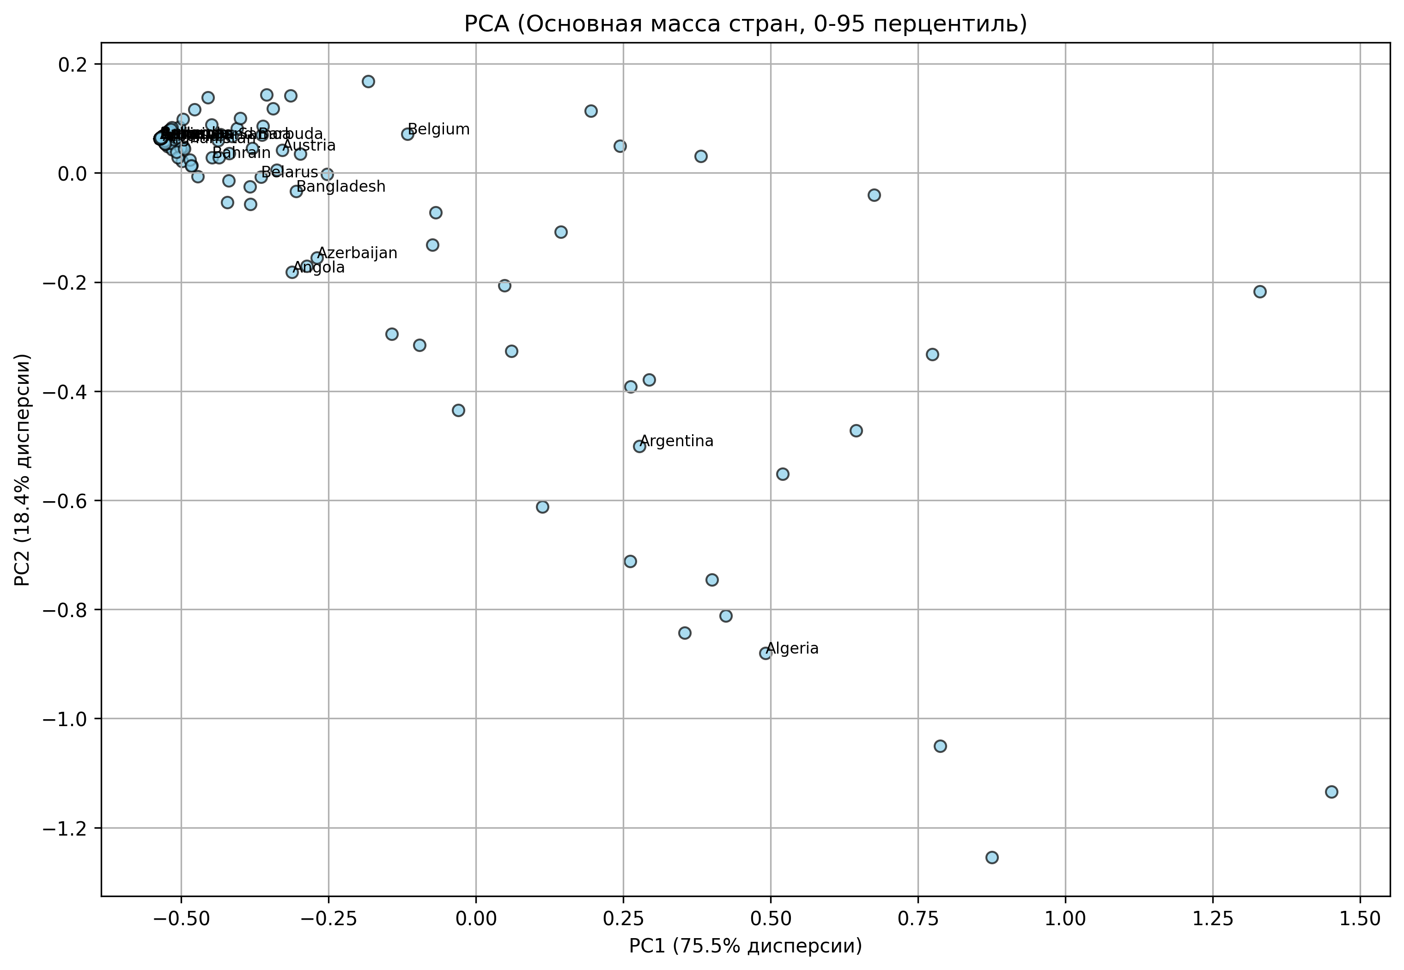
Picture 19 – PCA.

Outliers
Countries outside the 95th percentile are key players in the global market (the US, China, Russia, Saudi Arabia). They form their own unique vectors on the PCA graph.
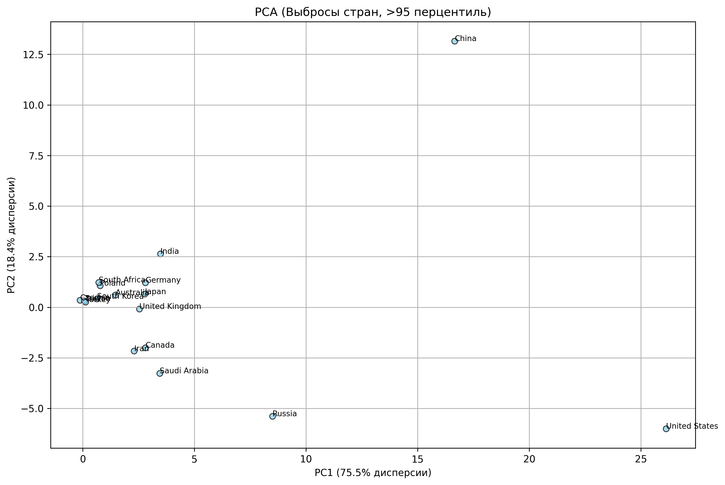
Picture 20 – PCA Outliners.

2. Country segmentation (K-Means Clustering)
We applied the K-Means algorithm to identify five clusters of countries with similar energy consumption and production patterns.

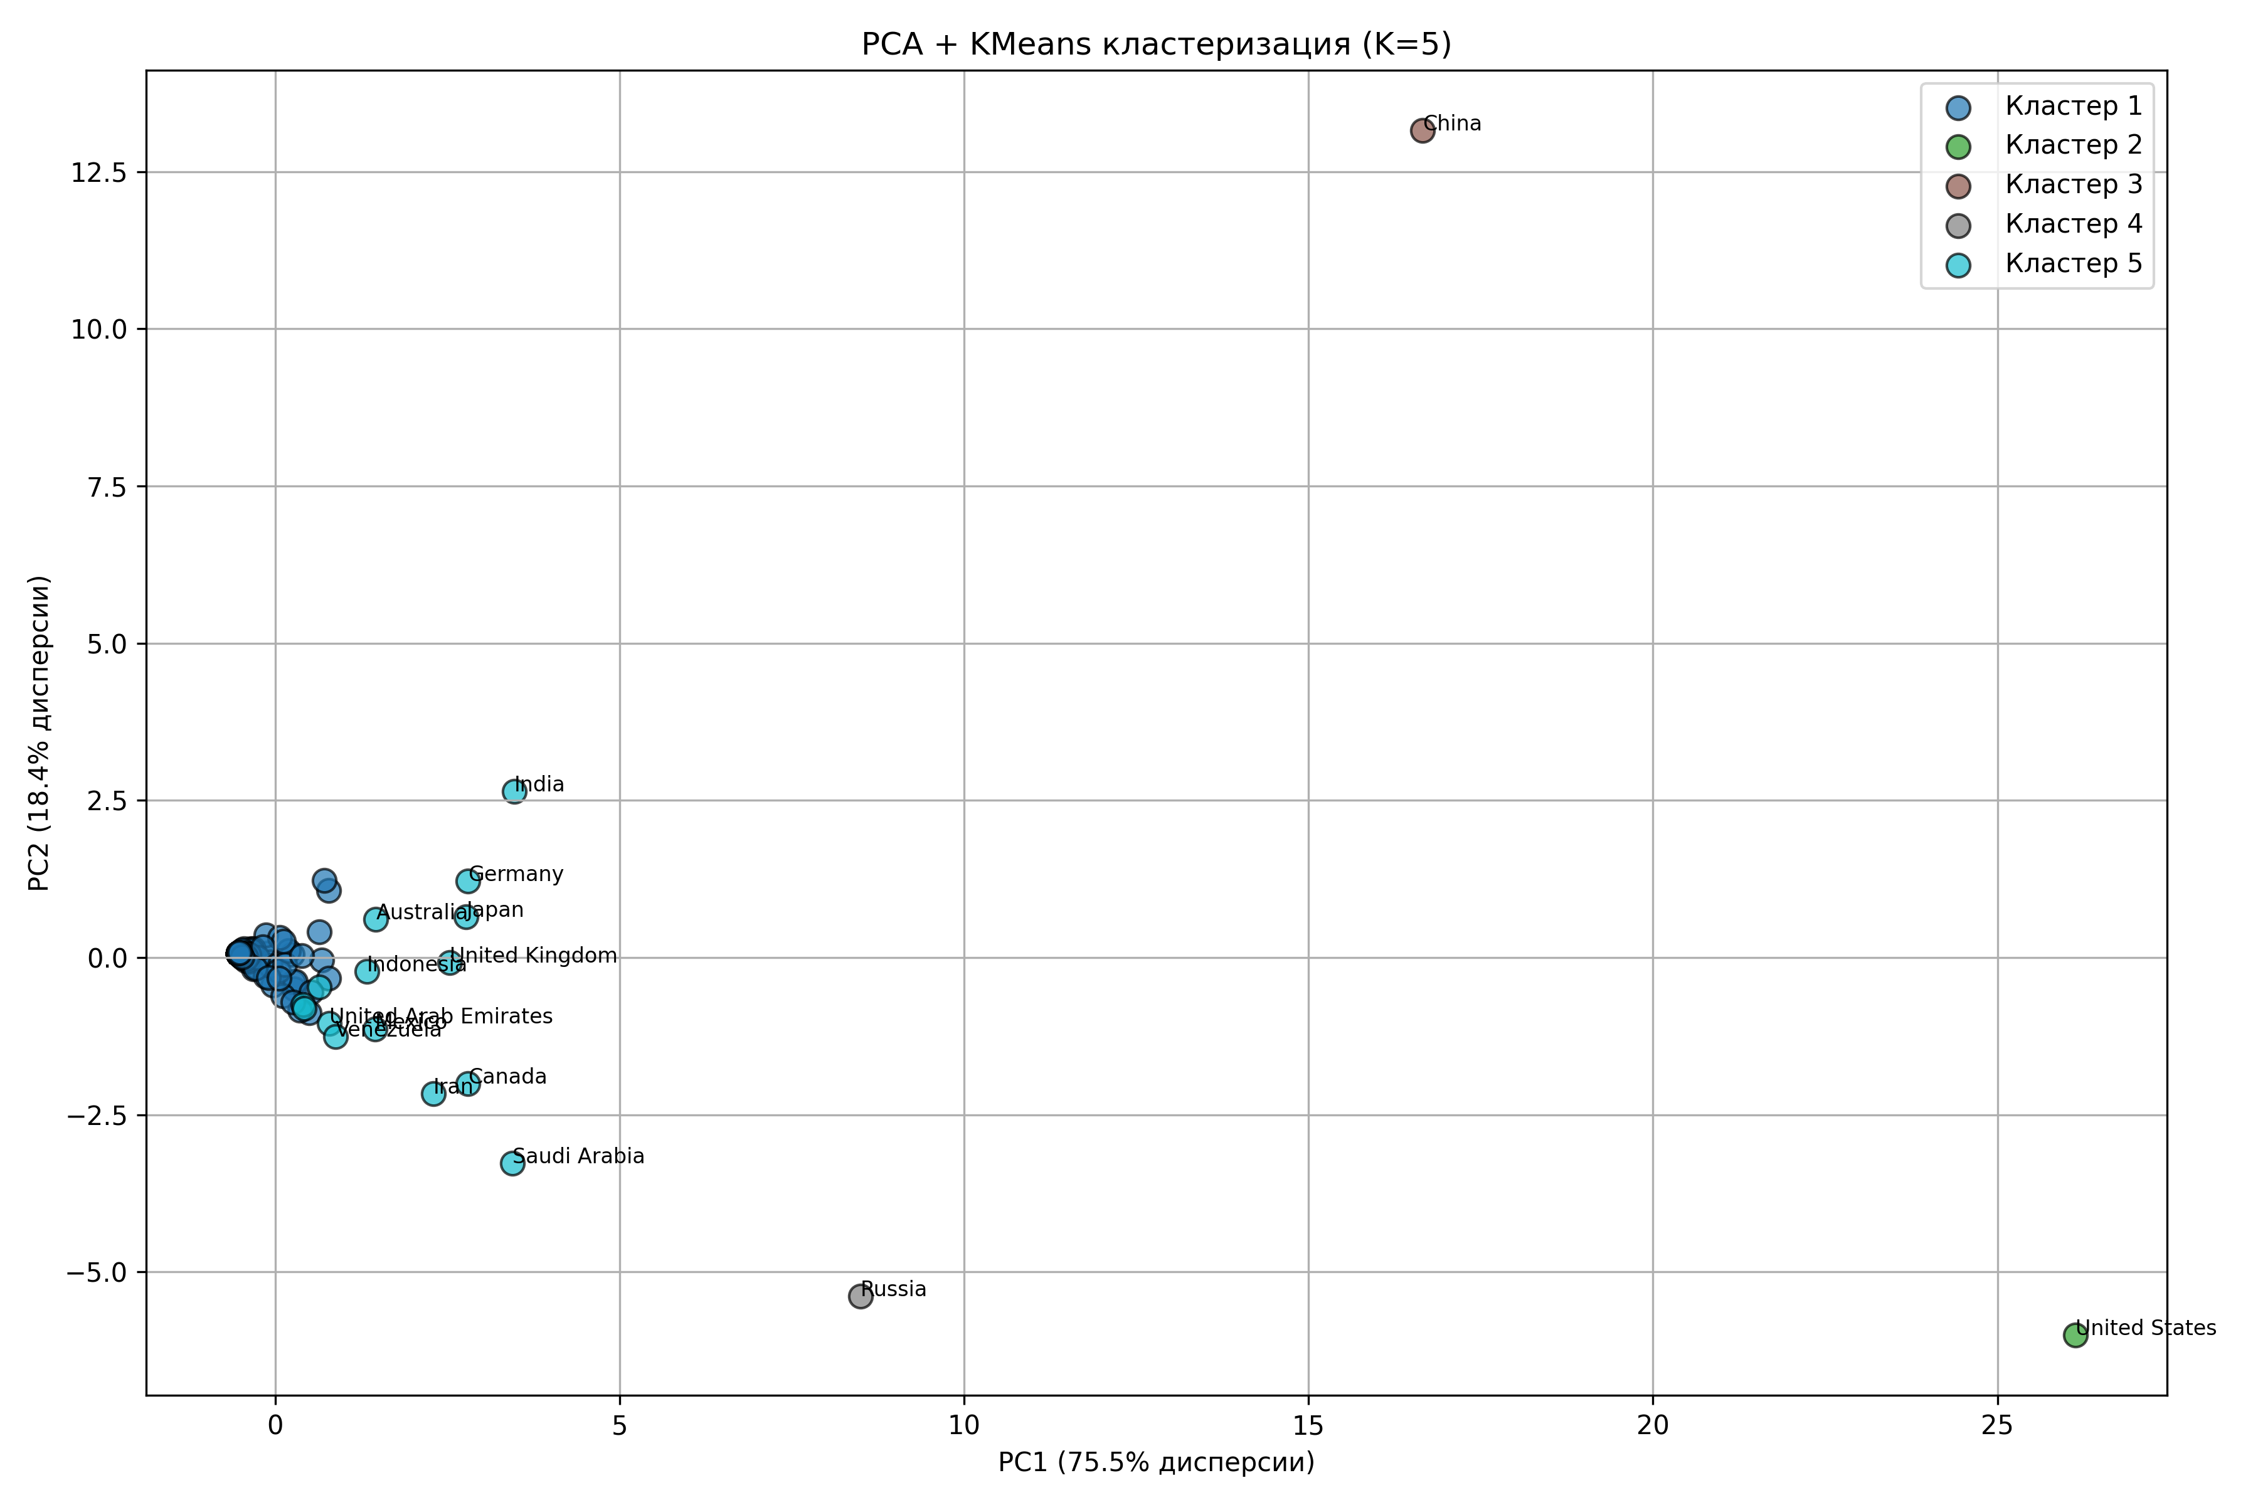
Picture 21 – PCA + KMeans.

Interpretation of clusters:
- Cluster 1 (Energy Giants): Includes China and the US. Maximum values on all axes. Huge consumption and production.
- Cluster 2 (Major Producers/Exporters): Countries such as Russia and Saudi Arabia. Characterized by a high shift towards production.
- Cluster 3 (Developed Consumers): Countries with high consumption levels but a smaller share of their own production (some European countries).
- Clusters 4 and 5 (Developing and Small Economies): The most numerous groups. They have low absolute values and are clustered around the center of the coordinate system.

3. Key findings of the multidimensional analysis
- Scale dominance: The first factor (economy and population size) accounts for 80-90% of the differences between countries in the energy sector.
- Clear segmentation: The energy world is extremely heterogeneous. Clustering confirms that decarbonization strategies must be different for the “giant cluster” and the “small economies cluster.”
- Visual confirmation of emissions: The leaders previously identified in T-tests (the US, China, Russia) are clearly separated from the bulk of countries on PCA graphs, confirming their exceptional influence on global statistics.

Energy sustainability and depletion risk forecast
This section analyzes the dynamics of the global energy sector through the lens of CAGR (compound annual growth rate) for the period 1990–2022.
DRI=Consumption-Production
- DRI > 0: Consumption is growing faster than production. The region is increasing its dependence on imports and rapidly depleting its domestic reserves.
- DRI < 0: Production is outpacing consumption. The region is strengthening its position as a global exporter.

1. Regional risk analysis
Data analysis has revealed a critical imbalance in developing economies: rapid industrial growth in these countries is not supported by adequate expansion of their own raw material base.
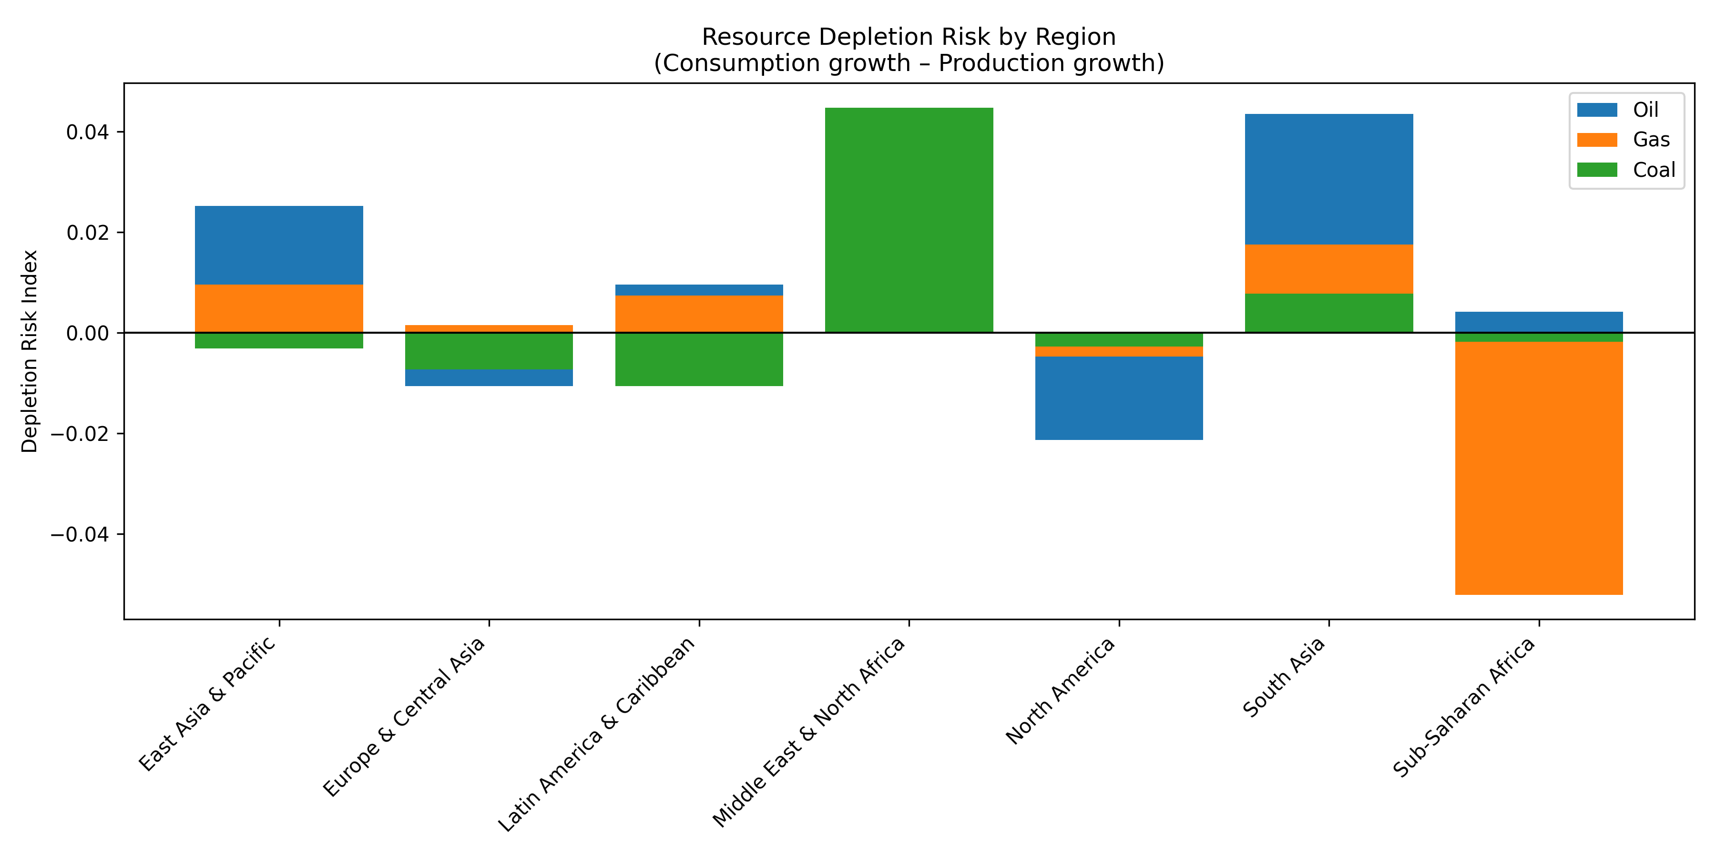
Picture 22 – Regional risks.

Key risk areas (Top 10 by DRI):
- Middle East and North Africa (Coal): Highest risk (0.044). With coal consumption growing at 3.5% per year, domestic production is falling by 0.9%. This signals a radical change in the energy paradigm in the region.
- South Asia (Oil & Gas): Critical zone. Oil consumption is growing by 4.2% annually, while production is stagnating or falling (-0.07%). This puts enormous pressure on government budgets due to import costs.
- East Asia and the Pacific: Despite its status as a major producer, the growth rate of gas (5.9%) and oil (2.7%) consumption consistently outpaces the rate of development of new fields.

2. Analysis by resource type

Oil — “Scarce resource”
Oil shows a positive risk index in almost all developing regions. We are seeing a global trend: old fields are reaching a plateau, while demand in Asia and Latin America continues to grow exponentially.

Natural gas — “Transitional fuel”
South and East Asia are experiencing extreme growth rates in consumption (up to 6% per year). Domestic production is not keeping pace with this rally, making these regions the main drivers of the global LNG market.

Coal — “Regional Polarization”
In India (South Asia), the risk index remains positive (0.007). Even with record domestic production volumes, the country is forced to increase imports to ensure the energy security of its power plants.

3. Conclusions on energy security
- South Asia — “red zone”: The region ranks in the top 10 in terms of risk (for all types of fuel) three times. This makes it the most vulnerable to global price shocks.
- Logistical fragility: The widespread growth of DRI for oil means that the global economy is becoming critically dependent on the stability of sea lanes and the tanker fleet.
- Economic incentive for renewable energy: High depletion rates in Asia are not only an environmental argument, but also a powerful economic argument for a rapid transition to renewable energy in order to reduce dependence on raw materials.

Final conclusion on global resource depletion
Based on the multidimensional analysis conducted, a fundamental conclusion can be drawn: the global energy system is in a phase of “transitional fragility.”
The main risk lies not in the physical disappearance of fossil fuels, but in the mathematical impossibility of maintaining current consumption growth rates through traditional extraction in the long term (until 2050). Regions with an accumulated deficit (DRI > 0.02) will be the first to face the need for a complete structural restructuring of their economies. The only path to long-term sustainability is a radical increase in energy efficiency and the replacement of scarce hydrocarbons with local generation.

