Write my own blog with django
write a basic frame--→make it prettier using plugins

stage 1:write a functional basic web blog
1.start a project named mysite
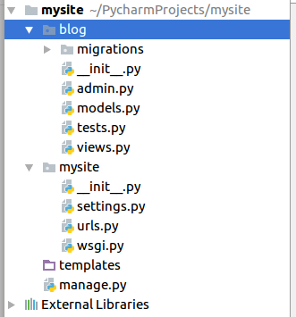
I used pycharm to create app blog directly. This helped me adding settings into settings.py

2.git init,add remote,commit,push

3.set static root
STATIC_URL = '/static/'
STATIC_ROOT = os.path.join(BASE_DIR, 'static')
4. write a model Post in models.py
5.make migrations
6.migrate
7.createsuperuser (pycharm control+shift+r)
8.Regiter Post in admin
admin.site.register(Post)

9.add urls.py
url(r'',include('blog.urls')),#send the rest of url to blog/urls.py(system will read urlspattern one by one
)
10.add urls.py
url(r'^$', views.post_list, name='post_list'),
11.define post_list in views.py
def post_list(request):
return render(request, 'blog/post_list.html', {})
12.write post_list.html

13. add post_detail url---display all items
basic priciple : you have to know the id of each item and fetch data from the database table with different id,then you have to display it.How do you kwow the different id?Where do users input this kind of id?-------two fundamental ways:1.by typing into the address directly with id;2.by clicking on specific href source.Either way you have to create a set of htmls with different item ids.(thats wrong!one html that will change its content according to different url.you have to parse url to get different id)but django facilitate your job

different url(specially made for this occasion)---→different pk-----→one model---→one table--→different query set--→one html

url(r'^post/(?P<pk>\d+)/$', views.post_detail, name='post_detail'),

14.set href----smart settings .you can get access to item id easily with django
pay attention to the parameter pass
all set!
Notice that server will check basic grammar for you even though you haven’t went into that page

15.use block to reuse html structure
{% block content %}
{%endblock%}

16.make css for admin right
python manage.py collectstatic
change /etc/apache2/apache.conf
add
-----Alias /static/ /var/www/mysite/static/
But why????
let ‘s say.Django does not serve static files,It was left for the web server.You want to find a static file
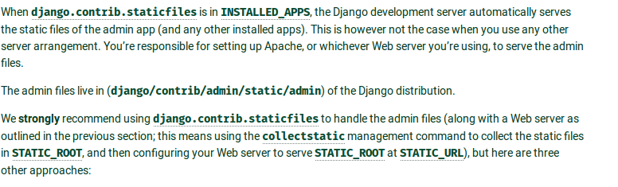
where to find?i don’t know.ask server.he knows

chinese support

import sys
reload(sys)
sys.setdefaultencoding('utf-8')

