ORIGINAL
  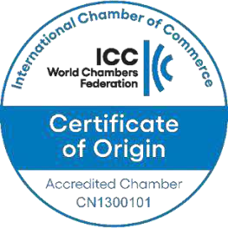  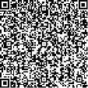    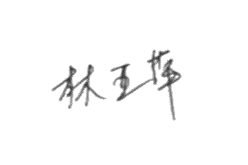  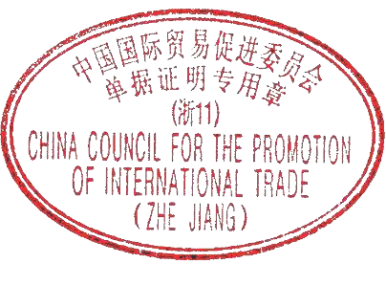  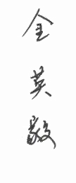  1.Exporter  Yiwu Kabul Daily Necessities Factory  ShowRoom 602, the 6th Floor, No.520, Dafuzhai Village, Houzhai Sub-dist, Yiwu City, Jinhua City, Zhejiang Province *** |  | Serial No. CCPIT3512500229074  Certificate No. 25C351120866/00014  CERTIFICATE OF ORIGIN OF  THE PEOPLE'S REPUBLIC OF CHINA
2.Consignee
ASHURBANIPAL COMPANY FOR GENERAL TRADE IN ELECTRICAL APPLIANCES AND HOME AND OFFICE FURNITURE, TRADE AND SUPPLY OF
KITCHENS, FURNITURE AND DECORATION, PROCESSING AND MARKETING OF SINGLE-USE HOUSEHOLD AND FOOD SUPPLIES.
ADDRESS : IRAQ - BAGHDAD / AL-QADISIYAH DISTRICT - MAHALLA / 606 - ALLEY
/ 8 - BUILDING NO. / 74 TABARAK CENTER BUILDING FLOOR NO. 5, OFFICE NO. 9
3.Means of transport and route  FROM NINGBO CHINA TO UMM QASR IRAQ BY SEA |  | 5.For certifying authority use only    VERIFY URL:HTTP://CHECK.ECOCCPIT.NET/
4.Country / region of destination
IRAQ
6.Marks and numbers | 7.Number and kind of packages;description of goods |  | 8.H.S.Code  851671.00 | 9.Quantity  G.WEIGHT 7,910 KGS G.W. | 10.Number and date of invoices  YKDNASH71374 93  OCT.09,2025
N/M SIX HUNDRED FORTY  (640) CTNS OF GLASS ELECTRIC KETTLE  **MOBILE NUMBER : 009647901860410 - 009647844702070 TAX NUMBER : 902191163  *** |  |  | 8.H.S.Code  851671.00 | 9.Quantity  G.WEIGHT 7,910 KGS G.W. | 10.Number and date of invoices  YKDNASH71374 93  OCT.09,2025
11.Declaration by the exporter  The undersigned hereby declares that the above details and statements are correct, that all the goods were produced in China and that they comply with the Rules of Origin of the People's Republic of China.  YIWU,CHINA NOV.25,2025  Place and date,signature and stamp of authorized signatory |  | 12.Certification  It is hereby certified that the declaration by the exporter is correct.  ADDRESS:FIRST FLOORNO.288,FUTIAN ROAD,YIWU, ZHEJIANG  FAX:0579-85570088 TEL:0579-85195422  YIWU,CHINA NOV.25,2025  Place and date,signature and stamp of certifying authority
Page 1 of 1

