COMPLETE TECHNICAL REFERENCE
NeuroScan — Technical Deep-Dive
Explainable Brain-Tumor MRI Classification · ResNet50 → GradCAM → Local-LLM Report

Contents
01 Project Overview
02 The Problem & Motivation
03 The Four Classes
04 System Architecture
05 The Dataset & Preprocessing
06 Data Augmentation
07 The Model: ResNet50 + Transfer Learning
08 Training Procedure & Results
09 Honest Limitations & the “Claimed” Accuracy
10 Inference Flow
11 Explainability: GradCAM
12 The Local-LLM Clinical Report
13 Backend: FastAPI
14 Frontend: the Next.js Web App
15 Deployment: Docker + nginx
16 The Full Tech Stack
17 How to Run It Yourself
18 Anticipated Questions & Answers
19 Glossary of Key Terms
20 Conclusion & Future Work

01 Project Overview
NeuroScan is an explainable deep-learning system that classifies a brain-MRI scan into one of four categories and then explains itself — visually and in words.
Most student ML projects stop at a prediction. NeuroScan goes three steps further: it (1) classifies the scan with a fine-tuned ResNet50 convolutional network, (2) draws a GradCAM heatmap showing exactly which pixels drove that decision, and (3) writes a short, structured clinical report using a local large-language model. The whole pipeline runs offline on the user's own machine — no cloud services and no API keys.
The three pillars
- Classification — what is it? A ResNet50 network outputs a probability for each of the four classes.
- Explainability — why did it say that? GradCAM highlights the regions the model relied on.
- Communication — what does it mean? A local LLM turns the numbers into a readable report.
There are two front-ends over the same model core: a professional Next.js + FastAPI web app (the primary product) and a legacy Gradio interface kept for quick local demos.
Important · Scope & safety
NeuroScan is an educational and research prototype. It is not a medical device and must never be used for real diagnosis or treatment decisions.

02 The Problem & Motivation
Reading brain MRIs is slow, requires a trained radiologist, and varies between readers. AI can assist — but only if clinicians can trust and understand it.
A bare classifier that only prints "Glioma, 92%" is hard to trust: the user cannot tell whether the model looked at the tumor or at an irrelevant artifact. This is the classic "black box" problem in medical AI. NeuroScan is designed around the idea that an AI tool in medicine must be transparent and communicative, not just accurate.
Design goals
- Accuracy — a strong classifier via transfer learning on a pretrained backbone.
- Transparency — every prediction comes with a visual explanation (GradCAM).
- Accessibility — a clear, written report a non-expert can read.
- Privacy — fully local; medical images never leave the machine.
- Honesty — the app states its own limitations instead of overclaiming.
03 The Four Classes
The model distinguishes three tumor types plus a healthy class. The index order is fixed everywhere in the code because the trained weights depend on it.
Index | Class | Medical description
0 | Pituitary | A tumor of the pituitary gland at the base of the brain. Most are benign (non-cancerous).
1 | No Tumor | A healthy scan in which no tumor is detected. Note the space in the label string.
2 | Meningioma | A tumor forming on the meninges, the membranes surrounding the brain and spinal cord.
3 | Glioma | A tumor originating in the brain's glial cells. It can be benign or malignant.

Note · Why the fixed order matters
The network's final layer outputs four numbers in this exact order. If the order were changed, the saved weights (model_class.pth) would map to the wrong labels. That is why the order Pituitary=0, No Tumor=1, Meningioma=2, Glioma=3 is duplicated identically in the model core, the backend and the frontend.

04 System Architecture
How the pieces connect: a browser talks to nginx, which routes the web page to Next.js and the API calls to FastAPI; the backend wraps the PyTorch model, GradCAM and a local LLM.
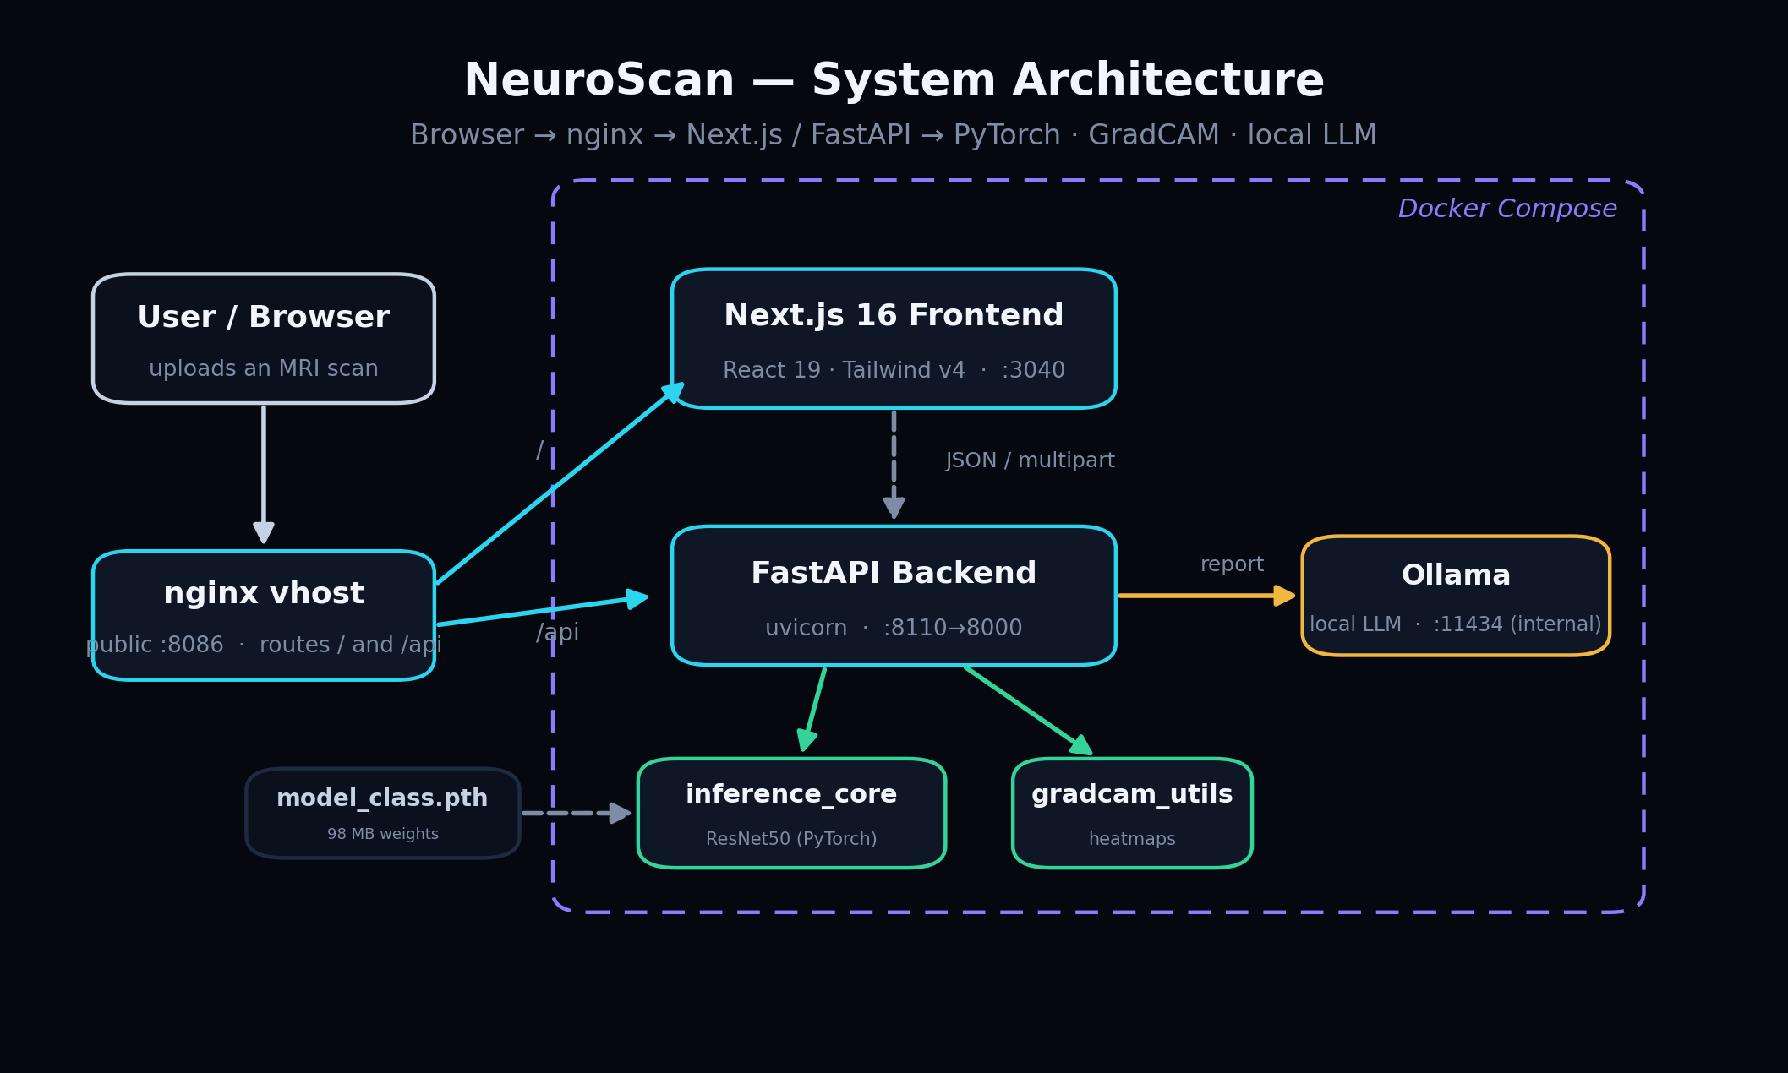
End-to-end architecture, from the browser to the model core.
The shared model core
At the center is inference_core.py — the single source of truth for the model. It defines how to build the network, the image transform, the class names, and the predict function. Crucially it is import-safe: importing it does NOT load the 98 MB weights, so the backend can start instantly and load the model deliberately at startup.
inference_core.py | build_model, load_model, TRANSFORM, CLASSES/CLASS_INFO, predict_core.
backend/ | The FastAPI app: routes, schemas, image validation, metrics parsing.
frontend/ | The Next.js web app: pages, components, and the API seam.
gradcam_utils.py / llm_report.py | Optional explainability and reporting helpers (degrade gracefully if absent).

05 The Dataset & Preprocessing
Every image is resized and normalized to look exactly like the data the ResNet50 backbone was originally trained on (ImageNet).
The model expects a 224×224 RGB image. The inference transform (the canonical TRANSFORM in inference_core.py) applies three deterministic steps:
- Resize to 224 × 224 pixels.
- Convert to a tensor (rescaling pixel values from 0–255 to 0.0–1.0).
- Normalize per channel with ImageNet mean [0.485, 0.456, 0.406] and std [0.229, 0.224, 0.225].
TRANSFORM = transforms.Compose([
transforms.Resize((224, 224)),
transforms.ToTensor(),
transforms.Normalize(mean=[0.485, 0.456, 0.406],
std=[0.229, 0.224, 0.225]),
])

Note · Why ImageNet statistics?
ResNet50's weights were learned on ImageNet, where inputs were normalized with these exact numbers. Feeding differently-scaled inputs would shift the distribution the network expects and hurt accuracy, so we reuse the same mean and standard deviation.

06 Data Augmentation
During training only, each image is randomly transformed so the model sees more variety and learns features that survive real-world noise.
Transform | Setting | Why (medical rationale)
Horizontal flip | p = 0.5 | Left/right symmetry — orientation should not change the class.
Vertical flip | p = 0.5 | Robustness to how a scan was loaded/oriented.
Rotation | ±15° | Tolerate small misalignment of the patient's head.
ColorJitter | brightness/contrast 0.2 | Different scanners produce different brightness and contrast.
GaussianBlur | kernel 3 | Simulate motion blur and out-of-focus artifacts.

Good to know · Validation stays clean
The validation transform applies only resize + normalize — no randomness. Evaluation must be deterministic so the reported numbers are reproducible.

07 The Model: ResNet50 + Transfer Learning
Rather than training a network from scratch, NeuroScan starts from an ImageNet-pretrained ResNet50 and adapts it to brain MRIs — the standard, data-efficient approach.
What is ResNet50?
ResNet50 is a 50-layer convolutional neural network. Its key innovation is the residual (skip) connection, which lets gradients flow through very deep networks without vanishing — making it possible to train 50 layers reliably. Pretrained on ImageNet (1.2M images, 1000 classes), its early layers already detect generic edges, textures and shapes that are useful for any image task.
Freezing and fine-tuning
- All backbone layers are frozen first (their weights won't change).
- Then layer3 and layer4 — the deepest blocks holding high-level features — are unfrozen.
- The optimizer updates only those unfrozen layers plus the new classifier head.
- This adapts the high-level features to MRIs while keeping the proven low-level detectors.
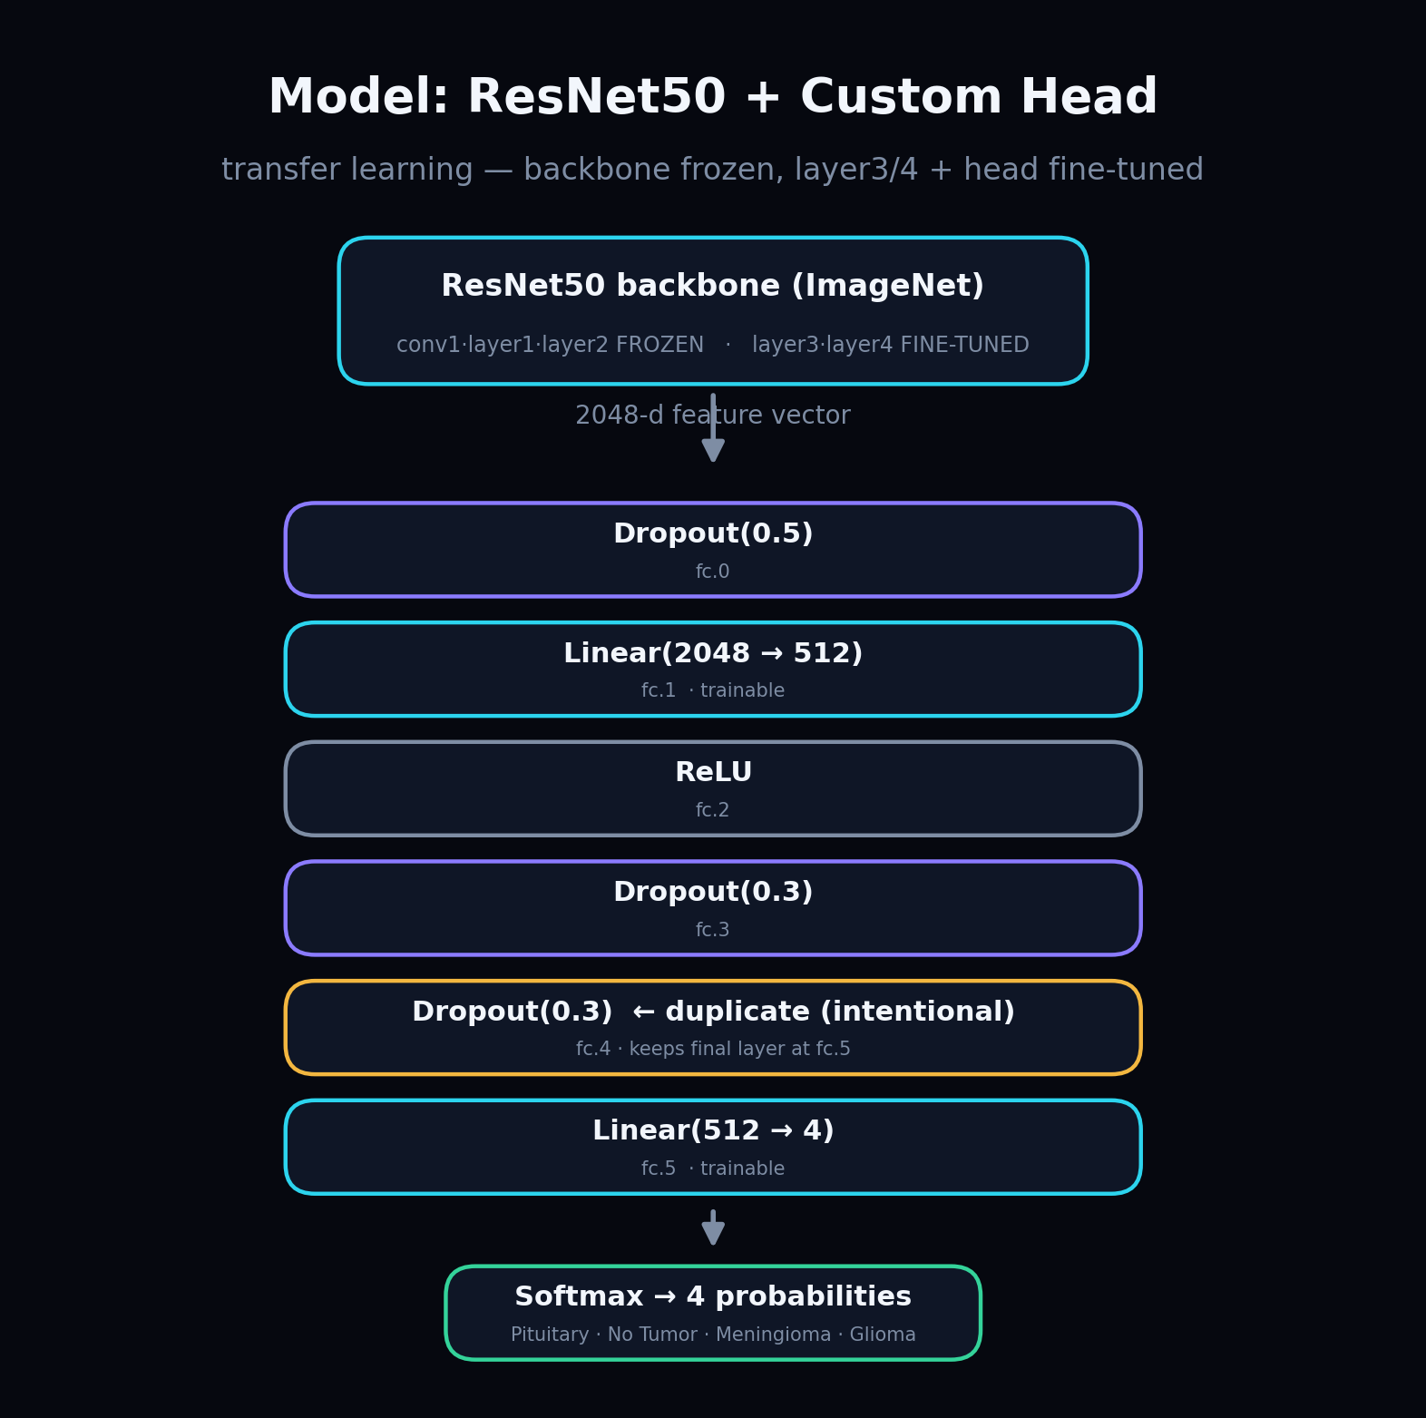
The custom classifier head replaces ResNet50's original 1000-class layer.
The classifier head — and a subtle detail
The original 1000-class layer is swapped for a small head that maps the 2048-dimensional feature vector down to 4 class scores, with dropout for regularization:
model.fc = nn.Sequential(
nn.Dropout(0.5), # fc.0
nn.Linear(2048, 512), # fc.1 (trainable)
nn.ReLU(), # fc.2
nn.Dropout(0.3), # fc.3
nn.Dropout(0.3), # fc.4 <- duplicate, intentional
nn.Linear(512, 4), # fc.5 (trainable)
)

Note · The intentional duplicate Dropout
Dropout layers have no learnable weights, so the duplicate Dropout(0.3) changes nothing numerically. Its only job is to keep the final Linear layer at state-dict key fc.5. The training script's head used a BatchNorm at that position; to load the shipped weights *strictly* at inference time, the inference head reproduces the same key layout with a second Dropout instead of BatchNorm. Remove it and the final layer shifts to fc.4 and the weights fail to load.

08 Training Procedure & Results
The model was trained with the Adam optimizer, label-smoothed cross-entropy, a learning-rate scheduler and early stopping — converging in only seven epochs.
Hyperparameter | Value | Purpose
Optimizer | Adam, lr = 1e-4 | Adaptive per-parameter step size; stable for fine-tuning.
Loss | CrossEntropy, label_smoothing = 0.1 | Softens hard labels to reduce over-confidence and overfitting.
Weight decay | 1e-4 | L2 regularization on trainable weights.
Scheduler | ReduceLROnPlateau, ×0.5 | Halves the LR when validation loss stops improving.
Batch size | 32 | Samples per gradient update.
Epochs | max 20, patience 5 | Early stopping ends training when val accuracy stalls.

Actual training log (model_log.csv)
Epoch | Train acc | Val acc | Train loss | Val loss
1 | 88.20% | 94.36% | 0.3306 | 0.1575
2 | 96.78% | 98.47% | 0.0999 | 0.0525
3 | 98.00% | 98.32% | 0.0683 | 0.0525
4 | 98.34% | 98.63% | 0.0540 | 0.0438
5 | 98.84% | 98.25% | 0.0438 | 0.0644
6 | 99.05% | 99.39% | 0.0305 | 0.0197
7 | 98.77% | 99.16% | 0.0482 | 0.0279

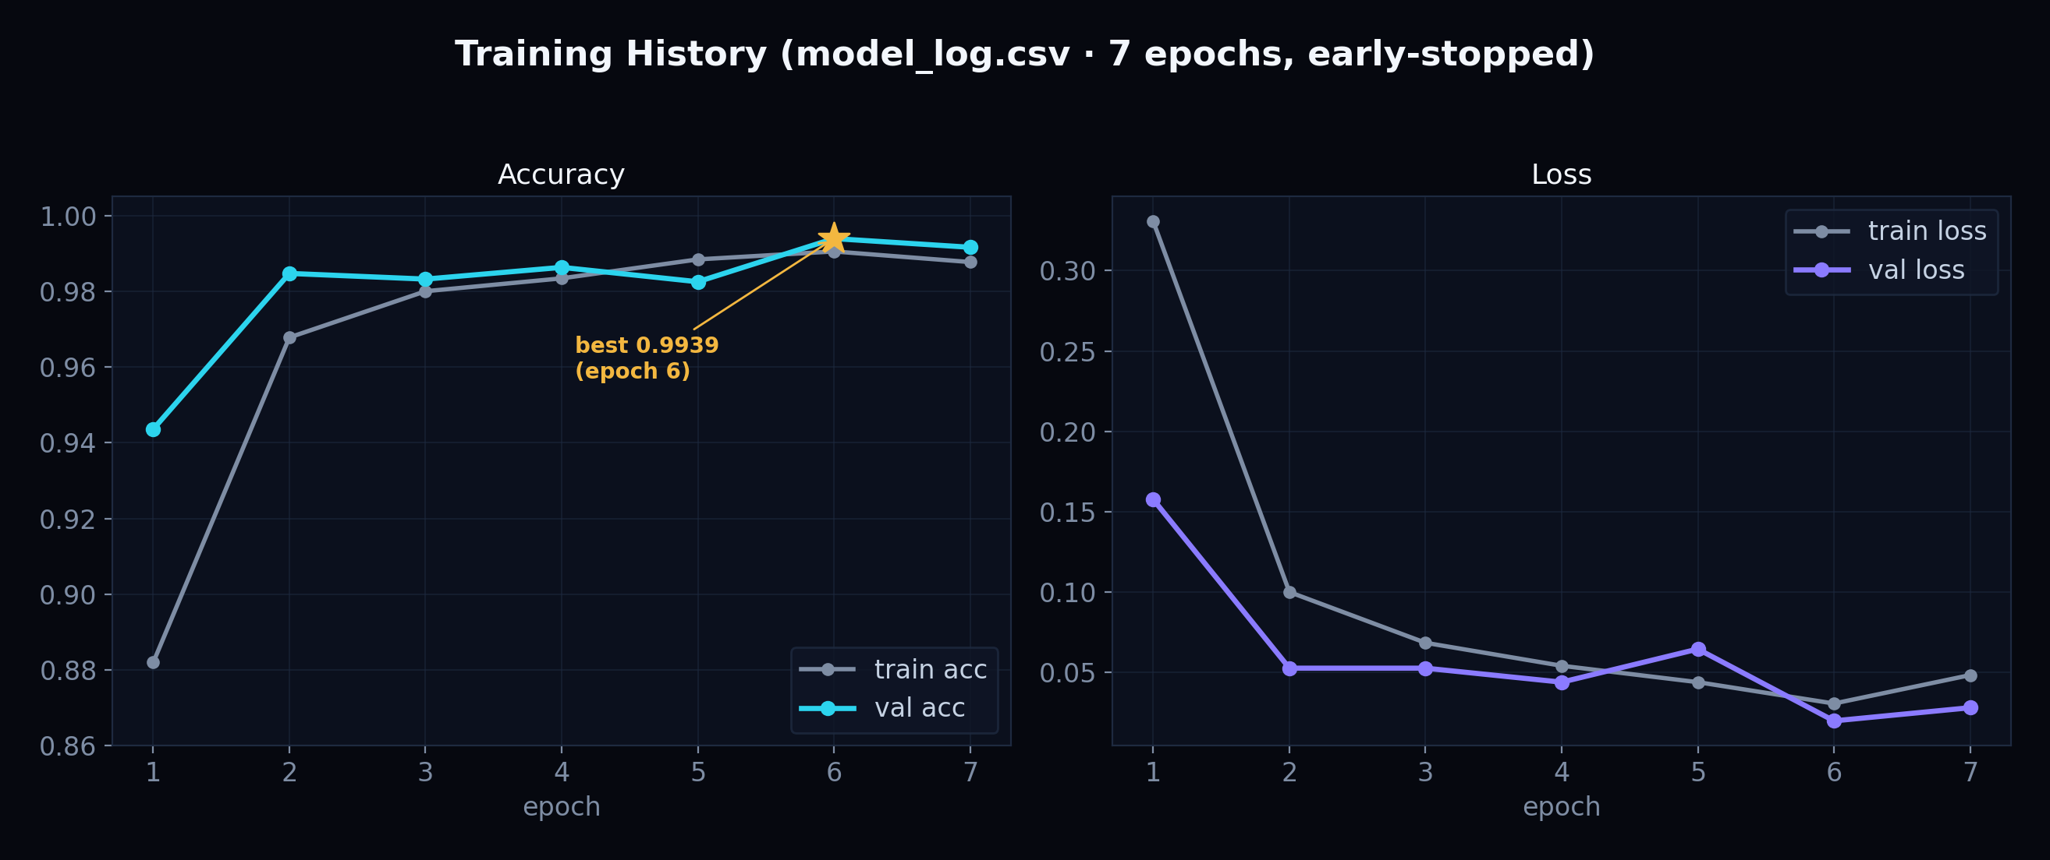
Accuracy and loss over the 7 epochs. Best validation accuracy was 99.39% at epoch 6.
Training also writes the weights (model_class.pth), the log (model_log.csv), and two plots (learning_curves.png, confusion_matrix.png) to the repository root.
09 Honest Limitations & the “Claimed” Accuracy
The headline 99% number is presented as “claimed,” not validated — because of a known methodological flaw the project openly documents.
Important · Data leakage: test set reused for validation
train.py uses the same test set for validation and early-stopping. That means model selection (when to stop, when to lower the LR) was tuned on the very data used to report accuracy. The result is an optimistic figure, not an unbiased estimate of how the model performs on truly unseen scans.

The backend's metrics endpoint and the web UI both surface this caveat explicitly, labelling the figure “claimed accuracy.” Acknowledging the flaw is deliberate: it is more scientifically honest than presenting 99% as a validated result.
Other limitations
- Single-source data: the model may not generalize to other scanners, hospitals or populations.
- Classification only: it does not localize, segment or stage a tumor.
- No clinical validation: it has never been tested in a real clinical workflow.
- Educational use only: by design, never a diagnostic tool.
10 Inference Flow
What happens, step by step, when one image is classified inside predict_core().
- Convert the uploaded image to RGB (drops any alpha channel).
- Apply TRANSFORM and add a batch dimension → tensor shape (1, 3, 224, 224).
- Run a forward pass with gradients disabled (torch.no_grad) → 4 raw logits.
- Apply softmax to turn logits into probabilities that sum to 1.
- Map each probability to its class name and pick the highest as the top class.
- Build a short markdown verdict from the class and confidence.
- Optionally generate the GradCAM heatmap for that prediction.
with torch.no_grad():
logits = model(img_tensor)
probs = torch.softmax(logits, dim=1).squeeze().cpu().tolist()
label_probs = {CLASSES[i]: round(probs[i], 4) for i in range(4)}
top_class = max(label_probs, key=label_probs.get)

The function returns the per-class probabilities, the top class and its confidence, the markdown verdict, and the GradCAM image — everything the API needs to build a response.
11 Explainability: GradCAM
GradCAM answers “where did the model look?” by producing a heatmap over the MRI that highlights the regions most responsible for the prediction.
How it works (intuition)
- Take the activations of the last convolutional block (model.layer4[-1]).
- Compute the gradient of the predicted class score with respect to those activations.
- Use the gradients as weights: feature maps that strongly raise the score count more.
- Combine the weighted maps into a coarse heatmap and overlay it on the original scan.
The implementation enables aug_smooth (averaging over small augmentations) and eigen_smooth (keeping the dominant component) to suppress noise and produce a cleaner, more trustworthy map. Red areas are the most influential; cool areas matter least.
Good to know · Graceful fallback
If the grad-cam package is not installed, generate_gradcam simply returns the resized original image instead of crashing, and the UI shows a one-line setup hint. Explainability is optional, never a hard dependency.

Note · Why explainability matters here
In medical AI, a correct answer for the wrong reason is dangerous. A heatmap lets a human verify that the model focused on the lesion rather than on text, borders, or scanning artifacts — turning a black box into something a clinician can sanity-check.

12 The Local-LLM Clinical Report
A local large-language model turns the raw prediction into a structured, human-readable report — with no cloud service and no API key.
The report is produced by Ollama, a tool that runs LLMs locally. The model is configurable via the OLLAMA_MODEL environment variable and defaults to qwen2.5:1.5b-instruct-q4_K_M — a small, quantized instruct model that runs even on modest hardware.
Prompt design
A system prompt sets the role (a careful, compassionate clinical assistant that always adds an educational disclaimer). A user prompt injects the prediction and probabilities and demands exactly five sections, 2–4 sentences each, under 230 words:
- Diagnosis Summary
- About <the tumor type>
- What the Heatmap Shows
- Recommended Next Steps
- Important Disclaimer
Generation uses temperature 0.3 (factual, low-variance text), a 2048-token context, and a capped output length. A helper strips any stray markdown code fence the model might add.
Note · Why a local LLM?
Privacy — medical images and findings never leave the machine. Cost — no per-call API fees. Availability — it works fully offline. The trade-off is speed: on CPU a report can take 1–2 minutes; on a GPU about 15 seconds.

Good to know · Degrades gracefully
If the Ollama client isn't installed, the server isn't running, or the model isn't pulled, the endpoint returns clear setup instructions instead of an error — and the rest of the app keeps working.

13 Backend: FastAPI
A small, robust FastAPI service wraps the model core, validates uploads, serializes inference, and exposes four JSON endpoints.
Startup & robustness
- A lifespan handler loads the model once, at startup, onto the chosen device (GPU or CPU).
- If loading fails, the API stays up and reports the error via /api/health — it does not crash.
- An INFERENCE_LOCK serializes model access because GradCAM registers hooks that are not thread-safe; requests run in a threadpool to keep the server responsive.
- CORS is restricted to the configured frontend origins.
The four endpoints
Endpoint | Method | Purpose
/api/health | GET | Liveness + capabilities (device, GradCAM, Ollama, class list).
/api/predict | POST | Multipart image → top class, all probabilities, verdict, base64 GradCAM.
/api/report | POST | Class + scores → a markdown clinical report.
/api/metrics | GET | Parsed training history + the accuracy caveat.

Upload validation
Before any inference, uploads are validated: the file must be non-empty, at most 15 MB, and a PNG/JPEG/WEBP/BMP image that actually decodes. Failures return precise HTTP codes (413 too large, 415 unsupported type, 422 empty/undecodable) in a uniform error envelope. The GradCAM output is encoded as a base64 PNG data URL so the browser can show it directly.
Request and response shapes are defined with Pydantic models (HealthResponse, PredictResponse, ReportRequest, MetricsResponse …), which validate types automatically and document the API.
14 Frontend: the Next.js Web App
A modern, polished single-page experience built with Next.js 16, React 19, TypeScript and Tailwind v4, with a clinical dark/light theme.
Pages & flow
- / — a landing page introducing the pipeline and the four classes.
- /analyze — the workspace: upload, prediction, GradCAM viewer, and the report panel.
- /metrics — training history with hand-drawn SVG charts and the accuracy caveat.
- /about — how it works and an honest list of limitations.
The API seam
All network calls go through lib/api.ts, a single seam that converts the backend's snake_case JSON into the frontend's camelCase TypeScript types (and back). It calls the FastAPI backend directly rather than through Next.js's proxy, because the proxy's ~30-second timeout would cut off a slow CPU-generated report; the backend base URL is set via NEXT_PUBLIC_API_BASE.
Design system
Tailwind v4's CSS-first approach defines the whole palette as CSS variables, with an instant dark/light switch. The dark “reading-room” theme uses a near-black background with cyan and violet accents; charts on the metrics page are drawn by hand in SVG (no charting library) for a lighter bundle and full control. Subtle motion and a radiological grid texture complete the look.
15 Deployment: Docker + nginx
The whole stack is containerized with Docker Compose and published behind an nginx reverse proxy on a VPS.
Three services
- backend — the FastAPI container, pinned to CPU PyTorch 2.6.0 to match the saved weights.
- frontend — the Next.js production server.
- ollama — a local LLM service, internal-only, never exposed to the public.
The application services bind only to localhost; a host nginx virtual host on port 8086 is the single public entry point. nginx routes /api requests to the backend and everything else to the frontend, so the browser sees one origin.
Tuned for a shared box
- PyTorch limited to 2 CPU threads (OMP_NUM_THREADS=2).
- Ollama unloads the model after 2 minutes idle and loads at most one model at a time.
- Health checks and restart policies keep the containers alive.
16 The Full Tech Stack
Every major technology used, and what it is responsible for.
Layer | Technology | Role
Language | Python 3.12 · TypeScript | Backend/ML in Python; frontend in TypeScript.
Model | PyTorch · torchvision | ResNet50 definition, training and inference.
Explainability | pytorch-grad-cam | GradCAM heatmaps.
Report LLM | Ollama | Runs a local LLM for the clinical report.
Backend | FastAPI · uvicorn · Pydantic | HTTP API, async server, schema validation.
Frontend | Next.js 16 · React 19 · Tailwind v4 | The web UI, routing and styling.
Packaging | Docker Compose · nginx | Containerization and reverse proxy.

17 How to Run It Yourself
The exact commands to start the backend, the frontend, and the optional local LLM.
Backend (from the repo root)
source venv/bin/activate
pip install -r backend/requirements.txt
uvicorn backend.main:app --port 8000 --reload

Frontend
cd frontend && npm install && npm run dev # http://localhost:3000

Optional local LLM report
ollama serve
ollama pull qwen2.5:1.5b-instruct-q4_K_M

A legacy Gradio UI is also available with `python app.py` (port 7860), and the model can be retrained with `python train.py --train_dir ... --test_dir ...`.
18 Anticipated Questions & Answers
The questions a panel is most likely to ask — with crisp, defensible answers.
Is the 99% accuracy real? | It is a “claimed” figure. Because the test set was reused for validation (data leakage), the number is optimistic. A proper train/validation/test split or cross-validation is needed for an unbiased estimate.
Why ResNet50 and not a Vision Transformer? | CNNs like ResNet50 are extremely data-efficient and easy to fine-tune on small medical datasets, whereas ViTs typically need far more data. ResNet50 is a proven, well-understood baseline.
How do you fight overfitting? | Four ways: dropout in the head, L2 weight decay, label smoothing, and heavy data augmentation. The tiny train/validation gap supports that it generalized within this dataset.
Why a local LLM instead of an API? | Privacy of medical data, zero per-call cost, and full offline operation. The cost is speed on CPU-only machines.
How does GradCAM actually work? | It weights the activations of the last convolutional layer by the gradient of the predicted class, producing a heatmap of the most influential regions.
Could this be used in a hospital? | No. It is an educational/research prototype with no clinical validation and known data issues; it is explicitly not a medical device.
Why two front-ends? | Gradio gave a fast prototype UI; the Next.js + FastAPI app is the polished, production-style product. Both reuse the same inference_core, so behavior is consistent.

19 Glossary of Key Terms
Plain-language definitions for the technical vocabulary used above.
CNN | A neural network that learns visual patterns through layers of small filters.
Transfer learning | Reusing a model pretrained on a large dataset and adapting it to a new, smaller task.
Residual connection | A “shortcut” that adds a layer's input to its output, enabling very deep networks.
Softmax | A function that turns raw scores into probabilities that sum to one.
Dropout | Randomly disabling neurons during training to prevent over-reliance and overfitting.
Logits | The raw, un-normalized output scores of the network before softmax.
Epoch | One full pass of the training data through the model.
Early stopping | Halting training when validation performance stops improving, to avoid overfitting.

20 Conclusion & Future Work
NeuroScan shows that a student project can be accurate, transparent, private and honest at the same time.
By pairing a fine-tuned ResNet50 with GradCAM explanations and a local-LLM report, NeuroScan turns a bare prediction into something a human can inspect and understand — all running offline on the user's machine, wrapped in a polished web app and deployed with Docker.
Future work
- Fix the evaluation: a true held-out test set or k-fold cross-validation.
- Add tumor segmentation to localize, not just classify.
- Support native DICOM medical-image input.
- Calibrate confidence and report uncertainty.
- Evaluate across multiple datasets and scanners for real generalization.
Important · Final reminder
NeuroScan is for education and research only. It is not a medical device and must not be used for diagnosis.

Educational & research prototype — not a medical device. Never use for diagnosis.

