Helwan University
Faculty of Computers and Artificial Intelligence

Round Robin vs SRTF
Scheduling Comparison
Fairness vs Efficiency in CPU Scheduling

Operating Systems Course Project
May 2026
Table of Contents
1. Introduction ............................................................................................
1.1 CPU Scheduling Overview ................................................................
1.2 The Comparison Scope .....................................................................
1.3 Problem Statement ............................................................................
2. Project Objective ...................................................................................
3. Scheduling Algorithms Overview ..........................................................
3.1 Round Robin (RR) Scheduling Algorithm .........................................
3.2 Shortest Remaining Time First (SRTF) Algorithm .............................
3.3 Key Differences Summary ................................................................
4. Analysis and Comparison Focus ..........................................................
5. System Design & Implementation ........................................................
5.1 System Architecture Overview ..........................................................
5.2 User Interface (UI) Components .......................................................
5.3 Implementation Details ......................................................................
5.4 Program Flow ...................................................................................
5.5 System Robustness & Error Handling ...............................................
6. Scheduling Metrics (Laws & Formulas) ................................................
6.1 Definitions and Formulas ..................................................................
6.2 Average Metrics Analysis .................................................................
6.3 Fairness Index .................................................................................
7. Testing and Validation (Scenarios) .......................................................
7.1 Scenario A: Basic Mixed Workload ....................................................
7.2 Scenario B: Quantum Sensitivity Case ..............................................
7.3 Scenario C: Short-Job-Heavy Case ....................................................
7.4 Scenario D: Interactive-Style Fairness Case ......................................
7.5 Scenario E: Validation Case ..............................................................
8. Results & Analysis (Gantt Chart Discussion) .........................................
9. Performance Analysis & Discussion .....................................................
10. Conclusion ...........................................................................................

1. Introduction
PU Scheduling Overview
In modern operating systems, CPU scheduling is a fundamental process that determines which process in the ready queue is allocated to the CPU for execution. The primary goal is to ensure system efficiency, maximize throughput, and provide balanced experience for all running tasks. Efficient scheduling is critical for optimizing resource management and maintaining system stability.
The Comparison Scope
This project focuses on a comparative study between two prominent preemptive scheduling algorithms: Round Robin (RR) and Shortest Remaining Time First (SRTF).
- Round Robin is a fairness-oriented algorithm that utilizes time-slicing (Time Quantum) to ensure every process gets an equal share of CPU time.
- SRTF is an efficiency-oriented algorithm that prioritizes processes with the least remaining execution time, aiming to minimize the overall waiting time.
Problem Statement
The challenge in CPU scheduling lies in the trade-off between fairness and efficiency. While Round Robin prevents starvation through its time-sharing nature, SRTF can significantly improve response times for shorter jobs but may lead to longer waiting times for larger ones. This project investigates these dynamics through practical implementation and metric analysis.

2. Project Objective
The primary goal of this project is to design, implement, and evaluate a CPU scheduling simulator... The specific objectives are as follows:
- Algorithm Implementation & Validation: To develop a functional simulation of RR and SRTF with a robust input validation engine that ensures all process data and the Time Quantum are positive, non-zero values to prevent system crashes.
- Performance Metric Analysis: To accurately calculate and compare key scheduling metrics (WT, TAT, RT) and their respective System Averages.
- Behavioral Evaluation: To analyze the impact of Context Switching overhead caused by small Time Quanta in RR versus the starvation risks in SRTF.

3. Algorithms Overview
3.1 Round Robin (RR) Scheduling Algorithm
Round Robin (RR) is a preemptive CPU scheduling algorithm designed to provide fair CPU allocation among processes. Each process is assigned a fixed time quantum, and processes are executed in a cyclic order using a ready queue.
In the implemented system, processes are first sorted based on their arrival time and then inserted into a queue as they arrive. The scheduler selects the process at the front of the queue and executes it for a maximum duration equal to the given time quantum or until the process completes, whichever occurs first.
If a process is not completed after its time slice, it is re-added to the end of the ready queue. The implementation ensures a "Correct Ready Queue" logic; if a new process arrives at the same time an existing one is preempted, the new arrival is prioritized in the queue to maintain system flow. This ensures all processes receive equal CPU opportunities.
During execution, the algorithm tracks:
- Remaining burst time for each process to manage execution cycles.
- First execution time to accurately calculate the Response Time.
- Completion time to compute the final Turnaround and Waiting times.
The Gantt chart is generated dynamically by recording each execution interval, which reflects the actual time-slicing behavior of the algorithm.

3.2 Shortest Remaining Time First (SRTF) Algorithm
Shortest Remaining Time First (SRTF) is a preemptive CPU scheduling algorithm that selects the process with the smallest remaining execution time at every decision point. It is considered an efficiency-oriented algorithm as it aims to minimize the overall waiting and turnaround times.
In the implemented system, at each time unit, the scheduler scans all available processes and selects the one with the minimum remaining burst time among those that have already arrived. If a new process arrives with a shorter remaining time than the current one, the running process is preempted immediately. The system performs a check at every time unit (Clock Tick) and upon every new arrival to guarantee that the CPU is always executing the process with the minimum remaining burst time.
dynamic Gantt chart construction ensures:
- Accurate representation of preemption behavior.
- Tracking of execution intervals; when a process is interrupted or switched, a new segment is recorded.
- Precise calculation of metrics including First Response Time, Completion Time, Turnaround Time, and Waiting Time.

3.3 Key Differences Summary
The main difference between Round Robin and SRTF lies in their scheduling strategy. Round Robin focuses on fairness by allocating equal time slices to all processes, while SRTF focuses on efficiency by always selecting the shortest remaining job.
Feature | Round Robin (RR) | SRTF
Primary Focus | Fairness through time-sharing | Efficiency & Throughput
Starvation | No (All processes get a turn) | Yes (Longer jobs may starve)
Overhead | High (Frequent context switching if Quantum is small) | Medium/High (Frequent checks at every arrival/tick)
Performance | Better for Interactive/Multi-user systems | Better for minimizing Average Waiting Time
Short Job Handling | Treated equally with long jobs | Strong advantage/Highest priority

4. Analysis and Comparison Focus
Through the simulation, the following dynamics are analyzed:
- Fairness vs. Efficiency: Evaluating how RR ensures no process is left behind, while SRTF pushes the system to its maximum throughput.
- Quantum Sensitivity: Observing the Round Robin behavior where a very large Quantum makes it behave like FCFS, while a very small Quantum increases the context-switching overhead.
- Response Time (RT): Comparing how RR provides a predictable first response for interactive tasks versus how SRTF minimizes RT specifically for short tasks.
5. System Design & Implementation
This section details the architectural design and technical implementation of the CPU Scheduling Simulator. The system is built with a focus on modularity, strictly separating the core scheduling logic from the Graphical User Interface (GUI) to ensure reliability and scalability.
5.1 System Architecture Overview
The application follows a structured workflow to ensure data integrity and accurate simulation:
- Input Module: Facilitates the entry of a dynamic number of processes (Arrival Time, Burst Time) and the Time Quantum through an interactive table.
- Validation Layer: A critical security gate that ensures no negative values, zero-value quanta, or duplicate process IDs are processed, rejecting invalid inputs safely.
- Processing Engine: The core where the Round Robin (RR) and Shortest Remaining Time First (SRTF) algorithms reside. It handles the discrete-time simulation and generates execution logs.
- Visualization & Analytics Layer: This layer transforms raw data into Separate Gantt Charts, Ready Queue Views, and Comparison Summary Panels.

5.2 User Interface (UI) Components
To fulfill the requirements, the UI is organized into three distinct functional zones designed for clarity and ease of comparison:
Input & Control Panel (Left):
- Contains the "Processes" data entry table.
- Features a dedicated Quantum Input Field for user-defined time slicing.
- Control buttons: "Run Simulation" and "Clear All".
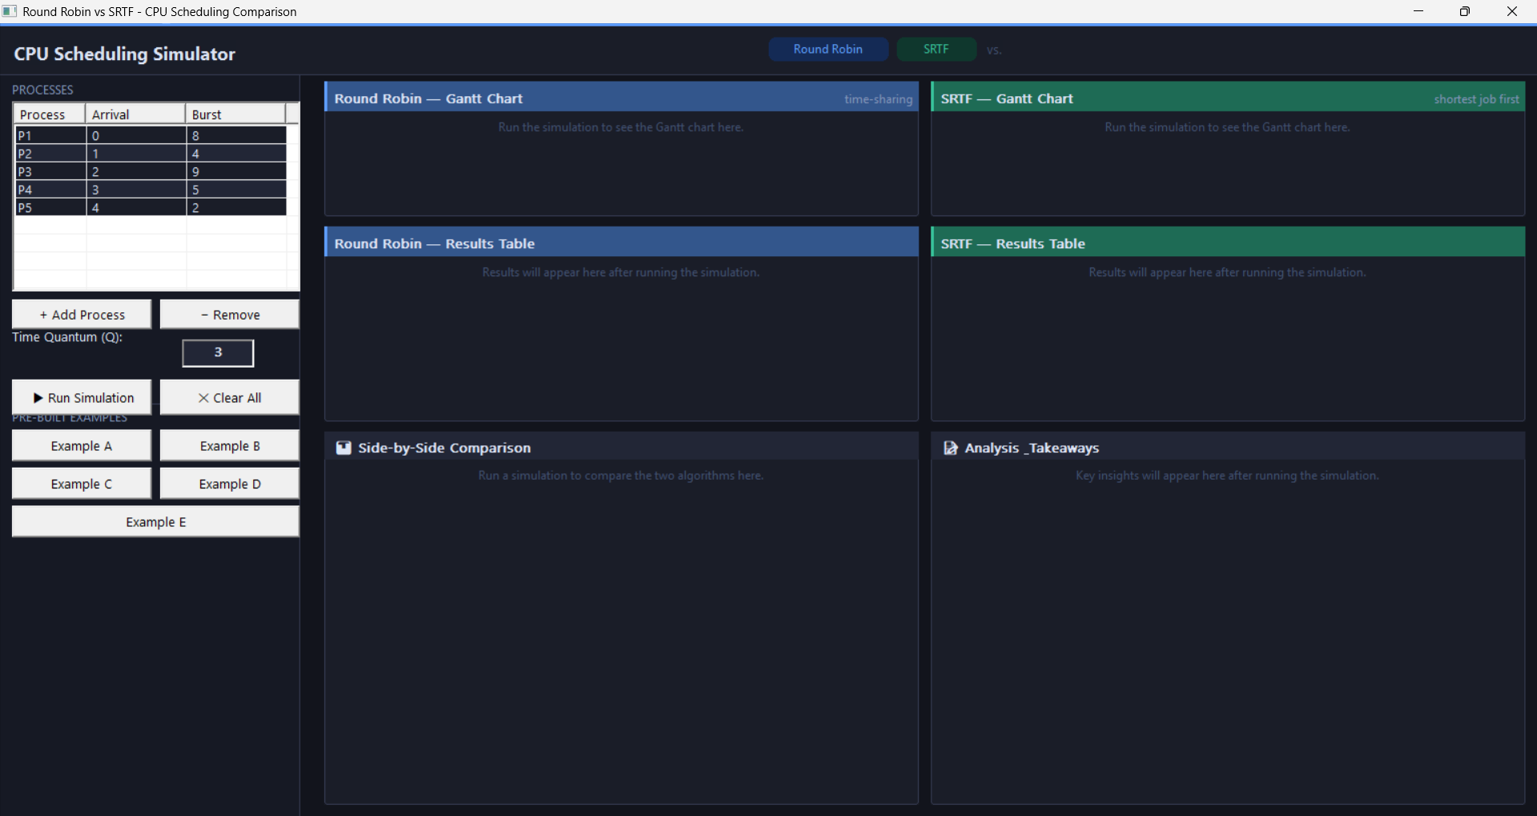
Figure 1: Initial state of the CPU Scheduling Simulator before data entry
Visualization Zone (Center):
- Gantt Charts: Separate charts for RR and SRTF using color-coded blocks to represent process execution.
- Ready Queue View: A real-time visual monitor specifically for Round Robin, showing the current order of processes waiting for CPU time.
Analytics Zone (Bottom):
- Results Tables: Separate, detailed tables for both algorithms displaying WT, TAT, and RT for every process.
- Comparison Summary Panel: A side-by-side dashboard comparing the Average WT, Average TAT, and Average RT of both algorithms.
- Final Conclusion Area: A "Analysis Takeaways" section that provides an automated verdict on the trade-off between fairness and efficiency.
5.3 Implementation Details
The simulation logic is built using the following technical specifications:
- Data Structures:
  - Process Objects: Store Arrival Time, Burst Time, and Remaining Time.
  - Ready Queue: A standard FIFO queue structure is used for Round Robin to manage cyclic execution and ensure correct process re-insertion after preemption.
  - Priority Logic: A dynamic selection mechanism for SRTF that identifies the shortest remaining job at every clock tick, allowing for immediate preemption.
- Metric Calculation: The engine calculates:
  - Waiting Time (WT), Turnaround Time (TAT), and Response Time (RT) for each process.
  - Averages for all metrics to facilitate the final comparison.
- Fairness Index: A unique feature comparing the distribution of waiting time to evaluate system "fairness."
5.4 Program Flow
- Input: The user populates the process table and sets the Time Quantum.
- Execution: Upon clicking "Run Simulation," the system executes both RR and SRTF in parallel on the same dataset.
- Output: The UI updates the Gantt charts, Ready Queue View, and Results Tables dynamically.
- Synthesis: The Comparison Summary Panel populates, and the Final Conclusion Area highlights key observations (e.g., "SRTF minimized waiting time, but Round Robin provided higher fairness").
5.5 System Robustness & Error Handling
- Input Validation: The system rejects any invalid quantum values (e.g., $Q \le 0$) and non-numeric process data.
- Dynamic Reset: A "Clear All" functionality allows for resetting the simulation without a full application restart.
- Pre-built Scenarios: Five pre-configured examples (A-E) are integrated to demonstrate specific behaviors like "Short-job heavy" or "High-Arrival frequency" workloads.
• 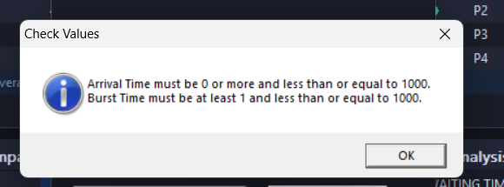
Figure 2: System alert for incorrect inputs to maintain simulation accuracy

6. Scheduling Metrics
To evaluate and compare the performance of Round Robin and SRTF, the system calculates four key metrics for each process. These metrics are the industry standard for measuring the efficiency and responsiveness of any CPU scheduler.
6.1 Definitions and Formulas
The system uses the following mathematical formulas to derive the results displayed in the "Results Table":
- Completion/Finish Time (FT): The exact time at which a process finishes its execution and leaves the system.
- Turnaround Time (TAT): The total time taken from the moment a process arrives until it is completely finished.
TAT = Finish Time – Arrival Time
- Waiting Time (WT): The total duration a process spends in the ready queue without being executed by the CPU.
WT = Turnaround Time – Burst Time
- Response Time (RT): The time interval between the process's arrival and the very first time it is assigned to the CPU.
RT = First Start Time - Arrival Time
6.2 Average Metrics
As shown in the simulator's dashboard, the system automatically computes the Average for each of these metrics. These averages are crucial for the "Side-by-Side Comparison," as they provide a high-level view of system performance. For example:
- A lower Average Waiting Time indicates a more efficient system (usually achieved by SRTF).
- A lower Average Response Time indicates a more interactive and responsive system (often the goal of Round Robin).
6.3 Fairness Index
In addition to standard metrics, our implementation includes a Fairness Observation. This is derived from how evenly the Waiting Time is distributed among all processes.
- In Round Robin: Waiting times are typically close to each other due to the cyclic nature of execution.
- In SRTF: Waiting times can vary significantly between short and long processes.

7. Testing and Validation
7.1 Scenario A: Basic Mixed Workload (Baseline)
- Description: This scenario evaluates the simulator using a standard workload with four processes of varying arrival and burst times. It is designed to verify the fundamental logic of both algorithms under normal operating conditions.
- Test Data: P1(0,8), P2(1,4), P3(2,9), P4(3,5) | Quantum: 4.
- Expected Result: SRTF is expected to yield lower average waiting times by prioritizing the shorter P2 and P4, while RR ensures steady progress for all tasks.

Figure 3:Comparison of RR and SRTF using a mixed workload (Q=3).

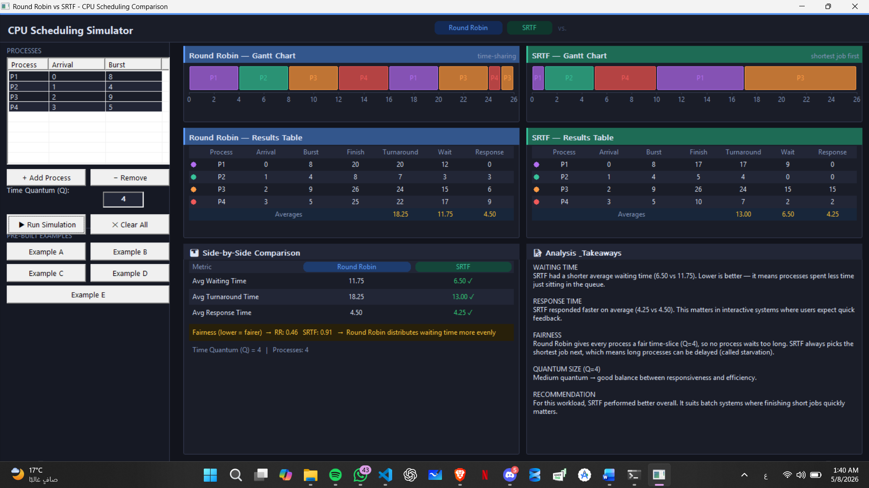

7.2 Scenario B: Quantum Sensitivity Case
- Description: This test demonstrates how the choice of Time Quantum ($Q$) drastically affects Round Robin behavior. We compare a small quantum (high context switching) against a large quantum (approaching FCFS behavior) using the same process set.
- Test Data: P1(0,20), P2(0,20) | Comparison: $Q=2$ vs. $Q=20$.
- Expected Result: A smaller quantum shows a significant improvement in initial Response Time but increases the total number of preemptions shown in the Gantt chart.
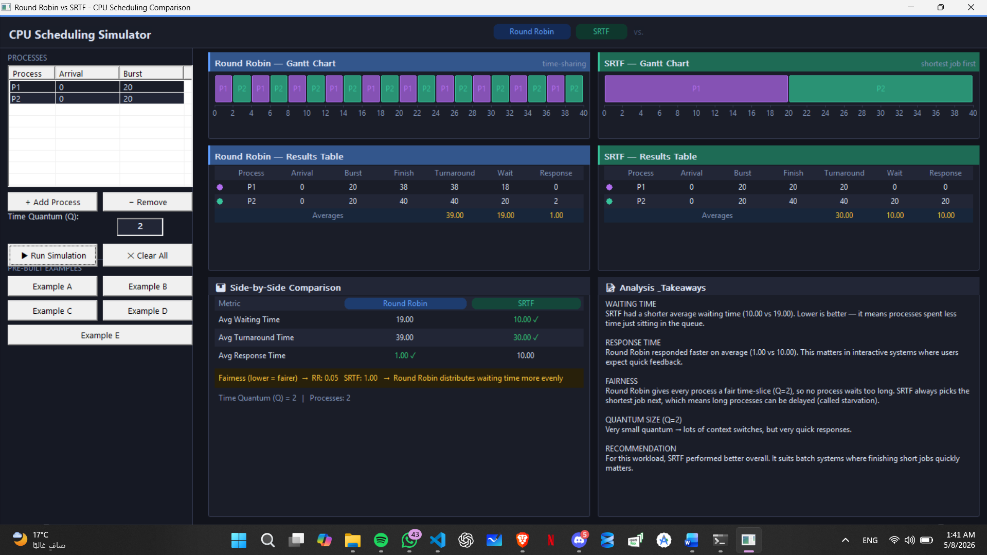
Figure 4: High context switching in Round Robin with minimum quantum (Q=1).

7.3 Scenario C: Short-Job-Heavy Case (SRTF Efficiency)
- Description: Designed to showcase the "Shortest-job preference" of SRTF. A long process arrives first, followed by a burst of very short processes. This highlights the efficiency gap between the two algorithms.
- Test Data: P1(0,15), P2(1,2), P3(2,1), P4(3,2) | Quantum: 5.
- Expected Result: SRTF will preempt the long P1 to finish all short jobs immediately, significantly reducing their waiting time compared to the Round Robin cycle.
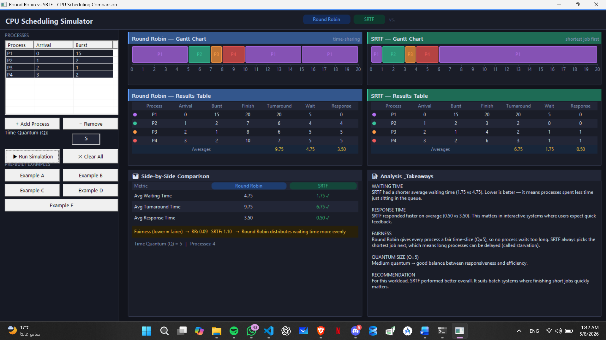
Figure 5: Preemption logic verification for a basic two-process scenario.

7.4 Scenario D: Interactive-Style Fairness Case
- Description: This workload tests "First Response" fairness. Multiple processes with identical or similar burst times arrive simultaneously to see which algorithm provides a better "interactive" feel.
- Test Data: P1(0,10), P2(0,10), P3(0,10) | Quantum: 2.
- Expected Result: Round Robin will show a superior "Fairness Index" and faster first response times for all processes, whereas SRTF will behave like FCFS, making the last process wait significantly longer.
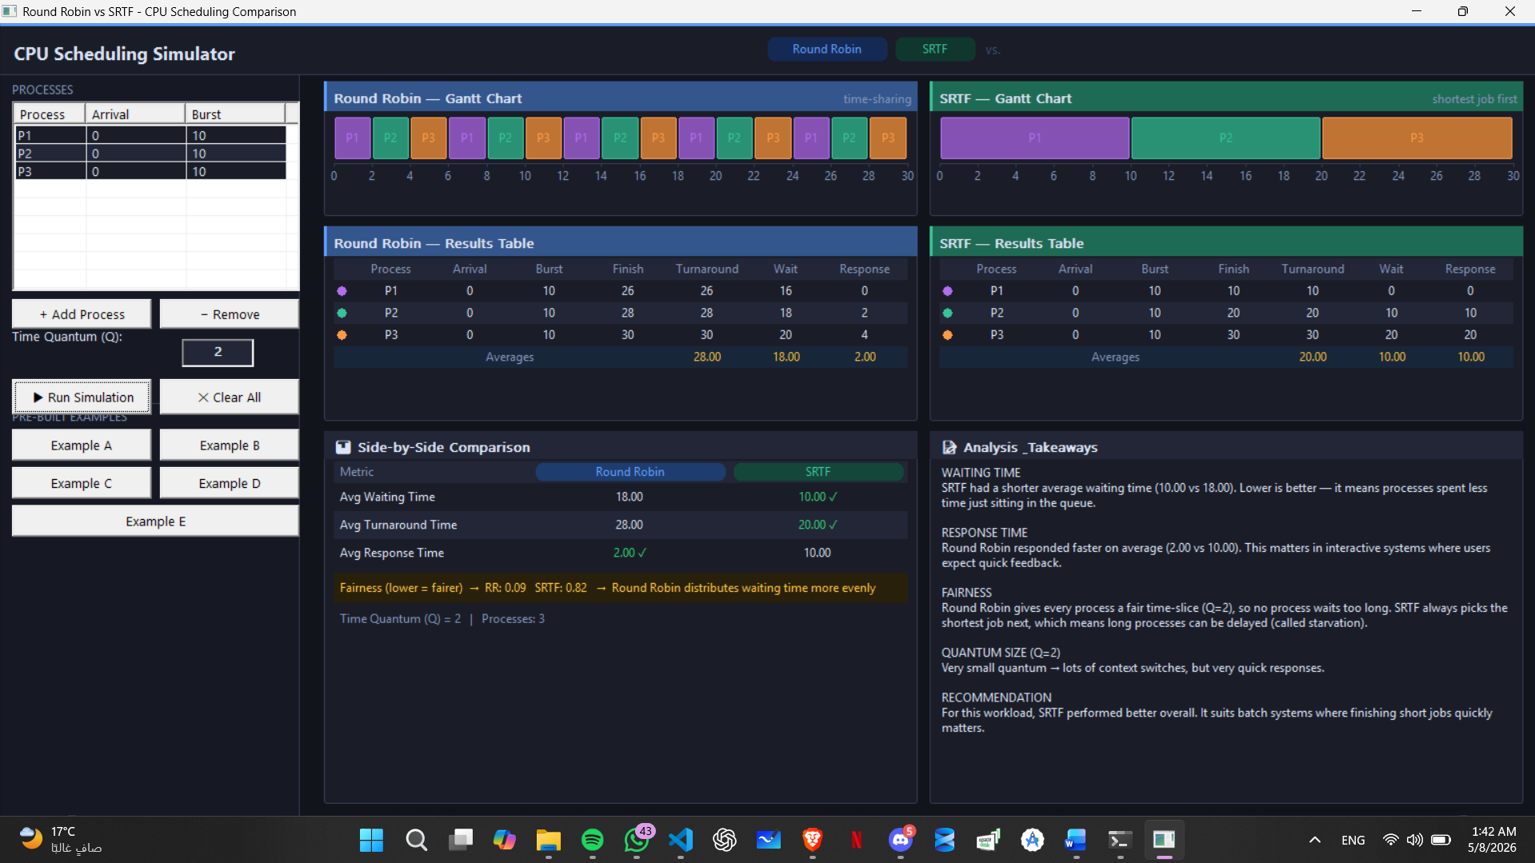
Figure 6: Starvation analysis: SRTF efficiency vs. Round Robin fairness.

7.5 Scenario E: Validation Case (Error Handling)
- Description: This case ensures the system is robust against user errors. We attempt to input invalid data to verify that the Validation Layer triggers the correct safety protocols.
- Test Input: Q = -5 or Burst Time = -10.
- Expected Result: The system should reject the input safely, preventing simulation execution and displaying a clear Error Alert/Notification to the user.
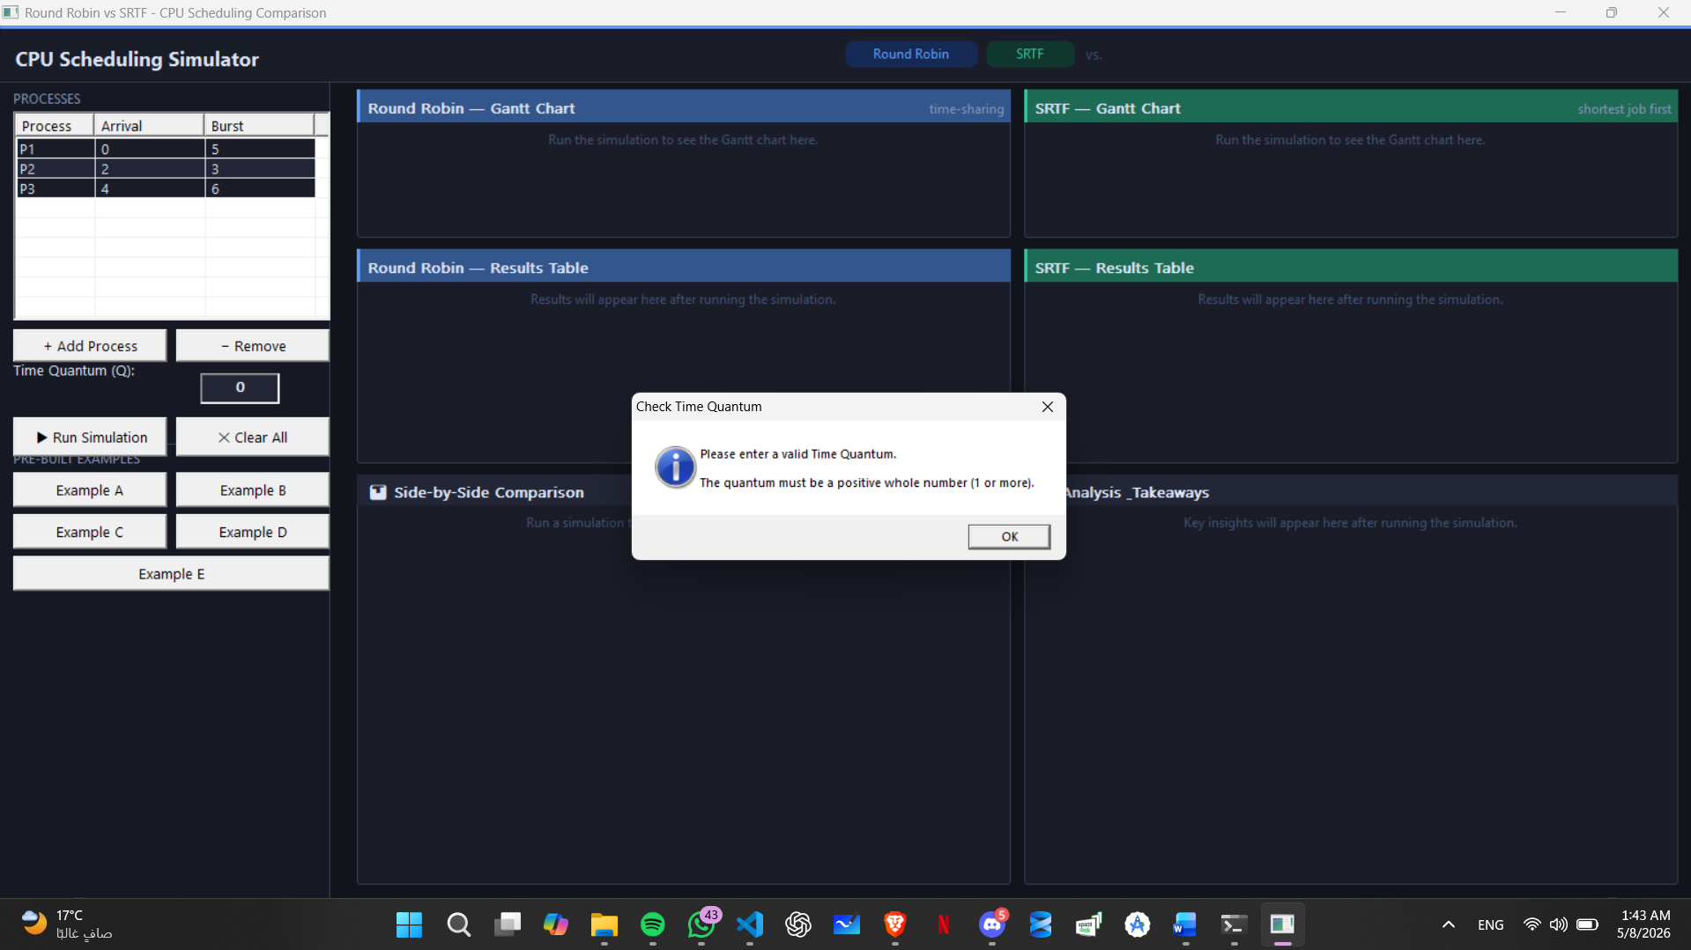
Figure 7 :Final synthesis of algorithm performance and fairness metrics.
8. Results & Analysis (Gantt Chart Discussion)
The Gantt Charts generated by the simulator serve as a visual validation of the scheduling logic. For Round Robin, the charts clearly illustrate the interleaved execution of processes based on the fixed time quantum. For SRTF, the charts show how the CPU switches to a shorter process immediately upon arrival (Preemption). These visualizations confirm that the system correctly calculates execution intervals and handles overlapping arrival times.
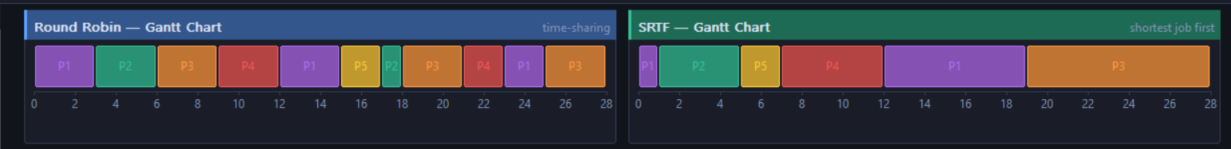
Figure 8: Gantt Chart

9. Performance Analysis & Discussion
Based on the simulation results and the five test scenarios conducted, the following analysis answers the core scheduling trade-offs:
- Which algorithm gave better average waiting time? SRTF consistently provided a lower Average Waiting Time (AWT). By always selecting the process with the shortest remaining time, it clears the system of short tasks quickly, preventing them from waiting behind long-duration processes.
- Which algorithm gave better response time? Round Robin (RR) generally provided a better (lower) First Response Time, especially with a small Time Quantum. It ensures that every process gets a share of the CPU almost immediately after arrival, whereas in SRTF, a long process might wait significantly before its first execution if shorter jobs keep arriving.
- Did Round Robin appear fairer across all processes? Yes. Round Robin demonstrated higher fairness because it uses time-slicing. No process is allowed to monopolize the CPU, and every process is guaranteed a turn in each cycle. This prevents the "Starvation" that can occur in SRTF for longer jobs.
- Did SRTF complete short jobs faster? Absolutely. SRTF is optimized for this exact purpose. In Scenario C, short jobs were completed almost immediately upon arrival because their remaining burst time was the lowest in the system, giving them absolute priority.
- How did the selected quantum affect the Round Robin results? The Time Quantum is the "lever" of Round Robin:
  - Small Quantum: Improved response time and fairness but would increase context-switching overhead in a real OS.
  - Large Quantum: Reduced context switching but made the algorithm behave like FCFS, increasing the waiting time for shorter processes.
- Which algorithm would you recommend for the tested workload, and why? The recommendation depends on the system's goal:
  - For Interactive Systems (like a PC or Smartphone), Round Robin is recommended because it prioritizes user responsiveness and fairness.
  - For Batch Processing Systems (where finishing tasks quickly is all that matters), SRTF is recommended as it maximizes throughput and minimizes average delays.

10. Conclusion
The simulation and comparative analysis of Round Robin (RR) and Shortest Remaining Time First (SRTF) have led to the following definitive conclusions based on the observed metrics and system behavior:
- Algorithm Performance by Metric:
  - SRTF performed significantly better in terms of Average Waiting Time (AWT) and Average Turnaround Time (ATAT).
  - Round Robin outperformed SRTF in First Response Time (FRT), ensuring that all processes enter the execution state earlier.
- Fairness Assessment: Round Robin appeared consistently fairer across all tested workloads. By utilizing a cyclic time-sharing approach, it prevented CPU monopolization and ensured that no process suffered from starvation, regardless of its burst time length.
- Efficiency Assessment: SRTF proved to be the more efficient algorithm regarding total system throughput and delay minimization. It successfully reduced the "convoy effect" by prioritizing shorter tasks, thereby clearing the ready queue in the shortest time possible.
- Effect of the Selected Quantum: The Time Quantum was observed to be the primary governor of Round Robin’s behavior. A small quantum maximized interactivity and responsiveness but increased the frequency of context switching (preemption). Conversely, a large quantum minimized switching overhead but caused the algorithm to lose its fairness advantage, eventually mimicking the behavior of First-Come, First-Served (FCFS).

