Homework 2

**Introduction to Machine Learning (02360766)**

Submitted by: Eyal Amdur, Gal Porat

ID: 318849270, 315116095

**Part 1: Basic model selection with k-Nearest Neighbors**

**(Q1)** **Training set score: 1.0**  **Test set score: 0.7**

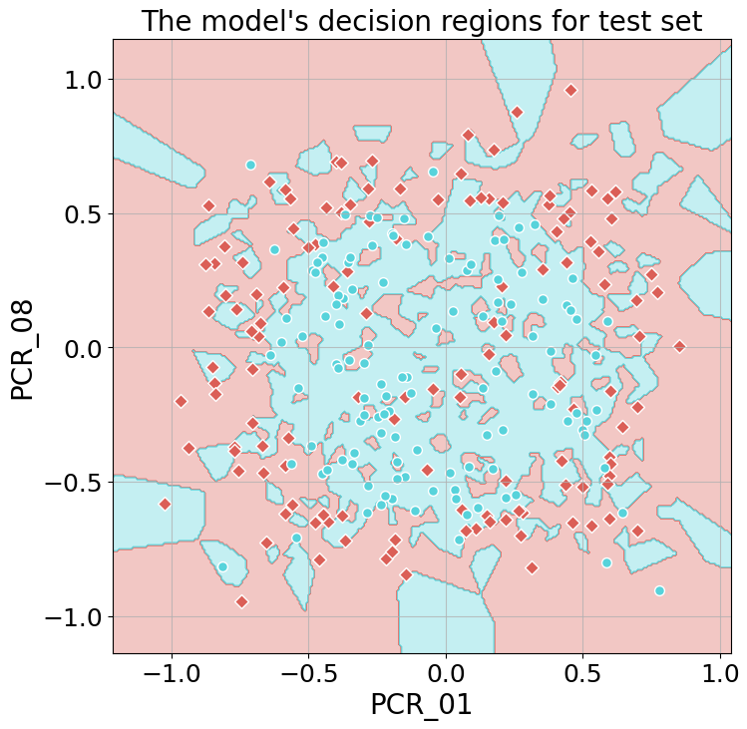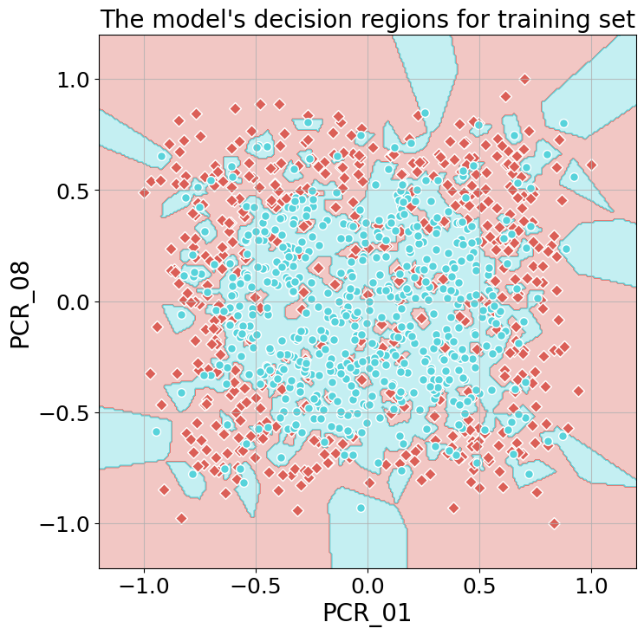

**(Q2)**