Homework 3

**Introduction to Machine Learning (02360766)**

Submitted by: Gal Porat, Eyal Amdur

ID: 318849270, 315116095

**Section 1: Linear regression implementation   
(Q1)** The analytical partial derivative $\frac{∂}{∂b }L\left(w, b\right)∈R$ is: $$\frac{∂}{∂b }L\left(w, b\right)=\frac{∂}{∂b }\left(\frac{1}{m} \sum_{i=1}^{m}{{\left(w^{T}x_{i} + b - y_{i}\right)}^{2}} \right)=\frac{∂}{∂b }\left(\frac{1}{m} \sum_{i=1}^{m}{{\left(\left(w^{T}x_{i}-y_{i}\right) + b \right)}^{2}} \right)= \\ =\frac{∂}{∂b }\left(\frac{1}{m} \sum_{i=1}^{m}{\left({\left(w^{T}x_{i}-y_{i}\right)}^{2} +2 \left(w^{T}x_{i}-y_{i}\right)b+b^{2}\right) } \right)= \\ =\frac{1}{m} \sum_{i=1}^{m}{\frac{∂}{∂b }\left({\left(w^{T}x_{i}-y_{i}\right)}^{2} +2 \left(w^{T}x_{i}-y_{i}\right)b+b^{2}\right) }= \\ \frac{1}{m} \sum_{i=1}^{m}{\left( 2 \left(w^{T}x_{i}-y_{i}\right)+2b\right) }=\frac{2}{m} \sum_{i=1}^{m}{\left(w^{T}x_{i}+b-y_{i}\right) }$$

**(Q2)** Our results:  
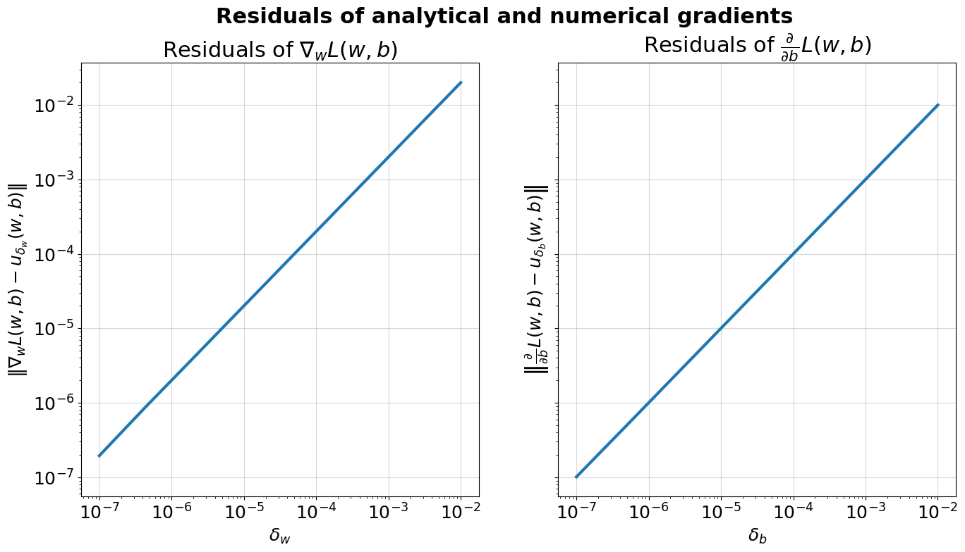

**(Q3)** Here are the graphs of the learning rates:

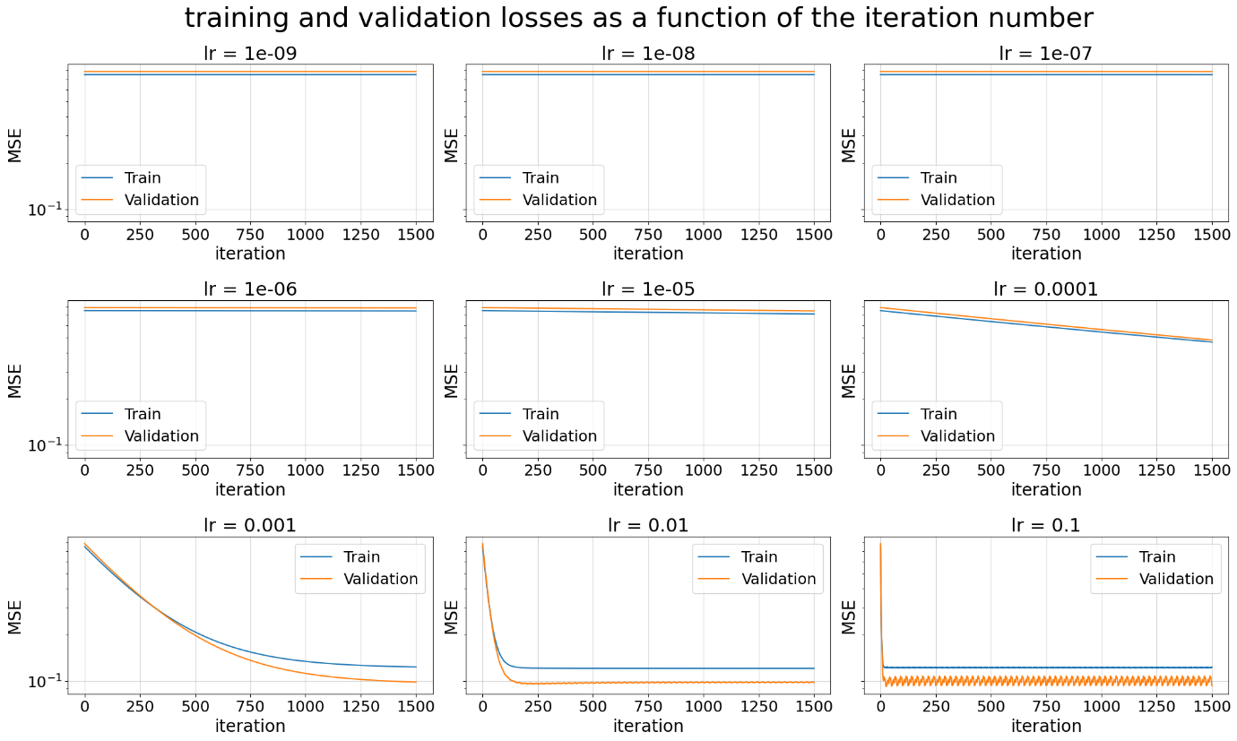

As we can see, as we increase the learning rate, there is an improvement in the rate of error reduction. We can explain this by noting that for 1500 iterations, small steps are not "sufficient" to improve the model and reduce the error, whereas larger steps lead to faster convergence.  
The “optimal” learning rate is 0.01 lr because it achieves stable convergence in about 100 iterations. There’s no need to add more iterations, as they will not significantly improve the error.

If we want to achieve the minimum error with the minimum number of iterations, we should choose 0.1 lr. Although it is less stable than 0.01, it converges faster to the close error and stays around those values.

* **Note:** the training error is higher than the validation error, which is strange at first but we found out that it depends on the partition of the data, so it can be explained by “lucky” partition.

**Section 2: Evaluation and Baseline**

**Simplest baseline**

**(Q4)** The table for MSE per model is:

|  |  |  |  |
| --- | --- | --- | --- |
| Model | Section | Train MSE | Valid MSE |
|  |  | Cross validated | |
| Dummy | 2 | 0.1723340019824137 | 0.1730235485493322 |

**Top of Form**

**Basic hyperparameter tuning**

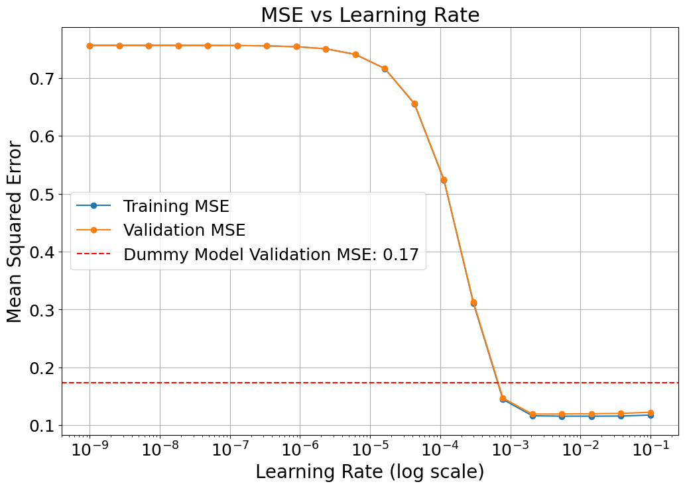**(Q5)** The plots and values detailed in “the repeated tuning process” are:



And the updated table is:

|  |  |  |  |
| --- | --- | --- | --- |
| Model | Section | Train MSE | Valid MSE |
|  |  | Cross validated | |
| Dummy | 2 | 0.1723340019824137 | 0.1730235485493322 |
| Linear | 2 | 0.11621842983634183 | 0.11922067354418046 |

**(Q6)** Had we chosen not to normalize features beforehand, we would get:  
- Dummy model: as for the Dummy model, it doesn’t care about the input features X_train because it makes predictions based only on the labels y_train, like their average. This means normalizing the features doesn’t make any difference to how the model works or what results it gives.  
Since the label’s average stays the same no matter what you do with the features, the predictions will always be the same whether the data is normalized or not.

- Linear model: as for the Linear model, if we don't normalize the features, the training performance won't change (assuming no numerical errors and no regularization). Linear regression is a convex problem, so while the weights (=vector w) may differ without normalization, the solution will still minimize the loss function optimally, yielding the same predictions and performance.

**Section 3: Lasso linear regression**

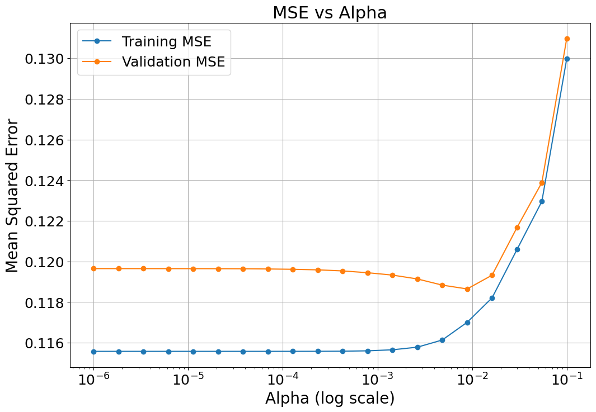**(Q7)** The plots and values detailed in “the repeated tuning process” are:



**(Q8)** And the updated table is:

|  |  |  |  |
| --- | --- | --- | --- |
| Model | Section | Train MSE | Valid MSE |
|  |  | Cross validated | |
| Dummy | 2 | 0.1723340019824137 | 0.1730235485493322 |
| Linear | 2 | 0.11621842983634183 | 0.11922067354418046 |
| Lasso Linear | 3 | 0.11700175082620592 | 0.11864425023047973 |

**(Q9)** The 5 features having the 5 largest coefficients (in absolute value) in the resulting regressor, from the largest to the smallest are:  
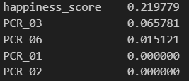

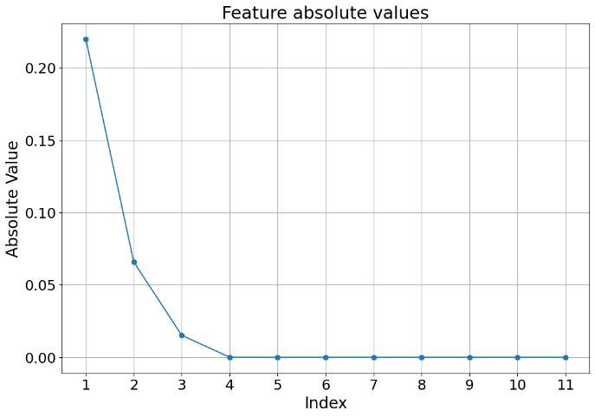**(Q10)** The plot of the absolute values of the learned coefficients is:

**(Q11)** The magnitude of the coefficients is interesting because it reflects feature selection. Lasso uses L1-regularization, which can shrink some coefficients to exactly zero, like we got on our report, effectively removing less important features from the model. By examining the magnitudes, we can identify which features contribute most to the predictions and which are irrelevant, helping with dimensionality reduction.  
Normalizing the features before applying Lasso ensures that all features contribute equally to the regularization process, allowing for a fair comparison of coefficient magnitudes and preventing features with larger scales from dominating the penalty, ultimately enhancing the model's ability to generalize well to unseen data.

**(Q12)** If we hadn't normalized the features before running the Lasso regression, the training performance of the model could definitely be different. Lasso uses L1 regularization, which adds a penalty based on the size of the coefficients. If the features are on different scales, the ones with larger values could end up having a bigger impact on the model than they deserve, while smaller-scaled features might get pushed down more than they should.   
This means the model might end up favoring certain features just because they have larger numbers, rather than based on how important they really are. So, without normalization, we might end up with a model that doesn't really capture the true relationships in the data and could perform poorly on new data.

**(Q13)** If we had used Ridge regression instead of Lasso regression, the coefficients of the trained model would likely be different in that Ridge would not shrink any coefficients to zero due to its use of L2 regularization, which penalizes the square of the coefficients. As a result, we would expect to see all coefficients remain non-zero, even for less important features, leading to a more uniform distribution of coefficients across the board. Ridge tends to reduce the magnitude of all coefficients more evenly, rather than selectively eliminating some as Lasso does, which means it does not perform automatic feature selection. This could be beneficial when many features contribute to the output, although it may also result in a more complex model.

**Section 4: Polynomial fitting (visualization)**