Eyal Espresso Detailed Design
Document Status: Working Design Baseline
Project Version Reference: 0.2.5
Owner: Eyal / Codex

1. System Context and Planned Split Architecture
Purpose: this document now covers both the current ESP32-S3 client implementation and the planned simulator-backed communication architecture that introduces an ESP32-C3-SuperMini transport controller between the PC simulator host and the client.
Deployment Topology:
PC Simulator Application -> USB COM link -> ESP32-C3-SuperMini transport controller -> Wi-Fi TCP link -> ESP32-S3 espresso client
Architecture Intent: the PC remains the simulator brain and user-facing operator console, while the ESP32-C3 owns low-level transport bridging, watchdog timing, CRC validation, and Wi-Fi TCP session handling.
Client Role: the ESP32-S3 client remains the application endpoint that consumes validated transport messages and exposes upper-level machine behavior, UI state, and compatibility logic.
Design Rule: high-level workflow, scenario selection, logging, and simulator intelligence stay on the PC host; low-level transport safety and timing enforcement stay on the dedicated ESP32-C3 controller.
Figure 1. Planned split architecture between the PC simulator, ESP32-C3 transport bridge, and ESP32-S3 client.
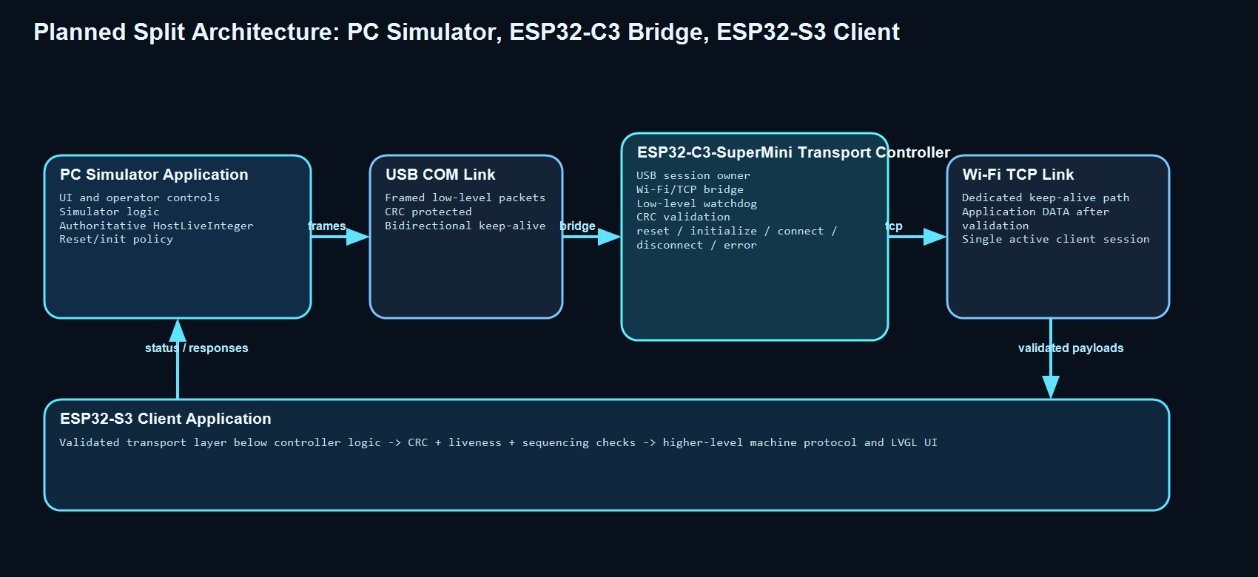

The architecture diagram is normative for responsibility ownership: only the ESP32-C3 bridge owns low-level Wi-Fi/TCP and USB COM transport, while the PC remains the authoritative supervisory host.

2. Client-Side Responsibility Allocation
Application Entry: main/Eyal_espresso_ESP32_main.c owns startup orchestration, staged initialization, offline or online mode selection handling, failure routing, and transition into the main user interface.
UI Layer: main/ui_screen.c owns LVGL screen creation, tab content, modal overlays, live clock rendering, and user interaction logic.
Display Layer: main/lvgl_port.c and main/lvgl_port.h own LVGL task execution, display flush behavior, touch feed, and panel integration timing.
Hardware Layer: main/hardware_init.c and main/hardware_init.h own board-specific setup such as RGB LCD, CH422G-controlled lines, and low-level panel support.
Peripheral Layer: main/peripherals_manager.c and main/peripherals_manager.h are the natural integration point for the planned network-controller link because they already own controller communication, version queries, simulated connection state, and connection snapshots exposed to the UI.
Configuration Layer: main/system_constants.c and main/system_constants.h load embedded XML defaults and expose parsed runtime constants to the rest of the system.
Planned Low-Level Client Transport Layer: a dedicated communication sub-layer should be inserted below the higher-level controller protocol and above the raw Wi-Fi/TCP transport. This layer validates CRC, watchdog counters, sequencing, and connection state before higher-level controller logic sees any payload.

3. Planned Low-Level Control State Machine on Both Sides
A mirrored simple state machine shall exist on the PC-host side logical controller, on the ESP32-C3 transport controller, and on the client-side low-level communication layer.
States:
reset = perform true reset, clear session state, run self-test, and load connection parameters
initialize = validate configuration produced by reset and prepare the low-level link
connect = establish or maintain a single low-level server/client session
disconnect = perform controlled shutdown of the low-level session
error = latched fault state entered after timeout, CRC fault, malformed frame, or transport failure
Primary State Diagram:
reset -> initialize -> connect
connect -> disconnect
connect -> error
initialize -> error
disconnect -> reset
error -> reset
error -> initialize
Figure 2. Mirrored low-level state machine shared by the host, ESP32-C3 bridge, and client low-level layers.
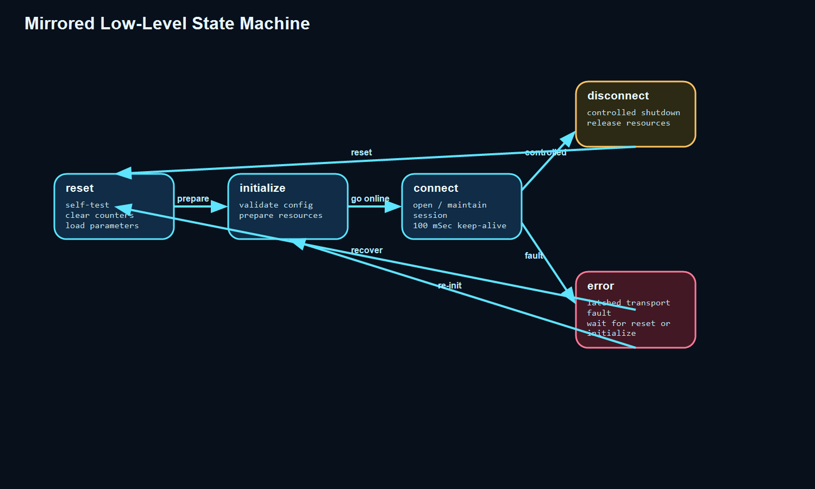

Reset State Responsibilities:
- clear transport counters, watchdog timers, and partial frame buffers
- clear stale TCP socket ownership and stale USB session ownership
- run a low-level self-test
- apply parameters that define the target connection role and transport settings
Initialize State Responsibilities:
- confirm that the reset parameters are internally consistent
- prepare Wi-Fi credentials, host/client role, port numbers, and watchdog timing
- prepare packet parser state without claiming that the link is yet healthy
Connect State Responsibilities:
- establish the low-level link
- enforce 100 mSec keep-alive cadence
- validate CRC before passing any payload upward
- increment or validate liveness counters according to ownership rules
Disconnect State Responsibilities:
- send or log a controlled disconnect reason
- close sockets cleanly
- release low-level resources
Error State Responsibilities:
- stop forwarding application payloads upward
- preserve the last known error cause
- wait only for explicit reset or initialize commands from the upper layer

4. Low-Level Packet Envelope and Data Model
Recommendation: use one standard low-level frame envelope with multiple message types, not one giant monolithic full-state packet for every exchange.
Reasoning: a single envelope guarantees consistency for CRC, framing, counters, and parsing, while multiple message types keep the protocol debuggable, low-latency, and extensible.
Recommended Envelope Fields:
SOF = fixed start-of-frame marker
protocol_version = low-level framing version
message_type = RESET, INITIALIZE, CONNECT, DISCONNECT, KEEPALIVE, DATA, ERROR, ACK
flags = optional control bits
payload_length = payload size in bytes
host_live_integer = authoritative host-side liveness counter
device_live_integer = optional device-side liveness counter returned by the controller
sequence = frame sequence for duplicate/missing-frame detection
payload = message-specific payload
crc = CRC16 or CRC32 over the protected frame bytes
CRC Guidance: checksum or CRC belongs to the low-level framing layer so the upper-level controller state machine can assume that every payload it receives has already passed integrity validation.
Counter Ownership Recommendation: the authoritative HostLiveInteger should be incremented by the upper-level host so the transport controller can detect that the host itself is not stuck. The transport controller may also publish its own DeviceLiveInteger so liveness can be checked in both directions.
Keep-Alive Recommendation: do not rely on generic data packets as proof of link health. Use a dedicated keep-alive packet every 100 mSec even when no application payload has changed.

5. Packet Types and Flow Diagrams
5.1 RESET Packet
Intent: force a true reset of the low-level controller and trigger self-test plus parameter reload.
Flow Diagram:
Host/Simulator -> RESET(packet with parameters or parameter reference)
Low-Level Controller -> clear state, run self-test
Low-Level Controller -> RESET_ACK(result, self-test summary)
Upper Layer -> if ACK ok then move to initialize else move to error handling
Figure 3. RESET packet flow from host command through low-level reset acknowledgement.
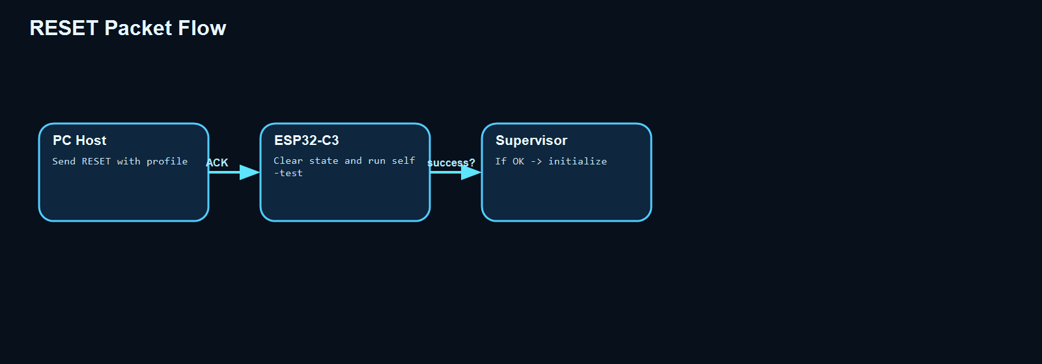

5.2 INITIALIZE Packet
Intent: instruct the low-level controller to prepare Wi-Fi/TCP roles, timing, and buffer state without claiming a healthy session yet.
Flow Diagram:
Host/Simulator -> INITIALIZE(connection profile, timing, role)
Low-Level Controller -> validate settings and prepare resources
Low-Level Controller -> INITIALIZE_ACK(status, validation result)
Upper Layer -> if ACK ok then request connect
Figure 4. INITIALIZE packet flow used to validate and prepare low-level transport resources.
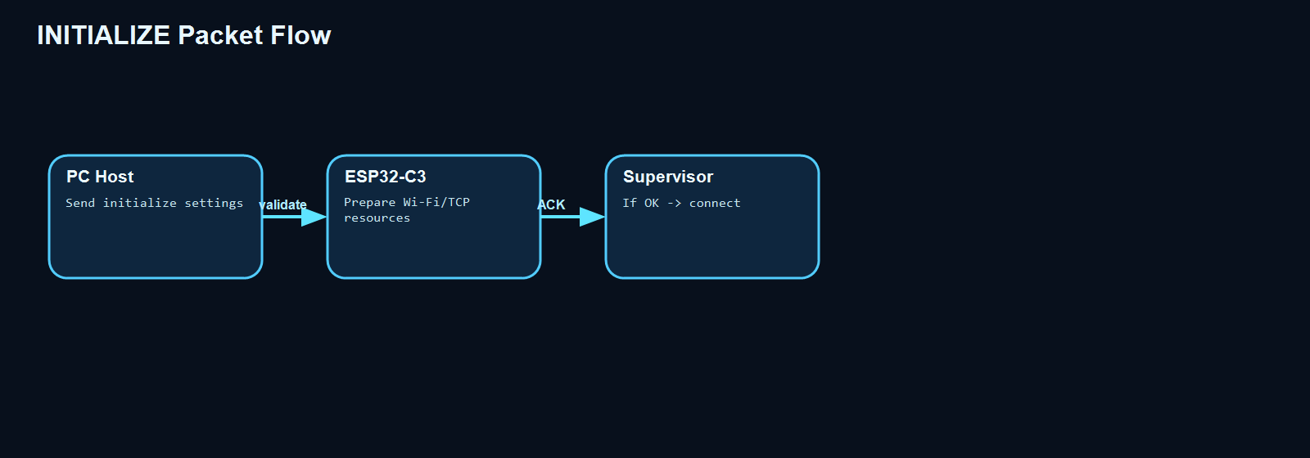

5.3 CONNECT Packet
Intent: enter the active low-level session state.
Flow Diagram:
Host/Simulator -> CONNECT(target endpoint details if required)
Low-Level Controller -> open socket or accept/connect according to role
Low-Level Controller -> CONNECT_ACK(connected or failure reason)
Both Sides -> begin periodic keep-alive exchange every 100 mSec
Figure 5. CONNECT packet flow leading into the active 100 mSec keep-alive session.
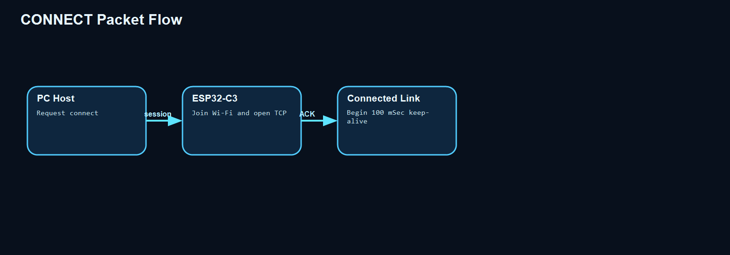

5.4 DISCONNECT Packet
Intent: perform a controlled tear-down without calling it an error.
Flow Diagram:
Host/Simulator -> DISCONNECT(reason)
Low-Level Controller -> stop periodic forwarding and close low-level session
Low-Level Controller -> DISCONNECT_ACK
Upper Layer -> return to reset or idle supervisory state
Figure 6. DISCONNECT packet flow for intentional low-level session teardown.
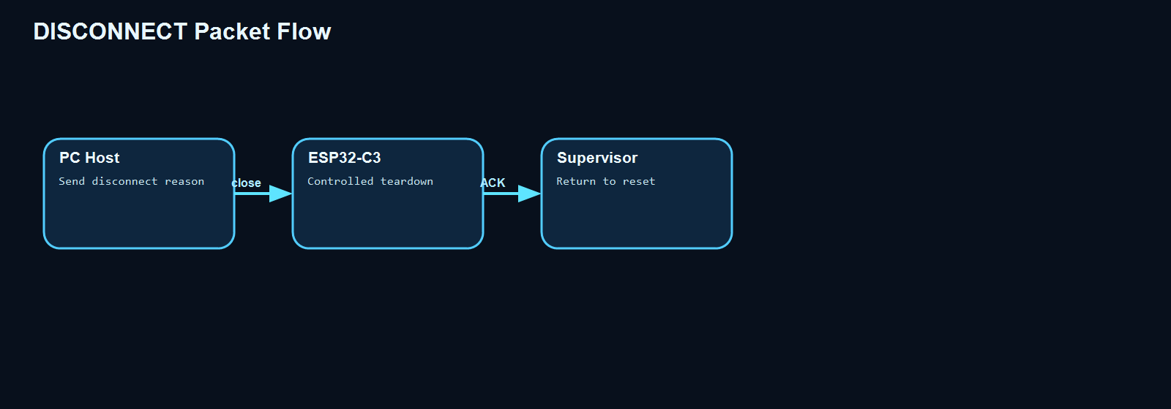

5.5 KEEPALIVE Packet
Intent: prove forward progress of the host and low-level controller independently of payload traffic.
Flow Diagram:
Every 100 mSec Host/Simulator -> KEEPALIVE(host_live_integer incremented)
Low-Level Controller -> validate that host_live_integer advanced
Low-Level Controller -> KEEPALIVE_ACK(device_live_integer, link health, transport status)
Upper Layer -> validate that device_live_integer and timestamps continue to advance
Timeout Rule: if a message is not answered with forward progress of the expected liveness counter within 100 mSec, the low-level controller shall enter error.
Figure 7. KEEPALIVE packet flow with HostLiveInteger ownership on the PC and status acknowledgement from the bridge.
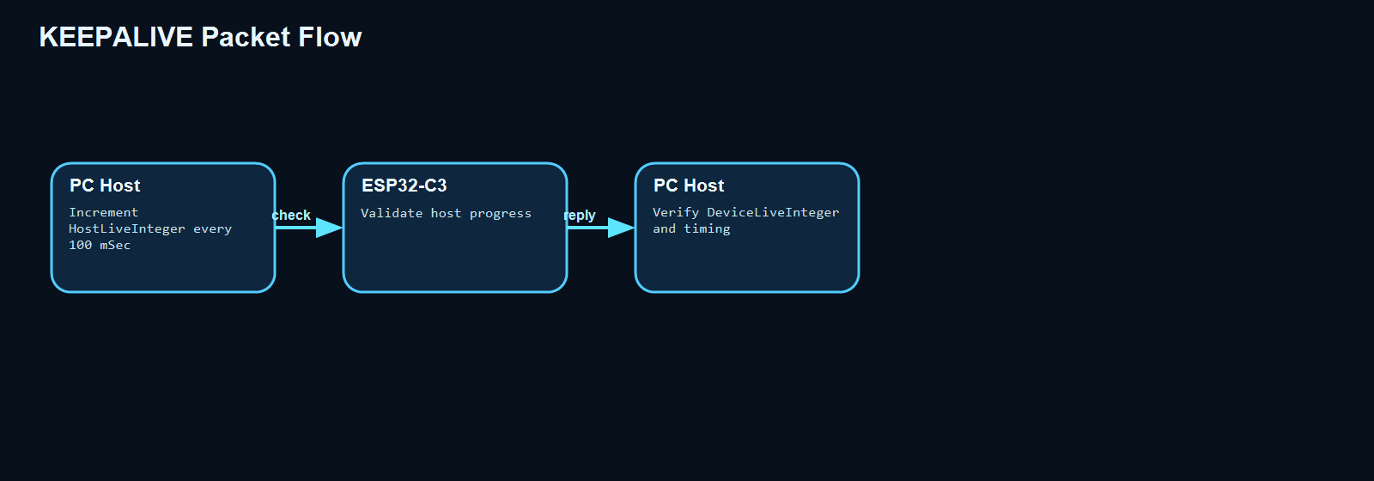

5.6 DATA Packet
Intent: carry application payload once the low-level link is healthy.
Flow Diagram:
Upper Layer -> DATA(payload)
Low-Level Controller -> validate CRC and framing
Low-Level Controller -> forward payload over TCP
Peer -> DATA_ACK or application response
Upper Layer -> consume payload only after low-level validation
Figure 8. DATA packet flow showing low-level validation before application payload handling.
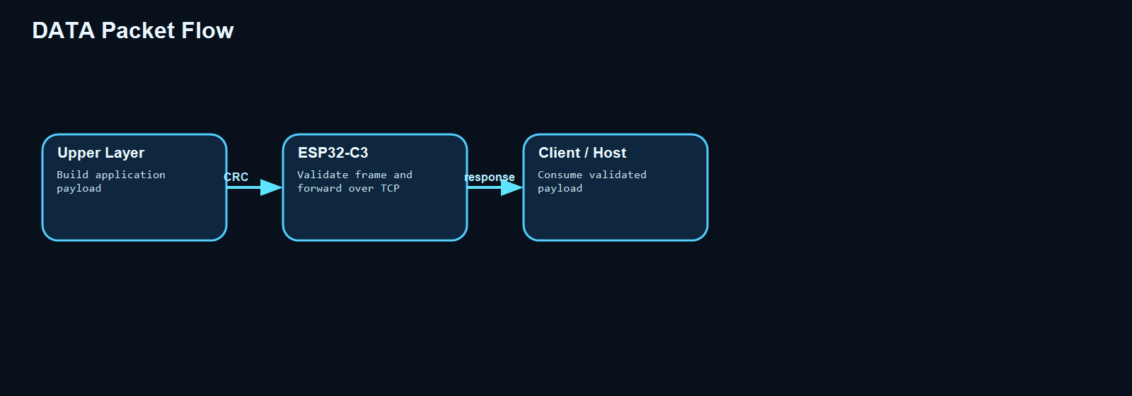

5.7 ERROR Packet
Intent: report a latched low-level fault with enough context for recovery.
Flow Diagram:
Low-Level Controller detects fault
Low-Level Controller -> ERROR(error_code, state, last counters, transport summary)
Upper Layer -> log fault and decide whether to send reset or initialize
Low-Level Controller remains in error until explicit recovery command
Figure 9. ERROR packet flow used to preserve fault context and drive explicit recovery.
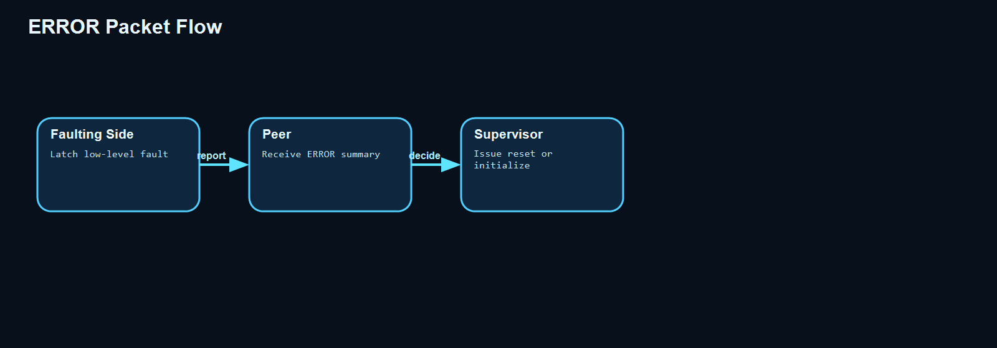

6. Keep-Alive, Watchdog, and Timing Policy
Heartbeat Cadence: keep-alive packets shall be generated every 100 mSec even when no new application payload exists.
Host Responsibility: the host-side layer must increment HostLiveInteger every heartbeat period to prove that the upper-level simulator or controller is alive and not stalled.
Device Responsibility: the low-level transport controller should answer every heartbeat period with transport status and an optional DeviceLiveInteger so liveness is visible in both directions.
Watchdog Trigger: if the expected counter does not advance within the watchdog window, the receiving side shall stop treating the link as healthy and move to error.
Separation of Concerns: keep-alive and watchdog semantics belong to the low-level transport contract; higher-level controller logic should observe the result of that contract rather than implement duplicate link health inference.
Design Recommendation: keep the bridge implementation simple. It should never invent host liveness on behalf of the host because that would hide a frozen simulator process.

7. Client-Side Planned Integration Path
Client Receive Path:
Wi-Fi/TCP bytes -> client low-level parser -> CRC validation -> liveness validation -> sequence validation -> higher-level controller logic
Client Send Path:
higher-level controller response -> low-level frame builder -> counters and CRC applied -> Wi-Fi/TCP transmission
Client-Side Supervisory Diagram:
reset -> initialize -> connect -> connected operation
connected operation -> error on CRC failure, timeout, malformed frame, or transport loss
error -> reset or initialize only
Planned Code Ownership: the client repository should isolate this low-level communication behavior inside a dedicated transport-oriented module rather than spreading watchdog and CRC checks across unrelated UI files.

8. Failure Modes and State Diagrams
A low-level transport fault shall always force a transition into the shared error state before higher-level controller logic consumes any additional payload.
Figure 10. Failure modes and recovery overview for CRC faults, watchdog failures, and transport loss.
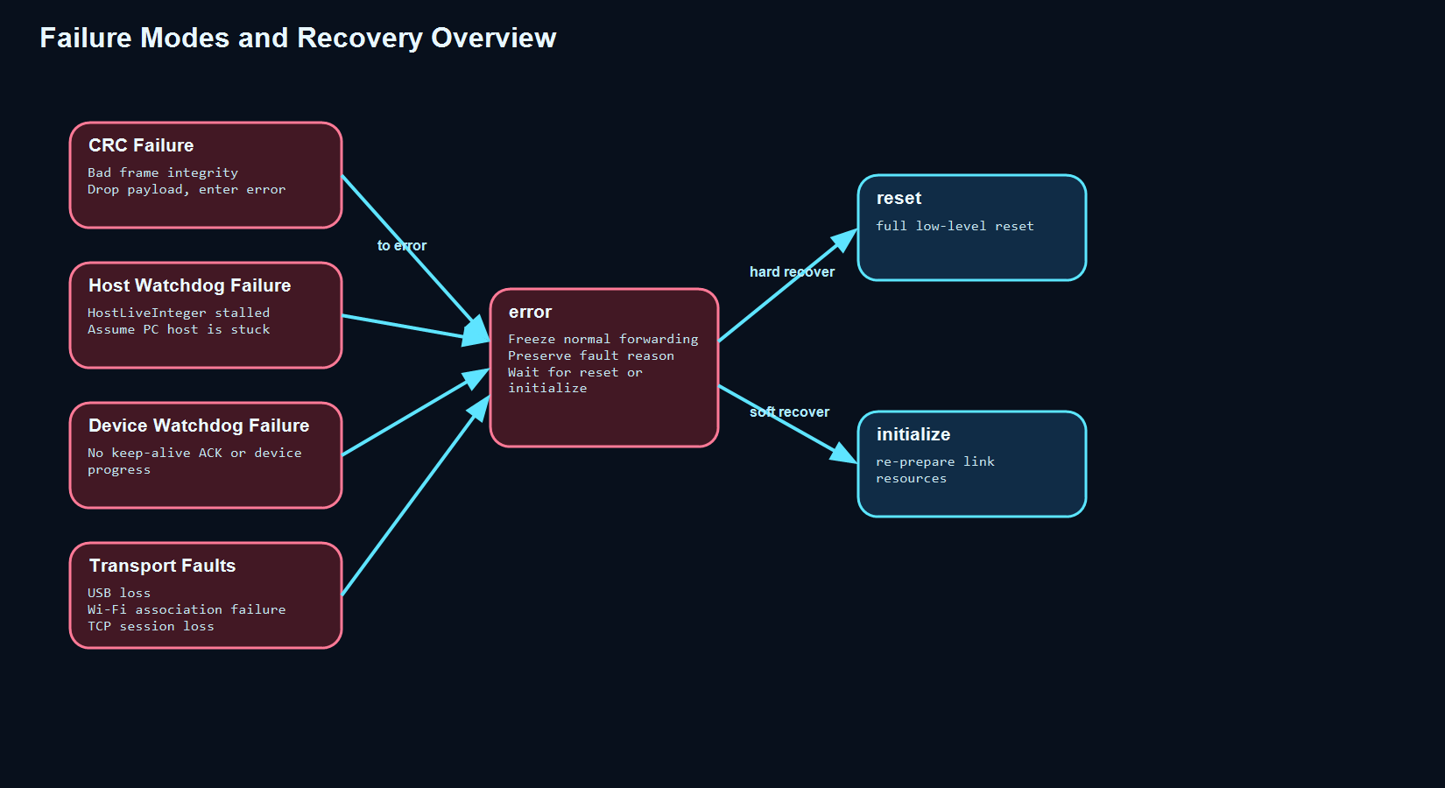

8.1 CRC Failure
Description: received frame fails CRC validation.
Diagram:
connect -> receive bad frame -> error
Recovery:
error -> reset
error -> initialize

8.2 Host Watchdog Failure
Description: HostLiveInteger stops advancing within the required heartbeat window, indicating the upper-level host may be stuck.
Diagram:
connect -> keepalive timeout without host counter progress -> error
Recovery:
error -> reset or initialize after operator or supervisory decision

8.3 Device Watchdog Failure
Description: the device-side keep-alive or status response does not arrive in time.
Diagram:
connect -> expected ACK missing -> error
Recovery:
error -> reset

8.4 USB COM Link Failure Between PC and ESP32-C3
Description: PC host can no longer reach the ESP32-C3 bridge over USB.
Diagram:
reset/initialize/connect -> USB session lost -> error
Recovery:
error -> wait for COM port reappearance -> reset

8.5 Wi-Fi Association Failure on the ESP32-C3 Bridge
Description: transport controller cannot join the configured network.
Diagram:
initialize -> Wi-Fi association failure -> error
Recovery:
error -> initialize with corrected credentials or reset

8.6 TCP Session Loss
Description: the Wi-Fi link may be up but the TCP socket is lost.
Diagram:
connect -> TCP socket loss -> error
Recovery:
error -> initialize -> connect

8.7 Malformed Packet or Unsupported Protocol Version
Description: parser detects bad length, unknown version, or unknown mandatory structure.
Diagram:
initialize/connect -> parser reject -> error
Recovery:
error -> reset after protocol review

8.8 Intentional Disconnect
Description: upper-level controller requests a clean shutdown.
Diagram:
connect -> disconnect -> reset
Recovery:
reset -> initialize -> connect when needed

9. Environment and Build Context
Toolchain: the project uses ESP-IDF 5.5.x for target esp32s3 on Windows, with scripts/idfw.cmd as the normal wrapper for build, flash, and monitor actions.
Build Directory: the active build output is generated under .idfbuild.
Primary Commands: scripts/idfw.cmd -DIDF_TARGET=esp32s3 reconfigure, scripts/idfw.cmd build, and scripts/idfw.cmd -p COM9 flash.
Monitoring Method: post-flash verification should capture at least 20 seconds of serial output; on this host, scripts/monitor_capture.ps1 is the approved fallback when idf.py monitor fails.
Verification Workflow: after code changes, reconfigure/build locally; after successful builds, play the configured success sound; after successful flash, run startup log verification before reporting success.
Versioning Method: project version is stored in VERSION using X.Y.Z, where X covers major feature/refactor boundaries, Y covers minor functionality or bug-fix milestones, and Z covers accepted successful build/flash patch releases.

10. Notes
This document is intended as a software design description baseline. It complements the requirements document and revision history rather than replacing them.
The transport architecture described above is intentionally more thorough than the current implementation so future client work can converge on a stable, reviewable low-level communication contract before code is fragmented across layers.

