Bridge Design Description - ESP32-C3 Serial Communication
Document Status: Design Baseline
Server Simulator Version: 0.2.4
Bridge Firmware Version: 0.1.21
Generated: 20-Mar-26 18:15:12
Owner: Eyal / Claude

1. Purpose and Scope
This document describes the complete design of the ESP32-C3-SuperMini bridge firmware that forms the low-level serial transport layer between the host Python simulator and the ESP32-S3 client application. It covers hardware topology, software architecture, communication protocol, state machines, frame format, memory allocation, error handling, build process, and operational workflow.

1.1 System Role
The ESP32-C3 bridge is a dedicated transport controller. It owns the USB serial link to the host PC and the Wi-Fi SoftAP TCP server link to the ESP32-S3 client. It does not implement application logic - it bridges, validates, and forwards framed messages between the two network segments.

2. Hardware Architecture
2.1 Physical Topology
Figure 1. Hardware topology: Host PC via USB to ESP32-C3 bridge, Wi-Fi to ESP32-S3 client.
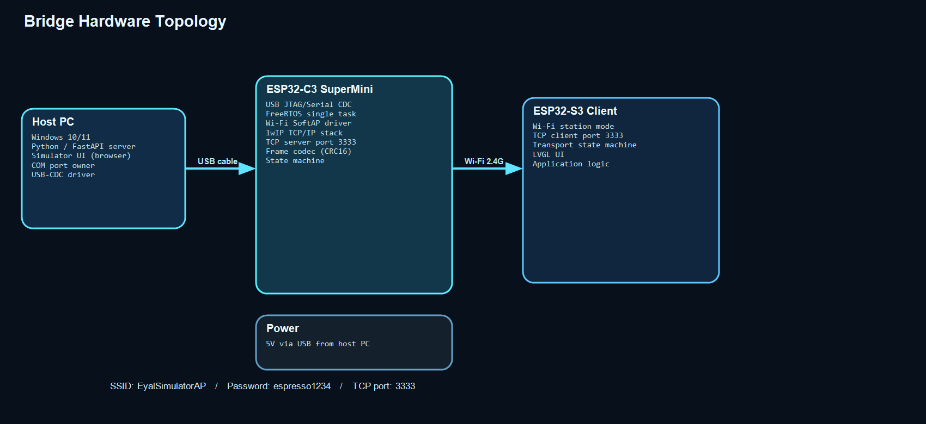

2.2 Hardware Components
ESP32-C3 SuperMini - RISC-V 160 MHz SoC, 4 MB flash, integrated USB PHY, 2.4 GHz Wi-Fi 802.11b/g/n.
Host PC - Windows 10/11 workstation running the Python FastAPI simulator. Provides 5V power to the ESP32-C3 via USB.
ESP32-S3 Client - Target application board. Connects over Wi-Fi as a TCP client to port 3333 on the bridge.

2.3 Physical Interfaces
USB: Full-speed USB 2.0 CDC/JTAG. The ESP32-C3 enumerates as a USB serial device (COM port) visible to the host OS.
Wi-Fi: The bridge creates a SoftAP with SSID EyalSimulatorAP, password espresso1234, channel 1, max 4 clients.
TCP: The bridge runs a TCP server on port 3333. Only one client session is active at a time.

3. Software Architecture
3.1 Layer Stack
Figure 2. Software architecture layer stack from ESP-IDF hardware drivers to application entry point.
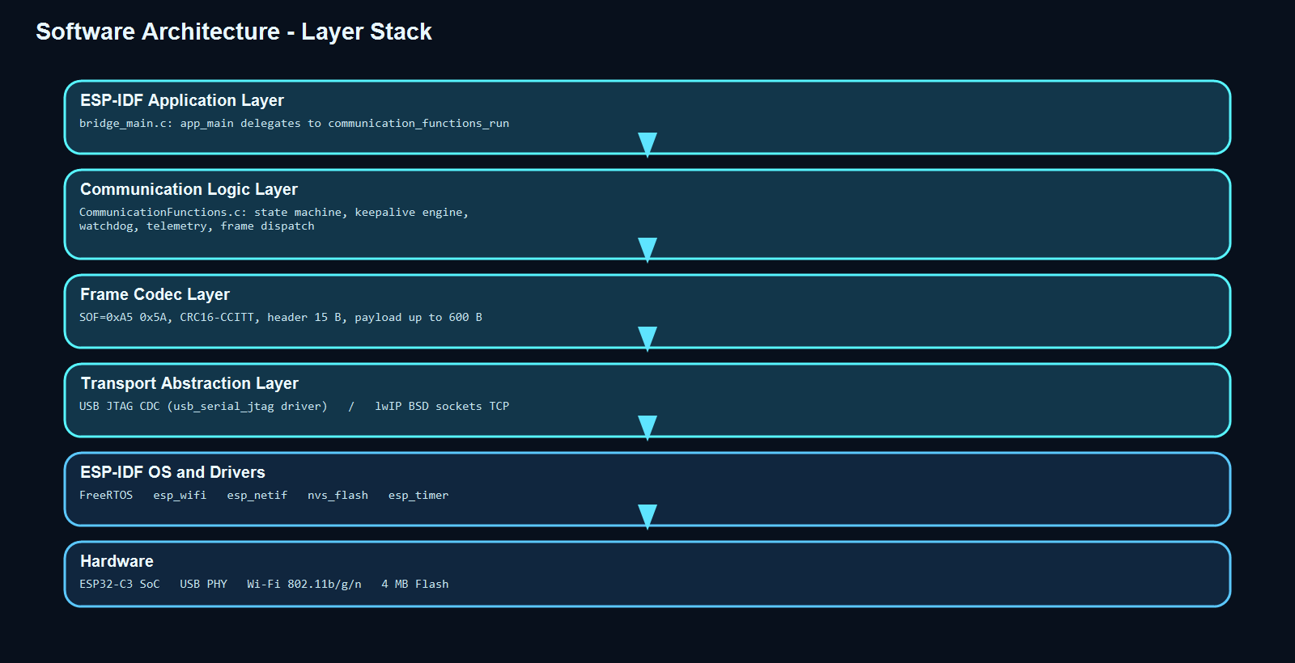

3.2 Source File Structure
bridge_main.c - ESP-IDF app_main() entry; delegates directly to communication_functions_run().
CommunicationFunctions.c - All runtime logic: state machine, keepalive, frame encode/decode, USB/TCP I/O.
CommunicationFunctions.h - Public API (single function) and shared compile-time constants.
CMakeLists.txt - ESP-IDF component build descriptor.
sdkconfig.defaults - Project-level Kconfig overrides (USB JTAG CDC enabled).

3.3 Threading Model
The bridge runs as a single FreeRTOS task on the application CPU core. There are no additional tasks or ISR-based communication threads. All USB reads, TCP accept/recv/send, keepalive timing, and state transitions occur sequentially within the main loop, which polls every 20 ms via vTaskDelay().

3.4 Libraries and Dependencies
ESP-IDF v5.x - Framework providing FreeRTOS, Wi-Fi stack, TCP/IP stack (lwIP), USB JTAG CDC driver, NVS, and timer APIs.
driver/usb_serial_jtag.h - USB serial I/O primitives: usb_serial_jtag_read_bytes(), usb_serial_jtag_write_bytes().
esp_wifi / esp_netif - Wi-Fi SoftAP lifecycle: init, start, ap config, event loop.
lwip/sockets.h - BSD socket API: socket(), bind(), listen(), accept(), recv(), send(), setsockopt().
nvs_flash - Non-volatile storage init required by Wi-Fi driver at startup.
esp_timer - esp_timer_get_time() for microsecond-resolution keepalive timestamps.
freertos/task.h - vTaskDelay() for 20 ms poll cadence.

4. Communication Protocol
4.1 Frame Format
Figure 3. Binary frame layout: SOF, message type, live integers, sequence, payload length, CRC16, and payload.
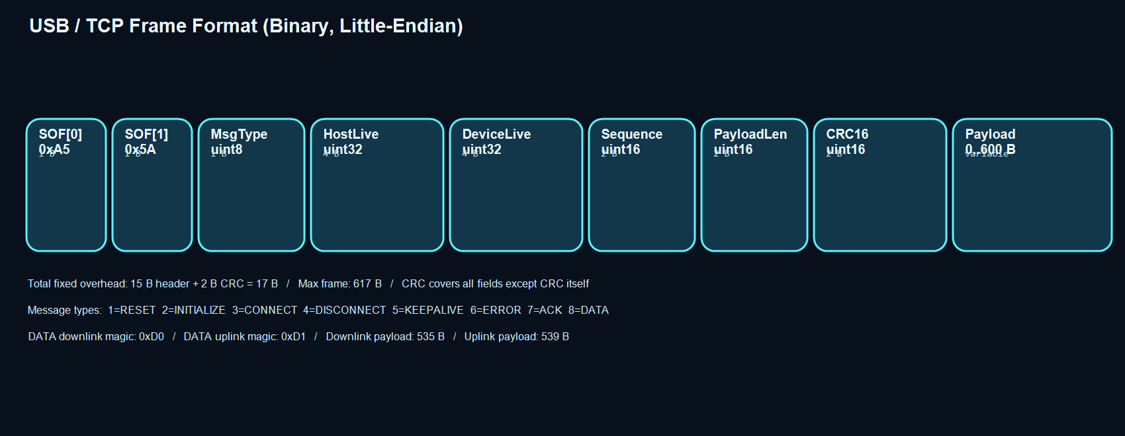

4.2 Frame Fields (all little-endian)
SOF[0] 1 B Fixed 0xA5.
SOF[1] 1 B Fixed 0x5A.
MsgType 1 B Message type enum 1-8, see below.
HostLiveInt 4 B uint32. Server-side liveness counter (even numbers, incremented per keepalive).
DeviceLiveInt 4 B uint32. Client-side liveness counter (odd numbers, incremented per keepalive reply).
Sequence 2 B uint16. Per-transport rolling sequence number.
PayloadLength 2 B uint16. Number of payload bytes, 0 to BRIDGE_FRAME_MAX_PAYLOAD=600.
CRC16 2 B uint16. CRC16-CCITT over all fields except the CRC field itself.
Payload 0-600 B Variable-length payload data.

4.3 Message Types
1 = RESET Host instructs bridge to clear state and restart.
2 = INITIALIZE Host sends configuration; bridge prepares Wi-Fi/TCP resources.
3 = CONNECT Host requests client session start; bridge begins accepting TCP connections.
4 = DISCONNECT Either side requests controlled session teardown.
5 = KEEPALIVE Periodic liveness frame exchanged between host and client via bridge.
6 = ERROR Either side reports a transport fault.
7 = ACK Bridge acknowledges a received command from the host.
8 = DATA Binary application data forwarded bidirectionally.

4.4 Text Payload Format (types 1-7)
Text payloads are null-terminated ASCII key=value strings (max 256 bytes). Examples:
KEEPALIVE request: session_id=1 request_id=5 live=10
KEEPALIVE reply: session_id=1 request_id=5 rver=1 delay_ms=28 max_delay_ms=30 errors=0
INITIALIZE: data_ver=1

4.5 Binary DATA Payload Format
Figure 4. Binary DATA channel: downlink from Python server to client, uplink from client to server.
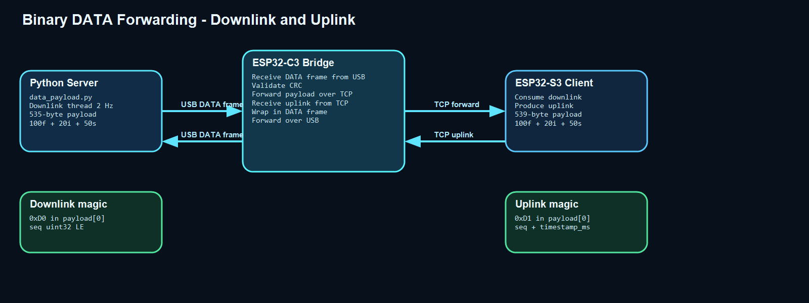

Downlink (server -> bridge -> client):
payload[0] = 0xD0 (magic)
payload[1..4] = seq uint32 LE
payload[5..N] = 100 floats + 20 int32s + 50-byte string (535 bytes total)

Uplink (client -> bridge -> server):
payload[0] = 0xD1 (magic)
payload[1..4] = seq uint32 LE
payload[5..8] = timestamp_ms uint32 LE
payload[9..N] = 100 floats + 20 int32s + 50-byte string (539 bytes total)

5. State Machine
5.1 Bridge State Machine Diagram
Figure 5. Bridge state machine: RESET -> INITIALIZE -> CONNECT -> KEEPALIVE cycle -> ERROR and DISCONNECT.
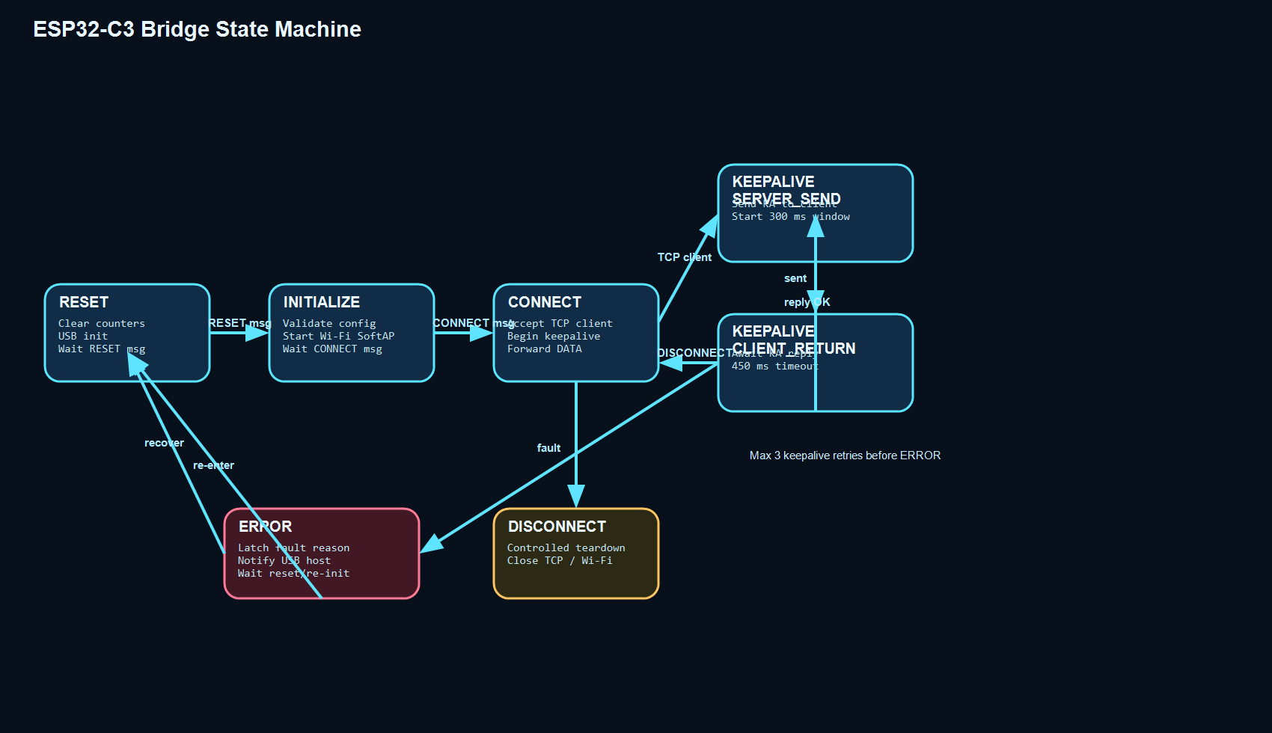

5.2 States
RESET (0) - Entry state after power-on or after any fault recovery. Awaits RESET message from host.
INITIALIZE (1) - Bridge configures Wi-Fi SoftAP and TCP listener. Awaits CONNECT message.
CONNECT (2) - Bridge enters TCP accept loop awaiting a client connection. Once accepted, begins keepalive.
KEEPALIVE_SERVER_SEND (3) - Bridge sends a KEEPALIVE frame over TCP, records timestamp, starts 300 ms window.
KEEPALIVE_CLIENT_RETURN (4)- Bridge awaits the client's KEEPALIVE reply within a 450 ms window.
DISCONNECT (5) - Controlled teardown: TCP client closed, ACK sent to host, transitions to RESET.
ERROR (6) - Latched fault state. Fault reason sent to USB host. Awaits RESET or INITIALIZE from host.

5.3 State Transition Triggers
RESET -> INITIALIZE: Host sends RESET frame; bridge ACKs and advances.
INITIALIZE -> CONNECT: Host sends INITIALIZE with data_ver=1; bridge validates, starts Wi-Fi, ACKs.
CONNECT -> KEEPALIVE_SERVER_SEND: TCP client accepted on port 3333.
KEEPALIVE_SERVER_SEND -> KEEPALIVE_CLIENT_RETURN: KEEPALIVE frame sent over TCP.
KEEPALIVE_CLIENT_RETURN -> KEEPALIVE_SERVER_SEND: Valid reply received within window; cycle repeats.
Any active state -> DISCONNECT: Host sends DISCONNECT frame.
Any active state -> ERROR: CRC mismatch, keepalive timeout (after 3 retries), TCP socket error, or running integer stall.
ERROR -> RESET: Host sends RESET frame.
ERROR -> INITIALIZE: Host sends INITIALIZE frame (soft recovery, keeps Wi-Fi stack up).

6. Main Loop Architecture
6.1 Main Loop Flowchart
Figure 6. Main loop sequence: init, USB poll, frame decode, keepalive service, 20 ms yield.
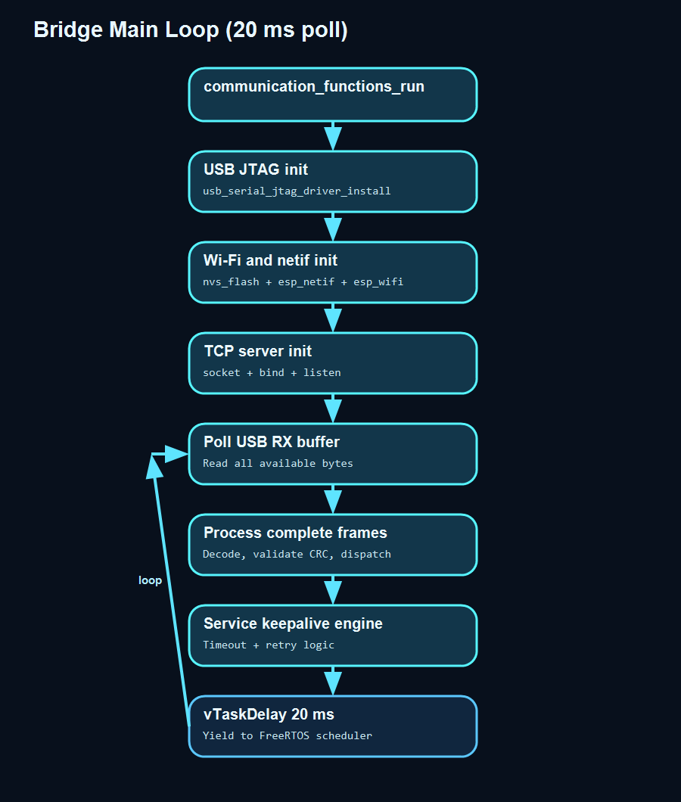

6.2 Poll Cycle Description
1. USB JTAG read - usb_serial_jtag_read_bytes() with 0 ms timeout. Bytes appended to assembly buffer.
2. Frame parser - Scans buffer for SOF 0xA5 0x5A, extracts length, validates CRC16, dispatches complete frames.
3. Frame handler - Dispatches by message type. RESET/INITIALIZE/CONNECT/DISCONNECT/KEEPALIVE/ERROR/DATA each invoke dedicated handler.
4. Keepalive engine - Checks elapsed time since last keepalive TX. If >= 300 ms, enters KEEPALIVE_SERVER_SEND. Checks reply window timeout. Manages retry count (max 3).
5. Transport watchdog - Checks that server HostLiveInteger has advanced in the expected window. If stalled: ERROR.
6. vTaskDelay(20 ms) - Yields CPU, preventing busy-loop. Allows FreeRTOS scheduler to run background Wi-Fi tasks.

7. Keepalive Protocol
7.1 Keepalive Sequence
Figure 7. Keepalive three-party sequence: Python server, ESP32-C3 bridge, ESP32-S3 client.
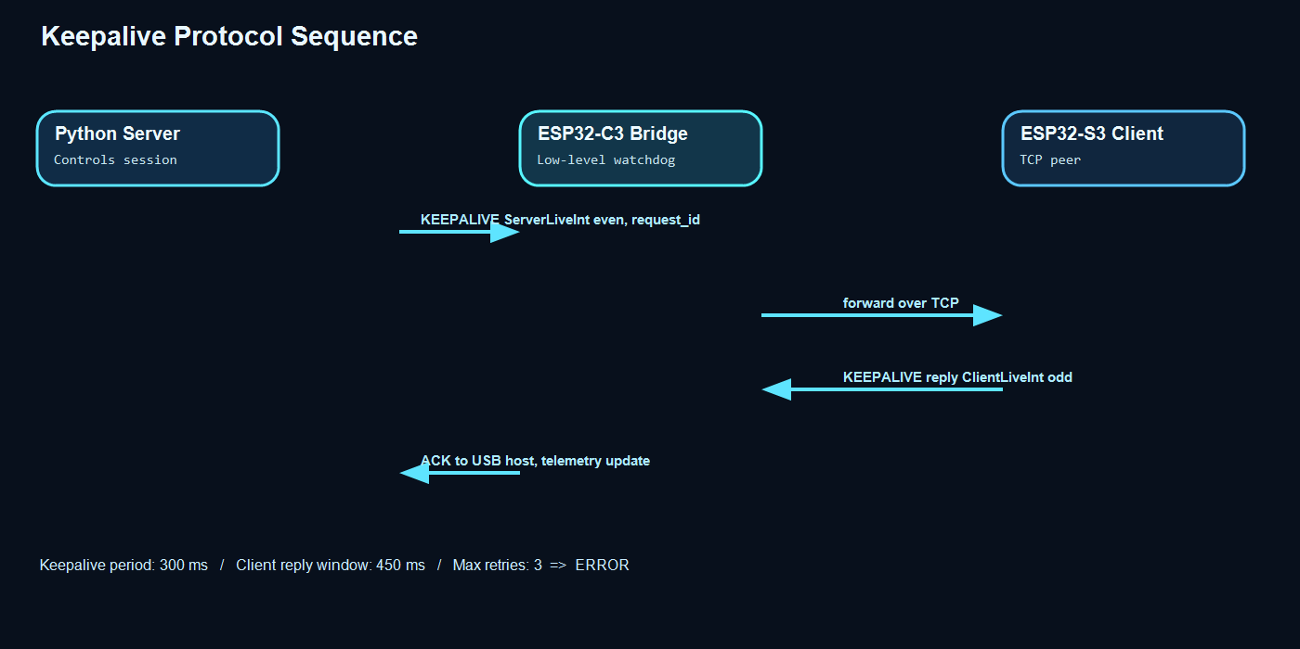

7.2 Keepalive Timing Constants
BRIDGE_KEEPALIVE_PERIOD_MS = 300 ms - Interval between consecutive keepalive transmissions.
BRIDGE_KEEPALIVE_WAIT_WINDOW_MS = 450 ms - Maximum wait for client reply per keepalive.
BRIDGE_RUNNING_INTEGER_RETRY_LIMIT = 3 - Max consecutive timeouts before ERROR transition.

7.3 Live Integer Protocol
ServerLiveInteger: even numbers (0, 2, 4...). Incremented by the Python server each keepalive cycle.
DeviceLiveInteger: odd numbers (1, 3, 5...). Incremented by the ESP32-S3 client in keepalive reply.
The bridge validates that both integers advance correctly. Stalled integers trigger the running integer failure path.
Telemetry: delay_ms (round-trip of last keepalive), max_delay_ms (maximum ever seen), total errors.

8. Memory Allocation
8.1 Memory Layout
Figure 8. Key static memory allocations: USB buffers, TCP buffer, frame struct, telemetry counters, and ESP-IDF managed heap.
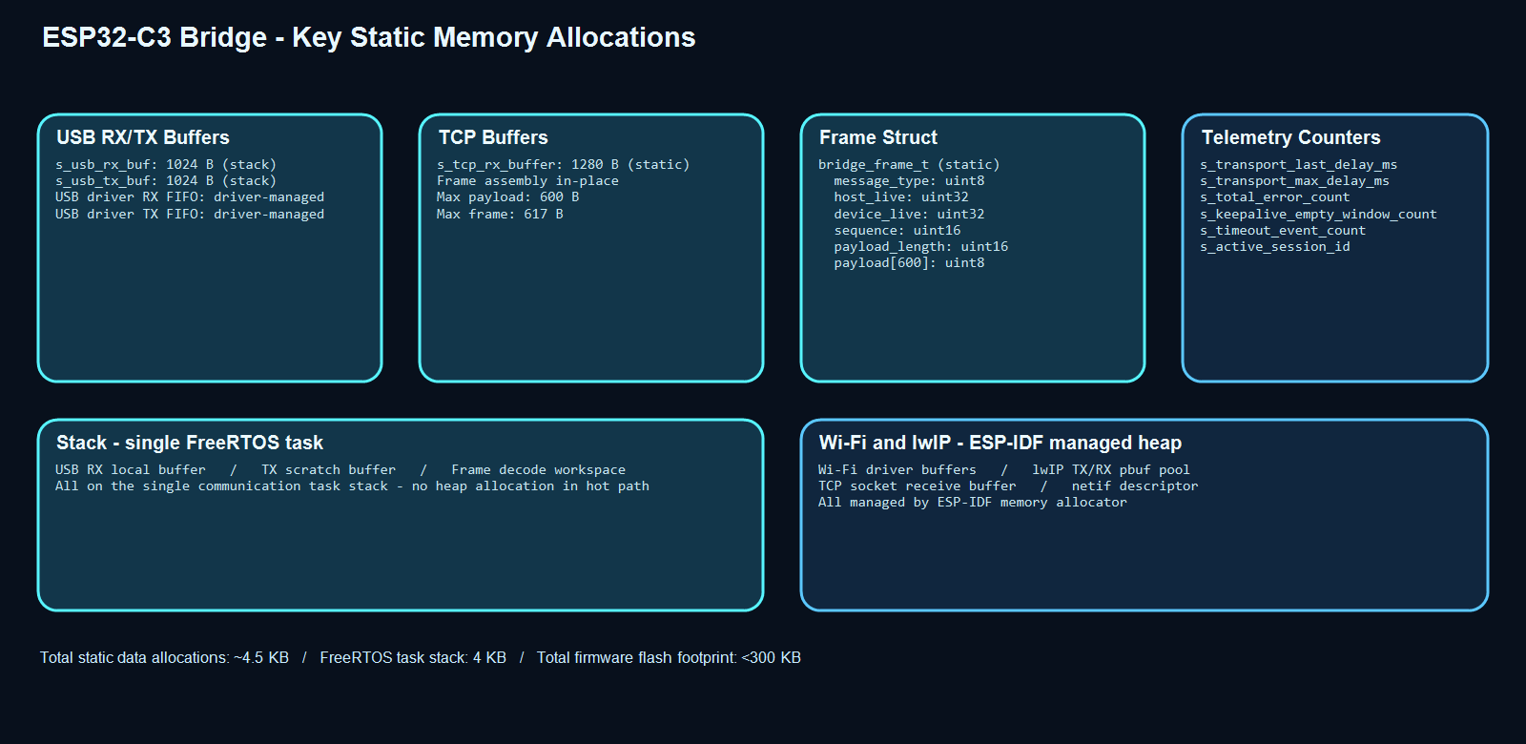

8.2 Static Allocations (compile-time)
BRIDGE_RX_BUFFER_SIZE = 1024 B - USB assembly scratch buffer (stack).
BRIDGE_TX_BUFFER_SIZE = 1024 B - USB transmit staging buffer (stack).
BRIDGE_TCP_RX_BUFFER_SIZE = 1280 B - TCP receive buffer (static global).
BRIDGE_FRAME_MAX_PAYLOAD = 600 B - Maximum frame payload size.
BRIDGE_FRAME_MAX_SIZE = 617 B - Includes 17-byte frame overhead.
bridge_frame_t = ~614 B - Decoded frame struct (static global).

8.3 Dynamic Allocations (ESP-IDF heap)
Wi-Fi driver internal buffers - allocated by ESP-IDF Wi-Fi subsystem.
lwIP pbuf pool - TCP/IP receive and transmit packet buffers managed by lwIP.
netif descriptor - allocated by esp_netif.
No heap allocation occurs in the bridge hot path - all frame processing uses stack or static memory.

8.4 Flash Footprint
Bridge firmware binary: approximately 250 to 300 KB including ESP-IDF Wi-Fi stack.
NVS partition: 16 KB for Wi-Fi calibration data.
Total flash: 4 MB device - firmware occupies less than 10%.

9. Error Handling
9.1 Error Recovery Diagram
Figure 9. Error sources (CRC, keepalive timeout, running integer stall, TCP error) and recovery paths (RESET, INITIALIZE, DISCONNECT).
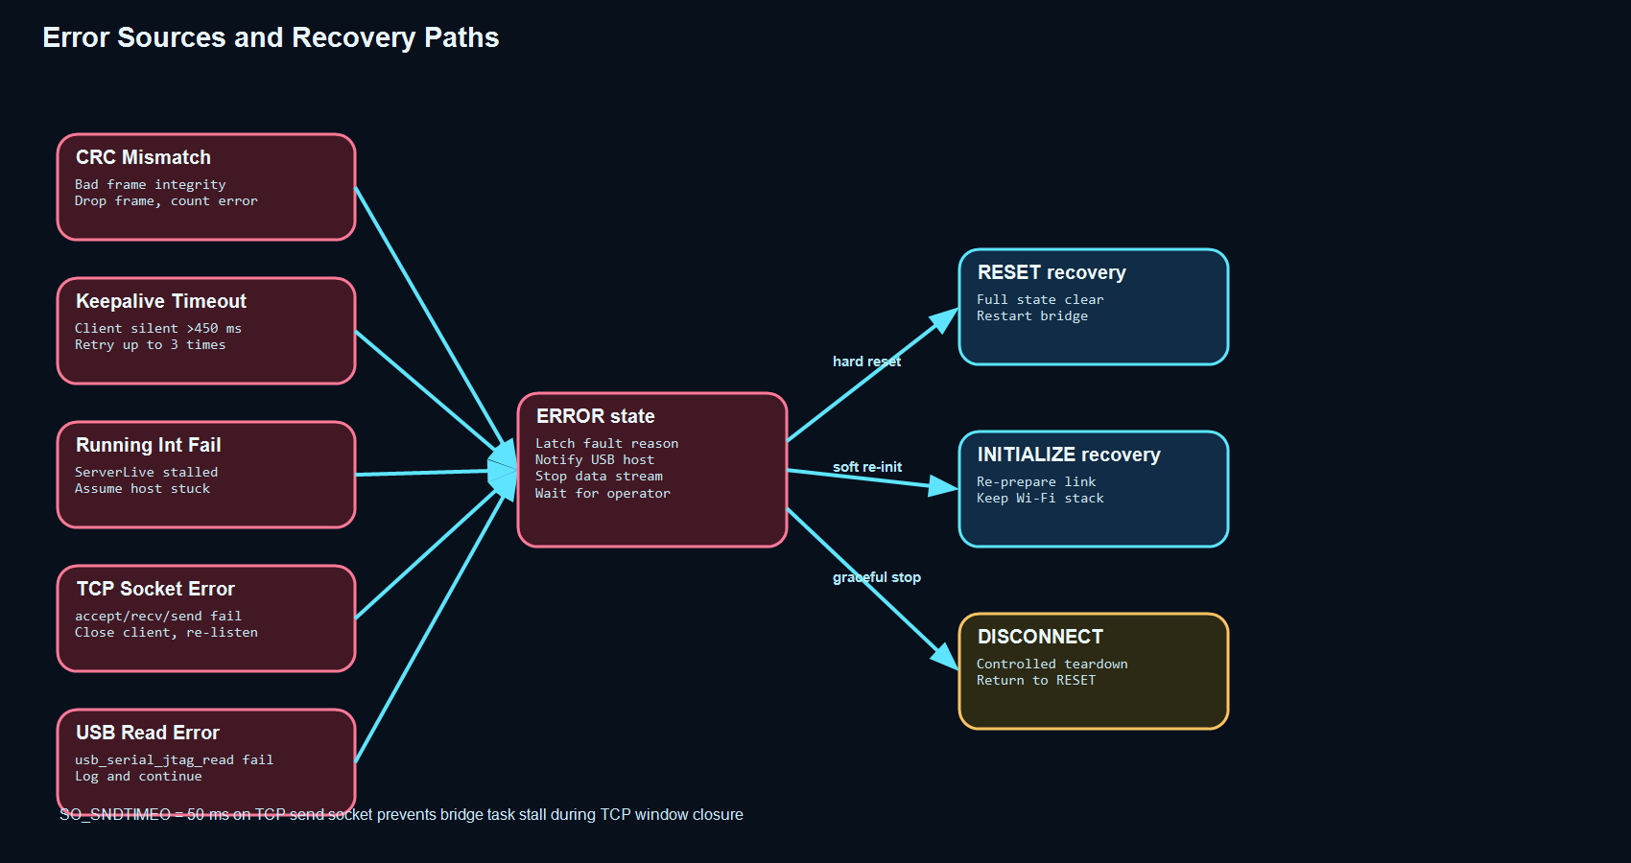

9.2 Error Categories
CRC Mismatch: Frame integrity failure. Frame is dropped silently. Error count incremented.
Keepalive Timeout: Client did not reply within 450 ms. Retry up to 3 times. After 3 failures -> ERROR.
Running Integer Stall: HostLiveInteger from server has not advanced. Assume PC host stuck -> ERROR.
TCP Socket Error: accept/recv/send returned error. TCP client closed, re-enter CONNECT listen loop.
USB Read Error: usb_serial_jtag_read_bytes returned error or 0. Logged, poll continues.

9.3 SO_SNDTIMEO Protection
A 50 ms SO_SNDTIMEO send timeout is set on the TCP client socket immediately after accept(). This prevents a blocked send() call from stalling the single bridge task when the TCP receive window closes. Without this protection, a slow or unresponsive TCP client could overflow the USB JTAG FIFO and cause byte loss on the host serial link.

9.4 Recovery Actions
RESET frame from host: Full bridge reset. Clears all state, counters, and Wi-Fi transport.
INITIALIZE frame from host: Soft re-entry. Re-prepares resources from INITIALIZE state (keeps Wi-Fi stack).
DISCONNECT frame from host: Graceful shutdown. Closes TCP client, ACKs host, returns to RESET.

10. Build and Compilation
10.1 Toolchain
Framework: ESP-IDF v5.x.
Compiler: xtensa-esp-elf-gcc / riscv32-esp-elf-gcc (ESP32-C3 uses RISC-V toolchain).
Build tool: idf.py (CMake + Ninja backend).
Host shell: Windows cmd.exe with ESP-IDF environment activated via export.bat / setup_idf_env.ps1.

10.2 Build Commands (Mandatory Method)
Build:
cmd.exe /c C:\Espressif\Eyal_Projects_ESP32_S3\Eyal_espresso_server_simulator\scripts\idfw.cmd build

Flash (replace COM4 with actual port):
cmd.exe /c C:\Espressif\Eyal_Projects_ESP32_S3\Eyal_espresso_server_simulator\scripts\idfw.cmd -p COM4 flash

Build then flash (sequential):
cmd.exe /c ... idfw.cmd build && cmd.exe /c ... idfw.cmd -p COM4 flash

10.3 Important Build Notes
The MSYSTEM environment variable must be cleared before invoking idfw.cmd to prevent MinGW/MSYS detection:
set MSYSTEM= (cleared in idfw.cmd before calling idf.py)
COM port must be released by the Python simulator before flashing:
POST http://localhost:8000/api/transport/release-com (called by idfw.ps1 wrapper)
The idfw.ps1 and flash_hidden.ps1 scripts call the simulator release endpoint automatically.

10.4 CMakeLists.txt Structure
cmake_minimum_required(VERSION 3.16)
include(\{IDF_PATH}/tools/cmake/project.cmake)
project(esp32c3_bridge)
Components: main (bridge_main.c, CommunicationFunctions.c, CommunicationFunctions.h)
Requires: driver, esp_wifi, esp_netif, esp_event, nvs_flash, lwip, esp_timer

10.5 sdkconfig.defaults Key Settings
CONFIG_ESP_CONSOLE_USB_SERIAL_JTAG=y - Enable USB JTAG CDC console.
CONFIG_FREERTOS_HZ=1000 - 1 ms FreeRTOS tick for accurate keepalive timing.
CONFIG_ESP32C3_REV_MIN_FULL=3 - Minimum chip revision.

11. Operational Workflow
11.1 Normal Startup Sequence
1. Power ESP32-C3 via USB from host PC.
2. Bridge firmware boots: nvs_flash init -> Wi-Fi stack init -> USB JTAG driver install -> TCP socket created.
3. Launch Python simulator on host PC.
4. Operator selects COM port (e.g. COM4) in simulator UI and clicks Open Transport.
5. Simulator sends RESET frame over USB. Bridge ACKs, enters INITIALIZE state.
6. Simulator sends INITIALIZE frame (data_ver=1). Bridge starts SoftAP, starts TCP listener, ACKs.
7. Simulator sends CONNECT frame. Bridge waits for TCP client.
8. ESP32-S3 joins EyalSimulatorAP Wi-Fi and connects TCP to 192.168.4.1:3333.
9. Bridge enters KEEPALIVE_SERVER_SEND. Normal keepalive cycle begins (300 ms period).
10. DATA frames flow bidirectionally: Python data_payload.py generates downlink at 2 Hz; client produces uplink.

11.2 Fault Recovery Workflow
1. On any fault: bridge transitions to ERROR, sends ERROR frame to USB host with reason string.
2. Simulator UI shows fault reason and error count.
3. Operator clicks Reset or Initialize in simulator UI.
4. Simulator sends RESET or INITIALIZE frame.
5. Bridge clears fault state and re-enters the command sequence.

11.3 Monitoring
USB console output: Tagged with [bridge] via ESP_LOGx. Visible in idf.py monitor (COM4).
Simulator UI telemetry: Transport Last Delay [mS], Transport Max Delay [mS], Total Errors - updated each keepalive.
sim_debug.log: Optional log file capture via run_sim_debug.ps1 for session-level tracing.

12. Version Control
Bridge firmware version is tracked in firmware/esp32c3_bridge/VERSION.
Server simulator version is tracked in VERSION.
Both follow X.Y.Z format: X=major feature changes, Y=bug fixes, Z=verified patch increments.
Versioning rules: increment Z on every accepted verification cycle; increment Y on bug fixes; X on architectural changes.
Current versions at document generation: Server=0.2.4 Bridge=0.1.21

