**Group Members:** Maanasa Neralla, Conor Gleason, Esaa Yamini, Patrick Wickliff, Peidong Zhao

**Topic:**

Our topic is to demonstrate the highest paid athletes from 1990 to 2019. We wanted to use the acquired dataset to present various visualizations that will:

* Rank highest paid athletes by year (Bar)
* Categorize which sports allow players more opportunity to earn the most income
* Show if the player is consecutively at the top or a “one-hit wonder”
* Show the peak age of the athletes

**Data Set:**

* <https://www.kaggle.com/parulpandey/forbes-highest-paid-athletes-19902019>

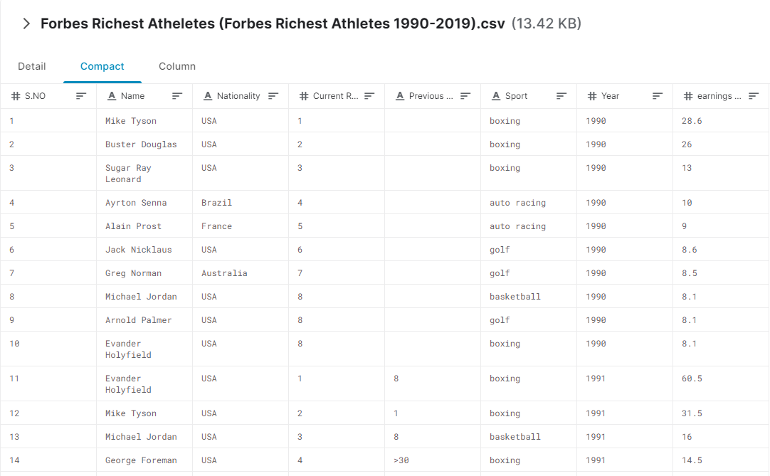

**GitHub Link:**

* https://github.com/mneralla/Project-Athlete

**Visuals:**

Bar Graph

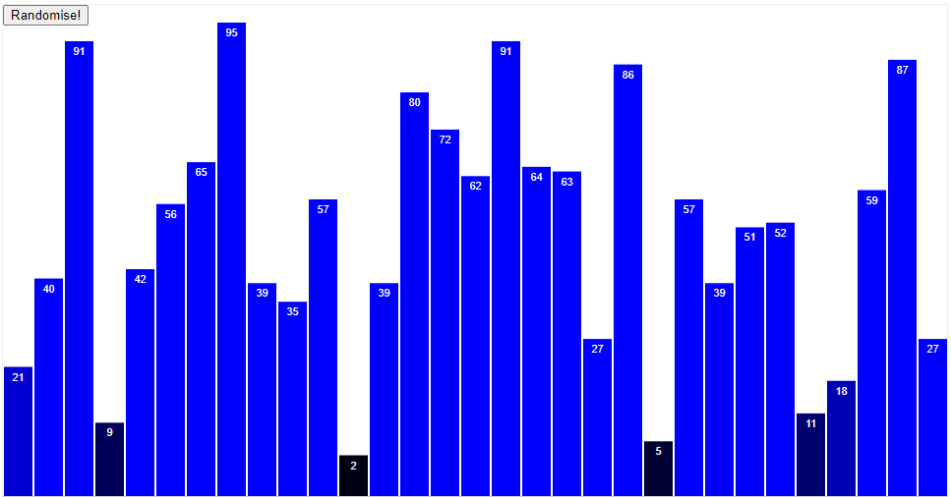

Histogram

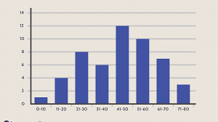

Line Graph

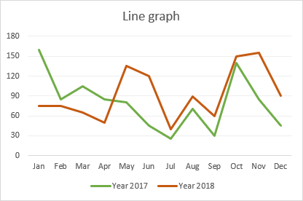

**Final Visual:**

