HandsMen Threads: Elevating the Art of Sophistication in Men’s Fashion

Project Overview
HandsMen Threads, an emerging leader in refined men’s fashion, implemented Salesforce to modernize business operations, strengthen customer engagement, and automate key workflows across sales, inventory, and loyalty management. This initiative centralizes business data, improves process efficiency, and ensures that critical information such as stock movement, customer orders, and loyalty status updates are fully synchronized across the organization.
Salesforce development, testing, and validation were conducted in a dedicated Developer Org to guarantee smooth deployment to Production and preserve system integrity.

Objectives

Objective | Description
Centralize Business Data | Consolidate customers, orders, products, loyalty programs, and inventory.
Automate Operational Processes | Order confirmations, low-stock alerts, loyalty tier updates, and nightly batch processing.
Enforce Data Quality | Validation rules, UI-level restrictions, and declarative governance.
Improve Customer Engagement | Automated communication and personalized loyalty management.
Ensure Scalability | Apex triggers, asynchronous Apex, and structured data models for long-term extensibility.

Phase 1: Salesforce CRM Implementation

Objects & Relationships

1. HandsMen Customer (HandsMen_Customer__c)
Captures customer demographics, contact info, and loyalty tier.
Relationship: Parent to Orders and Loyalty Status.
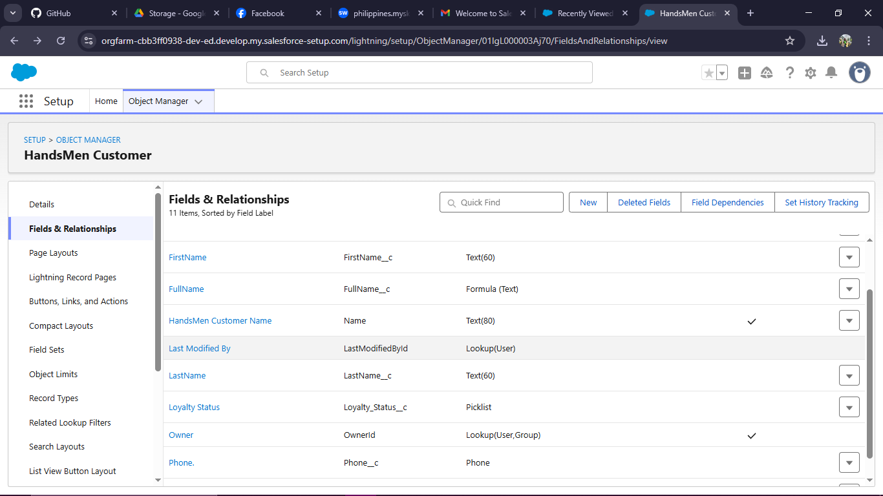
Figure 1. HandsMen Customer Object Structure

2. HandsMen Product (HandsMen_Product__c)
Stores SKU, price, stock quantity, category, and supplier details.
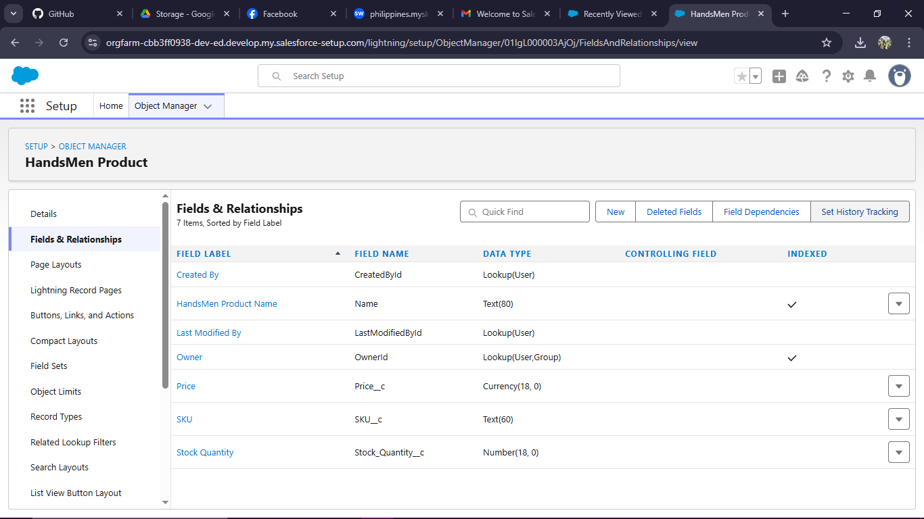
Figure 2. HandsMen Product Object Structure

3. HandsMen Order (HandsMen_Order__c)
Tracks items purchased, quantity, total amount, status, confirmation date, and customer reference.
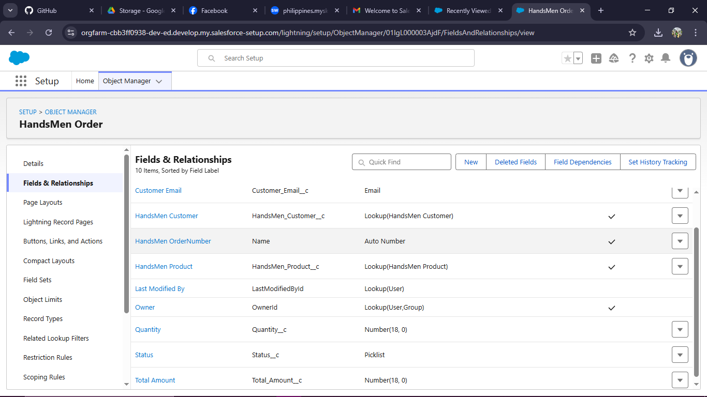
Figure 3. HandsMen Order Object Structure

4. Loyalty Status (LoyaltyStatus__c)
Stores accumulated points, loyalty tier (Bronze/Silver/Gold), and last update date.
Figure 4. Loyalty Object Structure

5. Inventory (Inventory__c)
Maintains real-time stock quantity tied to each product.
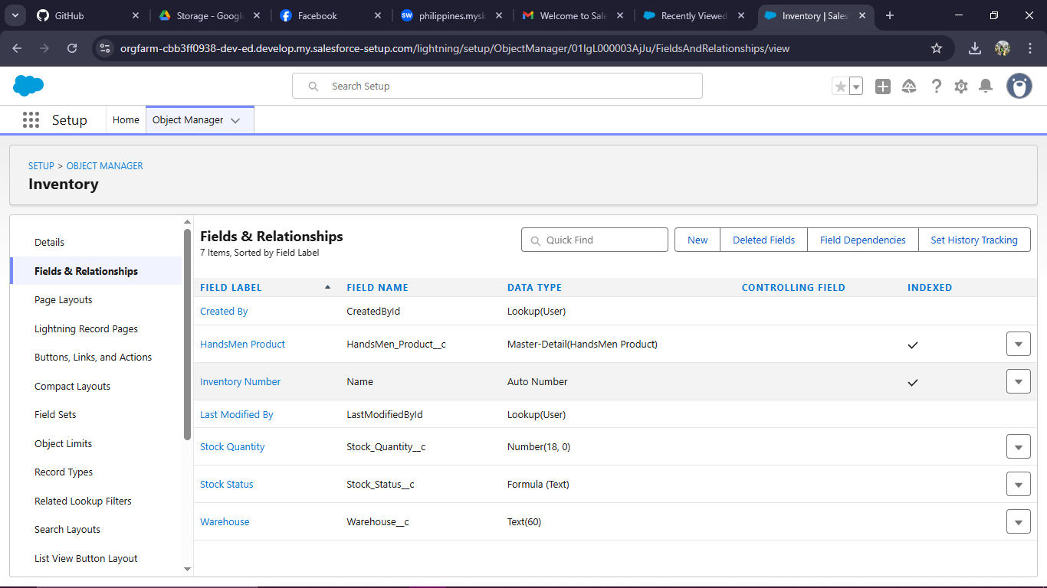
Figure 5. Inventory Object Structure

Lightning App & Tabs
A custom Lightning App titled HandsMen Threads Application was created to unify navigation across modules.
Tabs added:
- HandsMen Customer
- HandsMen Order
- HandsMen Product
- Loyalty Status
- Contacts
- Marketing Campaign
- Inventory
- Reports & Dashboards
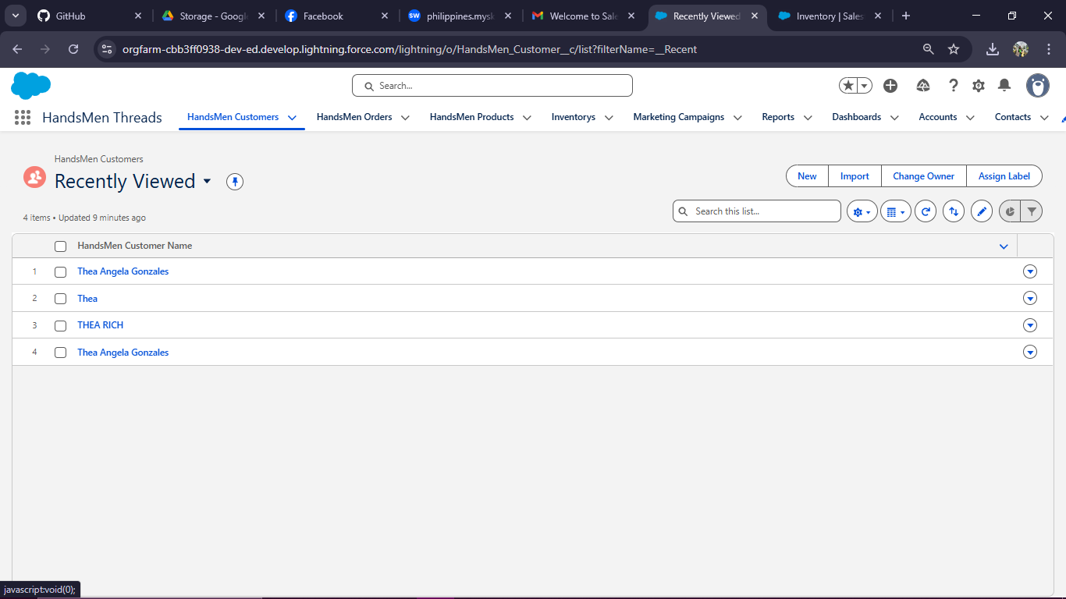
Figure 7. HandsMen Threads Lightning App

Roles, Profiles, and Permission Sets

Roles
- Sales Manager
- Inventory Manager
- Marketing Manager
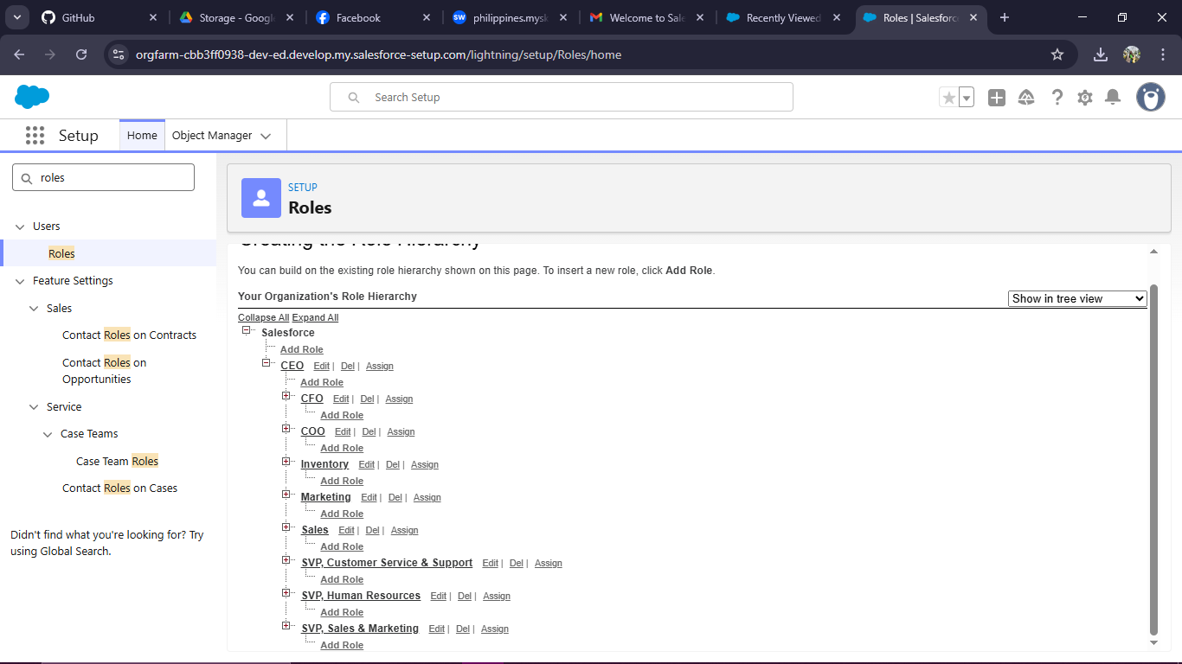
Figure 8. Role Hierarchy Structure

Record-Level Access (OWD)
Object | Access Level |  |  | Purpose
HandsMen_Customer__c |  | Private |  | Customer data protection
HandsMen_Order__c |  |  | Private | Order confidentiality
HandsMen_Product__c |  |  | Public Read Only | Allow product visibility
LoyaltyStatus__c |  |  | Private | Sensitive customer analytics
Inventory__c |  |  | Private | Controlled stock management

Phase 2: Process Automation & Validation

Flow 1: Order Confirmation Flow
Triggered when an order status = “Confirmed”.
Automatically emails customers using a standardized template.
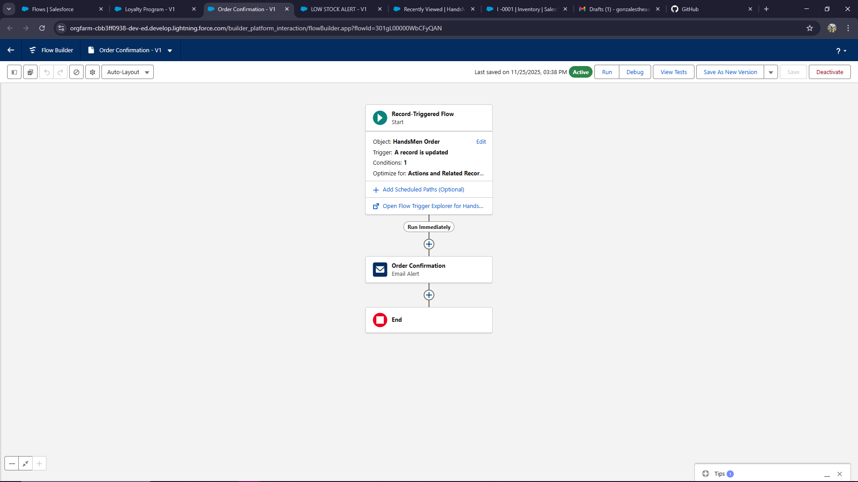
Figure 11. Order Confirmation Flow
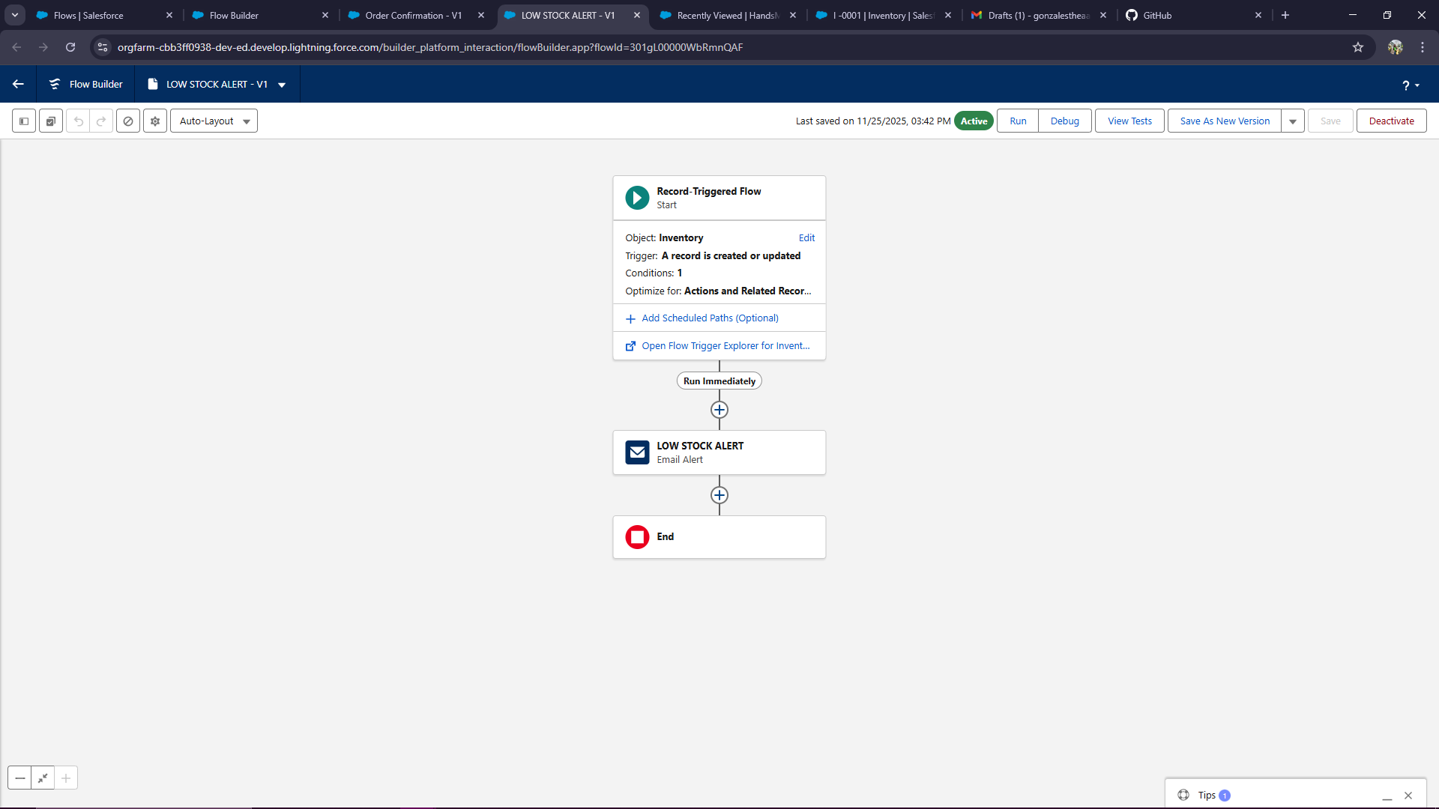

Flow 2: Low Stock Alert Flow
Triggered when Inventory Stock ≤ 5.
Sends alert email to marketing manager.
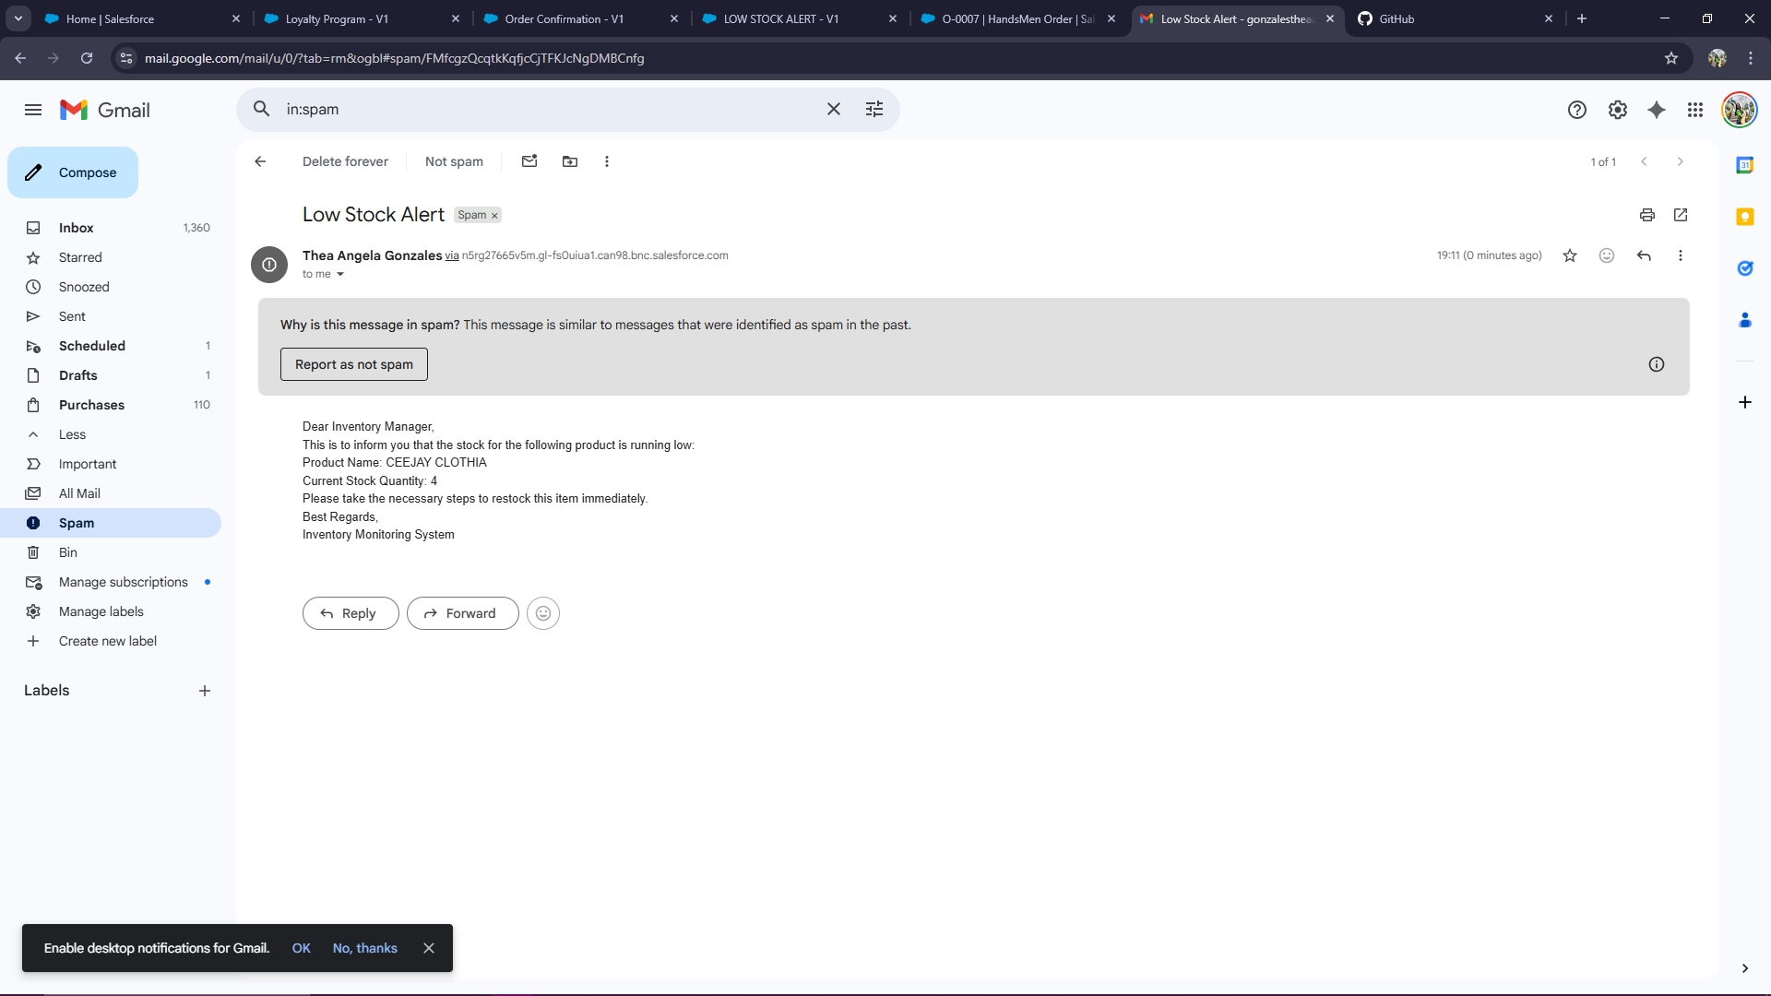
Figure 12. Low Stock Alert Flow

Flow 3: Loyalty Tier Adjustment Flow
Processes loyalty tier updates after each completed order.
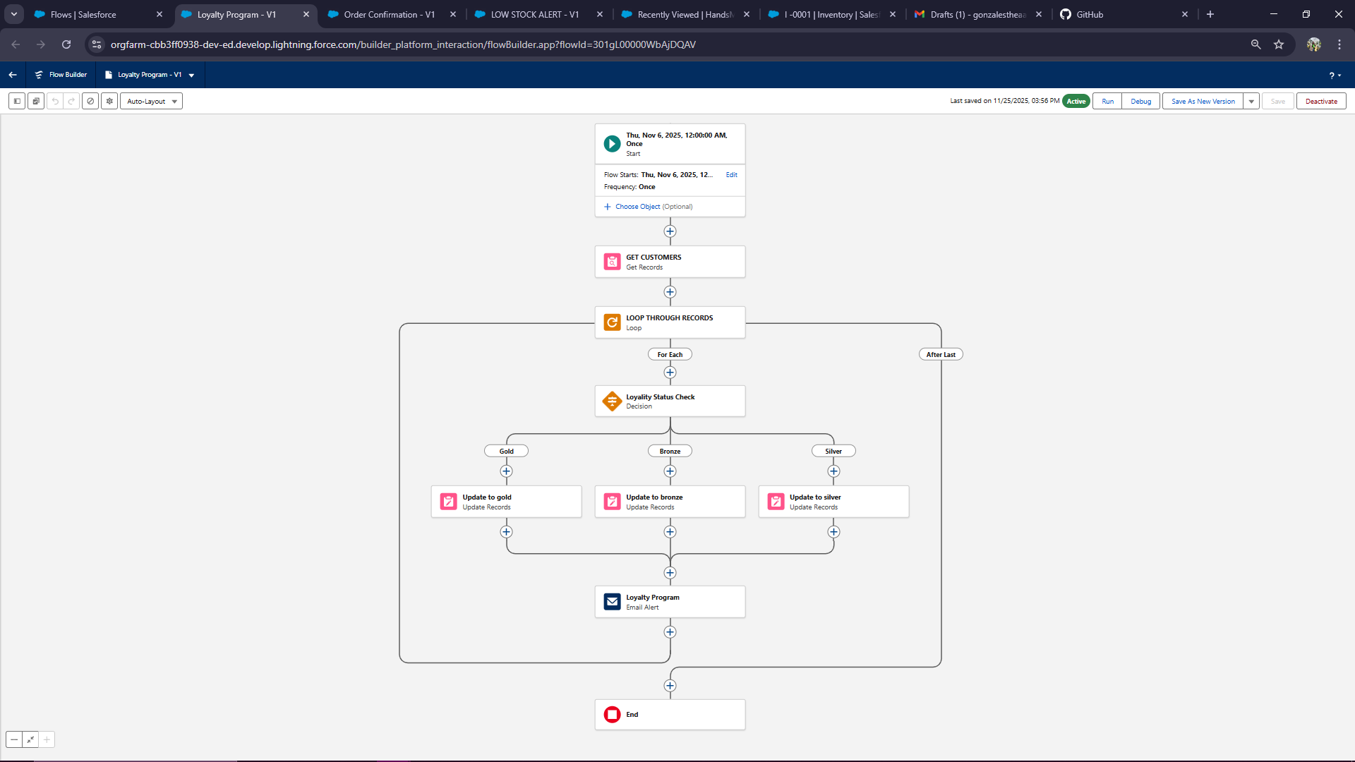
Figure 13. Loyalty Tier Flow

Validation Rules

1. Total Amount Check
Prevents saving orders with invalid total amounts.

2. Stock Cannot Be Negative
Ensures Inventory Stock ≥ 0.

3. Valid Customer Email
Checks for proper email formatting.
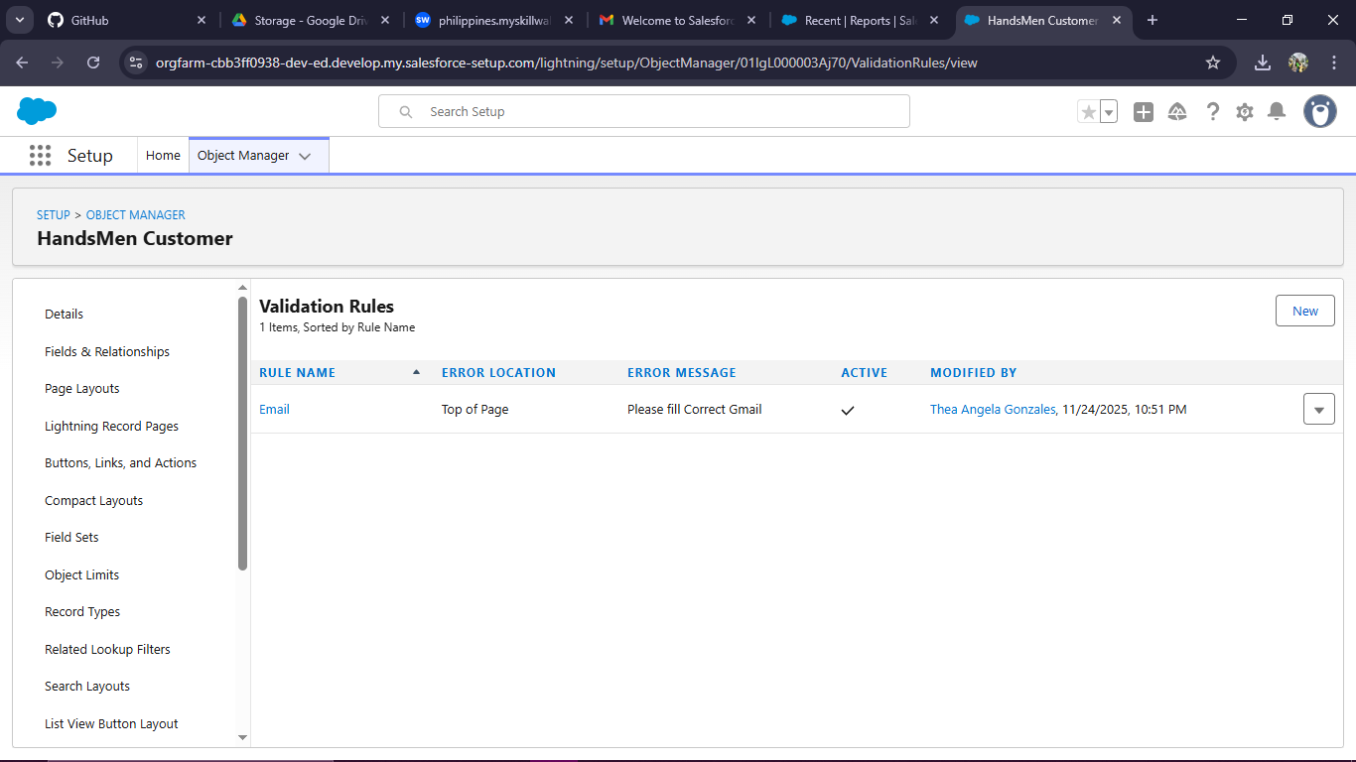
Figure 14. Validation Rules Setup

Phase 3: Apex & Trigger Development

Apex Trigger 1: Order Total Calculation (Before Insert/Update)
Automatically computes:
Total Amount = Quantity × Product Price
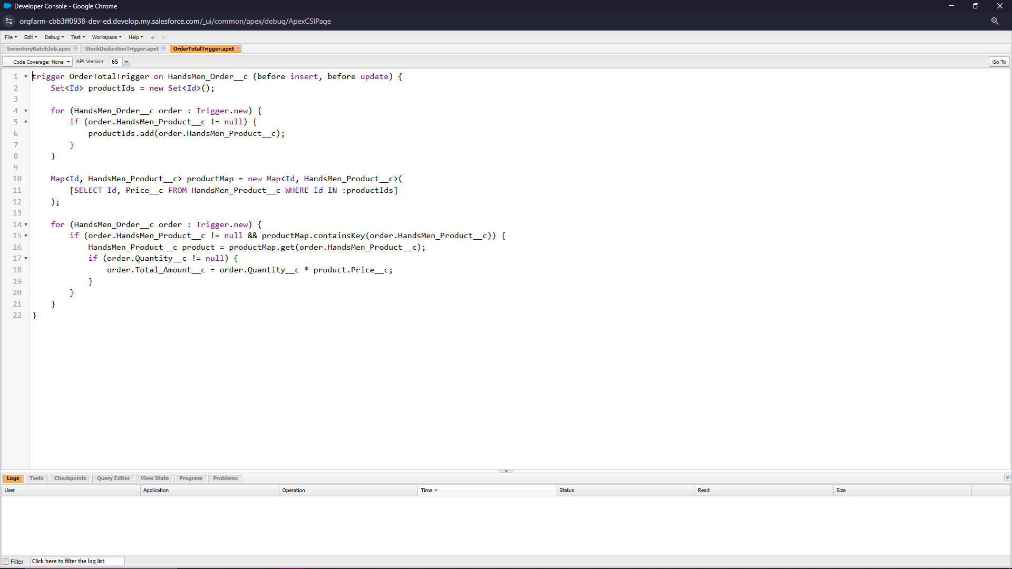
Figure 15. OrderTotalTrigger

Apex Trigger 2: Stock Deduction (After Insert/Update)
Reduces inventory when an order is confirmed.
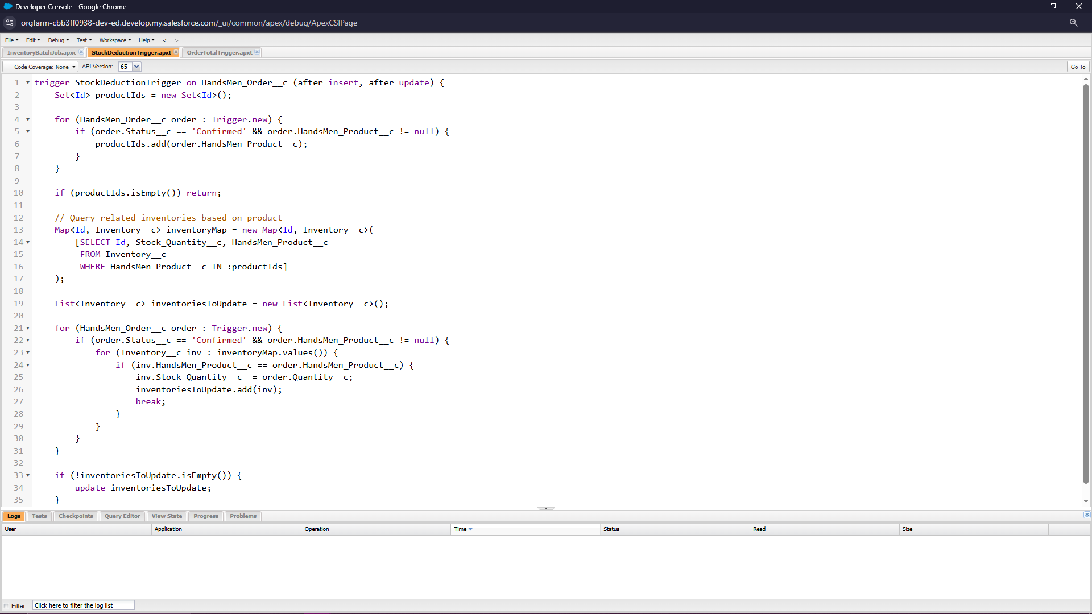
Figure 16. StockDeductionTrigger

Asynchronous Apex: Nightly Batch Job
Updates inventory, reconciles financial logs, and processes pending bulk orders at midnight.
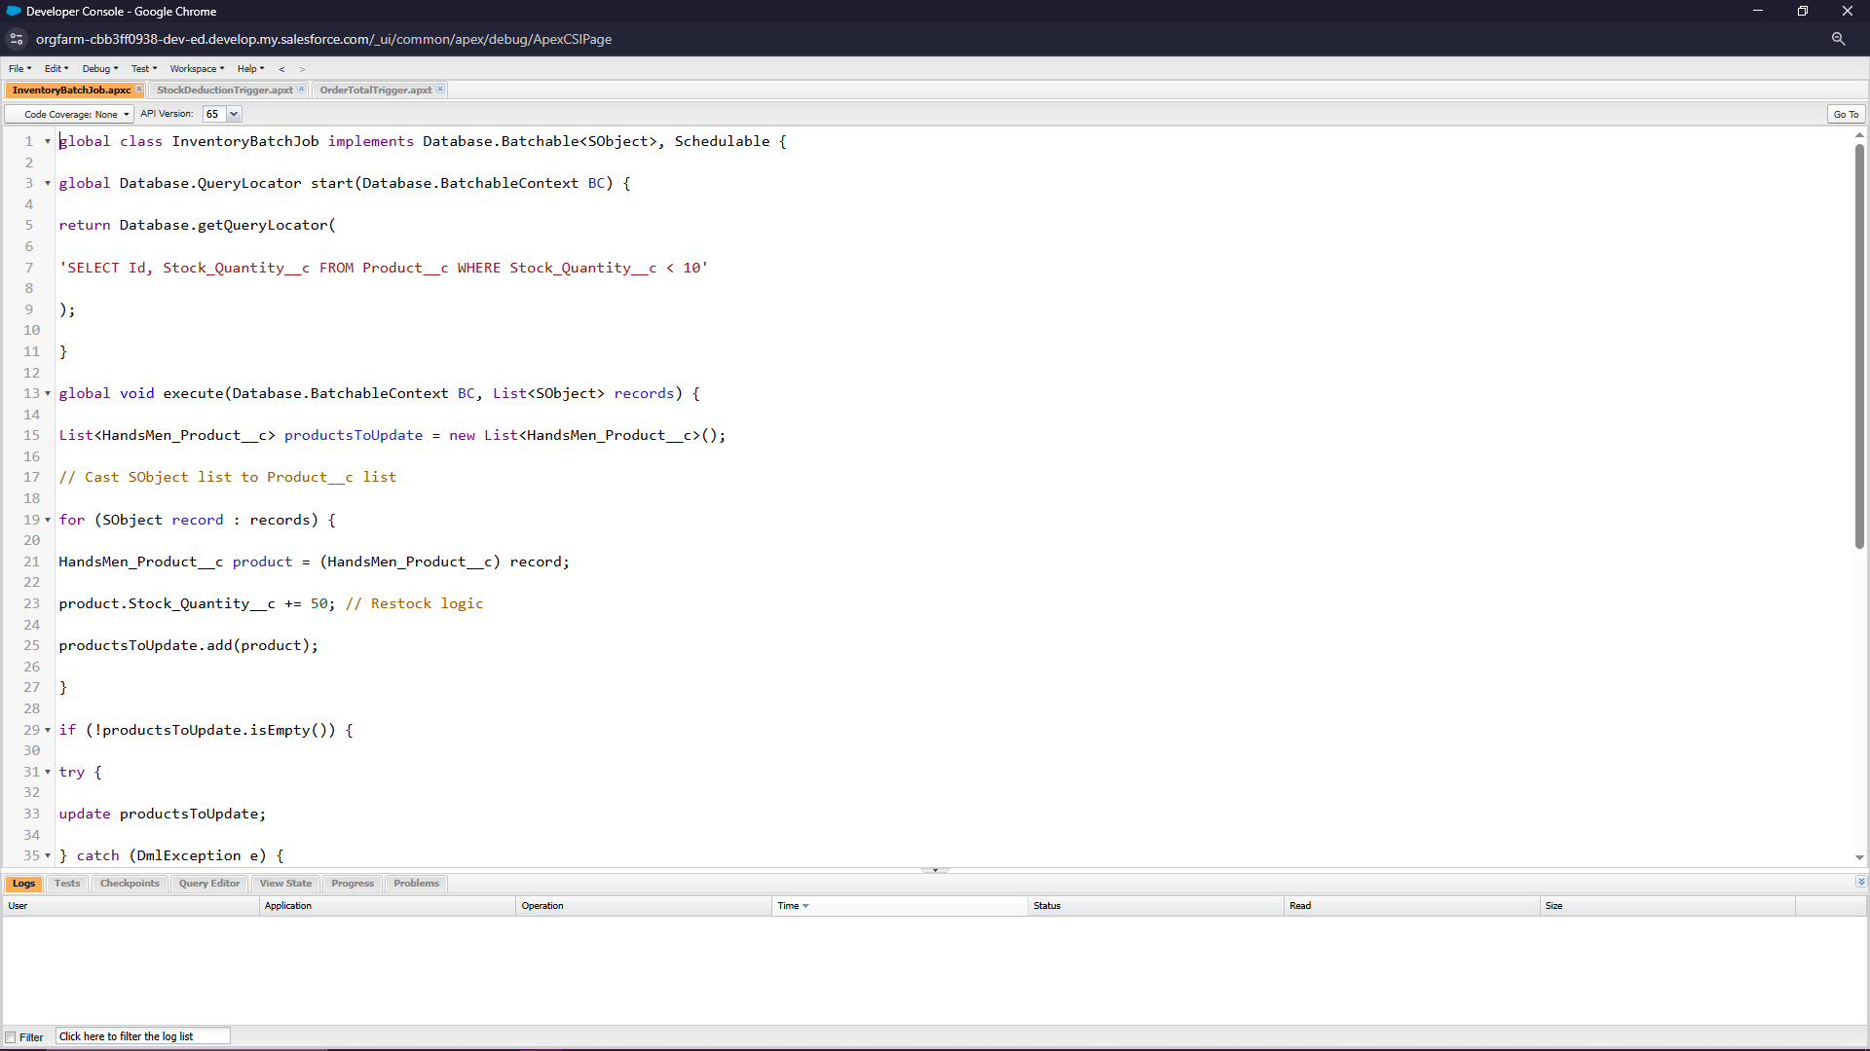
Figure 17. Batch Apex Job

Apex Test Classes
Dedicated test classes validate trigger behavior and guarantee >75% code coverage.

Phase 4: User Interface & Reporting

Lightning Pages
- Dynamic customer insights page
- Compact order management layout
- Inventory monitoring dashboard
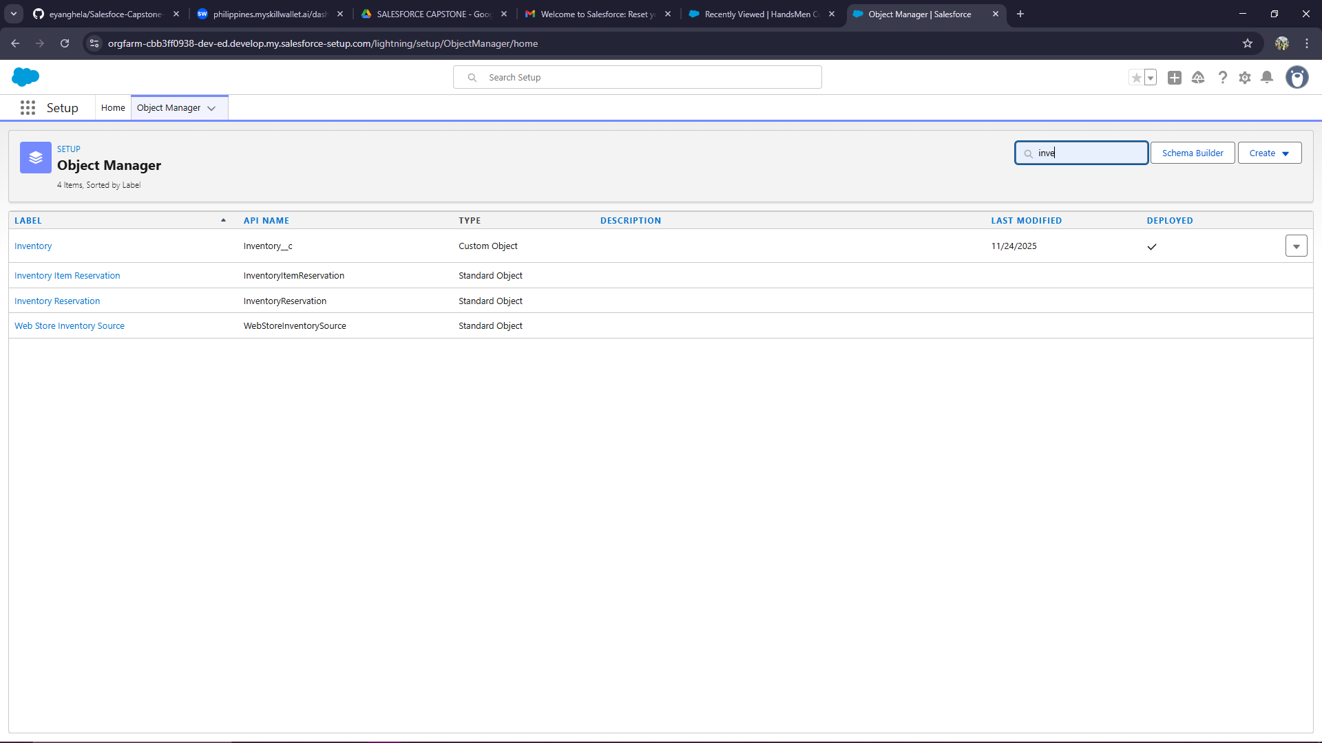
Figure 19. HandsMen Threads Lightning Pages

Reports & Dashboards
Generated insights include:
- Monthly sales
- Low stock report
- Loyalty tier distribution
- Customer purchase history

Conclusion
The Salesforce implementation for HandsMen Threads delivers a unified, automated, and scalable operational platform. Through structured data modeling, powerful automations, Apex-driven logic, and secure access control, the system significantly enhances efficiency, ensures data integrity, and elevates the overall customer experience.
The solution is fully aligned with Salesforce architecture standards, certification-level expectations, and industry best practices.

Future Enhancements
- LWC-based custom interfaces
- POS integration (real-time stock sync)
- Customer self-service portal
- AI-driven product recommendations (Einstein Next Best Action)
- Automated revenue and finance reconciliation

