CS308 README

CS308 – 2011 Project

Project: Patient Service System

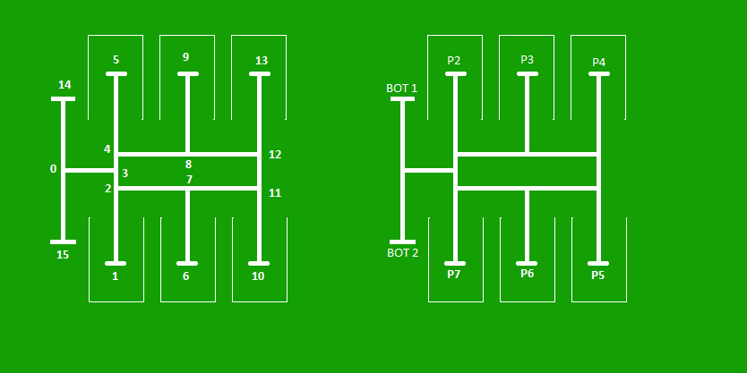
Project Title: Patient Service System

Students:
Name | Roll No. | Email
Pritish Kamath | 8005004 | pritishkamath@iitb.ac.in
Rohit Saraf | 8005040 | rohitsaraf@iitb.ac.in
Ashish Mathew | 8d10035 | ashishmathew@iitb.ac.in
Vivek Madan | 8005035 | vivekmadan@iitb.ac.in

Project Objective
The project aims at helping the patients and hostipal management by providing automated service bots, who can be called by the patient simply by using a cheap TV remote, and who provide a guarantee of no-deadlock/race conditions. The server uses a full fledged database (MySQL) to maintain the queue and manages the bot wisely using a perfectly scalable design. The bots are fair to all the patients. The bot notifies the guards if it is blocked by an SMS.
* For more details, see the code documentation.

Hardware Platform
- 2 x Firebird V ATMEGA2560
- Programmer, Linux(Ubuntu) system
- X-Bee and TSOP sensor in the bots
- TV Remote

Software
- avrdude
- avr-libc
- gcc-avr
- JDK
- MySQL
- All the software can be installed using ./install
It will install all the dependencies on an ubuntu system.

Code Description

Filename | Purpose | Executes on
Src/BOT_CODE/* | Code required for bot | Robots
Src/SERVER_CODE/* | Server code | PC
Install | Install dependencies and generate makefile to run the project | PC

Deliverables
Filename | Contains
cs308_group13.tar.gz | SourceCode of programs to be burnt on Robot as well as to be executed on PC.  Contains documentation of the code as well.  Install script (details below), Makefile

Execution Instructions (Ubuntu)
To execute the code for the first time, run the install script as
sudo ./install
(requires proxy settings)
This will install all the dependencies and drivers required for the project and generate a Makefile.
Note :
1.The properties file config/config.properties might require a change. (e.g. Zigbee COM port, Database settings)

Then to
compile the server code - make server
To run the server code - make run
To compile and program the serving bot no 1.
- make bot
To compile and program the serving bot no 1.
- make bot1
To compile and program the patient_IR handler bot - make patient
To clean - make clean
To open the documentation - make doc

Execution Instructions (Windows)
It will require changing the jar files and the makefile. We do not provide any configuration for windows system.
The code has been written and tested on Ubuntu 10.10 and 11.04.

