**Steps to obtain Azure Active Directory**

**Verifiable Credential Apprentice Credential**

1. Navigate to https:// website sent to you from [graye.holder.ctr@us.af.mil](mailto:graye.holder.ctr@us.af.mil). NOTE: The URL is specific for your registration and will end in .ngrok.io. For example, <https://3342-34-564-124-172.ngrok.io>
2. From a web browser, select Get CredentialGraphical user interface, text, application

   Description automatically generated
3. Click on Get Credential one more timeGraphical user interface, text, application

   Description automatically generated
4. Using your mobile device camera and scan the QR code with the Microsoft Authenticator App.

1. At this stage of development you’ll see a message warning that this app or website might be risky. Select Advanced.

1. At the risky website warning, select Proceed anyways (unsafe). You’re seeing the warning because the issuing domain isn’t linked to the Decentralized Identifier (DID). For this tutorial you can skip the verification and click on Proceed anyways (unsafe)

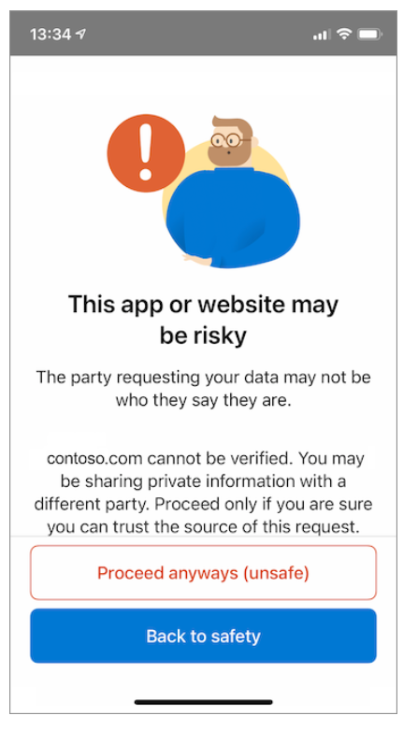

1. You’ll be prompted to enter a PIN code that is displayed in the screen where you scanned the QR Code. The PIN adds an extra layer of protection to the issuance. It is randomly generated every time an issuance QR code is displayed. Enter the QR Code

1. Select Add to accept your Verifiable Credential

1. Congratulations! You now have a Verifiable Credential Apprentice Credential
2. Explore the Tap on the Credential and familiarize your self with the “Verified info” (Claims) and “Activity” (Transactions) Tab
3. Feel free to go back and practice the issuance process and get another couple of credentials in your Microsoft Authenticator App (Digital Wallet)

Next, you’ll learn how to use the credential on a Verifier App to make the claim you’re an Apprentice and other associated claims in the credential and use the Issuer Decentralized Identifier (DID) to verify the issuer of the Credential.

[ION - an open, public, permissionless decentralized identifier network (identity.foundation)](https://identity.foundation/ion/explorer/)