Name: __Edward Yaroslavsky___________ Date: __10/14/19_________

Point values are assigned for each question. Points earned: ____ / 100

I pledge my honor that I have abided by the Stevens Honor System.

Consider the following graph:

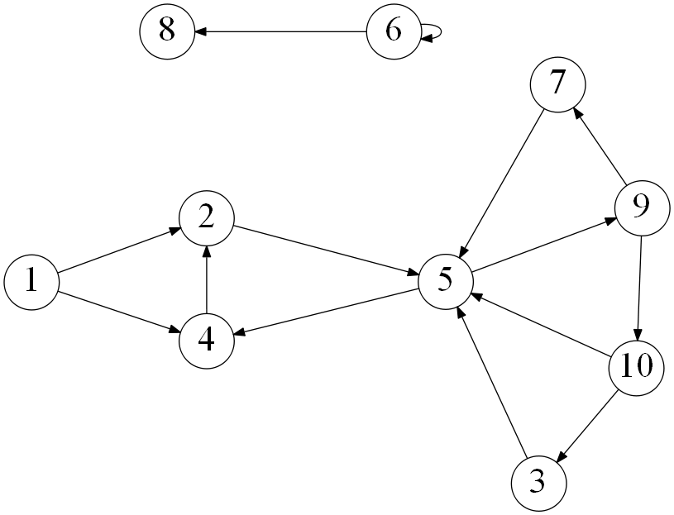

1. Draw how the graph would look if represented by an adjacency matrix. You may assume the indexes are from 1 through 10. Indicate 1 if there is an edge from vertex A -> vertex B, and 0 otherwise. (10 points)

|  |  |  |  |  |  |  |  |  |  |  |
| --- | --- | --- | --- | --- | --- | --- | --- | --- | --- | --- |
|  | **1** | **2** | **3** | **4** | **5** | **6** | **7** | **8** | **9** | **10** |
| **1** | 0 | 1 | 0 | 1 | 0 | 0 | 0 | 0 | 0 | 0 |
| **2** | 0 | 0 | 0 | 0 | 1 | 0 | 0 | 0 | 0 | 0 |
| **3** | 0 | 0 | 0 | 0 | 1 | 0 | 0 | 0 | 0 | 0 |
| **4** | 0 | 1 | 0 | 0 | 0 | 0 | 0 | 0 | 0 | 0 |
| **5** | 0 | 0 | 0 | 1 | 0 | 0 | 0 | 0 | 1 | 0 |
| **6** | 0 | 0 | 0 | 0 | 0 | 1 | 0 | 1 | 0 | 0 |
| **7** | 0 | 0 | 0 | 0 | 1 | 0 | 0 | 0 | 0 | 0 |
| **8** | 0 | 0 | 0 | 0 | 0 | 0 | 0 | 0 | 0 | 0 |
| **9** | 0 | 0 | 0 | 0 | 0 | 0 | 1 | 0 | 0 | 1 |
| **10** | 0 | 0 | 1 | 0 | 1 | 0 | 0 | 0 | 0 | 0 |

1. Draw how the graph would look if represented by an adjacency list. You may assume the indexes are from 1 through 10. (10 points)

1 -> [2,4]

2 -> [5]

3 -> [5]

4 -> [2]

5 -> [4,9]

6 -> [6,8]

7 -> [5]

8 -> [ ]

9 -> [7,10]

10 -> [3,5]

1. List the order in which the vertices are visited with a breadth-first search. If there are multiple vertices adjacent to a given vertex, visit the adjacent vertex with the lowest value first. (10 points)

1,2,4,5,9,7,10,3,6,8

1. List the order in which the vertices are visited with a depth-first search. If there are multiple vertices adjacent to a given vertex, visit the adjacent vertex with the lowest value first. (10 points)

1,2,5,4,9,7,10,3,6,8

1. a) What is the running time of breadth-first search with an adjacency matrix? (5 points)

θ(V2)

b) What is the running time of breadth-first search with an adjacency list? (5 points)

θ(|V| + |E|)

1. a) What is the running time of depth-first search with an adjacency matrix? (5 points)

θ(V2)

b) What is the running time of depth-first search with an adjacency list? (5 points)

θ(|V| + |E|)

1. While an adjacency matrix is typically easier to code than an adjacency list, it is not always a better solution. Explain when an adjacency list is a clear winner in the efficiency of your algorithm? (5 points)

In the case with a large number of vertices being directed towards a minimal number of other vertices, resulting in minimal edges, the adjacency list is a clear winner in efficiency. This is because while an adjacency matrix takes much longer to run since it has to store V2 elements, with V being the number of vertices, an adjacency list would be much more efficient since it only stores the vertices which a given edge is directed to. That way, the run time of an adjacency matrix in this case would resemble θ(n2) due to it having to consider all the possible combinations of vertices whereas the run time of an adjacency list would resemble θ(n).

1. Explain how one can use a breadth-first to determine if an undirected graph contains a cycle. (10 points)

One can use a BFS to determine if an undirected graph contains a cycle by going through the adjacent vertices of a current vertex. Then, by adding each adjacent vertex to a queue, we know what adjacent vertex we should make our new current vertex, repeating this pattern and adding to the queue. However, if a current vertex adds an adjacent vertex that has already been in the queue, then we know that the undirected graph has a cycle.

1. On undirected graphs, does either of the two traversals, DFS or BFS, always find a cycle faster than the other? If yes, indicate which of them is better and explain why it is the case; if not, draw two graphs supporting your answer and explain the graphs. (10 points)

On undirected graphs, DFS and BFS do not always find a cycle faster than the other. In an undirected graph such as:

a DFS approach would be more efficient, while in an undirected graph such as:

a BFS approach would be more efficient.

1. Explain why a topological sort is not possible on the graph at the very top of this document. (5 points)

A topological sort is not possible on the graph at the top because the graph at the top is a directed graph with cycles. This would make the graph a Directed Acyclic Graph (DAG), where a topological sort is not possible on those types of graphs.

Consider the following graph:

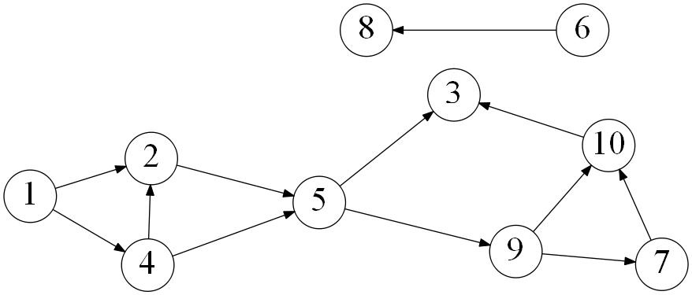

1. List the order in which the vertices are visited with a topological sort. Break ties by visiting the vertex with the lowest value first. (10 points)

1,4,2,5,6,8,9,7,10,3