Name: Edward Yaroslavsky

Date: 11/20/19

I pledge my honor that I have abided by the Stevens Honor System.

Point values are assigned for each question. Points earned: / 74, %

1. Show how the red‐black tree would look after inserting a node with the key 0043. Use the document on Moodle that explains the insertion process succinctly. List the case you applied (i.e. 1,

2a, 3b), and write the steps you took to fix the tree (also listed in the document).

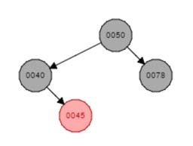

a) Draw the tree after a regular binary search tree insertion. (3 points)

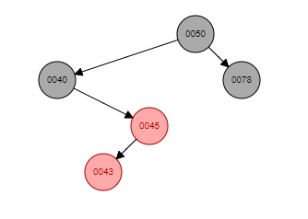

b) Which property is violated? (3 points) If a node is red, then both its children are black. This is not the case for node 0045.

Case seen after regular binary search tree insertion: (3 points) 2b

Steps taken to fix the tree: (3 points)

Set node 0043 to be the parent of 0043 and then perform a right-rotate on node 0043.

Draw the tree after taking the steps you just described. (3 points)

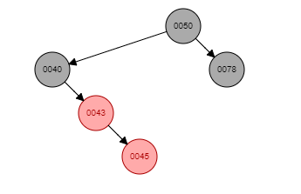

c) Which property is violated now? (3 points) If a node is red, then both its children are black. This is not the case for 0043.

Case seen after first fixup: (3 points) 2a

Steps taken to fix the tree: (3 points) Set node 0043 to be the parent of 0043 and then perform a left-rotate on node 0043.

Draw the tree after taking the steps you just described. (3 points)

2. Draw the 2‐3 tree after inserting each of the following keys. Redraw the tree for each part. a) 50 (1 point)

b) 76 (1 point)

c) 23 (3 points) d) 21 (3 points) e) 20 (3 points) f) 19 (3 points)

g) 18 (3 points)

3. Read pages 241‐242 in the textbook. Using that information, write pseudocode for computing the

LCM of an array A[1..n] of integers. You may assume there is a working gcd() function. (6 points)

**ALGORITHM** *LCM*(A[1..n]):

// Computes the least common multiple of all the integer in array A

4. Horner’s method:

𝑝(x) = 4x4 + 5x3 – 2x2 – 4x + 7

a. Repeatedly factor out x in the following polynomial so that you can apply Horner’s method.

Write your expression for 𝑝(𝑥). (5 points)

b. Show values of the array P[0..n] as needed to apply Horner’s method. (3 points)

c. Apply Horner’s method to evaluate the polynomial at x = 2. Make a table as we did in class showing the values 𝑥, 𝑝, 𝑛, and 𝑖, and then state your final answer for 𝑝(2). (5 points)

**x p n i**

𝑝(2) =

d. Use **synthetic** (not long) **division** to divide 𝑝(𝑥) by x - 2 to check your work. Be sure to show your work. (5 points)

5. Rewrite the *LeftRightBinaryExponentiation* algorithm on page 237 in the textbook to work for n = 0 as well as any positive integer. *No credit will be given for answers that simply start with an if statement for n = 0.* (6 points)

**ALGORITHM** *LeftRightBinaryExponentiation*(a, b(n)):

// Computes an