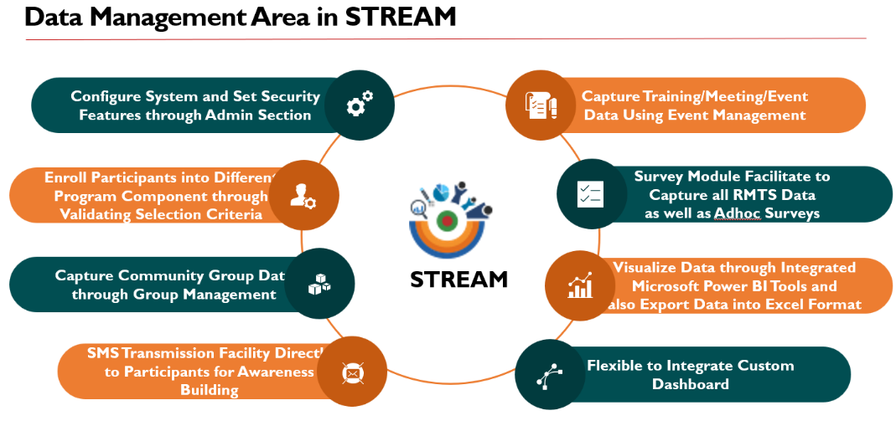

Guideline

on

System for Tracking Result and Evidence for Adaptive Management (STREAM)



# System for Tracking Result and Evidence for Adaptive Management (STREAM)

The System for Tracking Results and Evidence for Adaptive Management (STREAM) is an online-based routine monitoring data collection system utilized by SHOUHARDO III Plus. The purpose of STREAM is to collect data from remote locations and provide data visualization for management decision-making purposes. STREAM consists of two distinct modalities, namely Android Apps and a Web Application. The Android Apps mode will be utilized for offline data collection from remote locations, which will then be synchronized to a central server through the GSM network. On the other hand, the Web Application mode will be utilized for data extraction, visualization, and reporting purposes.

# ANNEX A: STREAM RMTS Update Guideline

|  |  |
| --- | --- |
|  | Click Survey Option from the STREAM features |
|  | * Click on Search Box ( ) to find expected survey form. * Click on individual survey form ( ) for starting specific survey. * Click on Navigation Menu () for see other survey options. |
|  | * Select Operational Period * Click Next ( ) button for select catchment area. * Click Back () button for go back to the survey form list. |
|  | * Select your desired catchment area. * Click Next ( ) button for Form Details. * Click Back () button for go back to the selecting Operational Period. |
|  | * Update all survey information. * Click Save () button for saving the information. * Select Cancel () button for go back to catchment area |

# ANNEX B: Signing Sheet Update Guideline

|  |  |
| --- | --- |
|  | Click SHOUHARDO III Plus Custom Option from the STREAM web application |
|  | Click on Signing Sheet option to update the signing sheet and it will brought to the summary list of the training completed. |
|  | |

|  |  |
| --- | --- |
| **Overview of Different Buttons** | |
|  | This button will allow user to download all signing sheet summary list which has been completed. |
|  | This button will allow user to download all members list who has been taken training in different event over the period. |
|  | To add a new sigining sheet information, user needs to follow this link. |
|  | To viw the specific event details, user should follow this link and it will provide the member list who has been attended to that specific event along with signed source document (ref. below Fig. Record view of existing event). |
|  | To edit specific event information, user should use this edit button which will allow users to update information for that specific selected event. Please note that if seleted event is verified, user will not have this option available. Means, before verified, user will bbe able to edit annd update information. |
|  | To delete any specific event records, user should use this option. Please note that if seleted event is verified, user will not have this option available. Means, before verified, user will be able to delete the records. |
|  | Once record is updated into the system, speccific user (e.g. M&E) will verify the records and they should use this option to update verification status. |
| **Fig. Record view of existing event** | |

|  |
| --- |
| **New Signing Sheet Update** |
|  |
| This is the first step of the signing sheet update process. Users will have to specific catchment area, event start and end date, training title as well venue. Also, it is required to select the specific types of participants to whom this training is conducted. Also, the user will have to provide the budget and expenditure information for that specific training.  It must be noted here that it is mandatory to upload the signing sheet for that specific event. Without having this document, system will not allow user to select the training participants. After providing all information, the user should click on “Generate List” which will provide all eligible list of participants to select for that specific event. |
|  |
| After having all eligible list, user will follow the source document to select the participants who has been attended during the training event. After selecting the participants, user should click on the button “Add Selected members” and it will add selected members as training participants for that specific training event during the mentioned period. |
|  |
| Once participants is selected, the user will be able to remove the participants from the list using the delete icon under the action part. Date of attendance will provide the facility, if there is a participant attending on a particular day and absent in specific day. User will be able to make that adjustment under this section. |

# ANNEX C: VSLA Group Update Guideline

|  |  |
| --- | --- |
|  | Click SHOUHARDO III Plus Custom Option from the STREAM web application |
|  | Click on VSLA Group Formation option to update the group information and it will brought to the summary list of the group formed. |
|  | |

|  |  |
| --- | --- |
| **Overview of Different Buttons** | |
|  | This button will allow user to download all group summary list which has been formed under the specific catchment. |
|  | This button will allow user to download all members list for the specfic selected catchment who has been enrolled as a group member to the specific group. |
|  | This button will allow user to generate the group list which has been created under the specific selected catchment. |
|  | To add a new group information, user needs to follow this link. |
|  | To viw the specific group details, user should follow this link and it will provide the member list who has been added to that specific group. |
|  | To edit specific group information, user should use this edit button which will allow users to update information for that specific selected group. Please note that if seleted group is verified, user will not have this option available. Means, before verified, user will be able to edit and update group information. |
|  | To delete any specific group records, user should use this option. Please note that if seleted group is verified, user will not have this option available. Means, before verified, user will be able to delete the group records. |
|  | Once record is updated into the system, speccific user (e.g. M&E) will verify the group records and they should use this option to update verification status. |

|  |  |
| --- | --- |
| **New VSLA Group Update** | |
|  | |
| This is the first step of group update process. Users will have to select a specific catchment area, Group Type and Formation Date and need to provide the Group Name. After providing all information, the user should click on “Generate List” which will provide all eligible list of participants to select for that specific group. | |
|  | |
| After having all eligible list, user will have to select the participants who has been enrolled to that specific group. After selecting the participants, user should click on the button “Add members” and it will add selected members as group members for that specific group. | |
|  | |
| Once participants are selected, the user will be able to remove the participants from the list using delete icon under the action part. By default, all group members will be added with “Member” designation and user needs to update the other designation using the button under the action column and icon specification is given below - | |
|  | Delete the specific member from the group |
|  | Change designation to “Chairperson” |
|  | Change designation to “Record Keeper” |
|  | Change designation to “Book Keeper” |
|  | Change designation to “Cash Counter” |
|  | Change designation to “Member” |