

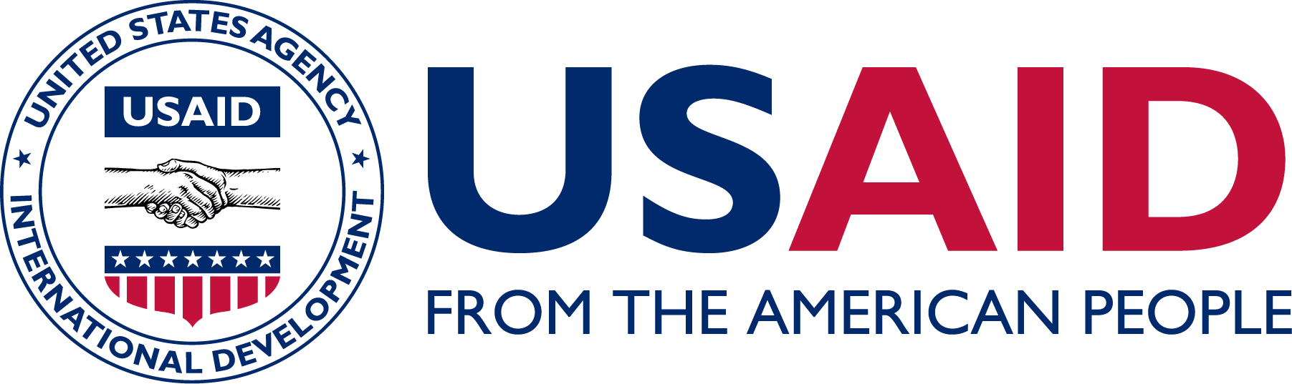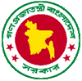

**Program Performance Report**

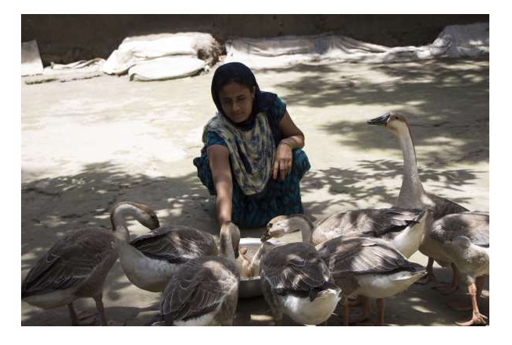

**Table of Contents**

**1 EXECUTIVE SUMMARY AND INTRODUCTION** 1

1.1 SHOUHARDO III Program Theory of Change (TOC) 3

1.2 Program Location and Beneficiary Coverage 4

**2 RESULTS AREA LEVEL PROGRES**S 5

2.1 Purpose 1: Increased equitable access to income for both women and men, and nutritious food for men, women, boys, and girls 5

2.2 Purpose 2: Improved nutritional status of children under five years of age, pregnant and lactating women, and adolescent girls. 10

2.3 Purpose 3: Strengthened gender equitable ability of people, households, communities and systems to mitigate, adapt to and recover from man-made and natural shocks. 14

Purpose 4: Increased Women’s Empowerment and Gender Equity 16

2.4 Women Empowerment 16

2.5 Purpose 5: Provision and utilization of public services (Local Elected Bodies & Nation Building Departments) for communities (especially for PEP women) increased. 19

**3** **MONITORING AND EVALUATION; KNOWLEDGE MANAGEMENT, Research AND LEARNING HIGHLIGHTS** 21

3.1 Monitoring and Evaluation 21

3.2 Knowledge Management, Research and Learning 24

3.3 Advocacy 27

**4** **SUSTAINABILITY OF PROGRAM OUTCOMES: AVAILABILITY, QUALITY, AND SATISFACTION ON SERVICE PROVISIONING** 27

4.1 Reflection on Sustainability approaches 30

4.2 Sustain service provision and outcomes 30

**5** **CHALLENGES, SUCCESSES, AND LESSONS LEARNED** 31

5.1 COVID-19 Effects on Activities 31

5.2 Effects of Changing Food, Fuel, and/or Fertilizer Costs 31

5.3 Other Significant Threats to Food Security 31

6 **CONCLUSIONS AND KEY REFLECTIONS** 34

**Acronyms**

|  |  |
| --- | --- |
| BHA | Bureau for Humanitarian Assistance |
| BMD | Bangladesh Meteorological Department |
| BSP | Blue Star Provider |
| CC | Community Clinic |
| CLF | Community Level Facilitator |
| COG | Core Occupational Group |
| COVID-19 | Coronavirus Disease 2019 |
| CRA | Community Risk Assessment |
| CSC | Community Score Card |
| DHRC-LRA | Deep Haor and Remote Char Livelihoods Recovery Assistance |
| DIP | Detailed Implementation Plan |
| DMC | Disaster Management Committee |
| DRR | Disaster Risk Reduction |
| EKATA | Empowerment Knowledge And Transformative Action |
| FFWC | Flood Forecasting and Warning Systems |
| FGD | Focus Group Discussion |
| FFBS | Farmer Field Business Schools |
| FLAIRb | Fostering Learning Adaptation in Resilience Building |
| FY | Fiscal Year |
| GBV | Gender-Based Violence |
| GCAT | Group Capacity Assessment |
| GMP | Growth Monitoring and Promotion |
| GoB | Government of Bangladesh |
| iDE | International Development Enterprises |
| IPTT | Indicator Performance Tracking Table |
| IGA | Income Generating Activity |
| KII | Key Informant Interview |
| KMRL | Knowledge Management, Research, and Learning |
| LOA | Life Of Award |
| LP | Latrine Producer |
| LSP | Local Service Provider |
| MCHN | Maternal and Child Health and Nutrition |
| MoH & FW | Ministry of Health and Family Welfare |
| MTE | Mid-Term Evaluation |
| M&E | Monitoring and Evaluation |
| MPPL | Master Program Participant List |
| NBD | Nation-Building Department |
| ODF | Open Defecation Free |
| PaBS | Participants Based Survey |
| PACC | Program Advisory and Coordination Committee |
| PCSBA | Private Community Skilled Birth Attendant |
| PEP | Poor and Extreme Poor |
| PNGO | Partner Non-Government Organizations |
| PRO-WASH | Practices, Research, and Operations in Water, Sanitation, and Hygiene |
| RFSA | Resilience Food Security Activity |
| RMS | Recurrent Monitoring Survey |
| SBCC | Social and Behavior Change Communications |
| SHOUHARDO | Strengthening Household Ability to Respond to Development Opportunities |
| SWIRL | Scaling-up WASH Innovations in Remote Locations |
| TOC | Theory of Change |
| UDMC | Union Disaster Management Committee |
| UDV | Union Disaster Volunteers |
| USG | United State Government |
| UP | Union Parishad |
| USAID | United States Agency for International Development |
| UzDMC | Upazila Disaster Management Committee |
| VDC | Village Development Committee |
| VSLA | Village Savings and Loan Association |
| WASH | Water, Sanitation, and Hygiene |
| WDDS | Women’s Dietary Diversity Score |

# EXECUTIVE SUMMARY AND INTRODUCTION

Strengthening Household Ability to Respond to Development Opportunities (SHOUHARDO) III is a Resilience Food Security Activity (RFSA) funded by the United States Government through the United States Agency for International Development/Bureau of Humanitarian Assistance (USAID/BHA), with complementary funding from the Government of Bangladesh (GoB).

The key program aims are to achieve improved gender equitable food and nutrition security and resilience for 16,8521 Poor and Extreme Poor (PEP) households living in eight districts of Northern Char and Haor regions of Bangladesh. Six Partner Non-Government Organizations (PNGOs) implement the program on the ground. This Final Performance Report covers the interventions and results for the period of 29 September 29, 2015 through December 31, 2022.

The last two program years (FY21 and FY22) were structured as SHOUHARDO III’s Extension period. During this phase, the program focused on two core areas: (1) establishing closer linkages between Local Service Providers (LSPs) and both public and private service providers, and (2) mobilizing communities to engage with LSPs to ensure long-term, community-oriented, sustained benefits.

The program acknowledged the critical importance of prioritizing LSPs’ maturity during the final stage of the program. The program facilitated linkages between the LSPs and both public and private sector actors. It also strengthened the capacity of LSPs by including support to ensure that LSPs receive service fees for their services, therefore addressing one of the major challenges they face. During the close-out stage, the program team focused on the completion of its remaining community-based activities and initiated operational close-out activities. The program successfully completed its interventions, including those that were delayed due to challenges resulting from COVID-19.

As a part of the close-out process, agreements with the Implementing Partner NGOs ended on August 31, 2022. Prior to this, the partnership with International Development Enterprises (iDE) closed on March 31, 2022. This partnership was for the implementation of the Scaling-up WASH Innovations in Remote Locations (SWIRL) Project, along with Water, Sanitation, and Hygiene (WASH) interventions.

Additionally, SHOUHARDO III facilitated exit meetings at both the community and union levels in the last quarter of FY22. These meetings focused on exploring government departments' roles in sustaining program outcomes and maintaining service models for the PEPs as a part of CARE’s close-out activities.

At the end of the program, COVID-19 infection rates remained low. Additionally, a total of 76 percent and 71 percent of the program population received single and double doses of the COVID-19 vaccine, respectively.

Despite an improved status of COVID-19 infection rates, the region continues to be under pressure from the rise in global commodity prices, which drove the country's inflation rate up to 6.33 percent in July 2022, as compared to 5.54 percent in July 2021[1]. Analysis of the program’s last annual Participants Based Survey [(PaBS FY22)](https://shouhardo.carebangladesh.org/wp-content/uploads/2022/10/BENEFICIARY-BASED-SURVEY-BBS-2022-4.pdf) indicated that most households were facing price hikes on essential commodities – another issue of strength and resilience.

**Table 1:** Highlights of program achievements (LOA)

|  |  |  |  |
| --- | --- | --- | --- |
| Indicator | Target | Achievement | % Achieved |
| Percentage of producers who used improved inputs during the past 12 months | 95.0% | 95.8% | 100.8% |
| Percentage of beneficiary households with increased food production | 65.0% | 62.5% | 96.2% |
| Percentage of people who received service from United States Government (USG) supported LSPs | 80.0% | 97.1% | 121.4% |
| Percentage of farmers who reported receiving market information in last 12 months | 70.0% | 73.5% | 105.0% |
| Percentage of pregnant women who received pregnancy care support (day-time rest, extra food) during pregnancy period | 60.0% | 84.1% | 140.2% |
| Percentage of households using health and nutrition services in past 12 months | 70.0% | 71.7% | 102.4% |
| Percent of households with soap and water at a handwashing station on premises | 65.0% | 87.1% | 134.0% |
| Percentage of households reporting receiving risk and early warning information | 95.0% | 100.0% | 105.3% |
| Average Coping Strategy Index of the targeted households[2] | 75.0% | 50.7% | 148.0% |
| Women’s Dietary Diversity Score (WDDS) | 6.5% | 7.4% | 113.1% |
| Percentage of program participants aware of cost and consequences of gender-based violence (GBV) | 70.0% | 98.0% | 140.0% |
| Percentage of participants who reported increased access to targeted public services | 85.0% | 94.9% | 111.6% |
| Percentage of respondents who are satisfied with overall services provided by local government (UP) | 65% | 77.7% | 119.5% |

## SHOUHARDO III Program’s Theory of Change (TOC)

SHOUHARDO III’s TOC incorporates the results of both program monitoring and formal studies that were captured in the Monitoring and Evaluation (M&E) plan. This includes the Annual PaBS, the Fostering Learning Adaptation in Resilience Building (FLAIRb) longitudinal survey, Group Capacity Assessment (GCAT), Management Score Sheet, and progress of the Detailed Implementation Plan (DIP).

CARE has a robust TOC, as seen in the diagram below. They have 174 result statements (such as the output and outcome statements) that were reviewed and organized into three categories - “strong”, “moderate”, and “behind” - based on the progress and performance of Life of Award (LOA) targets[3]. This categorization intends to initiate a programmatic discussion among the result areas and technical sector levels for necessary improvements in program implementation. The process was done to simplify monitoring data and facilitate learning and adaptive management across the program. Several Indicator Performance Tracking Table (IPTT) indicators were placed in the performance monitoring system to monitor the performance of each outcome in the TOC.

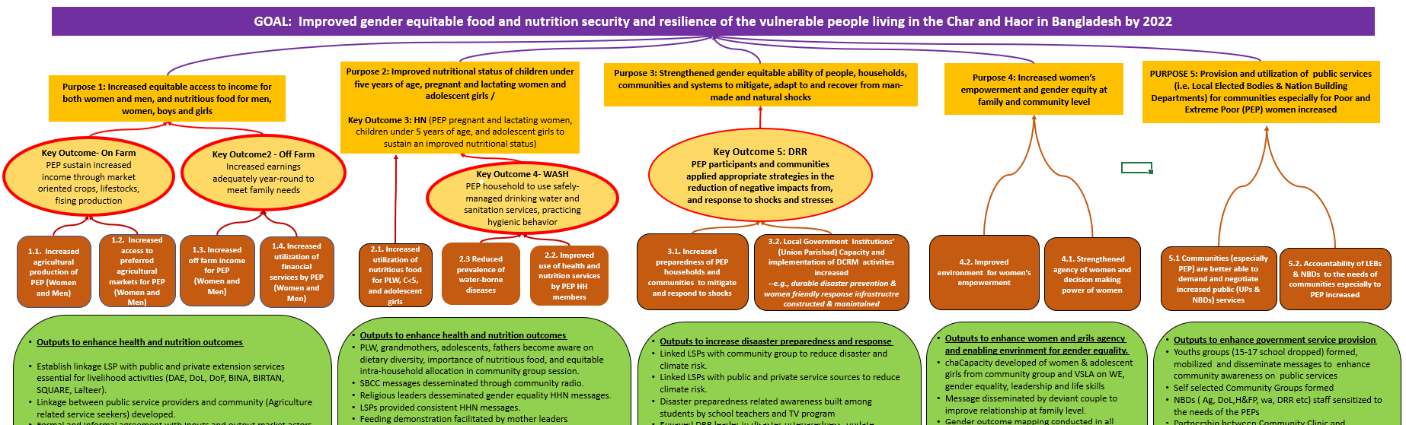

**Figure 1:** SHOUHARDO III Theory of Change

The program collected data through a survey and routine monitoring system. According to the FY22 achievement, 83.0 percent of program outputs and outcomes fell under the strong category (85.0 percent and above); nine percent of outputs and outcomes were in the moderate category (70.0 percent – 84 percent); and eight percent of outputs and outcomes were in the behind category (below 70.0 percent).

The high performance at the outcome level in each of the program’s result areas indicates that activities contribute to reaching the expected outcomes, which strongly supports the causal relationships postulated in the SHOUHARDO III TOC.

## Program Location and Beneficiary Coverage

**Table-2** summary of the program’s beneficiary coverage

|  |  |
| --- | --- |
| Total Number of Districts | 8 |
| Total Number of Upazilas | 23 |
| Total Number of Unions | 115 |
| Total Number of Villages | 947 |
| Total Number of PEP households reached | 168,599 |
| Total Number of participants reached | 485,533 |

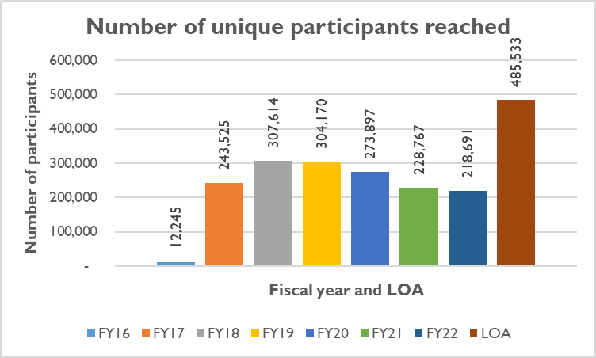

**Figure 2:** Number of Unique participants reached by fiscal year and LOA

Figure 2 shows the number of participants reached by the program in each year from 2016 to 2022, alongside the program's Life of Award (LOA). In 2016, the program began its implementation and gradually expanded its range of activities, resulting in an increase in the number of individuals reached over time. Throughout the entire period from 2016 to 2022, the program successfully reached a total of 485,533 unique individuals.

# RESULTS AREA LEVEL PROGRESS

## Purpose 1: Increased equitable access to income for both women and men, and nutritious food for men, women, boys, and girls

### On-farm livelihoods

Purpose 1 was designed to build the capacities of targeted households to expand their agricultural production, increase income to enhance purchasing capacity and accessibility to markets, and enable households to produce nutritious food. The program adopted a multi-prong approach throughout the program period to support these goals.

SHOUHARDO facilitated Farmer Field and Business Schools (FFBS) throughout program areas in order to build capacity. After training, participants were supported with a cash grant – BDT 3,000 (about US $28) for Poor and BDT 4,500 (about US $42) for Extreme Poor – to run their ventures. Sessions were facilitated by a range of actors, including Community Agriculture Volunteers, LSPs, and individuals representing both the public and private sectors. The goal of these sessions was to develop the capacities of targeted households to expand their agricultural production and enhance their purchasing capacity by diversifying their income sources and accessibility to markets, thereby enabling them to procure nutritious foods managed by CARE and implementing partners.

SHOUHARDO III program participants were also supported to enhance production and income by a range of technical (e.g., WorldFish Center) and collaborative partners from both the public (e.g., Department of Agriculture Extension (DAE), Department of Livestock Services (DLS), Department of Fisheries (DoF), Bangladesh Agriculture University (BAU), Bangladesh Institute of Nuclear Agriculture (BINA)) and private sectors (e.g., LalTeer Seeds, BRAC Seeds, Advanced Chemical Industries (ACI) Animal Health, Bengal Meat, eKshop).

Additionally, the program facilitated linkages between participants and relevant government offices, private sector service providers (including LSPs), and market actors to increase community access to services. This included training and obtaining quality inputs (e.g., seed, feed, vaccines) for production, which improved overall food and nutrition security, and resilience against shocks for target communities.

#### Sub-Purpose 1.1: Increased agricultural production of PEP

Participating households reported increased production consistently. This was supported by several agricultural practices which the participants mostly adopted after receiving training, input, and market linkage support from the program. According to the FY22 PaBS, 62.5 percent (392 of 660) of respondents stated they had increased food production due to the adoption of improved varieties and management practices. With continued application of improved agricultural practices - including quality inputs that yielded quality produce participants reported a significant increase in production. As per the FY22 PaBS survey, 95.8 percent of respondents reported using improved inputs in their agricultural ventures, indicating a positive community benefit from SHOUHARDO III’s training.

|  |  |  |
| --- | --- | --- |
| C:\Users\ACW\Desktop\Q1 Selected Picture\P1\Runa WBA# 0002 is Working her vegetable field village Dattopara Union Uttar Purbo Baniachong Upazila Baniachong District Habigonj photo cradit by Majharul Islam Sardar FT-AL&R Dated 24-11-2020.jpg  Photo: CARE/September2021 | |  | | --- | | Runa Begum, 33, from Baniachong Upazila of Hobiganj District, expressed her happiness as she harvested crops plentifully this year due to using good seed and adopted improved management practices in her tomato field. As a member of the SHOUHARDO III program through the Community Groups, Runa learned the use of quality seed and modern agricultural practices for tomato crops (like pruning) and applied these principles accordingly. She earned BDT 58,000 (about US $546) against an investment of BDT 6,800 (about US $6) in her 37-decimal tomato field. She said, *“It was possible by receiving proper training and communicating with agriculture service providers, including use of quality seed. I will continue this practice in coming years.”* | |

This increase in profit margin indicates that participants had extra money they could set aside for additional investment in diversified livelihoods and savings. The program promoted the adoption of diversified income sources to minimize adverse effects when one income source, or a single crop, was affected by a shock on the demand or supply side, thus building resilience. This allows participants to have a higher adaptive capacity in agricultural practices. Baseline PaBS and FLAIRb studies reported the average number of income sources of sampled households as being 2.30, which then rose to 2.74 income sources after the intervention.

In addition to this, the program facilitated the development of necessary life skills of PEPs via FFBS sessions and then by conducting face-to-face sessions. The sessions included topics such as communication, negotiation, decision making, problem solving, addressing gender-based violence (GBV) challenges, leadership, group management, business planning, financial planning and literacy to build their confidence. This enabled participants to establish demand based on their own needs for specific services (input and training) from providers.

To reach SHOUHARDO III’s targeted households with agriculture and livelihoods interventions, the program disaggregated its total 168,521 targeted households into four core occupational groups (COGs): Comprehensive Homestead Development (CHD), Field Crops, Fisheries, and Income Generation Activity (IGA) at the beginning of the program.

The CHD participants were selected based on suitability to use their homesteads for vegetables, fruit trees, poultry rearing, as well as participants’ interest and capabilities, and available market opportunities. Similarly, other COGs participants were selected based on their suitability to be engaged with appropriate market opportunities that could be implemented in a profitable manner. The COG members were then trained through FFBS, with the exception of non-farm IGA participants, who received training in FY16, FY17, and FY18 based on their chosen trades. Apart from training, PEP COG participants were provided cash support as start-up capital of BDT 3,000 (about US $28) and BDT 4,500 (about US $42), respectively.to extreme poor and poor.

**Table 3:** Core Occupational Group (COG) member received support from the program

|  |  |  |  |
| --- | --- | --- | --- |
| **Key Interventions** | **Female** | **Male** | **Total** |
| **Agriculture** | 7,091 | 22,821 | 29,912 |
| **Comprehensive Homestead Development** | 29,426 | 3,018 | 32,444 |
| **Fisheries** | **515** | **8,763** | **9,278** |
| Fish Capture | 349 | 8,194 | 8,543 |
| Fish Culture | 166 | 569 | 735 |
| **Income Generating Activities** | **71,603** | **21,528** | **93,131** |
| IGA off-farm | 8,403 | 7,205 | 15,608 |
| IGA on-farm | 63,200 | 14,323 | 77,523 |
| **Total COG Members** | **108,635** | **56,130** | **64,765** |

The program categorized whole households into four occupational groups in order to provide required training and input support to the poor and extremely poor.

During the final phase of the program, many program participants reportedly used lifesavings apps[4] such as Fosholi, Krishoker Janala, Livestock Diary, Daktar Bhai, and Maya Apa on their android phones. These apps offer a wide range of information, including agricultural and weather advisories, how to protect livestock from diseases with advanced farming technology, and health-related information.

#### Sub-Purpose 1.2: Increased access to agricultural markets for PEP Non-farm livelihoods

SHOUHARDO III facilitated diversified and sustainable livelihoods for male, female, adolescent, and youth participants from PEP households. The program worked with communities to identify viable income sources that would yield a high return on investment. The program improved financial inclusion for the communities by increasing access to non-farm LSPs, such as Sanchay Sathis. Sanchay Sathis are village agents who provide their services to form and manage Village Savings and Loan Association (VSLA) groups for a service charge. SHOUHARDO III trained Sanchay Sathis to form and manage the VSLAs for BDT 500 to BDT 2,000 (about US $5-$19).

VSLAs remain the key intervention for providing pro-poor financial services to the doorsteps of PEPs living in the Char and Haorregions. The program adopted the Sanchay Sathi-led VSLA formation model in 2019, thereby enhancing VSLA formation, maintenance, and share-out process. Over 3,000 VSLA groups were formed by program beneficiaries, and by the end of 2022, a total of 1,940 were still in operation.

Due to the COVID-19 pandemic and recurrent flooding many VSLA groups conducted early share out processes. Due to a lack of income, they could not accumulate enough savings for the VSLAs, and therefore many groups were disbanded. Of the 1,940 that were still in operation at the end of 2022, 777 were new VSLA groups formed by the Sanchay Sathis and the rest were a continuation of those formed in the previous year, including 29 adolescent female groups and 21 male groups. Apart from working as the saving agents, the Sanchay Sathis also sold seeds, hygiene products, livestock vaccines, and VSLA Kits to generate additional income in their communities. At present, 438 Sanchay Sathis are actively working in the SHOUHARDO III program area.

Members of the VSLAs found it challenging to calculate their share earnings, especially during the share-out process, due to low literacy rates. To address this, SHOHARDO III introduced a digital application for VSLA members called Sanchay Sathi App, reducing their time burden by reducing meeting time needed for manual calculation. This app incorporated complex logic of the VSLA process and simplified it so that the user can complete the process saving at least one-fourth of their time spent.

The app allows users to add members, form groups, set constitutions, conduct savings and loan meetings, calculate savings and loans, and includes displaying them during the meeting. Most importantly, the app can complete the share-out process in a few clicks, therefore saving the hours it would take for participants to calculate manually. User manuals and training videos were added to the app to help beneficiaries troubleshoot issues without the immediate assistance of project staff. The app also syncs VSLA data to a server whenever it is connected to the internet, thereby allowing users to access up-to-date information for the VSLA, even when internet access is not available. When the beneficiaries use the app, it reduces the need for manual recordkeeping through ledger books. All active 438 Sanchay Sathis in the program area have installed the app on their smartphone and started forming groups using the app.

SHOUHARDO III commissioned a [Financial Inclusion Policy Analysis (FIPA)](https://shouhardo.carebangladesh.org/wp-content/uploads/2022/10/SHOUHARDO-III-ARR-FY-22-ANNEX-7-Final-Report-of-Financial-Inclusion-Policy-Analysis.March_.2022.pdf) in 2021. The objective of the study was to identify and analyze the prospective opportunity to incorporate VSLA into the financial inclusion policy of Bangladesh, therefore paving the way for formal financial access for the VSLA groups already operating in the country, and for any future VSLA groups.

USAID led a Financial Inclusion Workshop in collaboration with its RFSA partners to present the FIPA study findings in December 2021. The key objectives of the workshop were to: (1) formally recognize savings groups and fee-for-service VSLA/Savings and Internal Lending Committee (SILC) agents in the national financial inclusion policy, and (2) explore pathways for the GoB and banks to help maintain VSLAs/SILCs and support village agents through technical assistance, bank accounts, and access to credit.

Following the workshop, the SHOUHARDO III team met with the Financial Inclusion Department of the Bangladesh Bank to explore opportunities to incorporate VSLAs in the National Financial Inclusion Policy of Bangladesh. During this meeting, the program agreed to organize field visits for bank officials, including representatives from leading banking agents and mobile financial service providers. However, the country’s financial crisis, which originated from the dollar crisis, put Bangladesh Bank in a difficult position and they did not participate in or organize any field meetings. Therefore, follow-up for VSLA-related advocacy was passed on to the SHOUHARDO III Plus project.

In 2018, the program initiated a Mid-Term Evaluation (MTE) to formulate recommendations for the program to increase effectiveness in achieving sustainable impact and increase resource usage efficiency. The MTE recommended that the program should develop a specific, tailored, livelihood-oriented strategy for the deep Haor region, with particular attention to the lean period.

The evaluation also found some common phenomena in both the Haor and Char regions: (1) regular annual disasters are normal, (2) populations are relatively mobile and usually migrate seasonally to find work, and (3) limited income sources and opportunities. Based on these MTE findings, the recommended livelihoods strategy was developed and tailored to the deep Haor, as well as a few remote Char districts that also fell under these conditions. The aim of the strategy was to promote diversified income for men, women, and youth based on market needs and available resources.

In 2021 the program provided Deep Haor and Remote Char Livelihoods Recovery Assistance (DHRC-LRA) support to the program and selected the participants who met three core criteria: they are extreme poor, have no access to land, and live in female-headed households. After this initial selection, specific participants were selected based on different age groups ranging from 16 to 60 years.

The entry point for this intervention was that after selecting a viable trade by the participants, the program facilitated them to develop a business plan. Based on the business plan’s requirements, the program provided skills training to the participants, followed by financial support in the amount of BDT 8,400 (about US $79), which was issued in two phases. From the first phase, the program learnt about the pros and cons of this cash transfer modality and adjusted to the second phase of implementation. The DHRC LRA intervention was implemented in 245 villages in 37 unions in 10 upazilas in seven districts, covering 17,086 PEP participants, 14,712 of whom were female and 2,374 of whom were male.

## Purpose 2: Improved nutritional status of children under five years of age, pregnant and lactating women, and adolescent girls.

Based on the lessons learned from SHOUHARDO I and II, SHOUHARDO III has continued to prioritize Social and Behavior Change (SBCC) interventions to achieve significant improvement in key Health, Hygiene, and Nutrition (HHN) indicators since. The program engaged Community Health Volunteers (CHVs) as crucial volunteers in implementing HHN activities at the community level.

In FY16, the program carefully selected 956 CHVs from 947 villages to conduct regular courtyard sessions with mothers' groups consisting of pregnant and lactating women. In 2017 SHOUHARDO III expanded its approach to include fathers and grandmothers of children under five and involved religious leaders to further promote behavior change in these sessions.

The program also utilized the community Radio and Cable TV Network during COVID-19 pandemic to broadcast SBCC messages to a wider audience of beneficiaries beyond the program’s geographical scope. The program implemented the SBCC interventions from 2017 to 2022, these included courtyard sessions, Infant and Young Child Feeding (IYCF) counseling, community cooking, and feeding practice along with Growth Monitoring and Promotion activity. The program also mobilized the health and family planning department including multisectoral nutrition platform at the Upazila and district level to cater to ensure required health, hygiene, and nutrition services for the PEPs communities.

According to the FY22 PaBS, the program has made significant progress in child nutrition, with the prevalence of children aged 6 to 23 months receiving minimum dietary diversity increasing from 9.7 percent to 69.8 percent, and minimum meal frequency increasing from 24.8 percent to 56.6 percent compared to the base value. Maternal nutrition has also been a focus area for behavioral changes, particularly in terms of extra food consumption, right to food equal to other family members, and daytime rest during pregnancy. The PaBS 2022 survey reported a consistent increase in these areas, exceeding the LOA target of 60 percent with an 84.1 percent increase. Moreover, the Women's Dietary Diversity Score (WDDS) has increased from 4.1percent at the base value to 7.35 percent in FY22, signifying the program's success in promoting women's empowerment and household food production.

It is worth mentioning that improved access to health and nutrition services was possible due to other on-farm and non-farm interventions of the program that increased the income of Pregnant and Lactating Women (PLW) households. This in turn helped PLW meet additional costs for travelling long distances to health facilities. Additionally, the EKATA intervention also improved women’s mobility, which therefore strengthens PLW to increase their movement at the community level, including primary health care centers.

**Increased Utilization of Nutritious Food**

At the end of the seven-year period a total 57,830 PLW (of whom 40,282 were pregnant), 104,483 children under the age of five, and 42,877 adolescent girls who were not PLW were reached. Different services were provided for improving their nutritional status, this included participating in various awareness sessions and receiving support through supplementary food rations. The program distributed supplementary food rations consisting of wheat (6.675 kg), peas (1.5 kg), and Vitamin A & D fortified vegetable oil (1 kg) to eligible PLWs and mothers of children under two years of age.

After ending the commodity ration distribution, the program extended the supplementary cash support to 5,556 PLW participants living in Deep Haor and Remote Char in FY2020-2021. This was done with the intention of meeting the participants’ nutrition needs by buying locally available, nutrient-dense foods for nutritious meals.

The program also targeted adolescent girls by conducting quarterly courtyard sessions that focused on important topics such as adolescence and the associated physiological changes that occur during the age of 13 to 19, HHN, early marriage, nutrition, and pregnancy.

According to the FY22 PaBS result, the children aged 6 to 23 months the minimum dietary diversity increased from a base value of 9.7 percent to 69.8 percent in FY22. Moreover, the mean decision making score for women in households (on a scale of 0-X) rose from 20.79 as a base value to 37.57 in 2022 after supplementary food rations were given by the program.

**Improved access to health and nutrition services.**

To fill the service gaps in the hard-to-reach areas, SHOUHARDO III tested health service models through pilot studies in FY20. At the end of the pilot, Private Community Skill Birth Attendants (PCSBAs) and Blue Star Providers (BSP) were identified as the most viable option for providing services such as child delivery and Anti Natal Care (ANC),they were able to earn additional money from Growth Monitoring and Promotion (GMP) services.

Based on this assessment, SHOUHARDO III developed 140 PCSBAs and 81 BSPs as the health LSPs in the program working areas. The program maximized its sustainability efforts for both by strengthening their capacity and connections with relevant stakeholders. For example, the program mobilized the Department of Health and Family Welfare to create a sitting arrangement for the PCSBAs in select community clinics. According to the PaBS FY22, 71.7 percent of households utilized health and nutrition services from PCSBAs and BSPs in 2021-22 as compared to the LOA target of 70 percent. Additionally, 57.2 percent of households received health and nutrition services from the health LSPs as compared to the LOA target 35 percent.

SHOUHARDO III established linkages between PEP households and public health service providers. To strengthen relations and engagement of the health LSPs with different levels of the Ministry of Health and Family Welfare (MoH&FW) staff, the program facilitates regular meetings of PCSBAs with Civil Surgeons, DD-Family Planning, Upazila Health & Family Planning Officer, Family Planning Officer, Family Welfare Visitor, Sub-Assistant Community Medical Officer, and Community Health Care Providers in the program areas.

**Facilitated Community Score Card (CSC) process to improve primary health care services through a community clinic**

SHOUHARDO III facilitated two rounds of Community Score Card (CSC) processes with 48 CCs from December 2019 to June 2022 to ensure the accountability and transparency of the services offered by Community Clinics (CC) in the Char and Haor regions. These CSC processes aimed to ensure that CCs provided high-quality and comprehensive services to the community.

The CSC is a two-way and ongoing participatory tool for the assessment, planning, monitoring, and evaluation of services. The CSC brings together the service users (the demand side) and the service providers (the supply side) of a particular service or program to jointly analyze issues underlying service delivery challenges and find a common and shared way of addressing those issues. To effectively track pertinent improvements, six specific indicators were selected in consultation with the service users and providers. These selected indicators were:

Indicator 01 - Timing and availability of service providers

Indicator 02 - Cleanliness and infrastructure of the clinic

Indicator 03 - Service delivery

Indicator 04 - Availability of pathological tests

Indicator 05 - Services during the disaster

Indicator 06 - Gender-friendly service delivery

The comparative status of the two rounds of pre- and post-intervention is below based on the six selected indicators. Satisfaction was measured on a scale of 0-10. Improvements occurred against all of the six indicators.

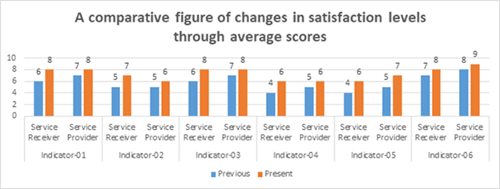

**Figure 3:** Improvement of services provided by community clinic

According to the FY22 PaBS report, 69.1 percent of PEP households received health services from community-level health facilities such as CCs, Union Health and Family Welfare centers, and satellite clinics, which is a significant increase from the baseline result of 27.6 percent. Additionally, the report revealed that households' satisfaction with Community Clinic services increased by 64.3 percent, which is higher than the LOA target of 60 percent. Furthermore, the child immunization rate against eight diseases under the GoB protocol increased by 76.6 percent in FY22, compared to the baseline rate of 48 percent in FY16.

**Water, Sanitation, and Hygiene**

SHOUHARDO III worked on reducing the prevalence of water-borne diseases by working with two key actors: the Department of Public Health Engineering (DPHE), and International Development Enterprises (iDE).The DPHE was involved with water quality and testing, and iDE was sub-contracted for the development and installation of latrines in the challenging contexts of deep Haor and remote Char.

The program mobilized communities towards being Open Defecation Free (ODF), improving their hygiene behavioral practices, and raising awareness through activities in their communities. Therefore, they can share their needs with the Union Parishad (UP), install sanitary latrines alongside other services that can then be used.

The community declared 799 communities as ODF villages with active support from the UP. SHOUHARDO III partnered with PRO-WASH to explore innovations for improved sanitation technologies for these remote locations. iDE conducted research and developed “Nirapod Latrine” models for the program areas in order toexpand and sustain positive WASH outcomes. The program developed 182 WASH LSPs and 66 latrine producers in different program areas. Through this initiative, SHOUHARDO III continued to improve its WASH targets and objectives.

According to PaBS FY22, 89 percent of households now have access to improved sanitation facilities, which is a notable improvement from the baseline results of 67.6 percentAdditionally, 87 percent of households had soap and water at a handwashing station in FY22, where the baseline result was 26 percent.

In order to ensure water quality, the program selected 15,159 tube wells in Char and Haor areas for arsenic field tests, and 6,106 TW for coliform tests at the DPHE lab. The program also disseminated the test results to the community and provided awareness messages about the harmful effects of arsenic and the importance of regular testing.

To educate people about the dangers of using arsenic-contaminated water, the program conducted arsenic awareness-raising sessions in 947 villages through community groups. Additionally, the program engaged 182 WASH LSPs to conduct arsenic tests on tube wells to identify arsenic contamination in water sources and reduce water-borne illnesses.According to the PaBS FY22 report, all households in the SHOUHARDO III program were using improved drinking water sources, indicating the intervention was successful. The report also reveals that 99.6 percent of participants are now aware of the arsenic concentration in tube-well water and the harmful effects of drinking arsenic-contaminated water.

### 2.3 Purpose 3: Strengthened gender equitable ability of people, households, communities and systems to mitigate, adapt to and recover from man-made and natural shocks

### Disaster Risk Reduction

The SHOUHARDO III Program increased the resilience of people, households, communities, and systems in the Char and Haor regions of Bangladesh. The program has achieved this by developing community plans, increasing resilience capacities, improving capacity building of stakeholders, and creating linkages with government and other relevant agencie

***Sub-Purpose 3.1: Increased preparedness of PEP households and communities to mitigate and respond to shocks***

The program improved the capacity of all program households and communities to assess disaster and climate risk through conducting a community-developed Community Risk Assessments (CRA) and facilitating community-level contingency plans in This approach prepared the communities to effectively respond to shocks.

Potential shock factors included failure to identify security threats for women, and early warning-identified risks. Upon completion of the community developed CRA, the additional contingency plans addressed identified risks at the community level.

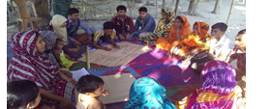

*Community members work collaboratively to document and evaluate their risk assessment findings in the Gaibandha District*

The FY22 PaBS showed three particularly imperative results: (1) 36.9 percent of households reported an increased understanding of elements of disaster preparedness, (2)100.0 percent of households reported receiving risk and early warning information, and (3) 89,363 people – 64.5 percent of whom were female – received and used climate information at their level.

The PaBS FY22 also revealed that SHOUHARDO III beneficiaries were more resilient in recovery after shocks, with the Average Coping Strategy Index (ACSI) at 50.66 percent as compared to the baseline target of 163.13 percent (this is a desired negative direction of change).This improved coping ability was achieved by increasing crop/vegetable production and income, improving disaster preparedness, building capacity through training of life and business planning skills, and enhanced decision-making capacities of the communities, especially for women in response to gender-based inequities The program developed and engaged 2,742 Disaster and Risk Reduction (DRR) leaders, approximately two-thirds of whom were women (1,832), and the majority being youth. These individuals led collective community action, disseminated early warnings and advisories, updated the Risk Reduction, Adaption, and Contingency Plans, and communicated needs to the UP to ensure safety net support for Vulnerable Group Feeding and Vulnerable Group Development. The DRR team continues to lead the disaster risk reduction procedure at the community level.

#### Sub-Purpose 3.2: Local Government Institutions' (Union Parishad) Capacity and implementation of DCRM activities increased

The Disaster Management Committee (DMC) (which includes the Union Disaster Management Committee (UDMC) and Upazila Disaster Management Committee (UzDMC)) implemented interventions to strengthen government capacities and responsiveness in disaster preparedness and early warning.

As a result of their work, the DMC supported communities in preparing for disasters, particularly during the monsoon. This was done through disseminating early warnings with the Union Digital Center (UDC), assisting with evacuation during the flood, and providing relief support. The program provided capacity-building training to 6,428 members from 115 UDMC’s and 770 members of 23 UzDMC’s. Additionally, the program capacitated 4,767 Union Disaster Volunteers (UDV) to assist the UDMC in disaster preparedness and response activities.

The program enhanced the capacities of 115 GoB-authorized Union Digital Center entrepreneurs to collect early warning information from the GoB’s BMD and FFWC websites. They initially shared their findings with UDMC and UDVs and then accordingly disseminated them to the community through microphone announcements, conducted emergencies, and displayed weather messages on notice boards.

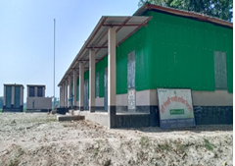

The program also supported 5,333 different infrastructure projects to create short-term employment opportunities to program participants and long-term access shelter. The main projects were: the U-Shaped Cross Drain Culvert, the Raised Homestead plinth, School cum Flood Shelters, and Brick Mound Protection Walls.

*A primary school in Nageshwari, Kurigam doubles as a flood shelter when the community is in need of a safe place to congregate. These dual function structures provide infrastructure that helps the community adapt in times of need.*

The interventions gave PEP participants cash (through Cash for Work activities) when disasters limit earning opportunities. The household owner used the raised plinths of their house in producing vegetables and rearing livestock. Teachers and students use schools as flood shelters during natural disasters.

## Purpose 4: Increased Women’s Empowerment and Gender Equity Women Empowerment

The SHOUHARDO III Program acknowledges the need to improve women’s self-efficacy, agency, and empowerment. This is imperative to strengthening intra-household relationship and across all aspects of implementation in Bangladesh. Key areas of women empowerment included control over assets, decision-making, increased capacity, and increased leadership of women and girls at both the family and community levels.

#### Sub-Purpose 4.1. Strengthened agency of women

CARE continued the implementation of the Empowerment Knowledge and Transformative Action (EKATA) model in all 947 villages in FY17, thereby building on the learnings of SHOUHARDO I & II The EKATA model was proven as effective for facilitating the process of women’s and girl’s empowerment, and addressing GBV at the community level. The PaBS has shown that women and girls who are the members of EKATA had an increased ability and capacity to solve problems in their communities such as child marriage, physical abuse, sexual harassment, and emotional oppression.

The PaBS findings revealed that the mean decision-making score for a woman at the household level rose from 20.79 in FY16 to 37.57 in FY22. This increased might be the result of multiple interventions implemented by the program throughout the LOA. These programs included involvement of women with farm and non-farm income earning activities, different community level platforms, and other women-centric interventions of the program.

According to the PaBS survey, 96.1 percent of PEP women had access to community-level platforms such as EKATA, Community Groups, VDC, and Women Empowerment Leader. These results also revolved around women participating actively in the community groups, and engaging in non-traditional employment, like mobile servicing and computer operating.

#### Sub-Purpose 4.2. Improved environment for women’s empowerment

Over the course of the program implementation period, women and girls continued to promote and demand their rights, both individually and collectively, which can be attributed to an increase of their knowledge and skills under EKATA. The results suggested that women’s decision-making authority also improved, and as a result they could visit service providers (e.g., UP, CCs, and satellite clinics), schools, and markets more often with greater freedom. According to the PaBS, 59.2 percent of women and girls aged 15 to 25 made decisions about their self-earned cash. Women reported increased access to resources and services (e.g., increased production, antenatal care services), better decision-making capacity, and participation in community platforms. All these aspects indicate women's inclusion in public domain is positively trending, and in part likely due to the interventions set forth by SHOUHARDO

SHOUHARDO III also implemented a men’s engagementprogram at the village level to raise awareness and motivation and to initiate action to address and respond to GBV. This helps equalize who carries the burden of GBV between men and women in Bangladeshi society According to the FY22 PaBS, 86.2 percent of surveyed women received assistance from their husband with household chores, as compared to 36.9 in FY16. The program developed male champions in the community so that they could promote positive norms and practices with their peers and families.

SHOUHARDO III’s interventions built up women and girls’ capacity to break gender stereotypes and manage a sustainable livelihood. Empowering women through agriculture and access to other socio-economic opportunities was a key driving force behind this. According to the FY 22 PaBS, 59.5 percent of women surveyed reported increased agricultural production, while 80.7 percent of women reported that they had market access. This was in comparison to 8.9 and 42.20 in FY16.

In FY20, the program shifted its focus to a more holistic and inclusive systems approach from a more stratified approach by increasing men engagement and building a society-wide community to discuss and identify appropriate practices. This led to the establishment of a social media campaign known as It Ends with Me[5], which took place between March 8, 2020, through September 30, 2021. The campaign reached over 17 million viewers and engaged on various topics, including domestic violence, sharing domestic roles, and access to and control over income and assets. The inclusion of men in the context of GBV is important to raising awareness from a bilateral perspective.

Additionally, SHOUHARDO III implemented a series of online webinars to combat child marriage in FY20. As a result of these interventions, 215 child marriages were successfully stopped in the communities where SHOUHARDO III was implemented. To address societal structures,SHOUHARDO III worked with faith leaders, civil society organizations, and service providers at the union level to help implement the Prevention of Domestic Violence Act, which was enacted by the GoB in 2010.

SHOUHARDO III conducted a child marriage study that identified and documented current practices and challenges in implementing the Child Marriage Restraint Act of 2017. The webinar discussions served as a valuable resource for relevant recommendations from participants. As a part of Child Marriage prevention advocacy work, the program published a [Position Paper](https://shouhardo.carebangladesh.org/wp-content/uploads/2022/07/Child-Marriage-Position-Paper-1-2.pdf) on the state of child marriage prevention in hard-to-reach Char and Haor regions in Bangladesh. This was followed by organizing a roundtable on the prevention of child marriage in September 2022. The event produced two major recommendations: 1) forming a district-level Child Marriage Prevention Committee, and 2) ensuring capacity building among faith leaders so that they can provide accurate documents relating girls’ date of birth.

The Ending Violence Against Women(EVAW) Story Telling Platform and Theater reached 180,00 men and boys, and addressed women's empowerment at the community level. Another part of addressing women’s empowerment involved improving the relationship between mothers and daughters-in-laws. The program focused on grassroots mobilization through Focus Group Discussion (FGD) and quarterly Addas (get together).

PaBS data collected by the program yielded interesting findings from these interventions in terms of changes to GVB and household decision-making, including:

* In FY20, 90.1 percent of interviewed women (957 of 1,050) reported knowing a neighbor or a friend who faced GBV within the last month of when the data was collected.
* The percentage of neighbors or friends reporting domestic violence decreased from 60.3 percent to 34.7 percent between FY21 and FY22.
  + Domestic violence includes child marriage, physical abuse, sexual harassment, and emotional oppression
* The percent of program participants aware of the cost and consequences of GBV rose from 51.5 percent in FY21 to 98.0 percent in FY22.

## Purpose 5: Provision and utilization of public services (Local Elected Bodies & Nation Building Departments) for communities (especially for PEP women) increased.

The SHOUHARDO III program advocated for good governance and aimed to promote this at all levels. It empowered communities to demand necessary services, and provided a mechanism for enhancing trust, accountability, and social contracts between communities and government service providers. It facilitated the process of enhancing accountability of Locally Elected Bodies (LEBs) and Nation-Building Departments (NBDs).

In addition to producing output results, the interventions conducted under this purpose also maximized the outcomes under other purpose areas. For example, under Purpose 5, the program organized several Program Advisory and Coordination Committee (PACC) meetings as an output, but, as a result, the Sub-Assistant Agriculture Officer (SAAO) also provided on-the-ground technical support to PEPs farmers. Findings from the PABS indicate that:

* In FY22, 77.7 percent of the respondents were satisfied with overall services provided by the UP against a baseline value of 18.6%.
* Access among respondents to targeted public services increased from 69.8% in FY19 to 94.9 percent in FY22.

#### Sub-Purpose 5.1: Poor and Extreme Poor communities are able to demand and negotiate increased public service provision

SHOUHARDO III worked to increase the communities’ ability in elevating pro-poor voices during comprehensive negotiation, and allowing them a seat at the table that they have historically been routinely denied. This was done in order to improve access to public and private services, such as safety nets, WASH information and products, and small infrastructure facilities in these vulnerable populations.

These communities demonstrated capacity building in dealing with local issues of PEPs They also made public service providers responsive and accountable by advocating for those issues to be addressed effectively – especially in the case of needs of PEP women. The program formed Village Development Committees (VDCs)s, youth groups, and community groups to enable local communities to liaise with public service providers.

*Members of a Village Development Committee (VDC) in Islampur, Jamalpur collectively organize in front of their local Community Resource Centre (CRC)*

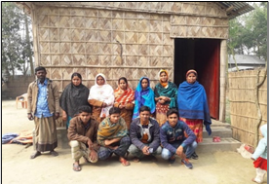

Major activities the program implemented included:

* Strengthening the capacity of the individual communities through empowering local VDCs, youth groups, and community groups
* Facilitating periodical meetings to prepare and organize Community Action Plans
* Youth capacity building through meetings and annual sports/cultural events.

From the [PaBSFY21](https://shouhardo.carebangladesh.org/wp-content/uploads/2023/02/BENEFICIARY-BASED-SURVEY-BBS-2021.pdf) it was found that:

* 78.0 percent of respondents from PEPs and non-PEPs acknowledged the presence of VDC in the program areas.

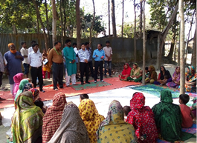

* Additionally, 76.0 percent of VDCs supported communities in implementing village development activities.
  + The field visit reports suggest that the communities came together in locally driven, grassroots efforts to solve problems through community-led initiatives such as small road construction, bamboo bridges, and tree planting.

*Government officials visit Jamalpur in order to engage with the local community. Program participants are able to directly voice concerns and queries with their government officials.*

***Sub-Purpose 5.2: Local Elected Bodies & Nation Building Department services are responsive to the needs of communities, especially to PEP women.***

The program supported UPs and extension officials of relevant NBDs by providing training on their roles and responsibilities. These included individuals from departments such as agriculture, livestock, health and family planning, DRR, social welfare, and women and children affairs. Additionally, the programs organized service fairs, field visits by the government officials, and regular PACC meetings to promote collaboration and engagement.

Service provision of and satisfaction with UPs among PEPs increased during the program’s implementation period, with the PaBS FY22 finding that, 77.7 percent of surveyed participants were satisfied with overall services provided by the union parishad as compared to the reference value of the 18.55 percent in FY16. As per the same PaBS, the average score of UP management capacity also increased from 45 percent in FY16 to 89.62 percent in FY21. Lastly,156362 beneficiaries reported increased access to targeted public services, a number that well exceeded the target of 140050.

A range of service providers also offered additional support, such as vaccination for poultry and cattle, technical support from Sub-Assistant Agriculture Officer (SAAO), and health and family planning services from the CCs. All three of which in turn contributed to maximizing production and income, as well as improving the health and resilience of the participants.

As per the commitment made by the Department of Livestock Services (DLS), an Artificial Insemination Center (AIC) was established at the UP level. This center aims to serve community demands for livestock rearing, thus maximizing results under Purposes 1 and 2. By utilizing khas land (Government owned land), alternative income sources were created for landless families; 16 such families received houses on the khas land. In addition to the economic and nutritional security aspect, these families now have permanent settlements, which upholds their dignity in the community now and for future generations.

*The local Union Parishad Chairman visits PEP program participants in Madan Upazila, Netrokona. As part of resilience building efforts, he is providing them with VGD cards.*

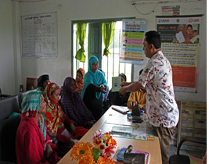

SHOUHARDO III facilitated a total of 248 PACC meetings at the national, divisional, district, and upazila levels to review and support program progress and identify ways to improve government services for PEPs.

* The program also facilitated 130 visitsfor PACC members to the program sites, exceeding the target of 92.
  + Their visits strengthened the demand side of economic activities in the program by encouraging program participants to utilize government services
    - They are simultaneously continuing their individual and collective community development efforts.
  + On the supply side, the visits motivated government staff to interact with the PEP about their lives and livelihoods to foster better troubleshooting processes
    - As per the field observations of the program staff, government officials provided positive feedback on the program’s implementation.

# MONITORING AND EVALUATION; KNOWLEDGE MANAGEMENT, Research AND LEARNING HIGHLIGHTS

## Monitoring and Evaluation

During start-up, the program developed tools and guidelines for selecting vulnerable people and prioritizing geographic areas, resulting in the selection of 947 villages and the identification of 168,521 PEP households. A census survey was conducted, and 674,856 individuals were listed on the Master Program Participant List (MPPL). The MPPL database was utilized to pinpoint beneficiaries for various program interventions, including COGs, health and nutrition, resilience, and cash support.

According to the guidelines of the BHA/ (formerly Food for Peace) Food and Nutrition Technical Assistance M&E workshops in Bangladesh, the SHOUHARDO III program established a robust M&E strategy aligned with its main activities and objectives to oversee the program's performance. This strategy required the development of key M&E documents, including the TOC, Logical Framework (Log frame), M&E Plan, Indicator Performance Tracking Table (IPTT), and Performance Indicator Reference Sheet (PIRS).

The TOC was reviewed annually in a systematic manner after the Mid Term Evaluation (MTW) to evaluate the effectiveness, relevance, and appropriateness of the causal relationship between the outcomes at each level. Due to COVID-19 pandemic, The program received an additional two-year extension to sustain its outcomes, considering the new extension program updated its M&E strategies and documents for the FY21 and FY22 periods in accordance with the program's sustainability framework.

The program developed M&E tools and guidelines to fulfill IPTT requirements. For output monitoring, the program created a Routine Monitoring Tracking System (RMTS), and for outcome monitoring, a PaBS was used to track indicator results.

In FY18, the program transitioned from manual tracking to an electronic M&E system called the System for Tracking Result and Evidence for Adaptive Management (STREAM), which enabled online data collection from the field.

The Participants Tracking System database was used for data management, and for easy reporting to the USAID Application and Award Management Portal and the Development Information Solution system. To ensure data quality, the program conducted Data Quality Assessments using structured tools and processes consistent with the guidelines set by USAID.

The SHOUHARDO III program commissioned the FLAIRb Longitudinal Study in FY17. This study was intended to measure the program's impact on beneficiaries' adoption of agricultural practices, women's empowerment, and health and nutrition practices. The study was conducted over seven rounds spanning five years.

In FY19, Recurrent Monitoring Surveys (RMSs) were introduced to ensure that the program remained responsive to emerging issues such as floods. In mid-FY20, another RMS was launched to track the effects of COVID-19 on program participants. Additionally, in FY22, the program collected data on price hikes resulting from the pandemic and the Ukraine-Russia conflict through the PaBS survey to understand the impact on the lives and livelihoods of program beneficiaries. All these surveys served the purpose of better understanding whether SHOUHARDO III was resilient, responsive, and adaptable to a wide variety of changing conditions and circumstances outside of the control of the local communities, CARE, and the GoB.

SHOUHARDO III developed a Beneficiary Tracking System (BTS) to manage the commodity beneficiary's database, and introduced a process monitoring systems to be applied to various interventions. These include supplementary food ration distribution, cash transfer, DHRC-LRA, COVID-19 cash support, multipurpose cash assistance, and Haor flood response. The program conducted additional monitoring activities that included participant selection re-monitoring, bkash number verification, and onsite/post distribution monitoring under these interventions.

The program also developed a participatory approach for community-led M&E. This involved local community members collecting, analyzing, and utilizing information. In FY19, all 947 communities conducted Village Grading to identify areas where they were lagging. In FY20, the program began conducting Group Capacity Assessments (GCAs on over 6,000 SHOUHARDO III community groups to evaluate their ability to work together, solve problems, and build connections.

The program effectively utilized M&E data to enhance, improve, strengthen, and better understand program interventions and make necessary adaptations. Notable instances of this include:

* During the development of the SBCC strategy, the FY16 PaBS survey showed low levels of hand washing practices among mothers, as well as low rates of exclusive breastfeeding
  + This information was consistent with previous M&E data from earlier phases.
* The program relies on its census data as a primary tool for planning and evaluation purposes. The comprehensive household data gathered from the census has proven useful in conducting surveys, targeting interventions, and revising program activities.
  + Examples include targeting the Core Occupational Group (COG), designing youth interventions, participant selection for cash and supplementary food distribution, and annual participant based survey.
* According to the FY17 PaBS survey, only 55.9 percent of households received risk and early warning information through different communication channels such as TV, radio, messaging by religious leaders, and more.
  + As a result, the program recognized the need to prioritize information dissemination at the community level. To address this, the program continued to disseminate the process of as a program priority through the Regional Integrated Multi-Hazard Early Warning System for Africa and Asia (RIMES), a technical partner of CARE Bangladesh.
* In FY18, a total of 117 youths were chosen at random to participate in an independent assessment of their employability skills and found 82.0 percent of these youth were students which is not acceptable for the program.
  + Based on these findings the program decided to not to continue this training for the school going student.

## Knowledge Management, Research and Learning

SHOUHARDO III’s branding and marking guidelines were approved in FY16. The guidelines were circulated among the staff along with comprehensive instructions for use.

The program updated its knowledge management advocacy and learning strategy in 2017 in order to strengthen the existing knowledge base and encourage it to embrace the integrated programming approach.

The SHOUHARDO III program was engaged in a regional stakeholder discussion and worked with government officials to ensure poor people’s access to common resources as stipulated in the government’s development policy released in 2018.

In FY19, SHOUHARDO III started following USAID’s framework on Collaboration, Learning and Adaptation (CLA), resulting in compelling initiatives across the program.

During the first wave of COVID-19 in 2020, the program managed to stay grounded, ensuring that interventions continued despite hurdles. They were able to create engagement using impact stories that were published to profile the program’s work even during difficult times.

A key factor in informing ongoing program interventions, particularly during the COVID-19 response, was the SHOUHARDO III mobile hotline. This hotline was available to participants to call for all their queries. At the peak of the lockdown, the program received 150 calls per day, with most of the calls being related to questions about the cash support participants received, and the bKash registration and verification process. The program produced a qualitative analysis for the RMS to complement the quantitative M&E findings.

In 2021, SHOUHARDO III Knowledge Management & Learning and Program Quality & Research units were merged to form the Knowledge Management, Research, and Learning (KMRL) unit. Over the course of the year, various research initiatives focusing on livelihoods, disaster risk reduction, and child marriage took place. As COVID-19 continued to impact the lives of the program beneficiaries, SHOUHARDO III conducted an additional study to better understand both COVID-19 and flood effects on crop and livestock activities.

Additionally, the KMRL team directly supported the M&E unit’s generation and analysis of five rounds of RMS-spell-2 data. They did this by leading qualitative assessments and internal queries on the impact of the pandemic beneficiaries’ lives and livelihoods. As more beneficiaries relied on mobile phone-based telemedicine services, the KMRL unit carried out an assessment of the quality of the telemedicine services.

The program conducted a study on child marriage and held a national webinar in December 2020 titled “National Webinar on Grassroots Approaches to Prevent Child Marriage,” and shared the study findings in this webinar. The program launched its bilingual [website](https://shouhardo.carebangladesh.org/en_US/) in both Bangla and English in 2020, thus providing greater accessibility to a wider range of potential audience members.

In FY22, SHOUHARDO III produced and distributed a wide range of knowledge management products, including learning briefs, impact stories, audiovisuals, and quarterly newsletters, all while maintaining a strong social media presence. This year, the program has produced a total of 48 knowledge and learning products so far. The program distributed 300 copies of the printed Annual Learning publication to stakeholders, circulated the digital version among wider global audiences, and organized a virtual photo exhibition to display the contents of the Annual Learning Publication. In addition, SHOUHARDO III developed ten videos and five digital training materials for LSP orientation. Below is a summary of the knowledge products produced in FY22:

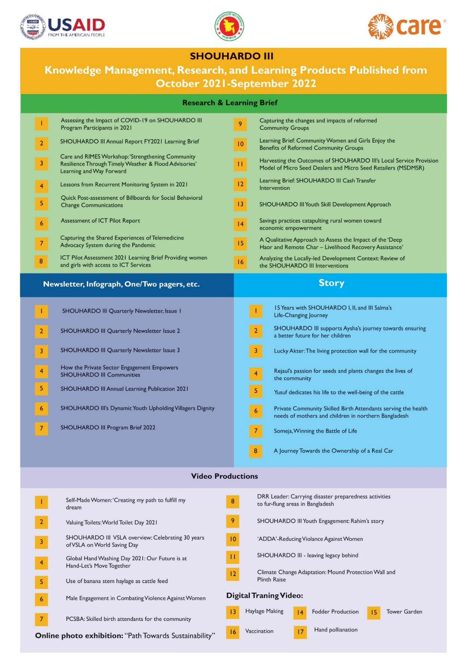

**Figure 4:** List of Knowledge and Learning products produced in 2021-22

## Advocacy

The program organized a Regional Char Convention in Rangpur in December 2021. The goals of this convention were to discuss and create collective advocacy momentum, and obtain commitments regarding development activities in the Northwest Char regions of Bangladesh. As a result, participants from this convention made an agreement to form a central coordination authority for the Char region. Momentum for collective advocacy also grew during this reporting period, likely attributable to the collective effort to mobilize on behalf of the Char region.

The program team held a meeting with the Deputy Minister, AKM Enamul Hoque Shameem, members of parliament, and the Ministry of Water Resources (MWR) to share updates on the outcome of the Char Convention held in Rangpur. Mr. Shameem suggested that the program prepare a policy brief to present before the Honorable Prime Minister of Bangladesh, and he committed to arrange a meeting for the SHOUHARDO III team with the Prime Minister to share issues in the Char Region that the program raised. The program developed a [learning brief](https://shouhardo.carebangladesh.org/wp-content/uploads/2022/10/Learning-Brief-Regional-Char-Convention-2021.pdf) to use as an advocacy tool in this regard.

Following the implementation of the Child Marriage Restraint Act of 2017, the program developed a [position paper on Child Marriage.](https://shouhardo.carebangladesh.org/wp-content/uploads/2022/07/Child-Marriage-Position-Paper-1-2.pdf) That considers the current child marriage trends in Bangladesh and captures the key findings from the Child Marriage study conducted in 2020 by SHOUHARDO III.  The program organized a roundtable discussion for the key stakeholders with a national news media house in the last quarter of FY22 with the objective of ensuring the effective implementation of the Child Marriage Restraint Act of 2017. A newspaper published a full-page supplementary with the [key recommendations](https://en.prothomalo.com/bangladesh/roundtable/k28qfja65w) taken from the roundtable discussion. After the program ends, CARE will follow up with the relevant ministries, departments, and stakeholders for the effective, sustainable, and long-term implementation of these recommendations from this roundtable.

# SUSTAINABILITY OF PROGRAM OUTCOMES: AVAILABILITY, QUALITY, AND SATISFACTION ON SERVICE PROVISIONING

To achieve the program goal of sustainability, SHOUHARDO has facilitated a total of 2667 LSPs (782 females and 1,885 males) and 6,774 Community-Level Facilitators (CLFs) (4,678 females and 2,096 males) across the program areas.

Findings from FY22 PaBS study suggests that the program was successful in promoting effective and efficient service provision models in both quantitative and qualitative terms. In the quantitative survey, both PEP and non-PEP respondents stated that they could access a range of services in their respective villages and union. SHOUHARDO III trained several types of LSPs, including community-based vaccinators, seed agents, fish fry hawkers, collectors, *Sanchay Sathis*, private community skilled birth attendants, BSPs, WASH LSPs, and Latrine Producers (LPs).

Additional findings from the survey indicated that:

* 87.0 percent out of a total 1,545 respondents received service from the community-based vaccinators.
* Approximately 84.0 percent (1,238 out of 1,545 respondents) received service from the seed agent
* Close to 48.0 percent of respondents (728 out of 1,545) received service from *Sanchay Sathis*
* 49.0 percent (665 out of 1,545) mentioned collectors
* 41.0 percent (539 out of 1,545) cited services from LPs.

The figure below also shows that the availability of LSPs increased in FY22 compared to FY21. The survey also revealed that around 35.8 percent (458 out of 1,374) of the respondents were fully satisfied and 61.2 percent (871 out of 1374) were moderately satisfied with LSP services.

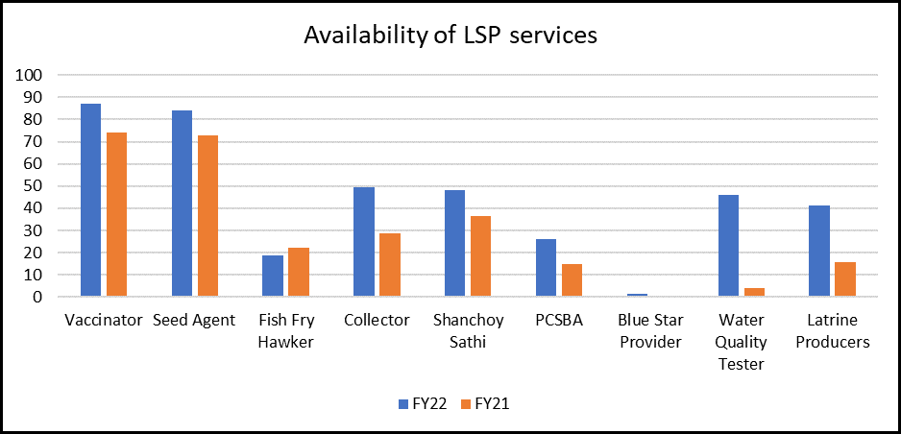

**Figure 5:** Availability of LSP services

The SHOUHARDO III program developed a wide range of Community Level Facilitators, such as VDC leaders, women’s empowerment leaders, DRR leaders, e-business actors, and Business Skills Development LSPs. These leaders worked in implementation for community development, enabling government services, addressing violence against women, reducing disaster risk reduction, and promoting business skill their communities. The most recent PaBS shows that the most available CLFs service were VDC leaders.

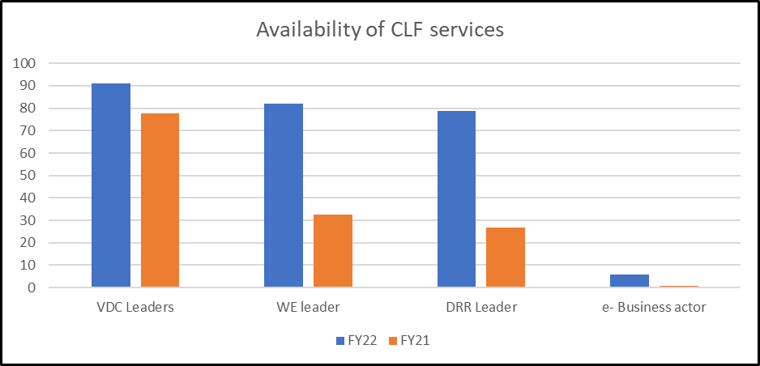

**Figure 6:** Availability of CLF services

As per the FY22 PaBS:

* Nearly 93.0 percent (1,467 out of 1,544) of surveyed respondents stated that their households received services from the CLFs in the last 12 months (2021-2022).
* According to respondents, 91.2 percent (1,396 out of 1,545) participants reported availability of VDC services.
  + As per the same respondents, the availability index for the other CLFs were, Women Empowerment leaders (82.0 percent of 1,545) and DRR leaders (78.6 percent of 1,545).
* Findings from the qualitative survey also gave evidence in favor of the LSPs/CLFs service availability and satisfaction on their service delivery.
  + According to FGDs with PEP and Non-PEP participants, there were many positive changes in their area over the last year (FY22).
    - The participants observed changes in agricultural activities, women’s empowerment, establishing good governance, and health-hygiene practices.
    - It was evident from the FGDs that LSPs and CLFs were working actively in the villages, and people were taking their services because they were readily available.

There were also changes in market access for farmers so they could sell their agricultural products in their village instead of traveling, therefore saving a significant amount of both time and transport costs. The LSPs helped them to form savings groups and encouraged them to save for the future. The CLFs, like the DRR leaders, helped participants to prepare for any natural disaster through early warning. The community mentioned services from LSPs and how it has improved the health, nutrition hygiene, and environment in their community. They even mentioned receiving streamlined computer services for registration and application purposes.

It was also found during FGDs that community people, particularly the females, improvised cost-effective ways to buy seeds. When they did not have enough money to buy a packet of vegetable seeds, they bought the packet in groups and distributed the seeds among themselves, thus creating a sense of communal good and interconnectedness.

Participants also mentioned, if necessary, they sometimes take a loan from the Village Savings and Loan Association (VSLA /Baksha Samity). The recipients were found to be satisfied because the service quality was good, convenient, and readily available. They also said that they preferred to use LSP services and products because it was cheaper than on the general, open market.

LSP services provide convenience to program participants by removing the obstacles of distance and lack of credit. Participants don’t have to worry as much about transportation costs, and they could get services and products from LSPs on credit within a fixed period. This empowers them with greater financial mobility and flexibility.

## Reflection on Sustainability approaches

Sustainability is one of the cornerstones of development and a core commitment of SHOUHARDO III. The program’s approach to sustainability and long-term impact was structured around building the following: 1) sustained resources, 2) sustained capacity, 3) sustained linkages, and 4) sustained motivation. The qualitative PaBS tried to find out the sustainable areas through the key informant interviews (KIIs) with the LSPs.

CLFs providing free services are often inspired to do so by their community’s respect and recognition of the importance of their role in serving the greater good. In other cases, some CLFs were destitute women who had experienced hardship in life, and therefore they were driven by their sense of social responsibility to help people. To them, commitment to their community, assisting people in their area, and collective social good are all more important than money.

The KII shows that the key motivators for LSPs are source of income, social identity, communal respect, improved sense of self-esteem, and responsibility for the members of their villages. Primary beneficiaries of LSPs were the PEP village people although other non-PEP people also engaged in services. The LSPs gave charges according to their respective service, or sold their products with a minimum profit. When people, particularly the poor, did not have money to pay them, the LSPs also provided their services or sold their products on credit to be paid later. All the LSPs mentioned that they were earning good money in this career.

Almost all the LSPs received skill development training in their respective field from SHOUHARDO III. According to them, the training helped them deliver their services to clients consistently and efficiently. None of them had to pay any money for the training; rather, SHOUHARDO III provided them with financial support for the training. Additionally, the program gave financial support to some LSPs to start their own businesses. The CLFs also received capacity-building training from the program, and, some went so far as to receive training from other local non-governmental organizations. Another important aspect to consider is that for many LSPs their years of experience in social work and acceptance in the community allows them to do their jobs more effectively.

LSPs/CLFs were found to be often in contact with both the public and the private sector for technical advice and input. LSPs had contact with relevant government officials and departments such as the DLS, Upazila Livestock Hospital, Upazila Health Complex, CCs, and more.

## Sustain service provision and outcomes

The qualitative study in FY22 offered valuable insights regarding the sustainability of the LSP and CLF initiatives under SHOUHARDO III. These initiatives made a significant impact on improving both peoples’ lives and livelihoods.

People connected with LSPs for a number of reasons, including, but not limited to:

Agricultural inputs/guidance: seeds, fertilizer usage, pest control, and modern technology use.

Livestock/poultry rearing: vaccination, animal disease detection, and treatment.

Maternal and child health and nutrition services (MCHN): treatment for their children, GMP, birth-control methods, antenatal care check-ups, safe childbirth, and referral to the government health complexes.

Locals reached out to CLFs for key issues such as obtaining financial assistance from government safety net programs (e.g., Vulnerable Group Development (VGD), Vulnerable Group Feeding (VGF), old, and widow and disability allowance), addressing child marriage and domestic violence issues, and for early warning, disaster preparedness, and management.

When the LSPs/CLFs could not provide sufficient support or the issue was beyond their capacity and/ or scope, they assisted their community members with reaching other local governance bodies (e.g., UP, government livestock department and agricultural extension workers). Data also showed that participants did not experience any discrimination or inequality while receiving services regardless of gender, age and disability. The KII and FGD findings suggested that LSP and CLF services had gained popularity, and it was apparent that these services would continue beyond the project. The following observations are considered essential contributing factors for sustaining LSP and CLF services:

* The scope of work for LSPs and CLFs included improved agricultural technologies, MCHN, safe WASH, environment, climate, disaster coping mechanisms, prevention of child marriage, domestic violence, and women’s empowerment.
* In terms of LSP services, it was a win-win situation for both the service providers and the service recipients where monetary value, service quality, and community acceptance was connected.
  + LSPs gained respect and reputation, leading to income generation opportunities or expansion of business, but also helped build communal trust in their services.
  + For the community being served, LSPs service quality was good and services were accessible, readily available, and affordable to the point that they could be also accessed through credit instead of money immediately, therefore allowing greater financial mobility
* For CLF’s, the sense of social responsibility and community respect they earned was the driving force behind responding to community people’s needs
  + This included working towards reducing poverty, strengthening disaster resilience capacity, and ending child marriage and domestic violence in their respective communities.

# CHALLENGES, SUCCESSES, AND LESSONS LEARNED

## COVID-19 Effects on Activities

From the onset of the pandemic in early 2020 until the end of March 2022, the GoB implemented a nearly yearlong national lockdown and put in place strict movement restrictions. These circumstances significantly affected the program’s planned interventions, as SHOUHARDO III staff had to work from home for extended periods. Additionally, staff and providers could only implement activities at a very limited scale in areas the GoB sanctioned for travel and movement.

At the end of 2021, the Detailed Implementation Plan (DIP) progress rate revealed that SHOUHARDO III only completed 53.0 percent of its activities, with the rest postponed until FY22. Significant delays took place regarding the scale-up of service models for LSPs that were based on pilot study findings, roll-out of training, and linkage-building. At the end of the program activities were completed, but LSPs had not reached the level of maturity required to sustain service delivery.

## Effects of Changing Food, Fuel, and/or Fertilizer Costs

As of September 2022, Bangladesh’s inflation rate remained at high levels (9.1 percent[6]) amidst a hike in global commodity prices attributable to the Russia-Ukraine war. In one year, the prices of most daily essentials, other than certain locally produced goods, increased:

* The price of rice/kg increased by BDT 16.94 about (US $0.17).
* The price for whole wheat flour/kg increased by BDT 20 (US $0.20).
* The price for a litre of oil increased by BDT 26.79 (USD $0.26)[7].

Between June and July, SHOUHARDO III conducted its annual PaBS and captured the impacts of the recent price hikes in the lives of the168,000 PEP households. The findings of the annual survey confirm that from January 2022 to June 2022 households experienced an increase in the prices of essential commodities. Almost all households indicated that the price increases were budgetarily significant for them during this time[8].

**Other Significant Threats to Food Security**

Heavy rainfall between May and July 2022 resulted in widespread flooding that affected the northeastern part of Bangladesh, impacting about 7.2 million people. Over 90.0 percent of the Sunamganj district and 70.0 percent of the Sylhet district were inundated by floodwaters for several days. A total of 8,700 SHOUHARDO III participant households were affected by the floods. The historic floods resulted in catastrophic losses of crops, livestock, and fish stock, destroyed latrines and tube-wells, disrupted school education, and contributed to significant income loss among both agricultural and non-agricultural laborers. Unfortunately, as a consequence a considerable number of people had to sell their assets, including land and livestock.

In the Rapid Food Security, Livelihood, and Market Assessment (July 2022) conducted by the Bangladesh Food Security Cluster, 94.0 percent of respondents reported adopting negative coping mechanisms. These mechanisms include reducing quality and amount of food intake, curtailing non-food expenses, reducing food purchases, and selling livestock. With no other source of income and dwindling support for the populations affected by the floods, households became unable to consume three meals a day. The 8,700 participant households affected by last summer’s flooding continue to face severe hunger, as the next harvest is not expected until April 2023.

* During the life of the program, SHOUHARDO III implemented a series of short-term emergency interventions to address the combined shocks from COVID-19 pandemic and natural disasters. These interventions also helped build resilience. For example, in FY22 this included: Unconditional multi-purpose cash grants to 2,700 SHOUHARDO III flash flood-affected households in the Sunamganj Through the DHRC-LRA initiative, the program enabled participants to either begin, resume, or sustain their IGAs.
  + It was initially a challenge to motivate participants to open their own bKash account, as many people were accustomed to receiving support from the program or other sources.
  + However, participants were ultimately motivated by the various independent functions offered in the mobile financial services and became skilled in conducting transactions through this platform.
* In addition, in line with the program’s sustainability agenda, SHOUHARDO III continuously worked with households (with an emphasis on female members to improve women’s empowerment) to buy mobile SIM cards as needed to open their own bKash account.
  + Supporting female family members to open a household-oriented bank account served the dual purpose of both contributing to financial inclusion and enhancing the decision-making capacity of women.

1. **CONCLUSIONS AND KEY REFLECTIONS**

Despite the set-backs and delays the program faced during the final years of its implementation due to COVID-19 pandemic, the PaBS 2022 showed positive trends in several participant-based indicators, especially against health, nutrition, and women’s empowerment. Several indicators’ progress suggested that the program participants had better access to health care services and facilities. Additionally, the findings showed a reduction in the prevalence of violence against women, and a greater sense of awareness among the community regarding the costs and consequences of GBV and female disenfranchisement. The program participants also reported significantly increased access to improved sanitation facilities and increased access to early warning information in order to better mobilize in the face of changing climate conditions.

Various program surveys indicated that program participants showed a great deal of resilience, and survived through the difficulties. In March 2022, the program conducted the sixth and final round of the RMS to assess the impacts of COVID-19 on the lives and livelihoods of SHOUHARDO III participants. Findings from the RMS showed that the average household monthly income increased from BDT 8,855 (US $86) to BDT 12,469 (USD $121) in the post-COVID-19 lockdown period and recovery phase. Findings from the PaBS also revealed that beneficiaries benefitted positively from the program’s interventions during the post-COVID period and bounced back with their improved resilience capacity. Over the LOA, the program had achievements with 485,533 unique participants and 168,599 households in the different result/purpose areas.

SHOUHARDO III has been working to support communities create service demand, ease access to services, and make services available at the community level. The services include agriculture and livestock, health and nutrition, disaster risk and reduction, women empowerment, and governance – all of which are considered fundamental needs in any community, especially for the remote areas where the private and public services are limited, and communities are more self-reliant. The program’s approach has been to sustain the services at the community level and create long-term, sustainable, and eventually self-sufficient positive impacts on community livelihood.

The programmatic approach of CG development was vital in strengthening community bonding and solidarity. This social cohesion accelerated collective action to claim their rights to public and private offices, and to build or repair infrastructures and roads. Moreover, the program developed CLFs promoted public and private services for the community people and raised awareness about their rights to seek those services. They also played a critical role in developing awareness in communities about violence against women, women’s empowerment, good governance, and how to demand their rights from relevant authorities.

DRR leaders also played an important role in raising community awareness on preparedness against natural calamities, which are most common in Char and Haor regions. The increased awareness on their rights to seek services and programmatic support is enabling sustainable livelihoods in communities, despite the vulnerable environmental and climatological conditions in remote Char and Haor areas.

The program’s service provisioning model made basic agricultural, health, savings, and WASH services readily available at people’s doorstep through LSPs – and these services are both forgiving and affordable even when participants have no cash. The program continued to foster a savings attitude in communities through the VSLA platform, which strengthened community resilience to cope with shocks and stressors. Moreover, VSLAs created easy access to credit, which led to increased opportunities, especially for the poor community, to invest in a small business or to diversify income streams. The SHOUHARDO III program has been a composite package and supports communities to raise demands collectively and access services/solutions locally. The LSPs, CLFs, and different thematic groups are practicing locally-led initiatives, activities, and efforts. They are making multisector support and services available to program communities

The program completed and closed out all planned activities by 31 December 2022 and transitioned to a new program called SHOUHARDO III Plus which will follow up on sustaining outcome of the SHOUHARDO III program.

1. <https://www.bb.org.bd/en/index.php/econdata/inflation>
2. Indicator Desired direction of change is Negative so Negative achievement is better.
3. Strong is equivalent to 85 percent and above; Moderate is equivalent to between 70 and 84 percent; and Behind is equivalents to less than 70 percent.
4. *Krisoker Janala, Livestock Diary, and Fosholi* are all apps aspiring to be a one-stop solution containing relevant agricultural information accessible for farmers. Dakhter Bhai and Maya Apa are mobile apps related to health and nutrition services
5. This is an online social media campaign around women empowerment and addressing GBV through Facebook, twitter and Instagram. This campaign was able to initiate online discussion and debate around GBV and engaging men and boys in greater community to enhance women empowerment.
6. <https://www.tbsnews.net/economy/inflation-jumps-95-aug-drops-91-sep-minister-508926>
7. 29 September 2022 Trading Corporation of Bangladesh market price list
8. <https://www.tbsnews.net/economy/inflation-jumps-95-aug-drops-91-sep-minister-508926>