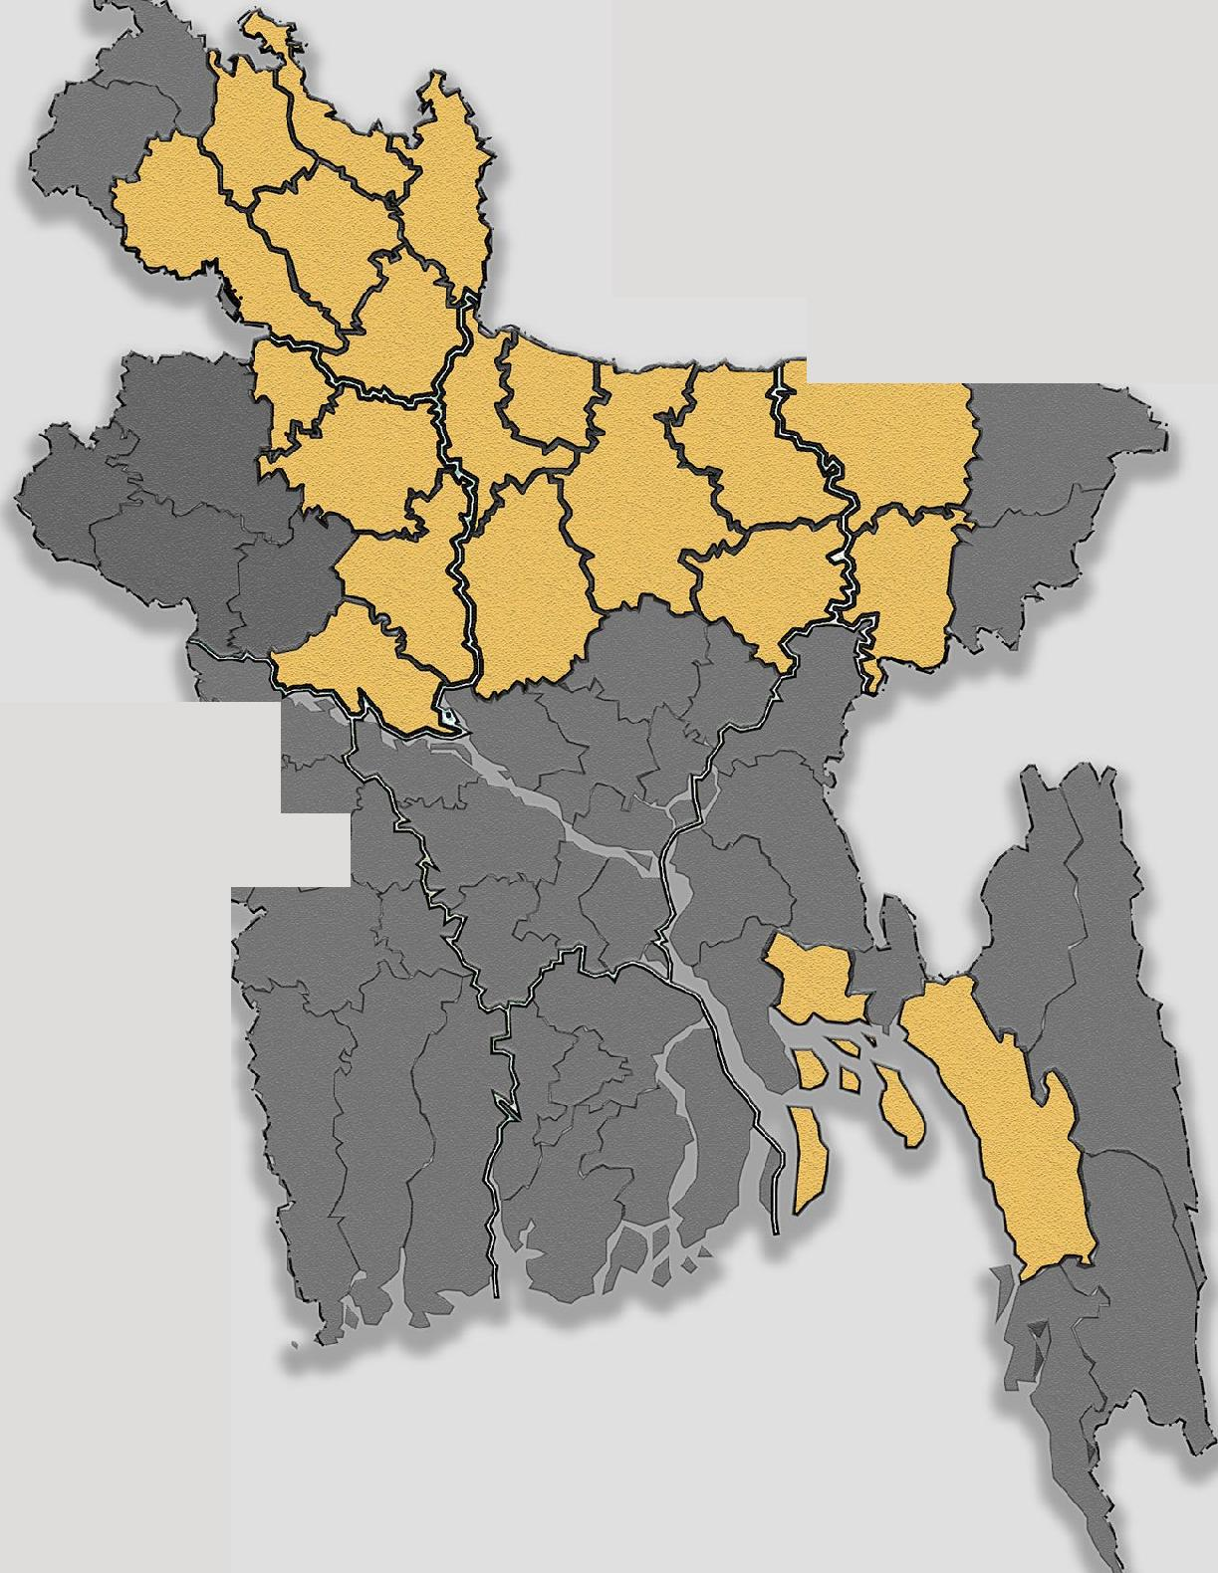



**Transformative Impact on Resilience, Empowerment, and**

**Sustainable Development**

**Introduction**

Between 2004 and 2022, the three consecutive SHOUHARDO (Strengthening Household Ability to Respond to Development Opportunities) programs, operated under the overarching goal of combating food insecurity, uplifting women, social inclusion of the poor and extreme poor **(PEP)** and bolstering community resilience across the most marginalized communities in Bangladesh. Primarily funded by the U.S. Government through USAID and supported by the Government of Bangladesh, each program targeted distinct communities. Together, these programs transformed the lives of over 950,000 poor and extreme poor households through comprehensive strategies that tackled poverty, malnutrition, and vulnerability.

**Individual Programs and Their Milestones**

SHOUHARDO
  
Working Area

*r*

*) r*

|  |  |  |
| --- | --- | --- |
| **(i.1 U SA I D**  FROM THE AMERICAN PEOPLE |  | **scare** |

|  |
| --- |
| **V**  **SHOUHARDO (October 2004 - May 2010)**  Funding:Approximately **$128** million US dollars |

Primary Objective

To reduce chronic and transitory food insecurity for 400,000 households across eighteen districts of Bangladesh Key Achievements

**I. Child Nutrition**

Achieved a significant 11.7 percentage point decrease in child underweight rates (U2), using a multifaceted approach that included economic interventions and maternal health and hygiene education, among other strategies.

**3. Women's Empowerment**

Increased women's influence in household decision-making by 23%, particularly linked to their involvement in Empowerment, Knowledge, and Transformative Action (EKATA) groups, as well as participation in other SHOUHARDO groups.

**2. Food Security**

Increased the average months of sufficient food access from 5.2 to 7.5.

**4. Community Preparedness**

Pioneered a 10-day advance flood forecasting system, a substantial upgrade from prior 48 to 72-hour forecasts, and incorporated it into a multi-modal warning system for robust, comprehensive community alerts.

**SHOUHARDO III (September 2015 - December 2022)**

Primary Objective

To enhance the lives of 370,000 Poor and Extremely Poor (PEP) households in eleven impoverished districts of Bangladesh

**2. Agricultural Productivity**

Crop-producing households adopting at least three optimal technologies rose from 42. I % to 92.9%.

**4. Improvements in Maternal Health**

Women receiving more food and more rest during pregnancy increased from 12.5% to 57.6% and 23.5% to 63.3%, respectively.

**6. Effective Disaster Management and Preparedness**

The program was successful in disaster management due to well-organized contingency planning and provided a 4-5 hour warning period before flash floods.

Key Achievements

**I. Food Security**

Increased adequate household food provisioning from 5.9 months to 11 months.

**3. Child Nutrition**

Achieved a 6.9 percentage point reduction in the prevalence of underweight among children (U5).

**5. Women and Girls Empowerment**

Final Evaluation highlighted remarkable achievements in improving the mobility, decision-making participation, and community awareness of women and girls

**■11111 SHOUHARDO II (June 2010 - September 2015")**

Funding:Approximately $132 million US dollars

Funding:Approximately $115 million US dollars

|  |  |
| --- | --- |
| Primary Objective  To improve gender-equitable food and nutrition security for Char and Haor regions.  Key Achievements  **I . Poverty Alleviation**  Achieving a 8.6 percentage point reduction in households living below the $1.90/day poverty line, coupled with a significant rise in daily expenditures from $1.93 to $2.29 in households led by adult females. | 168,521 households in eight districts of the  **2. Child Nutrition**  Achieved a 15 percentage point drop in the rates of underweight children (U5). |

|  |  |
| --- | --- |
| **3. Sustained Women's Empowerment**  23.8 percentage point women enjoyed sustained household decision making power.  **5. Creating Economic Opportunities** | **4. Climate-Resilient Practices**  Households demonstrated greater resilience to significant shocks by sustaining food consumption and effectively recovering through the use of sustainable agricultural and storage methods. Additionally, a CARE study reported a reduction in average production loss by USD 466.74 per household annually. |

Boosted community involvement in vital areas such as health, agriculture, and business, while specifically enhancing the economic stability of poor and female-led households in business ventures.

**Women's sustained decision-making power**

|  |  |  |  |  |
| --- | --- | --- | --- | --- |
| **SHOUHARDO** |  | **SHOUHARDO II** |  | **SHOUHARDO III** |

**Underweight reduction**

**-6.9% (U5)**



**-15%
  
(U5)**

|  |  |
| --- | --- |
|  | **-11.7% (U2)** |

**Child Malnutrition**

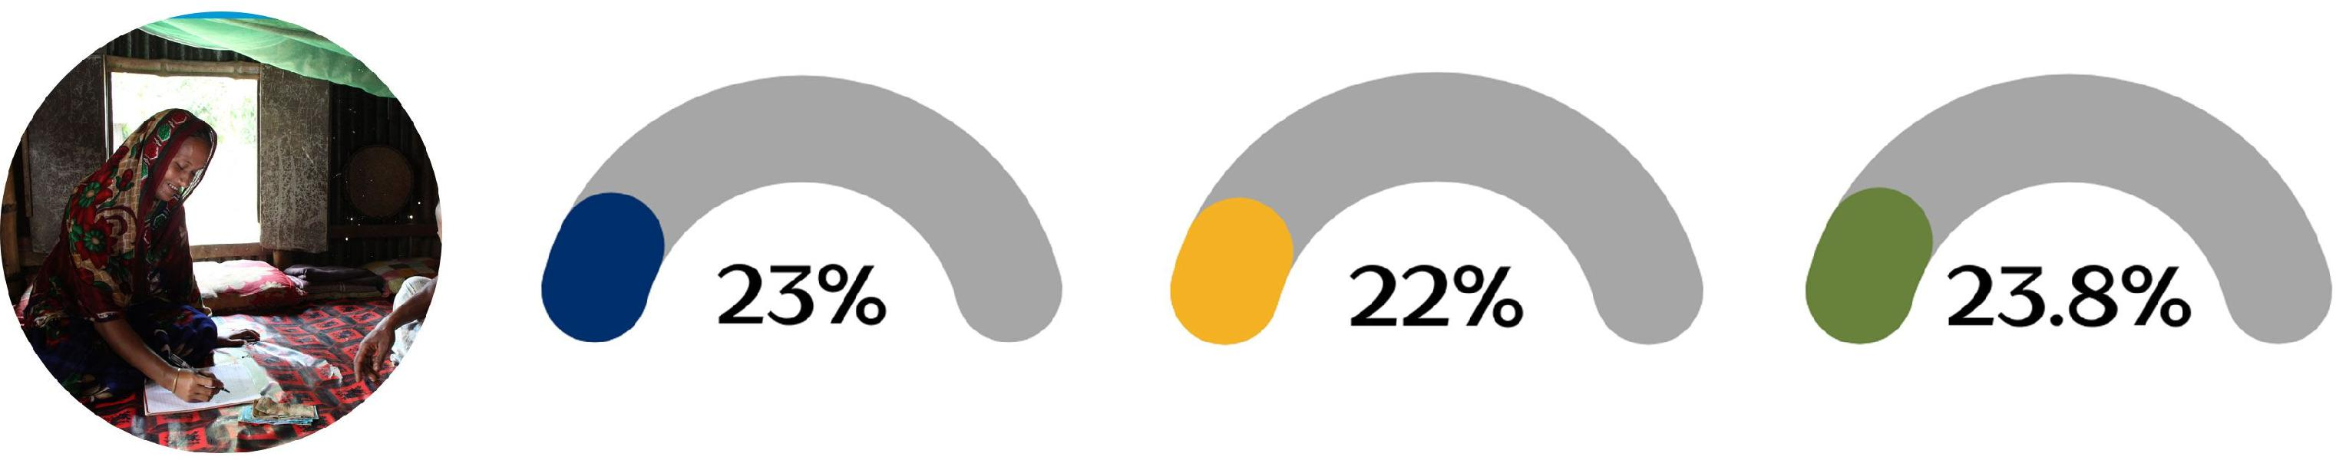

**Mothers' receiving antenatal care**

|  |  |  |
| --- | --- | --- |
|  |  | **85.3% 68.3%** |

**Households with access to an improved Sanitation facility**

|  |  |  |
| --- | --- | --- |
|  |  | **60.1% 52.8% i d49.4%** |

**Implementation Insights and Strategies**

**Women as the Driving Force**

**Locally-Led & Community-Centric Approach**

Community engagement has always been at the core of SHOUHARDO's programming, specifically targeting poor and extreme poor households. This community-centric strategy is evident through the establishment of Local Service Providers and Entrepreneurs who fill the gaps in government services in hard-to-reach areas.This approach focus not only on fostering community ownership but also contributes to the program's sustainability.

SHOUHARDO goes beyond mere participation by empowering women as agents of change. This involves engaging them in income-generating activities, decision-making processes, and community leadership roles. Such an inclusive approach has been instrumental in fostering social and economic changes, aligning well with the program's broader goals of resilience and adaptability.

**The Road Ahead: A Journey of Resilience**

**Resilience and Adaptability**

Despite facing global challenges like the

Understanding the necessity of resilience for vulnerable communities, SHOUHARDO adopts a multi-faceted programming approach. It layers multiple interventions that are tailored to community-specific needs, maintains a focus on inclusivity of poor and extreme poor, and promotes local ownership. This intricate design is particularly effective in enabling marginalized communities to adapt to various shocks such as climate change, economic fluctuations, and natural disasters.

COVID- I 9 pandemic and volatile food prices, SHOUHARDO communities have displayed immense resilience.This resilience is a testament to the program's robust design and effective implementation strategies. Building on the successes and lessons of the predecessor SHOUHARDO programs, SHOUHARDO **III** Plus is a two-year Activity (2022-2024) funded by the United States Agency for International Development (USAID). This Activity aims to deliver improved gender-equitable food and nutrition security and achieve resilience for 168,521 Poor and Extreme Poor (PEP) households in the Char and Haor regions of northern Bangladesh.

"This document is made possible by the generous support of the American people through the United States Agency for International Development (USAID).
  
The Contents are the responsibility of CARE Bangladesh and do not necessarily reflect the views of USAID or the United States."

|  |  |
| --- | --- |
|  | "I *do not need to buy vegetables from the markets anymore. Rather, I* sell the *surplus.* My *homestead garden fulfills the nutritional needs* of my *family and ensures some extra earnings.* I collect *quality* seed *and advisory from nearby* seed agents (LSP). I sell my vegetables *to a collector (LSP) which* saves *my* time, efforts *and* cost. I *encourage and advise other community people* to *do the homestead garden for nutritional security and additional income."*  **Urmi Khatun (37), SHOUHARDO Participant** |