Basic Concepts of Probability

Experiment: Experiment is an act that can be repeated under given conditions.

Outcomes: The result of an experiment is known as outcomes.
Ex: Throwing a die is a trial and getting 1 or 2 or 3 or 4 or 5 or 6 is an outcome
Possible outcomes: The numbers 1, 2, 3, 4, 5, 6

Mutually Exclusive Outcomes: Outcomes or cases are said to be mutually exclusive if the happening of any one of them precludes the happening of all others. Example-1) In tossing a coin, the outcomes hear and tail are mutually exclusive.2) In throwing a die, the six outcomes which are the different points on the faces of the die is mutually exclusive.

Equally likely Outcomes: Outcomes of a trial are said to be equally likely if we have no reason to expect any one rather than the other. Example-1) In tossing a fair coin, the outcomes head and tail are equally likely,2) In throwing a balanced die all the six faces are equally likely.

Event: An Event is the collection of one or more outcomes of an experiment.
One possible event: The occurrence of an even number. That is, we collect the outcomes 2, 4, and 6.

There are three definitions of probability: classical, empirical, and subjective.

Classical or mathematical Probability:
If there are n mutually exclusive, equally likely and exhaustive outcomes of an experiment and if m of these outcomes are favorable to an event A, then the probability of the event A which is denoted by 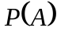is defined by
= Favorable outcomes of an event A/Total number of outcomes of the experiments
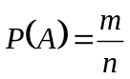

Example: After tossing a coin what is the probability that we will get head?

Solution:
We know,
Here total number of outcome is n= 2 and favorable outcome, m=1
So 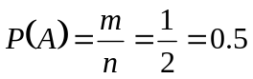
Empirical or statistical probability:
If an experiment is repeated a large number of times under the same conditions, then the probability of an event A is the limiting value of the ratio of the number of times that the event A happens to the total number of trails, as the number of trails increases indefinitely large, provided the ratio approaches a finite and unique limit.
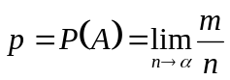
Example: Throughout her teaching career Professor Jones has awarded 186 A’s out of 1,200 students. What is the probability that a student in her section this semester will receive an A?

Solution: To find the probability a selected student earned an A:
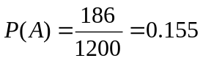

Subjective probability is based on whatever information is available.

Example: Estimating the probability the team X will win the football championship in this year.

Laws of Probability:
There are two laws which are very important.
- All probabilities are between 0 and 1 inclusive

i.e. 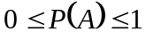
- The sum of all the probabilities in the sample space is 1

i.e. 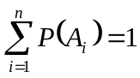

Probability Rules:
- Specific Addition Rule
If two events are mutually exclusive, then the probability of either occurring is the sum of the probabilities of each occurring.
P (A or B) = P (A) + P (B).

Example on probabilities:

Example: A bag contains 4 white, 6 black balls and 5 green balls. If one ball is drawn at random from the bag, what probability that it is 1) black, 2) white, 3) white or black.

Solution: Total numbers of balls are 15.Since one ball is draw from the bag; there are 15 mutually exclusive, equally likely and exhaustive outcomes of this experiment.

1) Let A be the event that the ball is black, and then the number of outcomes favorable to A is 6.hence

P (A) =Number of black balls/Total number of balls=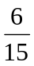=0.4.

2) Let B be the event that the ball is white, and then the favorable outcomes corresponding to B is 4.Therefore

P (B) =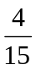=0.266

3) Let C be the event that the ball is white or black, then

P(C) =P (A or B) =+=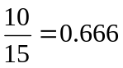

General Addition Rule:

In events which are not mutually exclusive, there is some overlap. When P (A) and P (B) are added, the probability of the intersection (and) is added twice. To compensate for that double addition, the intersection needs to be subtracted.
P (A or B) = P (A) + P (B) - P (A and B)

Example: In a sample of 500 students, 320 said they had a stereo, 175 said they had a TV, and 100 said they had both. 5 said they had neither. If a student is selected at random, what is the probability that the student has only a stereo or TV? What is the probability that the student has both a stereo and TV?

Solution: Let S and T be the events that students had stereo and TV, respectively. Then the probability that student has only stereo or TV is-
P(S or T) = P(S) + P (T) - P(S and T)
= 320/500 + 175/500 – 100/500
= .79.
The probability that the student has both a stereo and TV
P(S and TV) = 100/500
= .20
Exercise: A student is taking two courses, history and math. The probability the student will pass the history course is .60, and the probability of passing the math course is .70. The probability of passing both is .50. What is the probability of passing at least one?

Specific Multiplication Rule:
The Specific Rule of Multiplication requires that two events A and B are independent.
This rule is written: P(A and B) = P(A)*P(B)
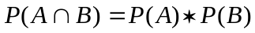

General Multiplication Rule

The General Rule of Multiplication requires that two events A and B are dependent
P (A and B) = P (A) * P (B|A)
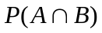= P (A) * P(B|A)
Joint probability:
Joint probability is the probability of two events in conjunction. That is, it is the probability of both events together. The joint probability of A and B is written P (A and B) or.
Example: The question, "Do you like watching TV?" was asked of 100 people. Results are shown in the table. What is the probability of a randomly selected individual being a male who likes watching TV?
 | Yes | No | Total
Male | 19 | 41 | 60
Female | 12 | 28 | 40
Total | 31 | 69 | 100

Solution: This is just a joint probability. The number of "Male and like watching TV" divided by the total = 19/100 = 0.19

Marginal probability:
Marginal probability is the probability of A, regardless of whether event B did or did not occur. If B can be thought of as the event of a random variable X having a given outcome, the marginal probability of A can be obtained by summing the joint probabilities over all outcomes for X.

Example: The question, "Do you like watching TV?" was asked of 100 people. Results are shown in the table. What is the probability of a randomly selected individual like watching TV?
 | Yes | No | Total
Male | 19 | 41 | 60
Female | 12 | 28 | 40
Total | 31 | 69 | 100
Solution: Since no mention is made of gender, this is a marginal probability, the total who like watching TV divided by the total = 31/100 = 0.31.

Conditional Probability:

The probability of an event occurring given that another event has already occurred is called a conditional probability. The probability of event B occurring that event A has already occurred is read "the probability of B given A" and is written: P (B|A)
If A and B are two events in a probability space, such that P [A]>0, then the conditional probability of B given A, denoted by P (B|A) is defined by
P (B|A) = P (A and B) / P (A)
=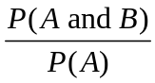; P (A)>0
Similarly, conditional probability of A given B is defined by
P (A|B) = P (B and A) / P (B)
=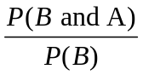; if P (B)>0
Example: The question, "Do you like watching TV?" was asked of 100 people. Results are shown in the table. What is the probability of a randomly selected individual is a male if it is given that he likes watching TV?

 | Yes | No | Total
Male | 19 | 41 | 60
Female | 12 | 28 | 40
Total | 31 | 69 | 100

Solution: The conditional probability M given Y is

P (M|Y) =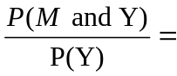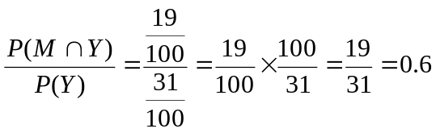

Some Principles of Counting:

- Multiplication Formula:
The Multiplication Formula indicates that if there are m ways of doing one thing and n
ways of doing another thing, there is m x n ways of doing both.

- Permutation: A Permutation is any arrangement of r objects selected from n possible objects. The order of arrangement is important in permutations.

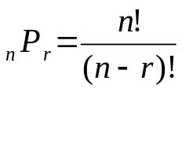

- Combination: A Combination is the number of ways to choose r objects from a group of n objects without regard to order.
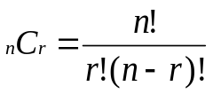

Example: Suppose there are 12 players on the Carolina Forest High School basketball team. Coach Thompson must pick five players among the twelve on the team to comprise the starting lineup. How many different groups are possible? (Order does not matter.)

Sol: 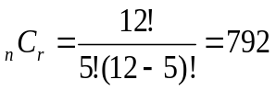

Example: Suppose that in addition to selecting the group, he must also rank each of the players in that starting lineup according to their ability (order matters).

Sol: 