**Ziegler-Nichols PID parameter calculation**

he steps of the Ziegler-Nichols method are shown below. 1. The derivative and integrative gain are reduced to zero.

2. The proportional gain of the controller (𝐾𝑝 ) is increased from 0 to critical value (𝐾𝑐𝑟 ).

At this point the system reaches to the oscillation. Period of sustained oscillations (𝑇𝑜𝑠𝑐 ) is measured and (𝐾𝑐𝑟 ) is noted.

Kcr=1.2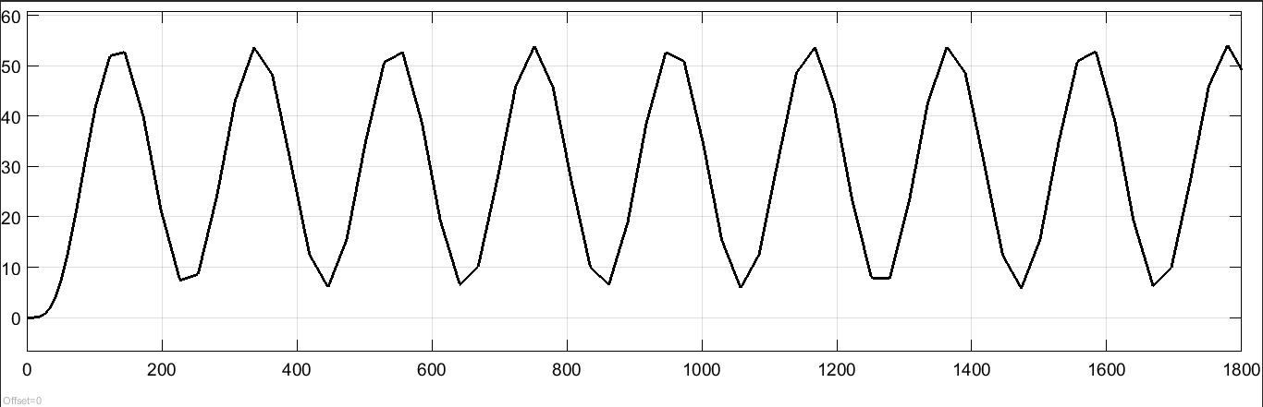

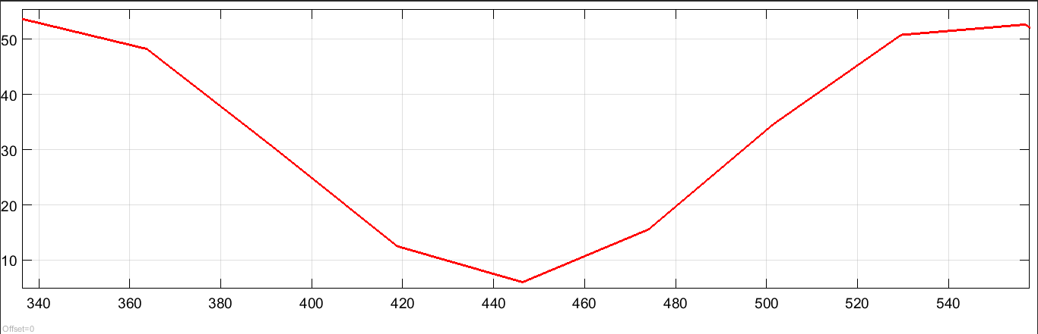

tosc=-336.5-145=191.5

the choose of kp, ki and kd by a trial because tosc is great

kp= 0.4

ki=0.0125

kd=15 with N=1

**transfert function identification : in matlab (command window)**

Inter your data in workspace with instruction Data=xlsread('Data.xlsx');

u=data(:,3)

y=data(:,4)

go to rebon apps

choose

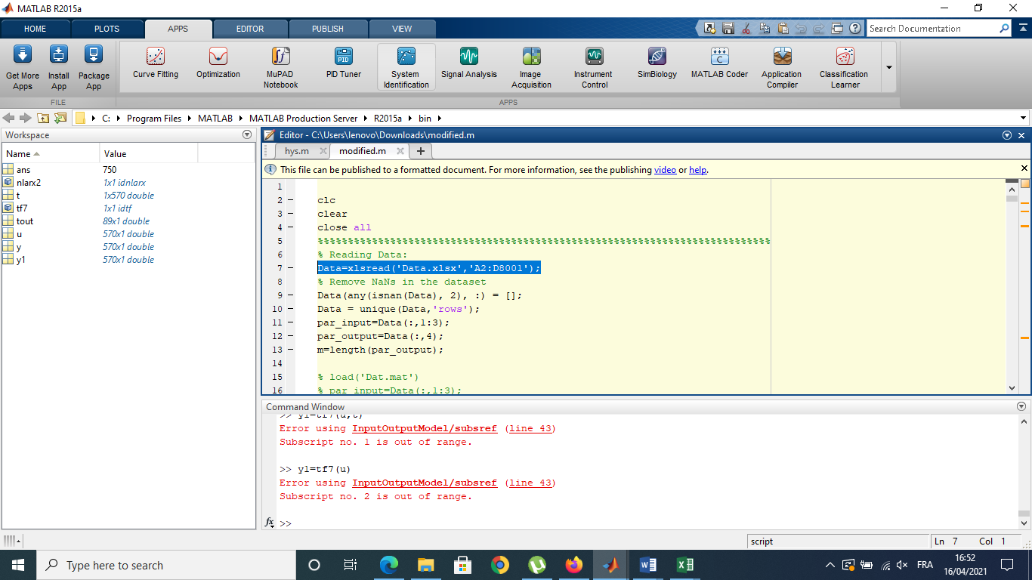

And Follow the steps import data choose time domain data

Then in the list estimate choose transfer function model

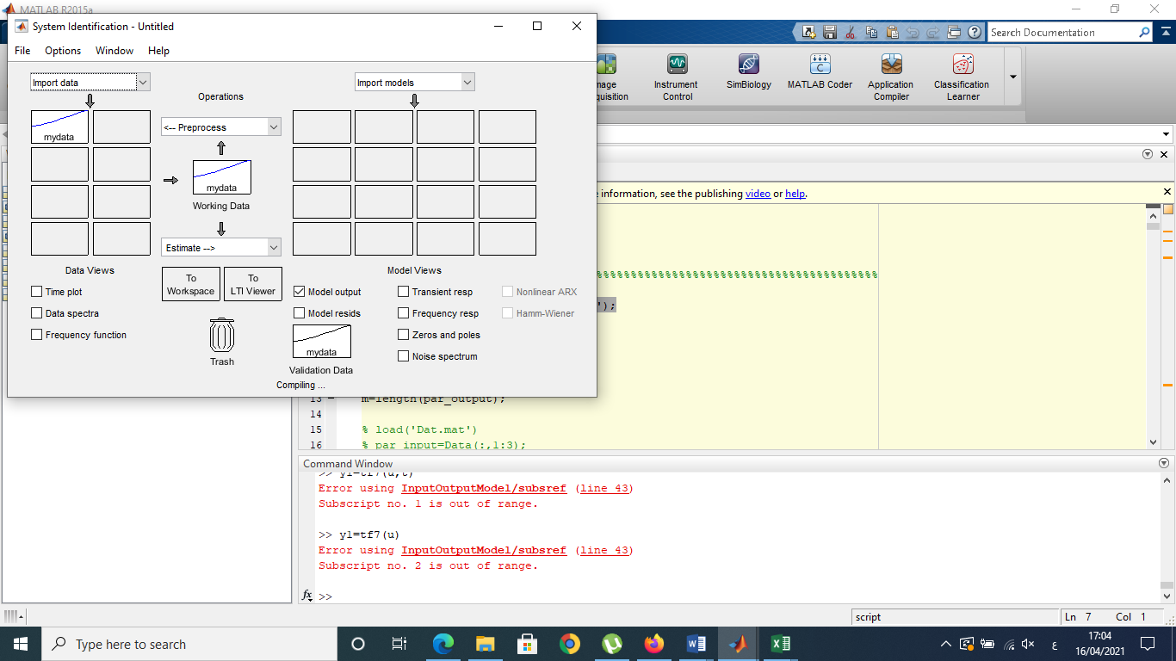

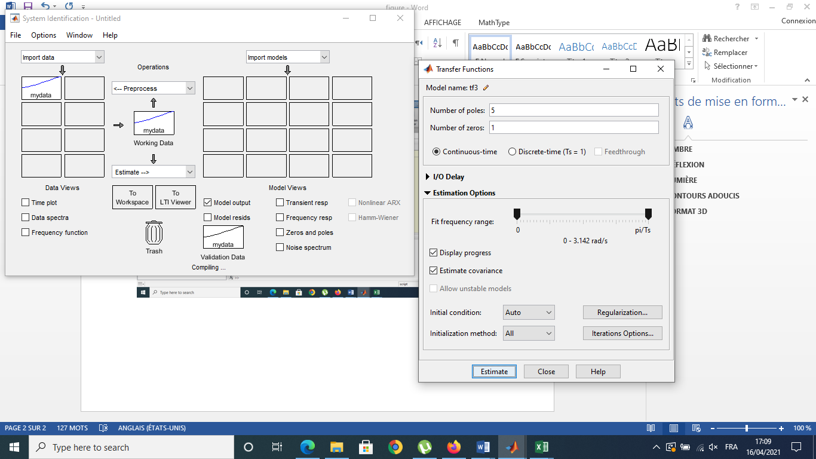-+

In this step try to change the pole name and the number of zero until getting   
The exact model

In our case 5 poles and 1 zero give perfect result

