Dutch Property Values: A Municipal Analysis
  - Analyzing WOZ Trends Across the Netherlands (2016 - 2024)
Reproducible Research Demo
2026-01-29
 Not a real research!
Don’t mind the narrative but the data is real.

1 Introduction
The Dutch housing market has experienced remarkable changes over the past decade. Property values, as measured by the WOZ (Waardering Onroerende Zaken) valuations, serve as a key indicator of real estate market dynamics (Vries et al. 2009). These official government valuations are used for property taxation and reflect market conditions across municipalities.
This analysis examines the evolution of property values across Dutch municipalities using data from Statistics Netherlands (CBS). We address the research question:
How have property values evolved across Dutch municipalities since 2016, and what spatial patterns emerge?
Our analysis uses R for data processing, statistical modeling, and visualization, demonstrating Quarto’s capabilities for reproducible research.

2 Data
We use the CBS Kerncijfers Wijken en Buurten (Key Figures for Neighborhoods and Districts) dataset (Statistics Netherlands (CBS) 2024), which provides annual statistics at the municipality (gemeente) level.
The dataset contains 3,236 observations covering 408 municipalities from 2016 to 2024.
Table 1: Data summary by year
year | Municipalities | Mean WOZ (€1000) | Median WOZ | Min WOZ | Max WOZ
2016 | 390 | 222.15 | 219.50 | 122 | 554
2017 | 380 | 226.96 | 224.00 | 121 | 588
2018 | 375 | 237.19 | 233.00 | 126 | 637
2019 | 355 | 258.33 | 250.00 | 131 | 681
2020 | 355 | 277.07 | 266.00 | 138 | 735
2021 | 352 | 296.08 | 284.50 | 148 | 775
2022 | 345 | 324.37 | 314.00 | 167 | 829
2023 | 342 | 374.01 | 363.00 | 195 | 925
2024 | 342 | 387.80 | 380.00 | 199 | 900

Beyond WOZ values, the dataset includes housing stock composition (see Figure 4 in the Section 8).

3 WOZ Trends

3.1 Growth Rate Methodology
We calculate the percentage growth in WOZ values for each municipality using the formula:
$$g_{i}=\frac{{\text{WOZ}}_{i,t_{1}}−{\text{WOZ}}_{i,t_{0}}}{{\text{WOZ}}_{i,t_{0}}}×100 \left(1\right)$$
where $g_{i}$ represents the total percentage growth for municipality $i$ over the 2016–2024 period.

3.2 Major Cities
Figure 1 shows the evolution of property values in the 4 largest Dutch cities (G4): Amsterdam, Rotterdam, Den Haag, and Utrecht .
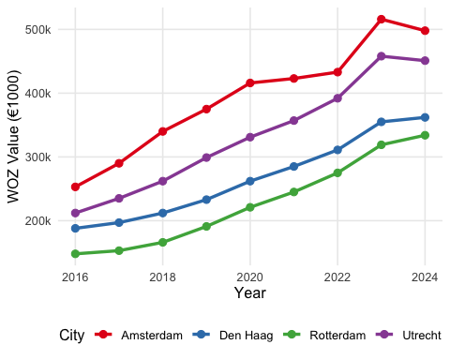
Figure 1: WOZ Value Trends in Major Dutch Cities (2016-2024)
Amsterdam shows the highest property values throughout the period, with WOZ values reaching €498k in 2024. The gap between Amsterdam and other cities has remained substantial.
The growth rates for the G4 cities between 2016 and 2024 are:
Table 2: WOZ Growth in Major Cities (2016-2024)
City | WOZ 2016 | WOZ 2024 | Growth (%)
Rotterdam | 148 | 334 | 125.7
Utrecht | 212 | 451 | 112.7
Amsterdam | 253 | 498 | 96.8
Den Haag | 188 | 362 | 92.6

4 Regression Analysis
To estimate the average annual growth rate across municipalities while controlling for municipal fixed effects, we estimate a panel regression model. Similar approaches using hedonic pricing models have been applied to Dutch real estate appraisals (Guliker, Folmer, and Sinderen 2022). We estimate:
$$log\left({\text{WOZ}}_{it}\right)=α+β⋅t+γ_{i}+ε_{it} \left(2\right)$$
where:
- ${\text{WOZ}}_{it}$ is the WOZ value for municipality $i$ in year $t$
- $β$ captures the average annual growth rate (in log points)
- $γ_{i}$ are municipality fixed effects
- $ε_{it}$ is the error term
The regression results indicate an average annual growth rate of 7.6% in WOZ values across Dutch municipalities (see Equation 2). This estimate is based on 3,233 observations across 408 municipalities.
Table 3: Panel Regression Results
fe_model
Dependent Var.: log_woz
Year (from 2016) 0.0733*** (0.0006)
Fixed-Effects: ------------------
region Yes
________________ __________________
S.E.: Clustered by: region
Observations 3,233
R2 0.97703
Within R2 0.93980
---
Signif. codes: 0 '***' 0.001 '**' 0.01 '*' 0.05 '.' 0.1 ' ' 1

5 Spatial Distribution
Figure 2 shows the geographic distribution of WOZ values across Dutch municipalities in 2024.
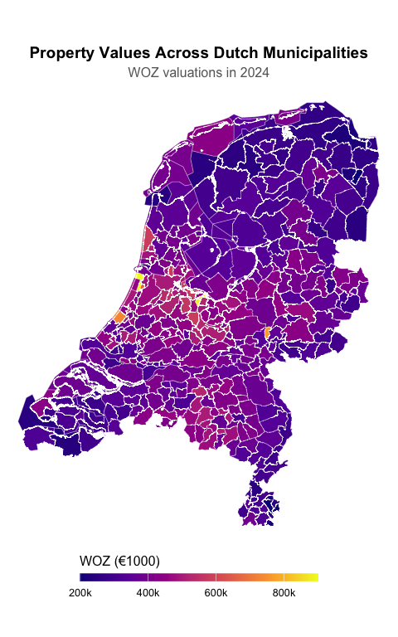
Figure 2: WOZ Values by Municipality (2024)
The map Figure 2 reveals clear spatial patterns: the Randstad region (Amsterdam, Utrecht, The Hague) and areas around Haarlem show the highest property values, while peripheral regions in the north and east have lower valuations (Claassens, Koomen, and Rouwendal 2020).

6 Compound Annual Growth Rate (CAGR) Analysis
Beyond simple growth rates, we can calculate the Compound Annual Growth Rate [CAGR; Cipra (2010)], which provides a smoothed annual rate of return:
$$\text{CAGR}={\left(\frac{{\text{WOZ}}_{t_{1}}}{{\text{WOZ}}_{t_{0}}}\right)}^{1/n}−1$$
where $n$ = 8 years.
 Note
The following figure is embedded from a separate analysis document using Quarto’s embed shortcode, demonstrating modular workflows:

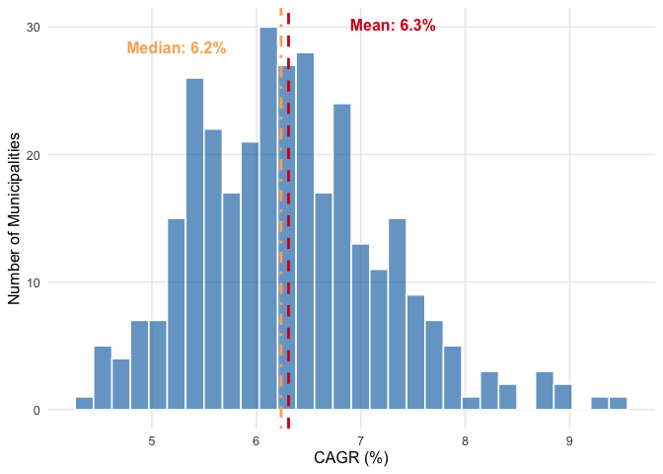
Figure 3: Distribution of Compound Annual Growth Rates

7 Conclusion
This analysis of Dutch property values reveals several key findings:
- Substantial growth: WOZ values increased by an average of 7.6% annually between 2016 and 2024
- Urban premium: Major cities, particularly Amsterdam, maintain significantly higher property values (Musterd, Hochstenbach, and Boterman 2020)
- Spatial patterns: Clear geographic clustering with highest values in the Randstad region
These insights have implications for policymakers, urban planners, and real estate stakeholders in understanding market dynamics and guiding future development.

References
Cipra, Tomas. 2010. Financial and Insurance Formulas. Physica-Verlag HD. https://doi.org/10.1007/978-3-7908-2593-0.
Claassens, Jip, Eric Koomen, and Jan Rouwendal. 2020. “Urban Density and Spatial Planning: The Unforeseen Impacts of Dutch Devolution.” Edited by Eda Ustaoglu. PLOS ONE 15 (10): e0240738. https://doi.org/10.1371/journal.pone.0240738.
Guliker, Evert, Erwin Folmer, and Marten van Sinderen. 2022. “Spatial Determinants of Real Estate Appraisals in the Netherlands: A Machine Learning Approach.” ISPRS International Journal of Geo-Information 11 (2): 125. https://doi.org/10.3390/ijgi11020125.
Musterd, Sako, Cody Hochstenbach, and Willem Boterman. 2020. “Ripples of Structural Economic Transformation: The Changing Social Geographies of Dutch Metropolitan Regions.” Applied Geography 116 (March): 102151. https://doi.org/10.1016/j.apgeog.2020.102151.
Statistics Netherlands (CBS). 2024. “Kerncijfers Wijken En Buurten.” https://www.cbs.nl/nl-nl/reeksen/kerncijfers-wijken-en-buurten.
Vries, Paul de, Jan de Haan, Erna van der Wal, and Gust Mariën. 2009. “A House Price Index Based on the SPAR Method.” Journal of Housing Economics 18 (3): 214–23. https://doi.org/10.1016/j.jhe.2009.07.002.

8 Appendix

8.1 Housing Stock Trends
Figure 4 shows trends in housing stock composition for the G4 cities.
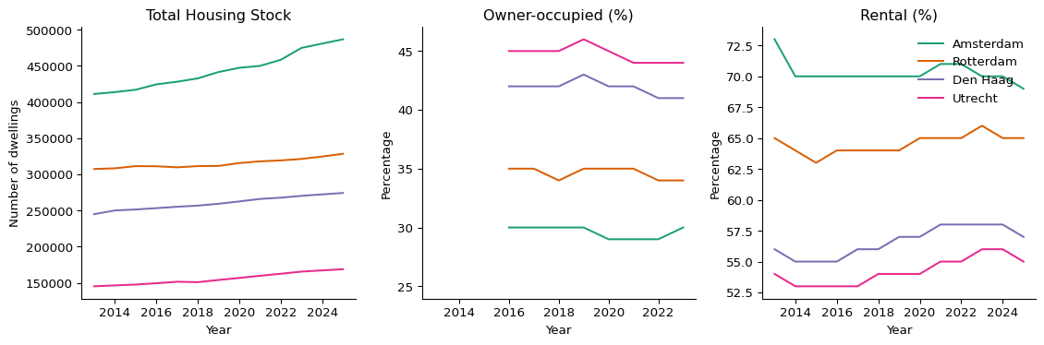
Figure 4: Housing Stock Trends in Major Dutch Cities
Note
Figure 4 is produced using Python and embedded via Quarto’s embed shortcode—demonstrating multi-language workflows.

