C# Notes

C –>Cpp-🡪C#(C me plus do Cpp , Cpp me enhancement C#) # means +4

C# is performance of Cpp and simplicity of Visual basic

C# developed by Andrean heisberg of Denmark

.Net= The Ecosystem (Language + Runtime(CLR) + Libraries(BCL(base class ) func, OSS libraries)

Java code 🡪Bytecode 🡪JVM🡪machine code

C# 🡪IL (with help of CLI)🡪CLR(managed Code)🡪machine code

CLI🡪your entry point,SDK,javac

NuGet🡪npm(in node) , Maven (java)-🡪(Package manager)

C# extension🡪.cs, IL extension🡪.exe,.dll(DOUBT)

.netFramework(only windows) 🡪.NetCore (cross platform)-🡪Mono for Xamarin(mobile dev)

.NetStd🡪Combn(.NetFramework and .NetCore)

.Net5🡪BAAP of ALL(Sab kuch web ,mobile,AI ,IOT)

Both are part of CLR

CTS—Common Type System🡪ref and types—related datatypes

CLS🡪Common Languange System🡪Common language Specification(language compliant)

Architecture of C#

Namespace= collection of logical related classes(just like packages in java)

For example 🡪namespaces for data, namespaces for classes, namespaces for images etc

In the real world as namespaces grow , we need a diff ways to partition an application,Hence came the introduction of ASSEMBLIES

An Assembly is a container for related namespaces.Physically it’s a file under the disc which can either be executable or dll(dynamic link libraries)

So when you compile an application, the compiler builds one or more assemblies depending upon how you partition your code.

A console applcn is an applicn which doesn’t have GUI

C# program fundamentals

References- assembly which our program refers and use . For eg, System , System.Data etc

App.config—Xml which includes connections to database and other such settings about your applications.

C# is case-sensitive language

Variables and consts are same as java

Pascal and CamelCase innovation are used.

Local variables: camel case

Const variable :pascal case

DATATYPES

PRIMITIVE Datatypes

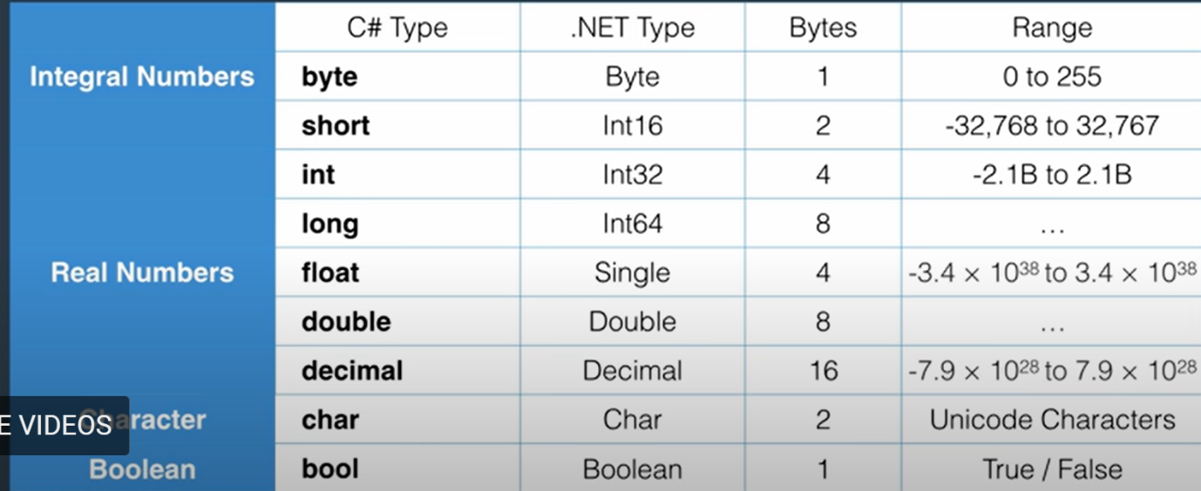

Double is the default type for real numbers.

For example: float number= 1.2f

Decimal number=1.2m

For the rest float and decimal we have to explicitly specify.

NON-PRIMITIVE

Array, Enum, Class ,String

OVERFLOWING—check (Read Article)

For Compiling code in VS-cntrl +shift +B, run=cntrl +f5

var(like javascript) is used for automatic default datatype selection,

#var only for DEFAULT DATATYPE SELECTION

var a=8🡪integer

var b=1.2🡪double

but agar default nahi chhaye , you want explicit datatype to then specify

eg byte a =2;

TYPE CONVERSIONS

Explicit byte a=1, 1000 check code(DOUBT)

Value datatype, reference datatype , pointer datatype

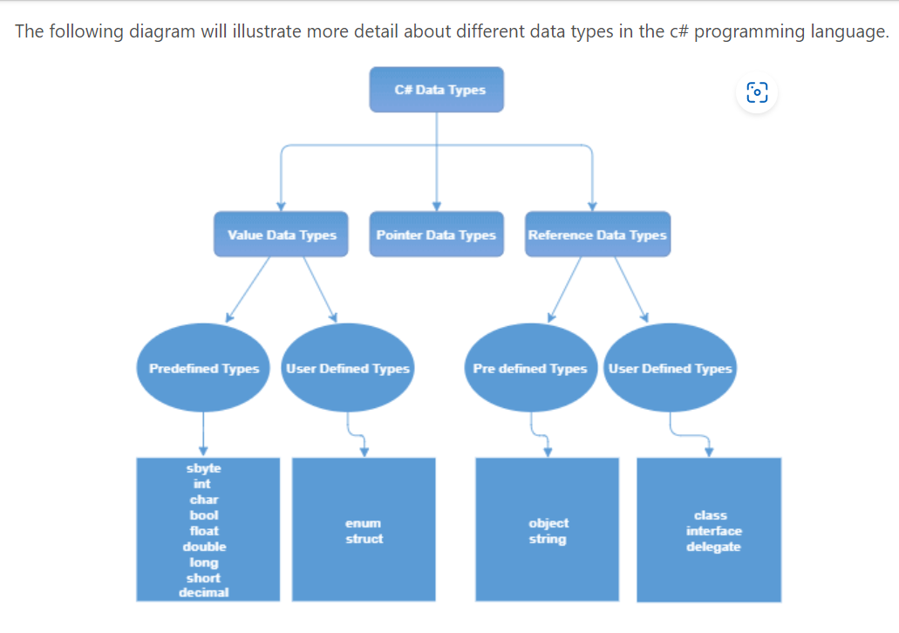

Null string and Empty string are diff

Out parameters 🡪Doubt

Array—Single, MultiDimensional , Jagged array

[,]🡪2D array

[][]🡪Jagged Array

Switch statement 🡪char, int, string, bool, enum(string and bool are extra)

Switch case w/o goto, break, return compile time error

Inheritance base class—base() keyword(parameteerised constructor)

Doubt

Auto-implemented property

Method hiding and Method Overriding

[Overriding Vs Shadowing in C# (c-sharpcorner.com)](https://www.c-sharpcorner.com/UploadFile/ff2f08/overriding-vs-shadowing-in-C-Sharp/)

Access specifier🡪internal, protected internal

Exception Handling🡪throw and propagation upwards

Delegates