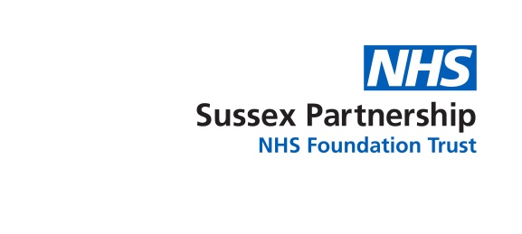
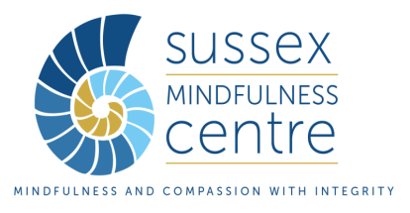

Sussex Mindfulness Centre Foundation training

in Mindfulness-based Approaches (MBCT/MBSR)

Application form (external) 2021

(for people who are not employed by Sussex Partnership or for SPFT employees who are self-funding the training in their own time)

Before completing this form, please read the 2021 Handbook for Foundation Training in Mindfulness-based Approaches available from:
http://sussexmindfulnesscentre.nhs.uk/train-to-teach-mindfulness/

Your details
Your full name:

Your Job title:

Your professional training/background:

If you are employed, please give brief details of your role:

Your correspondence address:

Your email address(es):

Your telephone number(s):

So we can understand how to best let people know about our work, please tell us where you heard about this training:

Your experience of mindfulness and group work
Please tell us something about your personal practice, including how long and how regularly and over what time frame you have been practising mindfulness meditation, and other related disciplines such as yoga or Qi Gong.

When, where and with whom, did you do the 8 week MBCT or MBSR course as a participant?

Can you tell us about any experience of having led MBCT / MBSR or mindfulness meditation groups or having used mindfulness meditation in your work?

Can you tell us about any experience of having run groups (not necessarily mindfulness groups)?

Can you tell us about any other clinical or other experience relevant to running mindfulness groups?

Your use of the training and attendance
Why do you want to do this training? How do you plan to use it?

Having read the course handbook, do you foresee any difficulties attending any aspect of the training (please refer to the handbook for dates)? Please give details.

Do you have any current stress factors or vulnerabilities that it would be helpful for us to know about that may impact on your completion of the training or for which it might be helpful to have additional support? This will not affect your chances of getting to the next stage of selection, but we would like to discuss it with you face to face.

Funding of the training – manager approval if not self-funding
The fee of £3,950 will need to be paid to Sussex Partnership Foundation Trust in full by the 3rd February 2021. Payment by instalments can be arranged if needed. You will pay for the retreat separately, as detailed in the handbook.
Please state if you will be self-funding or if an organisation or employer will be funding this training:

(If self-funding, please ignore next section)
If you are planning for an organisation or employer to fund this training, then funding must be agreed with an authorising manager before submitting this application. Please ask the authorising manager responsible for your funding to sign here to indicate that funding has been agreed if a place is offered:

Signature of manager:

Date:

Name of manager:

Title of manager:

Organisation:

Manager’s contact telephone:

Manager’s email:

Signature of applicant | Date
For the applicant: Please return the application form to smc@sussexpartnership.nhs.uk, or post to Sussex Mindfulness Centre, Psychology and Psychological Therapies Department, Aldrington House, 35 New Church Road, Hove, BN3 4AF. They should arrive before 9th November 2020.

Interviews will be on 30th November, 1st December and 2nd December 2020 in Brighton or online, depending on social distancing restrictions. For any queries please telephone 0300 304 2057.

Applicants who are external to Sussex Partnership NHS Foundation Trust (SPFT) are welcome to submit their applications early and to request an earlier interview date.

Thank you for completing this form. Please find overleaf an equality monitoring form, which will be separated from your application form prior to selection.

Equality Monitoring Information
Sussex Partnership NHS Foundation Trust recognises and actively promotes the benefits of a diverse workforce. Completing this form is optional but is also a vital part of monitoring equality of opportunity in this scheme; the answers you give will be anonymous and not be reviewed by those selecting to the training.

Country of Birth
Nationality
Age | 18-24☐ 25-34 ☐ 35-44 ☐ 45-54 ☐ 55-64 ☐ 65-74☐ 75+☐
Do you consider yourself to have a disability?  *Please state the type of impairment which applies to you | Yes*☐ | No☐ | Prefer not to say☐
 | Physical Impairment☐ | Learning Difficulty / Disability ☐ | Sensory Impairment☐
 | Mental Health Problems ☐ | Long-standing illness☐ | Other☐
Ethnic Origin | WHITE (A)British ☐ | WHITE (B) Irish☐ | WHITE (C) Any other White Background ☐
Ethnic Origin | MIXED (D) White and Black Caribbean ☐ | MIXED (E) White and Black African ☐ | MIXED (F) White and Asian ☐
Ethnic Origin | MIXED (G) Any other mixed background ☐ | ASIAN or ASIAN BRITISH (H) ☐ | ASIAN or ASIAN BRITISH (J) Pakistani☐
Ethnic Origin | ASIAN or ASIAN BRITISH (K) Bangladeshi☐ | ASIAN or ASIAN BRITISH (L) Any other Asian background☐ | BLACK or BLACK BRITISH (N) African☐
Ethnic Origin | BLACK or BLACK BRITISH (P) Any other Black background☐ | OTHER ETHNIC GROUP (R) Chinese☐ | OTHER ETHNIC GROUP (S) Any other ethnic groups☐
Ethnic Origin | Prefer not to say☐
Gender | Male ☐ | Female ☐ | Non-binary ☐
Gender | Trans ☐ | Intersex person ☐ | Prefer not to say ☐
Gender | Prefer to self-describe:
Sexuality | Lesbian☐ | Gay☐ | Bisexual☐
Sexuality | Heterosexual ☐ | Other ☐ | Prefer not to say ☐

