start up | shut down | maintenance

Crackling Data Machine
mixed media installation (2014 - 2016)
85 x 100 x 66 cm, steel, single board computers, printer, sound, paper and custom software
Ali Tnani & Lukas Truniger

artist contact details in case of technical problems:
email: lukas.truniger@gmail.com
cell phone: +33 7 82 99 35 15

start up

-plug in mains power
-wait for 60 – 120 seconds for computer to start and the printer and sound to begin
-verify printing (ink and paper)

shutdown

-shutdown is automatically initiated at 19:00 of each day

maintenance

→ if the printer or sound is not working
1. unplug the mains power, wait for 30 seconds, replug the mains power, wait for the printer and sound to restart
2. if it is still not working: exchange the sd card (cf. image below) and contact the artists
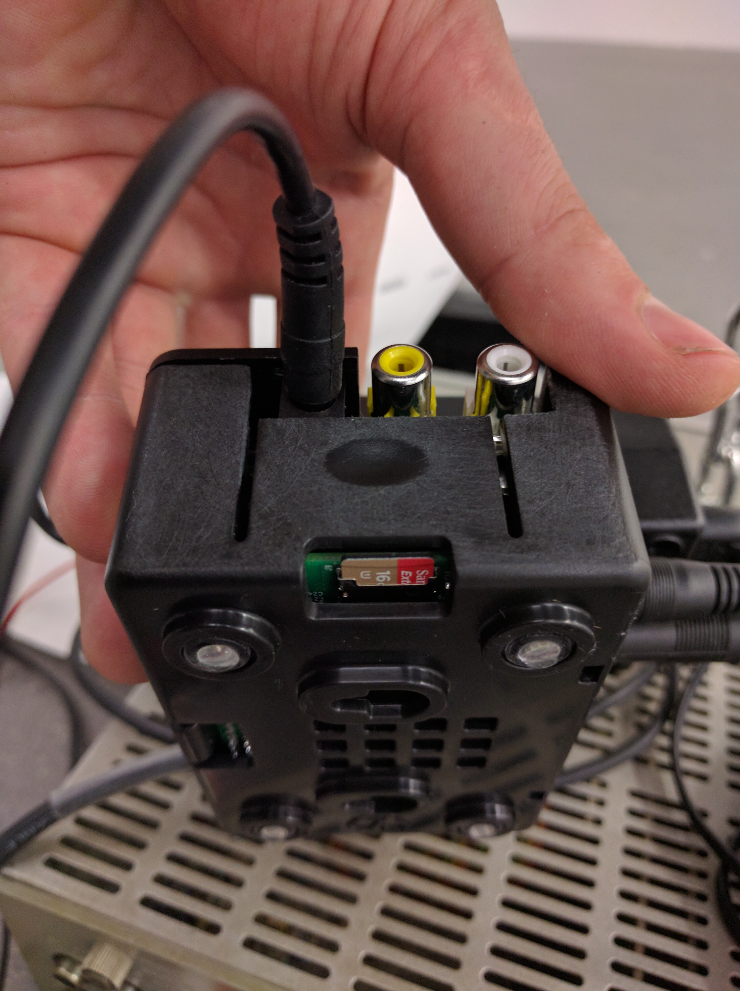
→ if paper roll is finished
unlock the carabiner (cf. image below), remove the steel cable from the carabiner, remove the remaining cardboard tube from the steel cable, prepare the paper roll (remove packaging, remove sticker) ad a new paper roll (cf. direction), put back the steel cable into the carabiner
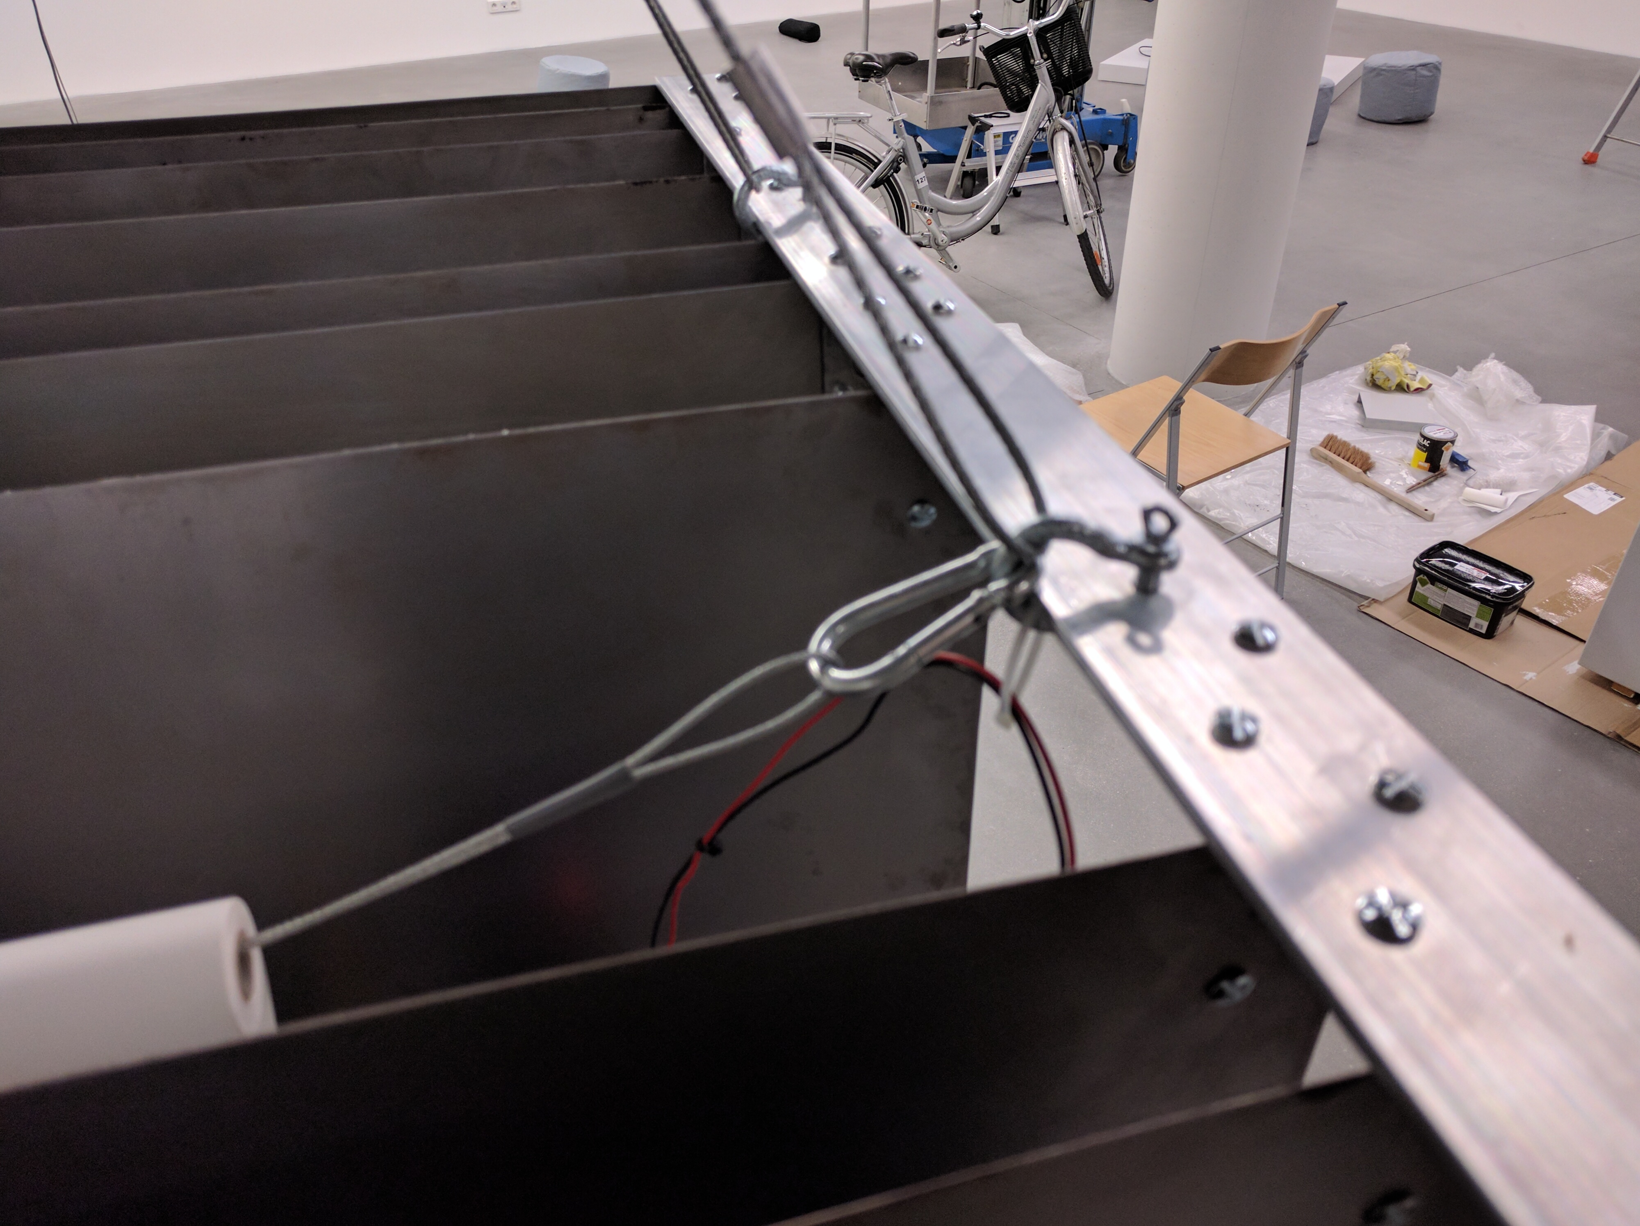
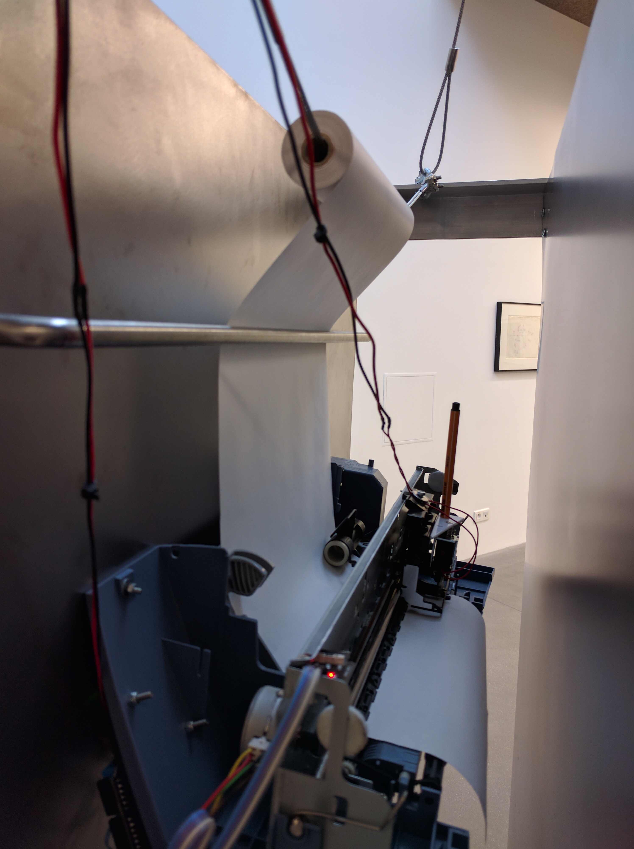

→ if ink of pen is empty
1. take the “pen change tool” (cf. image below), place it on top of the pen holder of the printer and gently pull and turn the pen, until it comes of (cf. image below)
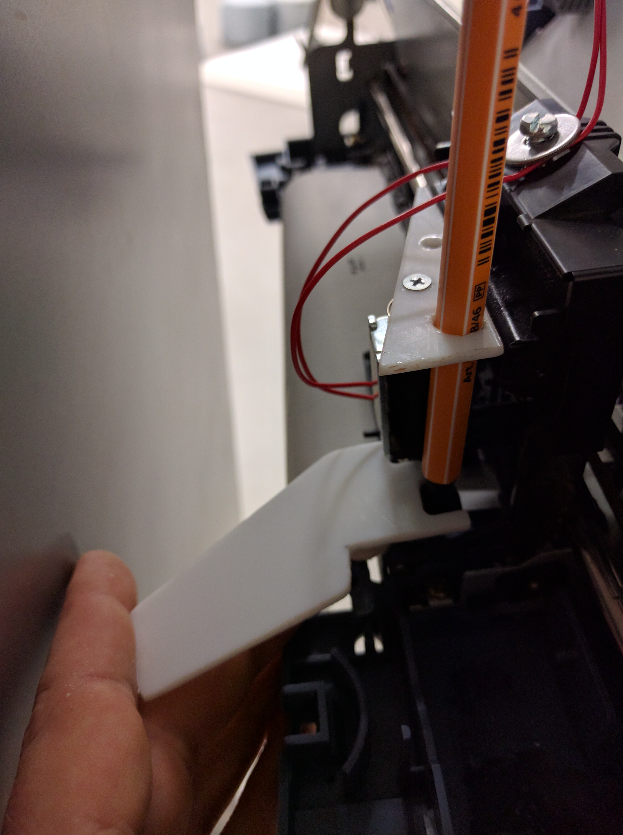
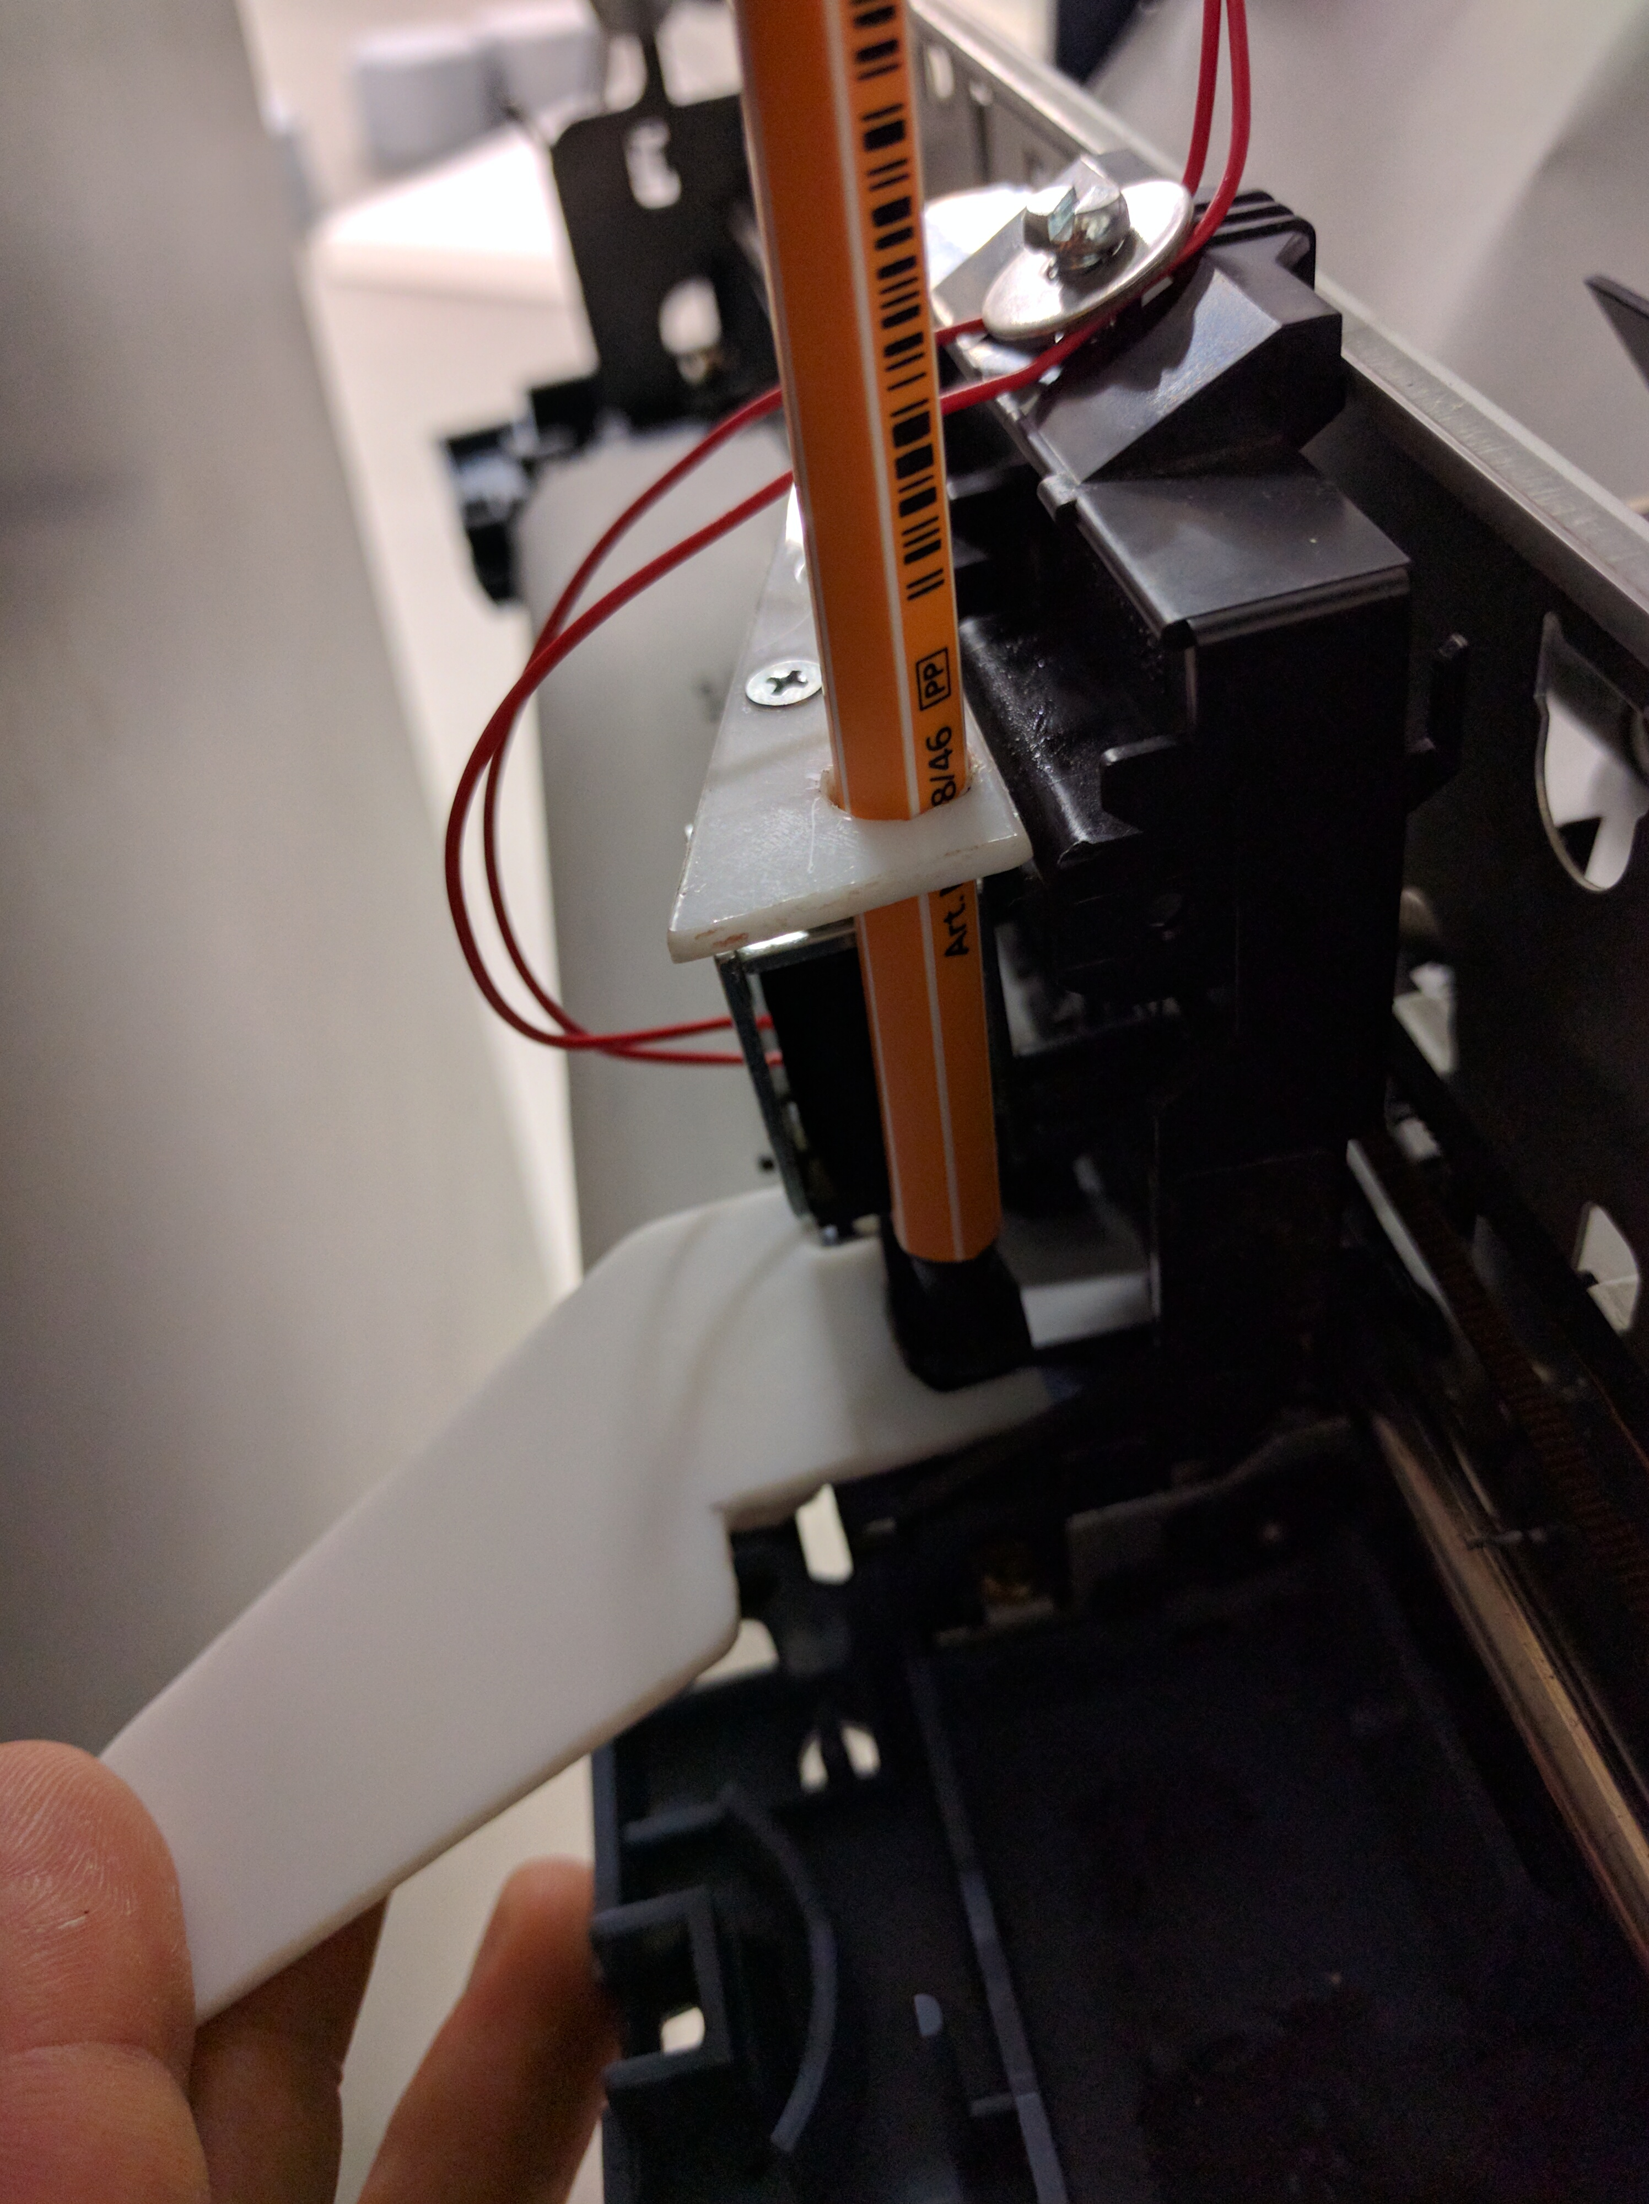
2. take a new pen, place the “pen change tool” under the pen holder and gently turn and push the pen, until it holds firmly in the pen holder of the printer (cf. image below)

