Index

1 Overview 2

2 System description 2

2.1 Data flow 2

2.2 Hardware 2

2.2.1 Main computer 2

2.2.2 HUB 2

2.2.3 Nodes 2

2.3 Software 2

2.3.1 Database 2

2.3.2 Python 2

2.3.3 Arduino HUB 2

2.3.4 Ardino Node 2

2.3.5 Webapp 2

2.3.6 CRUD 2

2.4 System Requirements 2

2.5 Installation 2

2.6 Configuration 2

# Overview

Inserire qui overview

# System description

## Data flow

## Hardware

### Main computer

### HUB

### Nodes

## Software

### Database

### Python

### Arduino HUB

### Ardino Node

### Webapp

### CRUD

## System Requirements

Hardware

Main unit and hub

A computer with a Linux distribution (Ubuntu 14 and above) + Arduino Due

Or

Integrated PC with Arduino Embedded (Udoo Quad <https://www.udoo.org/udoo-dual-and-quad/>)

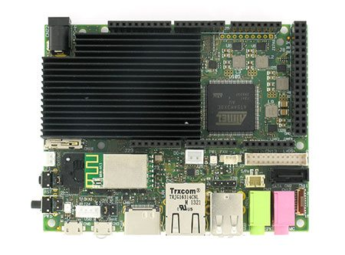

SATA Hard disk or SSD (from 32Gb)

Xbee S2 or Xbee SC

End nodes

Arduino Fio, Arduino Fio V3, Arduino Mini Pro

Xbee S2 or Xbee SC

Software

|  |  |  |  |
| --- | --- | --- | --- |
|  |  | Version | Options and modules |
| Linux OS | Ubuntu | 14.04 and above |  |
|  | Apache 2 |  |  |
|  | MySQL | 5.6 |  |
|  | PHP | 5.5 |  |
|  | Arduino IDE | 1.6.3 and above |  |
|  | Python | Min 3.4.4 | pyserial  mysql.connector  pytradfri |
|  |  |  |  |

## Installation

Install Linux

Install Lamp (Linux Apache MySQL PHP)

sudo apt-get install apache2

sudo apt-get install mysql-server

sudo apt-get install php5 libapache2-mod-php5

Restart

Complete instruction [here](http://howtoubuntu.org/how-to-install-lamp-on-ubuntu)

Install Python

This section describes how to install Python 3.6 on Ubuntu Linux machines.

To see which version of Python 3 you have installed, open a command prompt and run

$ python3 --version

If you are using Ubuntu 16.10 or newer, then you can easily install Python 3.6 with the following commands:

$ sudo apt-get update

$ sudo apt-get install python3.5

If you’re using another version of Ubuntu (e.g. the latest LTS release), we recommend using the deadsnakes PPA to install Python 3.6:

$ sudo add-apt-repository ppa:fkrull/deadsnakes

$ sudo apt-get update

$ sudo apt-get install python3.5

If you are using other Linux distribution, chances are you already have Python 3 pre-installed as well. If not, use your distribution’s package manager. For example on Fedora, you would use dnf:

$ sudo dnf install python3

Note that if the version of the python3 package is not recent enough for you, there may be ways of installing more recent versions as well, depending on you distribution. For example installing the python36 package on Fedora 25 to get Python 3.6. If you are a Fedora user, you might want to read about multiple Python versions available in Fedora.

Complete instructions [here](http://docs.python-guide.org/en/latest/starting/install3/linux/)

Install additional modules in Python

PySerial

sudo pip3 install pyserial

mysql.connector

Pytradfri (required for Ikea Tradfri smartlights)

## Configuration