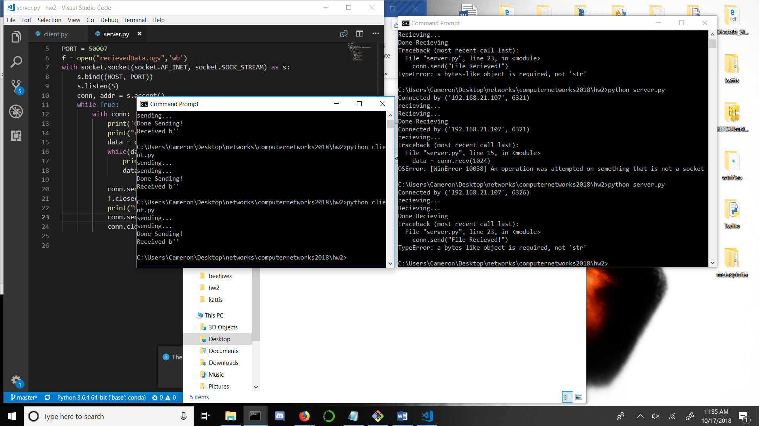

While some errors were received, connection was made and file was sent to server and written in same folder as server.py:

