Exercise 2.A Improving Weak Prompts

1. Explain Regression
Improved Prompt:
Explain linear regression in simple terms with an example related to business or real-world data. Include what it is used for and how it helps in data analysis.
Why this prompt is stronger:
This prompt is clearer because it asks for simple language, a real-world example, and specifies the topic (linear regression). It guides the AI to give a more useful and focused answer.
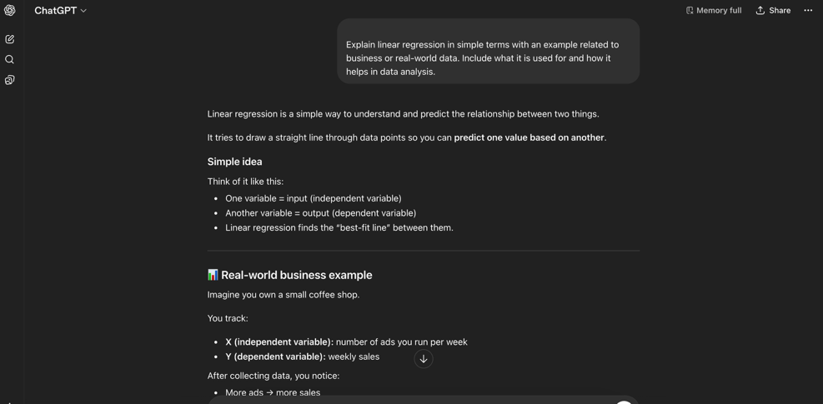

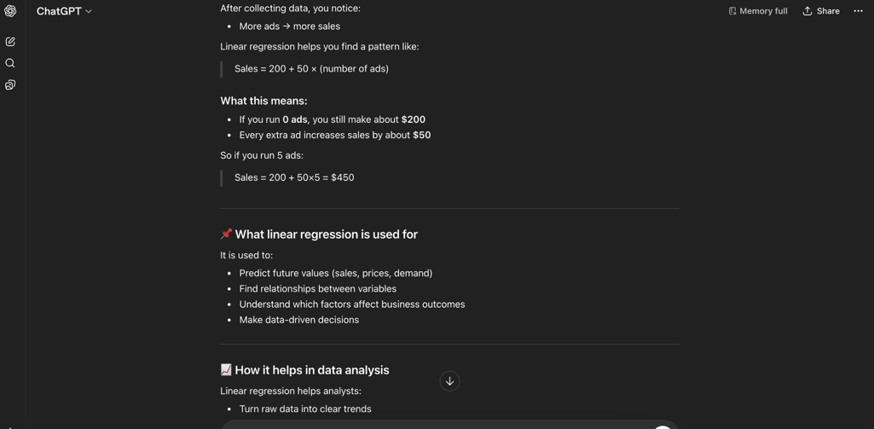
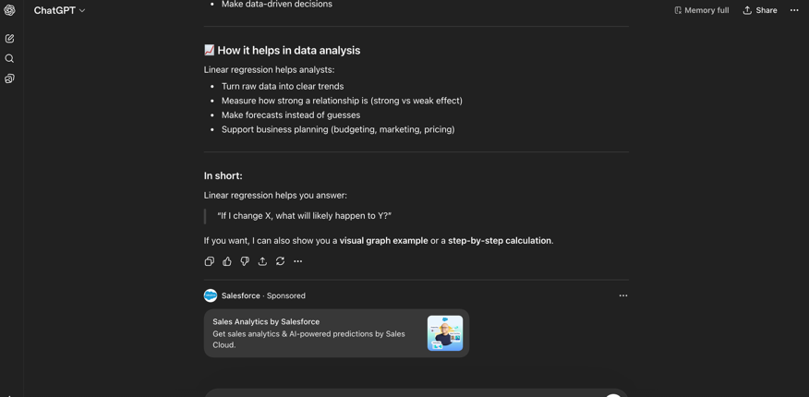

2. Help me understand SQL
Improved Prompt:
Explain SQL basics for beginners. Include what SQL is, why it is used in data analytics, and give simple examples of SELECT, INSERT, and WHERE commands.
Why this prompt is stronger:
This prompt is stronger because it defines the audience (beginners), specifies what topics to include, and requests examples to make learning easier.

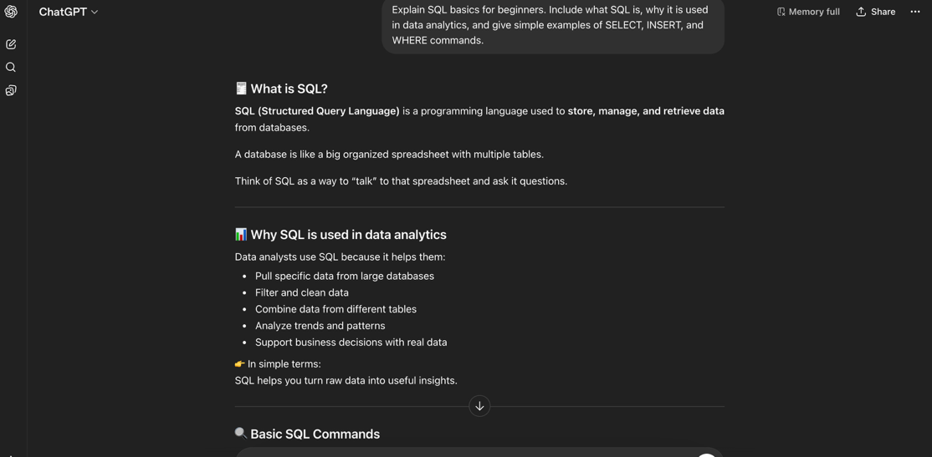
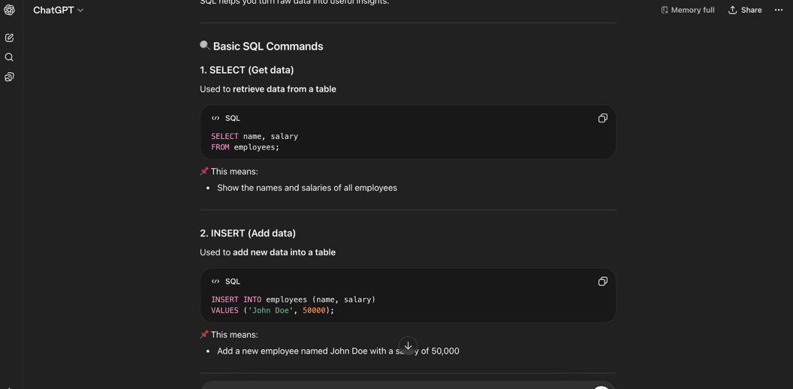
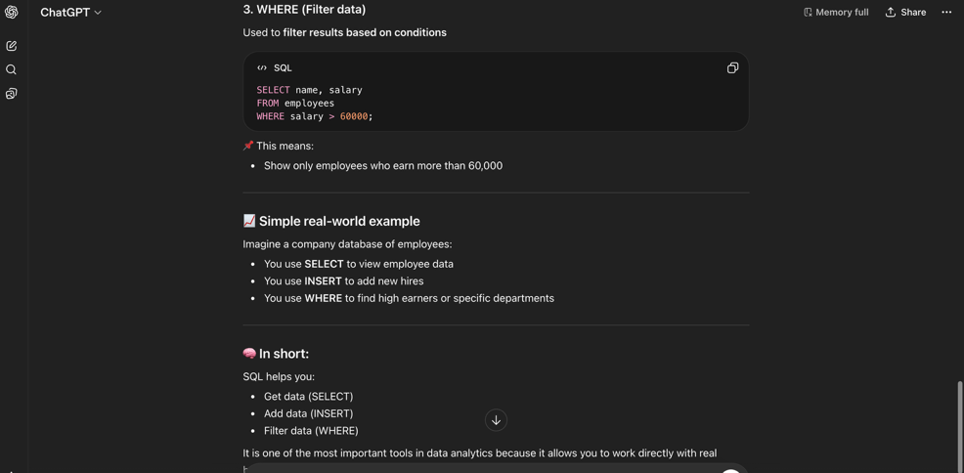

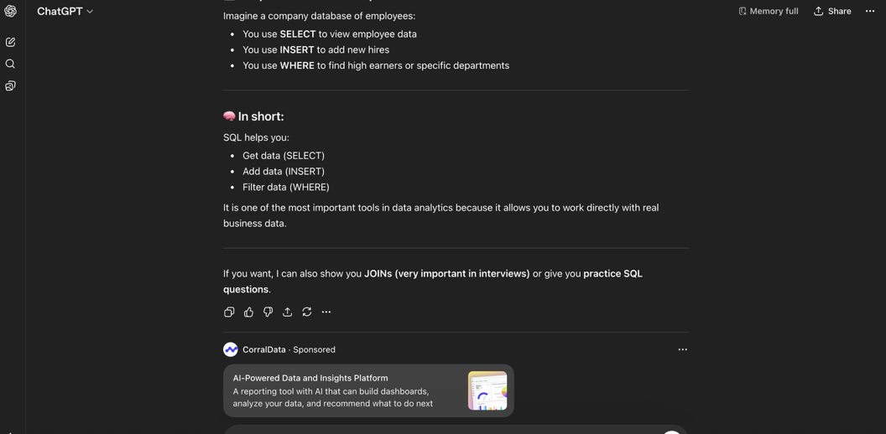

3. Create a Dataset
Improved Prompt:
Create a simple sample dataset for a data analytics beginner. The dataset should include 10 rows and columns such as Name, Age, Job Title, Salary, and Location. Provide it in a table format.
Why this prompt is stronger:
This prompt is more specific because it defines the size of the dataset, the column names, and the format (table), making the output more useful.

