Eyerusalem Debero

04/03/2026

Exercise 2.B: Creating a Learning Project

ChatGPT Project Instructions
I created a project called Data Analytics Academy and used persistent instructions to guide the AI. The instructions I set were:
You are my data analytics learning assistant. Explain concepts clearly for a beginner. Use simple examples with small numbers. Ask follow-up questions to test my understanding.

Test Prompt
I used this prompt to test the project:
What is correlation in data analysis?

AI Response (What I got)
Correlation in data analysis means how two variables move in relation to each other.
In simple terms:
- If one thing goes up and the other also goes up → positive correlation
- If one goes up and the other goes down → negative correlation
- If there is no clear pattern → no correlation
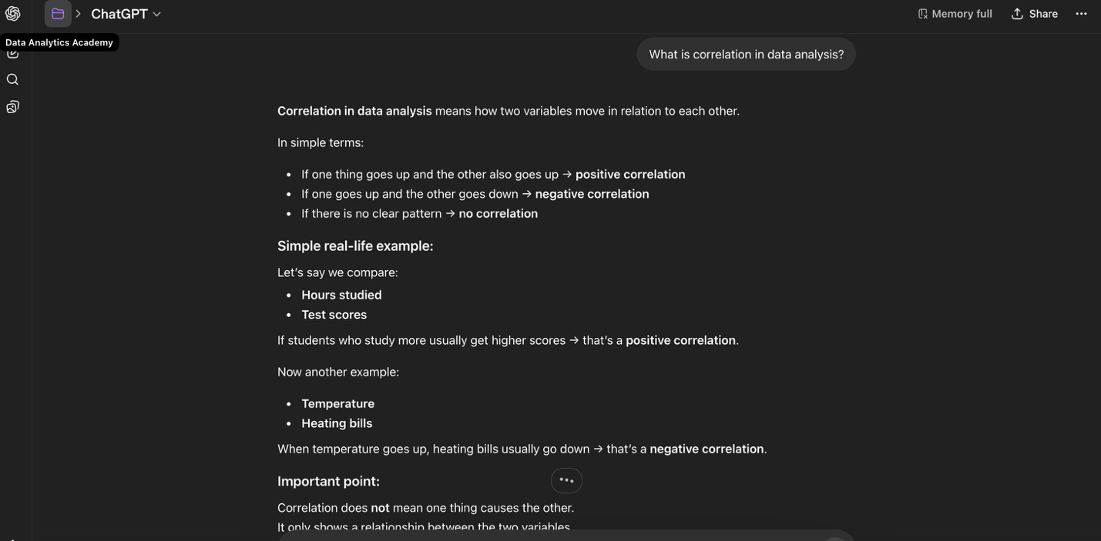
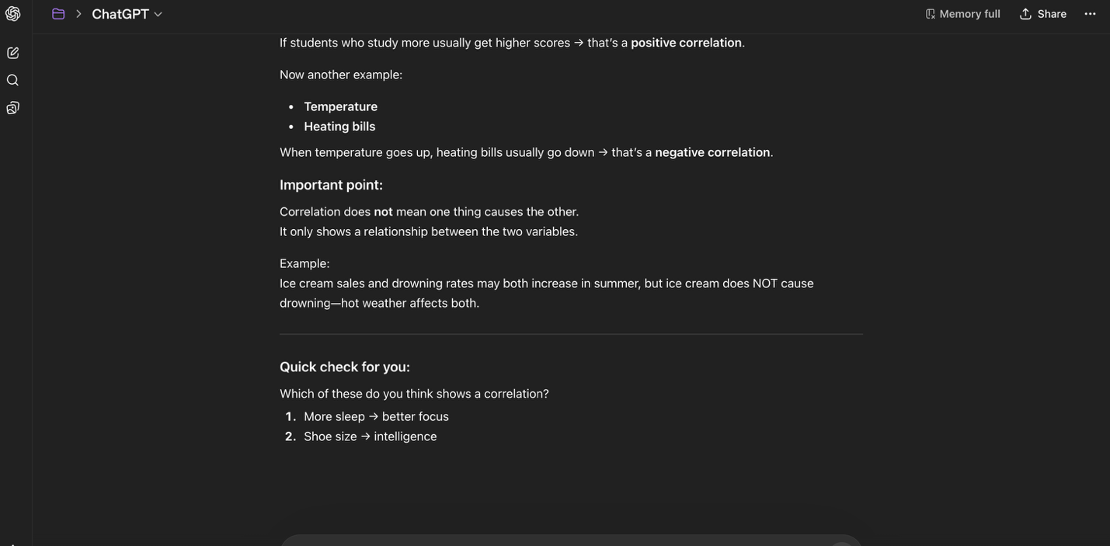

Simple real-life example:
Hours studied → Test scores
Students who study more usually get higher scores → positive correlation
Temperature → Heating bills
When temperature goes up, heating bills go down → negative correlation

Important point:
Correlation does not mean one thing causes the other. It only shows a relationship between variables.
Example:
Ice cream sales and drowning rates both increase in summer, but ice cream does not cause drowning—weather affects both.

Quick check question:
Which of these shows correlation?
- More sleep → better focus
- Shoe size → intelligence

Reflection (3–4 sentences)
- The persistent instructions helped the AI give a clear and structured explanation. The response was easy to understand because it used simple language and real-life examples. It also included a follow-up question that made me think more about the concept. Overall, the project helped improve how I learn data analytics concepts in a beginner-friendly way.

