Aim: Write A Program To Implement Abstract Class, Implement Interface in Python
- Interface :
Input:
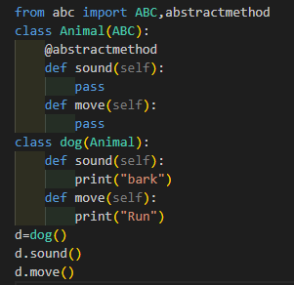
Output:
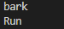
- Abstract Method:
Input:
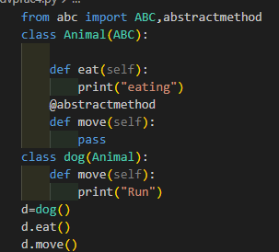
Output:

