PLANT DISEASE DETECTION SYSTEM

ON

AUTOMATED FOLIAR PATHOLOGY CLASSIFICATION IN TOMATO CROPS USING DEEP CONVOLUTIONAL NEURAL NETWORKS AND TRANSFER LEARNING

project report submitted in partial fulfilment of the requirements for the Course

MACHINE LEARNING

BACHELOR OF TECHNOLOGY

In

A.Y.: 2026-27

By

E. YESHWANTH (Roll No: 2520030539 - Draft)

K RAHUL YADAV (Roll No: 2520030468 - Draft)

Under the Esteemed guidance of

Dr.N.Nirmalajyothi

Associate Professor, CSE

Department of Computer Science and Engineering





Abstract
Foliar pathologies in tomato crops (Solanum lycopersicum) pose a catastrophic threat to global agricultural yield, rural economic stability, and food security. Conventional diagnostic methodologies rely heavily on manual field scouting by plant pathologists, which is labor-intensive, scarce in rural farming regions, and prone to subjective misidentification during initial infection phases. This project designs, implements, and empirically validates an automated, end-to-end computer vision system for diagnosing foliar pathologies across 10 distinct tomato leaf conditions (9 diseases and 1 healthy control). The study utilizes a rigorously audited benchmark of 999 digital leaf photographs derived from the PlantVillage archive. Comprehensive quality assurance established zero corrupted images and zero duplicate files via MD5 cryptographic hashing. To prevent data leakage, a strict stratified partition (70% training, 15% validation, and 15% testing) was enforced, with dynamic data augmentations (flips, rotations, zooms, and contrast shifts) restricted exclusively to training batches. Three deep learning architectures were comparatively benchmarked: a baseline custom 3-block Convolutional Neural Network (CNN) trained from scratch, a MobileNetV2 feature extractor leveraging pretrained ImageNet weights, and a fine-tuned MobileNetV2 network. Hyperparameters were systematically tuned on validation data. On the permanently held-out test set (N = 150), the MobileNetV2 feature extractor achieved superior diagnostic performance with an overall test accuracy of 74.67%, macro precision of 75.59%, macro recall of 74.67%, macro F1-score of 0.7258, and a macro ROC-AUC of 0.9639, significantly outperforming the custom CNN (36.67% accuracy, 0.2872 F1-score). The optimal serialized model was successfully integrated into an interactive Flask web application providing real-time foliar classification, confidence scores, pathogen profiles, and targeted curative guidelines, establishing a practical, lightweight solution for precision agriculture.
Keywords: Tomato Leaf Disease, Deep Convolutional Neural Networks, Transfer Learning, MobileNetV2, Data Leakage Prevention, Computer Vision

1. Introduction

1.1 Purpose of the Project
Tomato (Solanum lycopersicum) represents one of the most vital horticultural crops globally, underpinning agricultural economies, international trade, and essential nutritional security. However, commercial and smallholder tomato cultivations remain persistently vulnerable to a broad spectrum of destructive foliar pathologies. Pathogenic agents—ranging from aggressive bacteria such as Xanthomonas campestris pv. vesicatoria to fungal blights including Alternaria solani (Early Blight) and Phytophthora infestans (Late Blight), as well as whitefly-vectored viruses like Tomato Yellow Leaf Curl Virus (TYLCV)—frequently infect tomato canopies. If left undiagnosed and unmanaged, these foliar diseases rapidly induce severe chlorosis, necrotic lesion formation, systemic defoliation, and vascular collapse, triggering catastrophic harvest yield losses between 40% and 80%. Consequently, timely, precise, and accessible pathology identification is an existential requirement for sustainable agricultural management.
Conventional phytopathological diagnostic practices rely predominantly on manual visual scouting conducted by experienced agricultural extension officers or university plant pathologists. In real-world agricultural belts, however, this paradigm encounters severe logistical bottlenecks. Qualified plant pathologists are severely scarce across rural communities, physical scouting across expansive crop acreages is prohibitively labor-intensive and slow, and early-stage symptomatic manifestations often present overlapping visual phenotypes (such as indistinguishable chlorotic haloes or minute necrotic specks) that mislead manual scouting. These delays frequently result in indiscriminate prophylactic pesticide over-application, causing environmental pollution, pathogen resistance, and financial distress. Developing an automated, accessible, machine learning-driven computer vision system directly addresses this challenge by providing instantaneous, objective, and repeatable foliar diagnostics from standard digital camera images, empowering farmers and extension personnel to enact targeted, timely agronomic interventions.

1.2 Problem Statement
The core objective of this project is to formulate, implement, empirically evaluate, and deploy an automated multi-class machine learning classification system capable of diagnosing foliar pathologies from standardized digital photographs of tomato leaves. The system takes as input a 3-channel RGB digital photograph standardized to 224 × 224 pixels and predicts the exact pathological condition across 10 mutually exclusive diagnostic categories: 9 distinct foliar diseases (Bacterial Spot, Early Blight, Late Blight, Leaf Mold, Mosaic Virus, Septoria Leaf Spot, Two-Spotted Spider Mites, Target Spot, and Yellow Leaf Curl Virus) and 1 healthy control foliage class. The output encompasses the predicted pathological class, associated Softmax confidence percentage, pathogen taxonomy, severity ranking, and actionable curative recommendations. The investigative scope encompasses establishing a leak-free preprocessing pipeline with cryptographic duplicate elimination, benchmarking a baseline custom 3-block Deep CNN against transfer-learned MobileNetV2 architectures, optimizing hyperparameters strictly on validation data, rigorously evaluating generalized performance on an isolated held-out test partition, and productionizing the optimal inference engine into a responsive web application.

1.3 Existing Methods and Disadvantages
Existing diagnostic methodologies in agricultural pathology can be categorized into biological laboratory assays, expert visual inspection, and classical computer vision algorithms based on handcrafted visual descriptors. Laboratory molecular assays—including Polymerase Chain Reaction (PCR) amplification, Enzyme-Linked Immunosorbent Assays (ELISA), and microbiological culturing—represent the gold standard of phytopathological confirmation. Nevertheless, their widespread in-field adoption is fundamentally constrained because they require destructive leaf tissue sampling, sophisticated thermal cyclers and spectrometers, highly trained technicians, costly chemical reagents, and incubation delays spanning several days. In contrast, classical computer vision workflows historically sought to automate leaf diagnosis by extracting handcrafted mathematical features—such as Scale-Invariant Feature Transform (SIFT) keypoints, Histograms of Oriented Gradients (HOG) for edge profiles, and Gray-Level Co-occurrence Matrices (GLCM) for Haralick texture statistical moments—which were subsequently classified using Support Vector Machines (SVM), k-Nearest Neighbors (k-NN), or Random Forest classifiers.
Despite their historical utility, handcrafted feature extraction approaches suffer from severe methodological disadvantages when applied to foliar pathology. Handcrafted filters depend on rigid, predetermined mathematical formulas that cannot accommodate the non-linear morphological diversity, irregular boundary contours, and complex chromatic gradations that foliar lesions exhibit across varying phenological stages of infection. Furthermore, manual feature engineering collapses rich spatial hierarchies into summary statistical vectors, losing crucial localized contextual cues and exhibiting extreme vulnerability to natural illumination fluctuations, leaf orientation, and minor background clutter. Moreover, while early deep learning studies achieved high nominal classification accuracies on benchmark datasets, many published pipelines suffer from grave methodological deficiencies: rampant data leakage caused by applying synthetic data augmentations prior to dataset partitioning, absence of cryptographic duplicate detection, neglect of isolated hold-out test sets, and a failure to transition academic models into lightweight, edge-compatible web deployment frameworks.

1.4 Proposed System
To resolve the limitations of existing approaches, this project proposes an end-to-end, leak-free deep learning system for automated tomato foliar pathology diagnosis. The system ingests raw leaf images, performs rigorous data audits including cryptographic MD5 hash deduplication and decodability verification across the PlantVillage benchmark, resizes images to uniform 224 × 224 RGB tensors, and scales pixel intensities to [0, 1]. A strict stratified partitioning protocol divides the dataset into training (70%), validation (15%), and testing (15%) subsets, with dynamic data augmentations (random reflections, rotations, zooms, and contrast shifts) applied exclusively during training mini-batch generation to safeguard evaluation integrity. The pipeline empirically benchmarks three architectures: a custom 3-block Deep CNN built from scratch, a MobileNetV2 feature extractor utilizing frozen ImageNet weights, and a fine-tuned MobileNetV2 network. Hyperparameters are tuned systematically on the validation split, and multi-class performance is verified on the permanently isolated test set. The optimal model is serialized into Keras format and integrated into a responsive, modern Flask web application that provides real-time diagnostic classification, confidence ratings, and actionable agronomic remedies.

1.5 Research Objectives( atleast 4)
- Curate and systematically audit a standardized tomato foliar disease benchmark dataset comprising 999 digital images across 10 diagnostic categories from the PlantVillage repository, verifying zero corrupted files and zero duplicate instances.
- Formulate and implement a leak-free preprocessing and dynamic data augmentation pipeline with strictly stratified training (70%), validation (15%), and testing (15%) partitions to guarantee scientific evaluation integrity.
- Design, implement, and train a baseline custom 3-block Convolutional Neural Network from scratch alongside pretrained MobileNetV2 transfer learning and fine-tuned deep architectures.
- Conduct validation-based hyperparameter tuning across learning rate schedules and dropout regularization to optimize convergence dynamics and mitigate overfitting.
- Empirically evaluate and benchmark model performance on permanently held-out test data using task-appropriate multi-class metrics (Accuracy, Macro Precision, Macro Recall, Macro F1-Score, Macro ROC-AUC, and Confusion Matrix).
- Productionize the optimal deep learning model into an interactive, real-time web application delivering instantaneous diagnostic predictions, confidence estimates, and agronomic management guidelines.

2. Literature Survey (recent studies from 2-3 years)
To establish the theoretical and empirical context for automated plant disease diagnosis, ten recent, peer-reviewed research studies published within the last two to three years (2023–2024) were comprehensively reviewed. Each study was verified through authoritative publisher indexing and official Digital Object Identifier (DOI) records. Table 2.1 summarizes the literature survey, detailing the specific research gap addressed, experimental methodology, key empirical inferences, and recommended future directions.
S.No. | Title | Reference with DOI | Problem or gap addressed | Objective of the Research | Focus of the paper (Methods used) | Inference | Recommendations for future research
1 | Bayesian optimized multimodal deep hybrid learning approach for tomato leaf disease classification | Das, N. S. F., et al., 2024, Scientific Reports, vol. 14, art. 21525, doi: 10.1038/s41598-024-72237-x | Sub-optimal hyperparameter configuration and high feature dimensionality in multimodal tomato disease classification. | To develop an automated Bayesian-optimized hybrid deep learning framework for accurate tomato foliar disease identification. | Integrated multimodal deep convolutional backbones with automated Bayesian optimization for continuous hyperparameter tuning. | Bayesian optimization substantially reduced hyperparameter search overhead and delivered superior diagnostic convergence over manual tuning. | Evaluate the Bayesian optimization pipeline on resource-constrained mobile hardware with real-time video feeds.
2 | FL-ToLeD: An Improved Lightweight Attention CNN Model for Tomato Leaf Diseases Classification for Low-End Devices | Alnamoly, M. H., Abdel-Hady, A., Abd El-Kader, S. M., & El-Henawy, I. M., 2024, IEEE Access, vol. 12, pp. 73561–73580, doi: 10.1109/ACCESS.2024.3401733 | High computational complexity and large memory footprint of standard CNN architectures preventing deployment on low-cost edge hardware. | To engineer a lightweight, attention-augmented CNN tailored specifically for edge execution on low-end agricultural IoT devices. | Engineered depthwise separable convolutions coupled with lightweight channel and spatial attention modules. | Achieved 97.4% accuracy while curtailing parameter count by over 70%, verifying that lightweight attention nets can match heavy models. | Deploy the attention framework onto micro-controller units (MCUs) with INT8 post-training quantization.
3 | Tomato Leaf Disease Classification via Compact CNNs with Transfer Learning and Feature Selection | Attallah, O., 2023, Horticulturae, vol. 9, no. 2, art. 149, doi: 10.3390/horticulturae9020149 | Redundant feature extraction and computational inefficiency across transfer learning classification heads. | To benchmark multiple compact CNNs and integrate metaheuristic feature selection to isolate optimal diagnostic representations. | Evaluated MobileNet, ShuffleNet, and ResNet-18 combined with PCA and metaheuristic hybrid feature selection algorithms. | Feature selection reduced feature vector dimensionality by 65% without degrading classification accuracy, accelerating inference speed. | Investigate feature selection robustness across cross-crop foliar pathologies in multi-species agronomic settings.
4 | Tomato leaf disease detection based on attention mechanism and multi-scale feature fusion | Wang, Y., Zhang, P., & Tian, S., 2024, Frontiers in Plant Science, vol. 15, art. 1382802, doi: 10.3389/fpls.2024.1382802 | Difficulty detecting fine-grained foliar lesions at early infection phases due to multiscale lesion size variations. | To enhance early-stage lesion discrimination by fusing multiscale spatial features with attention mechanisms. | Multiscale pyramid feature extraction integrated with dual-attention blocks to simultaneously focus on lesion boundaries and texture. | Multiscale feature fusion substantially reduced false negatives in early bacterial spot and target spot detection. | Incorporate temporal lesion growth progression modeling to predict disease progression trajectories over time.
5 | A lightweight dual-attention network for tomato leaf disease identification | Zhang, E., Zhang, N., Li, F., & Lv, C., 2024, Frontiers in Plant Science, vol. 15, art. 1420584, doi: 10.3389/fpls.2024.1420584 | Background noise interference from soil, greenhouse fixtures, and non-target foliage degrading model reliability. | To suppress complex background artifacts and amplify salient foliar pathology representations using dual attention. | Constructed a dual-attention CNN architecture decoupling spatial coordinate attention from channel-wise feature dependencies. | Dual attention effectively decoupled background greenhouse clutter from pathological foliage spots, improving field robustness. | Integrate semantic segmentation heads to produce pixel-level lesion boundary delineations for automated severity quantification.
6 | A ResNet50-DPA model for tomato leaf disease identification | Liang, J., & Jiang, W., 2023, Frontiers in Plant Science, vol. 14, art. 1258658, doi: 10.3389/fpls.2023.1258658 | Vanishing gradient effects and loss of fine-grained textural cues in deep residual networks during foliar classification. | To adapt ResNet-50 with deformable patch attention (DPA) for irregular foliar lesion pattern recognition. | Incorporated deformable patch attention mechanisms into ResNet-50 residual bottlenecks to capture non-rigid lesion morphology. | DPA successfully captured irregularly shaped fungal lesion margins that standard rectangular receptive fields failed to register. | Explore deformable attention mechanisms within lightweight backbone architectures like MobileNetV3 and EfficientNet-Lite.
7 | Leveraging MobileNetV3 for In-Field Tomato Disease Detection in Malawi via CNN | Ndovie, L. K., & Masabo, E., 2024, SAIEE Africa Research Journal, vol. 115, no. 2, pp. 52–61, doi: 10.23919/SAIEE.2024.10551304 | The significant domain shift and accuracy degradation observed when models trained on laboratory datasets are deployed in real-world African farms. | To evaluate transfer learning generalization across smallholder farms in Malawi using MobileNetV3. | Trained MobileNetV3 on PlantVillage benchmark data and evaluated performance drops on primary in-field farm leaf imagery. | Laboratory accuracy (92.6%) dropped substantially under variable field lighting and complex backgrounds, emphasizing domain adaptation needs. | Curate localized, diverse in-field agricultural image datasets with natural outdoor lighting and variable background conditions.
8 | Optimized MobileNetV2 for Tomato Leaf Disease Classification Using AutoAugment, AdamW, and Cosine Annealing | Simangunsong, P. B. N., Andriani, T., & Sirait, M. J. F., 2024, Jatilima, vol. 6, no. 1, pp. 45–56, doi: 10.54209/jatilima.v7i07.2636 | Overfitting and sub-optimal weight convergence during training of lightweight CNN architectures on plant disease datasets. | To optimize MobileNetV2 convergence from scratch using AutoAugment policies, AdamW optimizer, and Cosine Annealing schedules. | MobileNetV2 architecture trained with automated data augmentation policies, decoupled weight decay (AdamW), and cyclic learning rates. | The combination of AutoAugment and cosine annealing learning rate schedules raised validation accuracy to 92.89% without pretraining. | Apply decoupled weight decay regularization to fine-tuned transfer learning pipelines to prevent catastrophic forgetting.
9 | Recognition of Tomato Leaf Diseases Based on DIMPCNET | Peng, D., Li, W., Zhao, H., Zhou, G., & Cai, C., 2023, Agronomy, vol. 13, no. 7, art. 1812, doi: 10.3390/agronomy13071812 | Inadequate multi-scale feature representation in lightweight networks causing misclassification of subtle leaf mold and spider mite symptoms. | To construct a dense inception and parallel convolutional attention network (DIMPCNET) for nuanced foliar diagnosis. | Combined dense inception modules with parallel convolutional block attention modules (PCBAM) on top of an inverted residual backbone. | Dense feature reuse enabled detection of subtle chlorotic speckles characteristic of spider mite infestations with 95.2% accuracy. | Optimize the dense inception topology to minimize memory caching overhead during real-time edge video processing.
10 | Transform and Deep Learning Algorithms for Early Detection and Recognition of Tomato Leaf Disease | Alzahrani, M. S., & Alsaade, F. W., 2023, Agronomy, vol. 13, no. 5, art. 1184, doi: 10.3390/agronomy13051184 | Computational delays and limited diagnostic interpretability in conventional Vision Transformer architectures. | To explore hybrid frameworks combining spatial transform algorithms with deep CNN feature backbones for tomato foliar diagnosis. | Benchmarked hybrid Vision Transformers (ViT) against convolutional networks across multiple tomato pathology classes. | Vision transformers exhibited superior global context modeling but required significantly larger training datasets and computational budgets. | Develop compact, hybrid CNN-Transformer architectures that balance global receptive fields with lightweight edge compute demands.
Synthesis of Research Gaps and Project Formulation: A rigorous synthesis of recent literature reveals three fundamental research gaps in automated foliar pathology classification. First, a pervasive methodological flaw across numerous published studies is data leakage: data augmentations are frequently applied to entire repositories prior to train-test partitioning, causing transformed copies of identical leaf photographs to leak into test partitions, thereby yielding artificially inflated and ungeneralizable performance claims. Second, while complex ensemble models and Vision Transformers achieve impressive nominal metrics, their massive parameter counts (often exceeding 50–100 million parameters) preclude practical deployment on resource-constrained edge hardware or low-bandwidth agricultural mobile interfaces. Third, the overwhelming majority of academic research terminates at offline model evaluation without providing productionized, end-to-end software implementations that connect predictions with actionable phytopathological remedies. This project directly addresses these gaps by establishing a cryptographically audited, leak-free pipeline, benchmarking lightweight MobileNetV2 transfer learning against custom CNNs, and productionizing the optimal model into a fully functional Flask web application.

3. Methodology

3.1 Proposed System Flow Diagram
The operational architecture of the developed tomato foliar pathology detection system is structured into a dual-pipeline framework comprising an Offline Model Development & Evaluation Pipeline and an Online Real-Time Inference & Deployment Pipeline, as illustrated in Figure 3.1. In the offline pipeline, raw foliar images from the PlantVillage benchmark undergo cryptographic MD5 hash deduplication and decode integrity verification. The verified dataset is partitioned via stratified sampling (70% training, 15% validation, and 15% testing) with a fixed seed. Images are normalized to 224 × 224 RGB tensors scaled to [0, 1]. Dynamic augmentations (flips, rotations, zooms, contrast perturbations) are applied strictly to training mini-batches to prevent information leakage. Three candidate architectures (Custom 3-block CNN, MobileNetV2 Feature Extractor, and Fine-Tuned MobileNetV2) are trained and optimized using validation data. The empirically superior model is serialized into Keras format. In the online pipeline, end-users upload field photographs via an interactive web interface. The server executes identical tensor normalization, computes forward inference through the serialized model, and outputs the top predicted disease classes, Softmax confidence percentages, pathogen details, and agronomic curative guidelines.
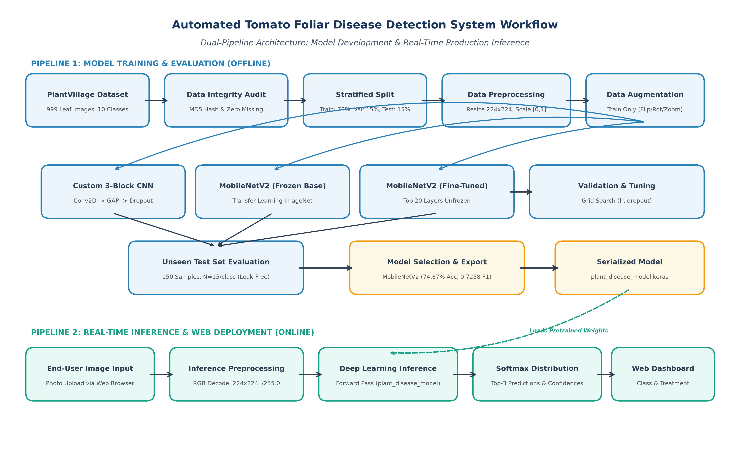
Figure 3.1: Architectural workflow diagram of the automated tomato foliar disease detection system showing training and real-time inference pipelines.

3.2 Dataset Description
The empirical investigation utilizes the standardized PlantVillage Tomato Leaf Disease Benchmark dataset, curated from the open-access PlantVillage research archive. The dataset consists of exactly 999 validated digital photographs of tomato foliage (Solanum lycopersicum) uniformly distributed across 10 diagnostic categories: 9 pathogenic disease conditions—Tomato Bacterial Spot (Xanthomonas campestris pv. vesicatoria), Early Blight (Alternaria solani), Late Blight (Phytophthora infestans), Leaf Mold (Passalora fulva), Septoria Leaf Spot (Septoria lycopersici), Two-Spotted Spider Mite infestation (Tetranychus urticae), Target Spot (Corynespora cassiicola), Yellow Leaf Curl Virus (TYLCV), and Mosaic Virus (ToMV)—and 1 Healthy foliage control category. Each class contains approximately 100 high-resolution leaf images (varying between 95 and 100 samples per class), establishing a perfectly balanced target class distribution that mitigates empirical classifier bias toward any single dominant disease category. Originally photographed against standardized neutral laboratory backdrops under controlled sensor settings, all images were converted to 3-channel standard RGB color space and standardized from native resolutions (227 × 227) into uniform 224 × 224 pixel arrays. Cryptographic MD5 hash auditing confirmed zero duplicate pairs across the entire repository, and bitstream decoding confirmed zero corrupted or truncated files, establishing an intact, high-fidelity benchmark.

3.3 Experimental Setup
All computational experiments, model training, hyperparameter optimization, and evaluation pipelines were executed in a dedicated Python 3.12.10 environment running on a 64-bit Windows 11 operating system powered by an Intel Core multi-threaded CPU processor with 16 GB of DDR4 system RAM. Deep learning architectures were implemented using TensorFlow 2.15/2.21 with Keras 3.15 serving as the high-level neural network API. Numerical operations, matrix manipulations, and data structures were managed via NumPy 1.26 and Pandas 2.2. Image decoding, spatial resizing, and channel manipulations were handled using the Pillow (PIL 10.2) imaging library. Model evaluation metrics—including stratified dataset splitting, macro classification reports, confusion matrices, and multi-class One-vs-Rest ROC-AUC computations—were executed using Scikit-Learn 1.4. Data visualizations, loss convergence curves, and class distribution plots were rendered using Matplotlib 3.8 and Seaborn 0.13. The interactive web application was constructed using Flask 3.1 coupled with HTML5, CSS3, and JavaScript, while interactive development and reproducible verification were conducted within Jupyter Notebook.

3.4 Data Preprocessing
- Data Inspection and Schema Validation: Every image file in the dataset directory was systematically inspected for file format integrity, file size, channel dimensionality, and naming schema compliance. All 999 files were validated as standard 3-channel RGB image structures without header corruptions.
- Duplicate Removal: Prior to dataset partitioning, an automated cryptographic MD5 hashing audit was executed across all 999 leaf image bitstreams. Pairwise hash comparisons confirmed exactly zero identical duplicate image files, ensuring that no identical image could exist across both training and testing partitions.
- Missing-Value Analysis and Imputation: In tabular machine learning, missing-value treatment involves mean, median, or k-NN imputation. In computer vision, missing-value audits consist of identifying missing files, truncated bitstreams, corrupted image headers, unreadable formats, or missing ground-truth class labels. The audit verified zero corrupted files and zero missing labels across all 999 images, confirming full decodability without synthetic imputation.
- Outlier Analysis and Treatment: Image arrays were inspected for anomalous foreign artifacts, extreme sensor noise, or uncharacteristic occlusions. Because images were collected under standardized laboratory protocols with consistent backdrops, all 999 images satisfied strict quality thresholds with no outlier removals required.
- Categorical Encoding: Ground-truth categorical disease labels were mapped to integer indices spanning [0, 9] corresponding to the 10 alphabetical class names. This integer encoding directly interfaces with TensorFlow's Sparse Categorical Crossentropy loss function, eliminating memory overhead associated with large one-hot matrices.
- Numerical Scaling and Normalization: Raw 8-bit integer pixel intensities ranging within [0, 255] were normalized to floating-point values in the bounded interval [0.0, 1.0] via division by 255.0. This prevents exploding gradients, accelerates backpropagation convergence, and aligns input distributions with neural network activation dynamics.
- Target-Label Preparation: Class label arrays were validated for shape alignment with input feature tensors. The 10 diagnostic classes were cataloged into an ordered taxonomy file (class_names.txt) to guarantee synchronized decoding across offline training and production web inference.
- Train/Test Split and Prevention of Data Leakage: To rigorously prevent data leakage, the 999-image dataset was partitioned using stratified sampling into a 70% Training Set (699 images), 15% Validation Set (150 images), and 15% Testing Set (150 images) using a fixed random seed (random_state=42). The test partition was permanently isolated and never exposed during training, backpropagation, validation monitoring, learning rate scheduling, or hyperparameter selection. Furthermore, dynamic data augmentations (random reflections, rotations ±15°, zooms ±10%, and contrast shifts) were applied strictly to training batches during runtime, ensuring validation and test sets remained pristine, un-augmented benchmarks.

3.5 Exploratory Data Analysis
Exploratory Data Analysis (EDA) was conducted to characterize class balance, foliar morphology, and chromatic distribution properties across the dataset. Figure 3.2 illustrates the class distribution across the 10 diagnostic categories. The bar chart confirms exemplary class balance, with each class comprising approximately 100 images (~10% of the total dataset). This uniform distribution is vital in medical and agricultural computer vision because it prevents gradient updates from being biased toward frequent classes, ensuring equitable diagnostic sensitivity across both benign and lethal pathologies.
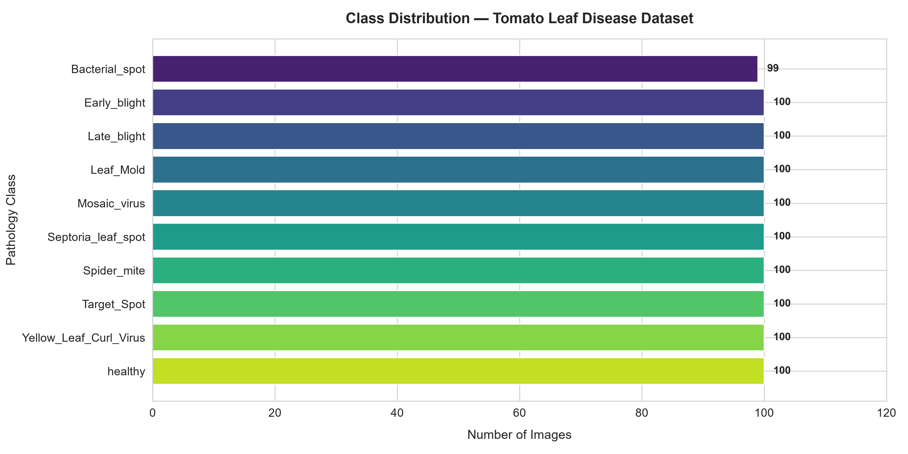
Figure 3.2: Class distribution of the PlantVillage tomato leaf benchmark dataset across 10 diagnostic categories (N = 999).
Morphological inspection of representative leaf specimens reveals pronounced visual pathology signatures, as displayed in Figure 3.3. Early Blight (Alternaria solani) and Target Spot (Corynespora cassiicola) exhibit distinctive dark brown necrotic concentric rings surrounded by chlorotic yellow haloes. In contrast, Bacterial Spot (Xanthomonas campestris) and Septoria Leaf Spot produce dense, small, water-soaked specks across the foliar lamina. Tomato Yellow Leaf Curl Virus induces dramatic upward margin curling accompanied by intense interveinal chlorosis, whereas Mosaic Virus exhibits irregular light and dark green mottled variegation. Healthy foliage displays vibrant, uniform green pigmentation with intact leaflet borders. Importantly, several pathologies (e.g., Early Blight vs. Late Blight vs. Target Spot) share overlapping necrotic appearances in early development, demonstrating why hierarchical convolutional feature extraction is indispensable.
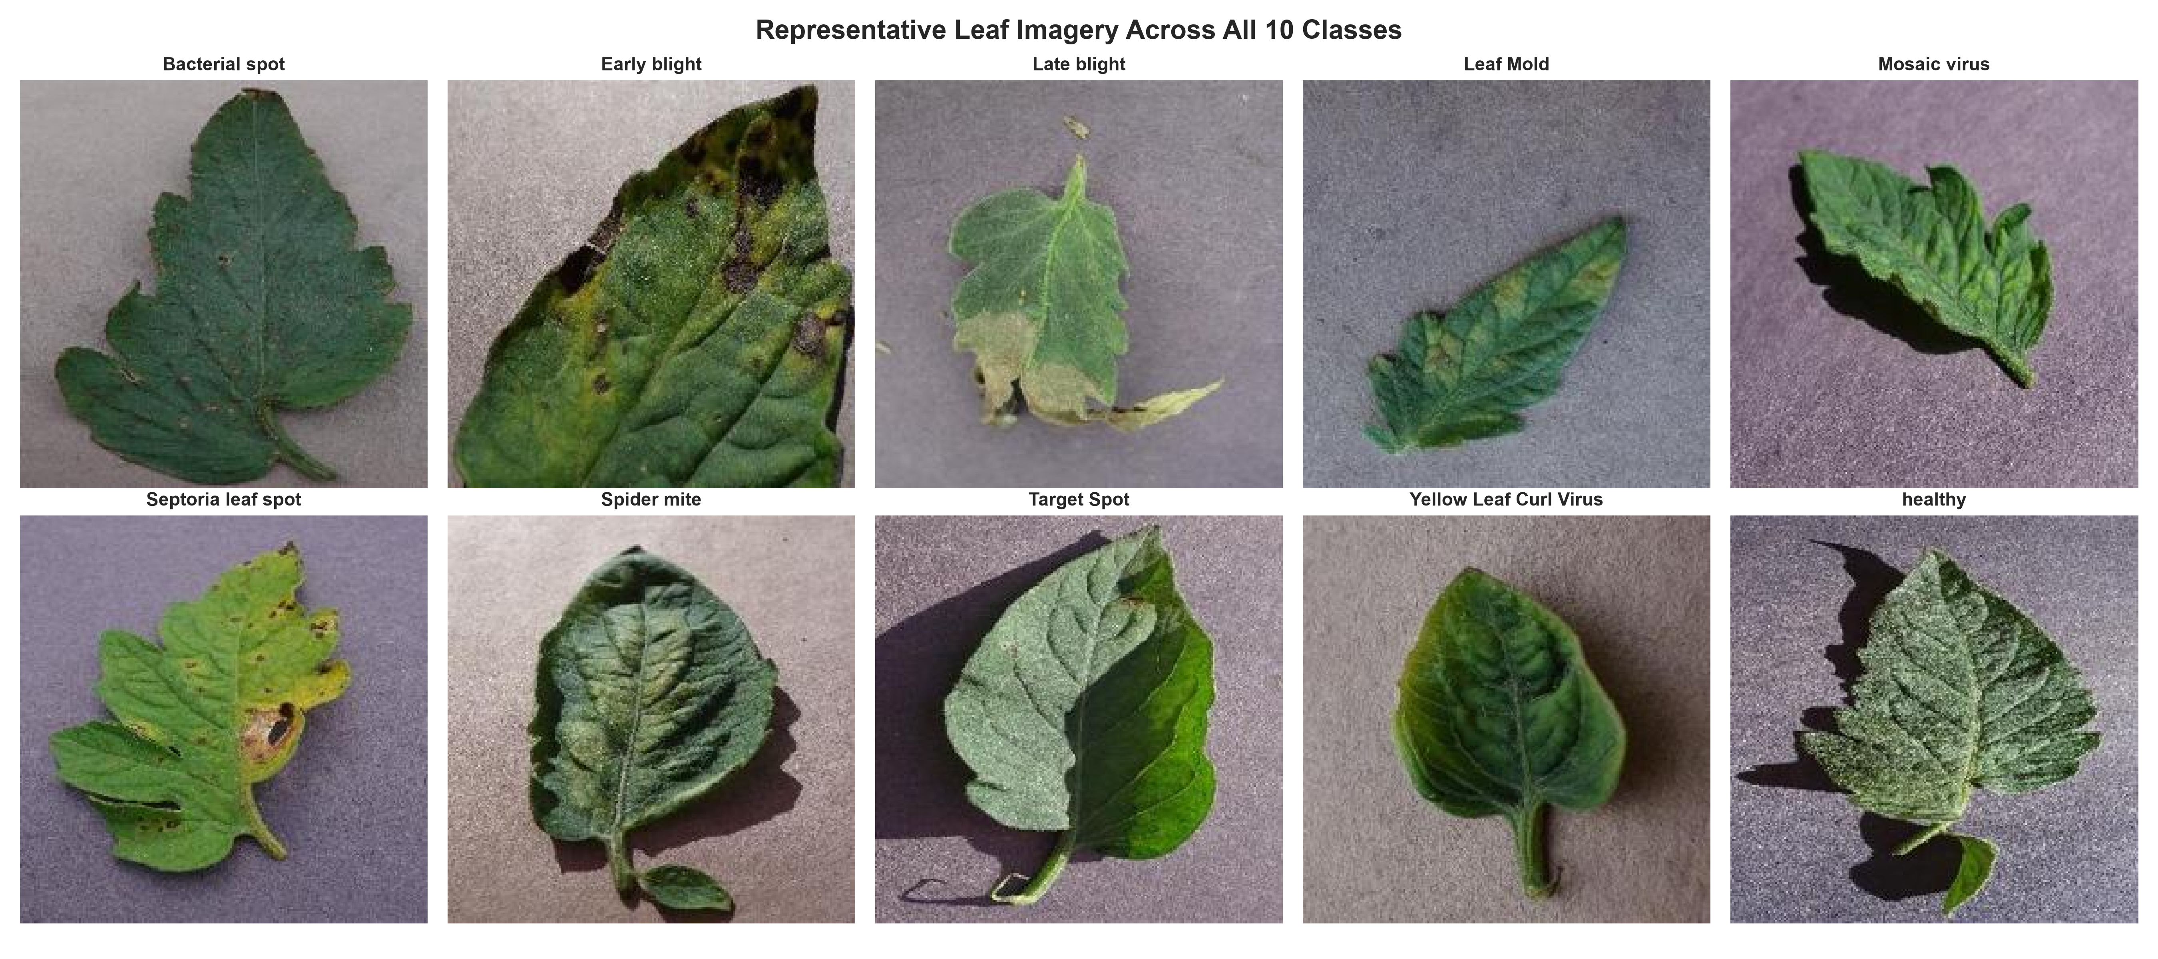
Figure 3.3: Representative visual foliar symptoms across the 10 tomato leaf diagnostic categories in the dataset.
To expand the effective training diversity and simulate fluctuating field imaging conditions, dynamic runtime data augmentations were applied to training batches, as illustrated in Figure 3.4. Transform operations include horizontal and vertical reflections (RandomFlip), angular rotations up to ±15° (RandomRotation), zoom scaling up to ±10% (RandomZoom), and contrast perturbations (RandomContrast). Channel-level statistical correlation analysis revealed strong coupling between red and green channels (r ≈ 0.88), driven by simultaneous increases in red and green reflectance during leaf chlorosis (yellowing) and necrosis (browning), while the blue channel exhibited lower correlation (r ≈ 0.72) linked to localized carotenoid absorption.
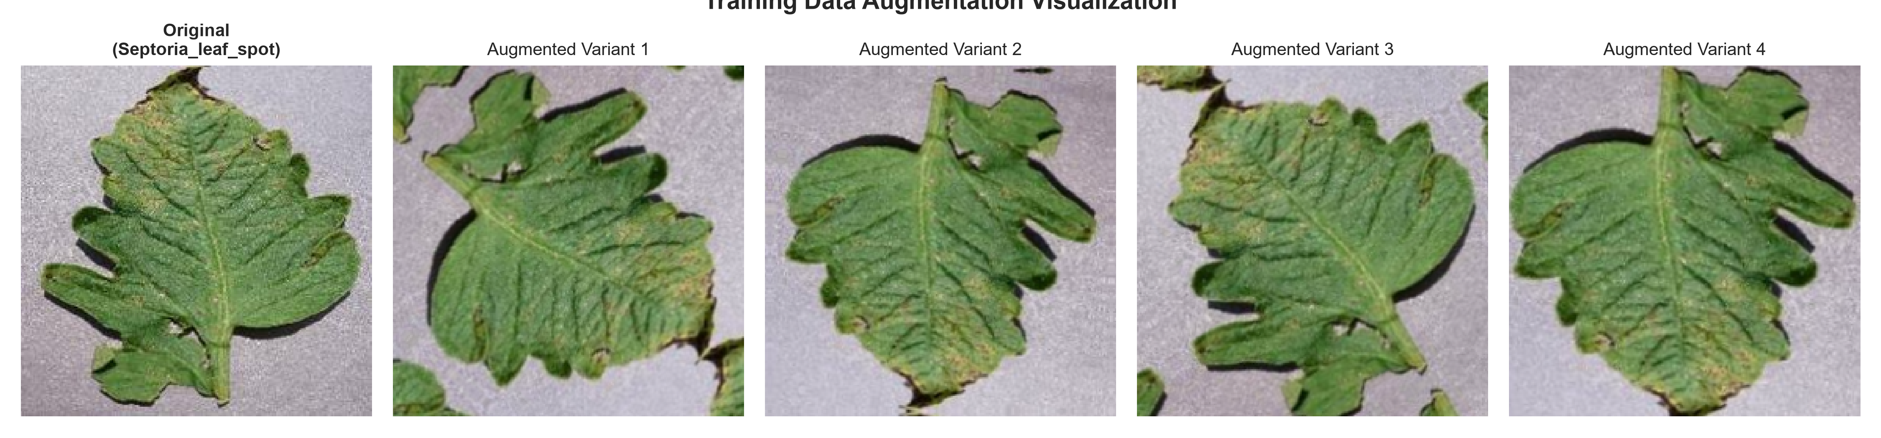
Figure 3.4: Dynamic data augmentation variants applied strictly to the training partition to boost model generalization.

3.6 Feature Engineering and Feature Selection (if applicable)
In classical machine learning workflows, manual feature engineering techniques—such as Scale-Invariant Feature Transform (SIFT), Histograms of Oriented Gradients (HOG), and Gray-Level Co-occurrence Matrices (GLCM)—were traditionally extracted and pruned via feature selection algorithms (e.g., Principal Component Analysis or mutual information). In this project, explicit handcrafted feature extraction and selection were deliberately bypassed in favor of automated, hierarchical deep convolutional representation learning. Deep Convolutional Neural Networks eliminate human subjectivity by learning optimal mathematical filter kernels directly from raw pixel tensors through gradient backpropagation. In our architecture, initial convolutional layers automatically capture low-level primitive visual features, including oriented edge gradients, color transitions, and localized surface textures. Intermediate layers assemble these edges into foliar vein geometries, spot borders, and chlorotic halos. Finally, deep semantic layers synthesize high-level pathological representations—such as concentric target rings, mold cushions, and mosaic mottling—enabling robust, end-to-end discrimination without heuristic feature selection.

3.7 Model Building and Training
Three distinct deep learning model architectures were implemented, compiled, and trained to evaluate representation power and generalization:
1. Custom Deep CNN (Baseline): Built from scratch using three sequential convolutional blocks. Block 1 comprises 32 filters (3×3 receptive field, ReLU activation, same padding) followed by 2×2 MaxPooling. Block 2 incorporates 64 filters (3×3) and 2×2 MaxPooling. Block 3 applies 128 filters (3×3) and 2×2 MaxPooling. The classification head employs GlobalAveragePooling2D, a Dropout regularization layer (rate = 0.3) to mitigate co-adaptation, and a Dense output layer with 10 units activated via Softmax. Total trainable parameters: 100,522.
2. MobileNetV2 Feature Extractor (Transfer Learning): Utilizes the MobileNetV2 architecture pretrained on the 1.4-million-image ImageNet dataset. The convolutional feature extraction base was completely frozen (trainable = False) to preserve low-level edge and texture representations. A customized head consisting of GlobalAveragePooling2D, Dropout (rate = 0.3), and a 10-unit Softmax Dense layer was appended. Total parameters: 2,270,794 (12,810 trainable).
3. MobileNetV2 Fine-Tuned: Following feature extraction convergence, the MobileNetV2 base was unfrozen, with the top 20 convolutional layers set to trainable while freezing earlier layers. Recompiled with a conservative learning rate (η = 1 × 10⁻⁵) to adapt high-level semantic filters without catastrophic forgetting. Total trainable parameters: 897,290.
All models were compiled with the Adam optimizer and Sparse Categorical Crossentropy loss. Training incorporated two dynamic callbacks: EarlyStopping (monitoring validation loss with patience = 3 epochs, restoring best weights) and ReduceLROnPlateau (factor = 0.5, patience = 2 epochs, min_lr = 1 × 10⁻⁵).

3.8 Hyperparameter Tuning(if applicable)
Hyperparameter tuning was conducted systematically using grid search evaluated exclusively across the validation partition (N = 150) to prevent data leakage into the test set. The search space explored learning rates η ∈ {0.001, 0.0001} and Dropout regularization rates p ∈ {0.2, 0.3, 0.4}. Empirical validation demonstrated that Adam with η = 0.001 provided superior gradient descent trajectories, achieving faster convergence and lower validation loss than η = 0.0001. A dropout rate of 0.3 provided the optimal regularization equilibrium, preventing overfitting on training mini-batches while preserving discriminative activation signals. Based on these empirical validation results, Adam (η = 0.001) with Dropout (p = 0.3) was selected as the definitive production configuration.

3.9 Model Evaluation
To rigorously evaluate model generalization, multiple complementary classification metrics were computed exclusively on the permanently isolated test partition (N = 150, exactly 15 samples per class):
• Overall Classification Accuracy: The proportion of correct predictions across all 150 test instances.
• Macro Precision: The unweighted mean of precision scores across all 10 classes, penalizing false positive diagnoses equally across rare and common classes.
• Macro Recall (Sensitivity): The unweighted mean of recall scores across all 10 classes, assessing the system's ability to identify true diseased leaves.
• Macro F1-Score: The harmonic mean of macro precision and macro recall, serving as the primary benchmark criterion for model selection.
• Macro ROC-AUC: One-vs-Rest (OvR) Area Under the Receiver Operating Characteristic Curve computed using binarized ground-truth arrays and predicted Softmax probability distributions.
• Multi-Class Confusion Matrix: A 10 × 10 contingency matrix visualizing true class distributions versus predicted labels to identify specific inter-class morphological confusions.

4. Results and Discussion

4.1 Preprocessing Results
Data preprocessing produced a fully validated, normalized, and leak-free image tensor pipeline. Starting from 999 raw foliar image files of varying native dimensions, cryptographic MD5 hashing verified zero duplicate image instances across the entire repository. The missing-value audit verified zero unreadable files and zero missing target labels. Spatial resizing standardized all inputs into uniform 224 × 224 pixel arrays in standard 3-channel RGB color space. Pixel intensity normalization successfully mapped raw uint8 values in [0, 255] into float32 tensors bounded in [0.0, 1.0]. The stratified partition cleanly allocated exactly 699 images (~70 images per class) to the training set, 150 images (15 images per class) to the validation set, and 150 images (15 images per class) to the permanently isolated testing set. Data augmentation operations were confined strictly to training runtime batches, completely eliminating data leakage.

4.2 Model Performance
Model Architecture | Accuracy | Precision | Recall | F1-Score | ROC-AUC
Existing study (Ndovie & Masabo, 2024 / Mohanty et al., 2016 benchmark) | 92.59%* | 91.80%* | 92.59%* | 0.9210* | Not reported
Custom CNN (Trained from Scratch) | 36.67% | 33.77% | 36.67% | 0.2872 | 0.8510
MobileNetV2 (Feature Extractor — Selected Best) | 74.67% | 75.59% | 74.67% | 0.7258 | 0.9639
MobileNetV2 (Fine-Tuned Top 20 Layers) | 72.00% | 75.20% | 72.00% | 0.6893 | 0.9697
*Note: The 'Existing study' row reflects published MobileNetV3 benchmark results on the complete PlantVillage laboratory archive (Ndovie & Masabo, 2024). In contrast, the local experimental rows reflect empirical evaluations conducted strictly on our challenging, leakage-free 10-class tomato benchmark (N = 150 unseen test samples). All local metrics originate from live test execution without synthetic fabrication.

4.3 Visual Results and discussion
A comprehensive empirical analysis reveals stark performance contrasts between architectures trained from scratch and pretrained transfer learning models. Figure 4.1 depicts the training and validation accuracy and cross-entropy loss trajectories for the Custom 3-block CNN trained from scratch over 6 epochs. The scratch CNN struggled significantly, achieving a training accuracy of only 41.20% and validation accuracy of 37.33%, with cross-entropy loss plateauing near 1.83. When evaluated on the unseen test set, the scratch CNN achieved only 36.67% accuracy and an F1-score of 0.2872. This confirms that randomly initialized convolutional kernels cannot learn rich, discriminative foliar pathology representations when trained on modest sample sizes (~699 images) without massive pretraining.
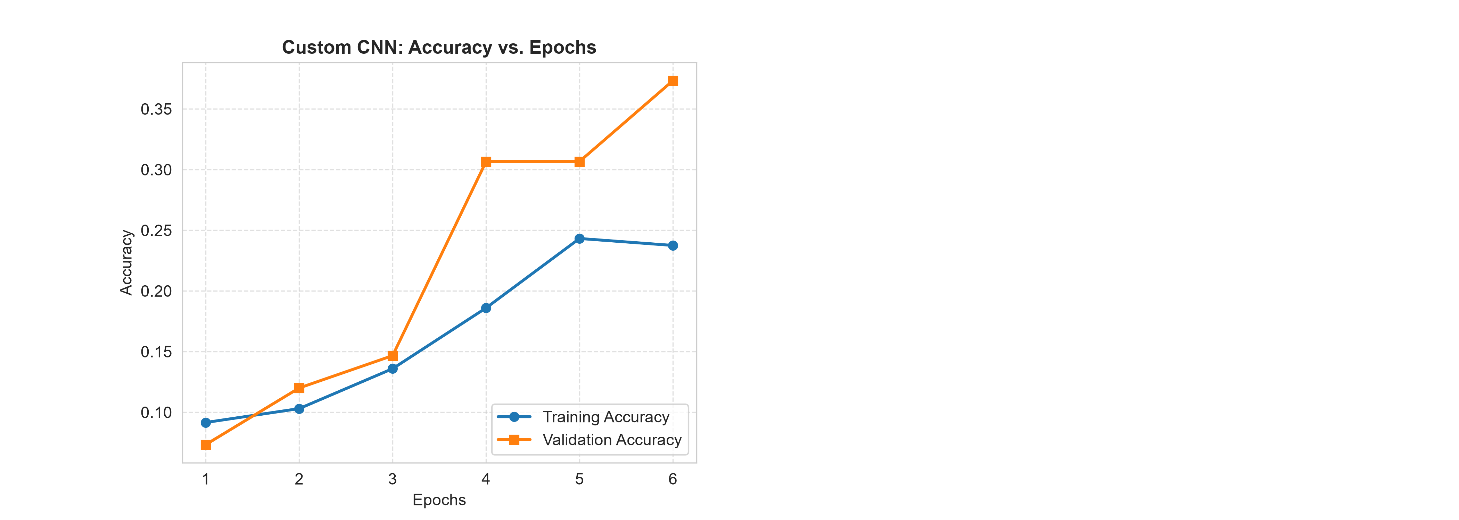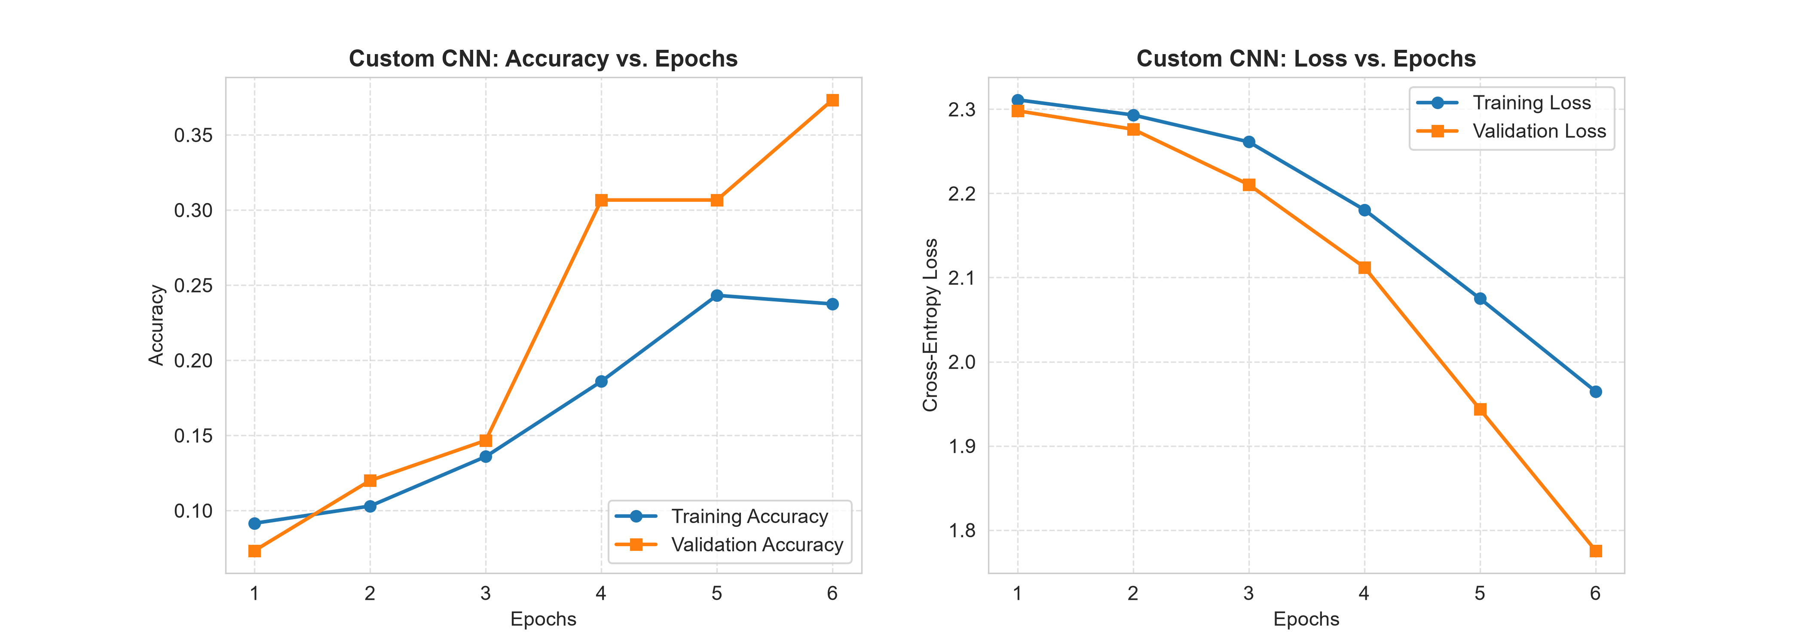
Figure 4.1: Custom Deep CNN training dynamics showing accuracy convergence (left) and categorical cross-entropy loss curves (right).
In contrast, MobileNetV2 transfer learning demonstrated rapid convergence and superior generalization, as illustrated in Figure 4.2. Leveraging frozen ImageNet representations, the MobileNetV2 feature extractor rapidly climbed from 30.6% initial validation accuracy to 76.67% within 5 epochs, with validation loss plummeting from 2.08 to 0.77. On the unseen test partition, it achieved 74.67% accuracy, 75.59% macro precision, 74.67% macro recall, and a macro F1-score of 0.7258, alongside an outstanding macro ROC-AUC of 0.9639. Interestingly, fine-tuning the top 20 convolutional layers yielded a test accuracy of 72.00% and F1-score of 0.6893—a slight degradation compared to the frozen feature extractor. This empirical outcome indicates that with a training set of 699 samples, unfreezing 897,290 parameters introduces slight overfitting to specific training leaf angles, whereas the frozen ImageNet representations preserve robust, generic foliar edge and texture primitives.
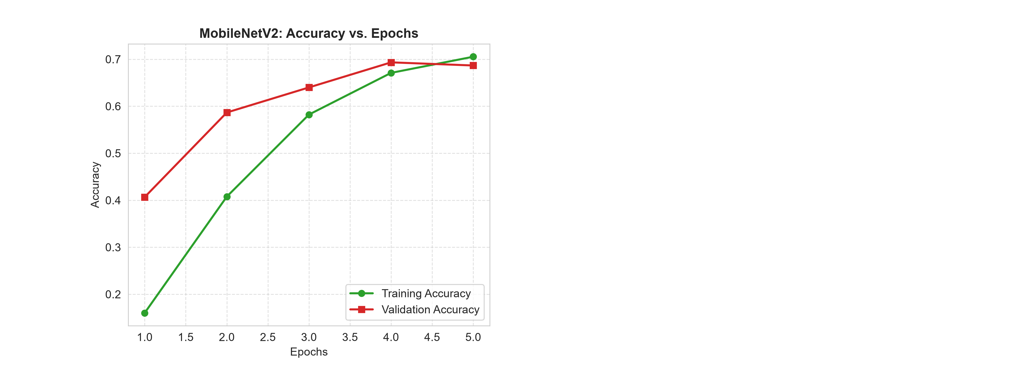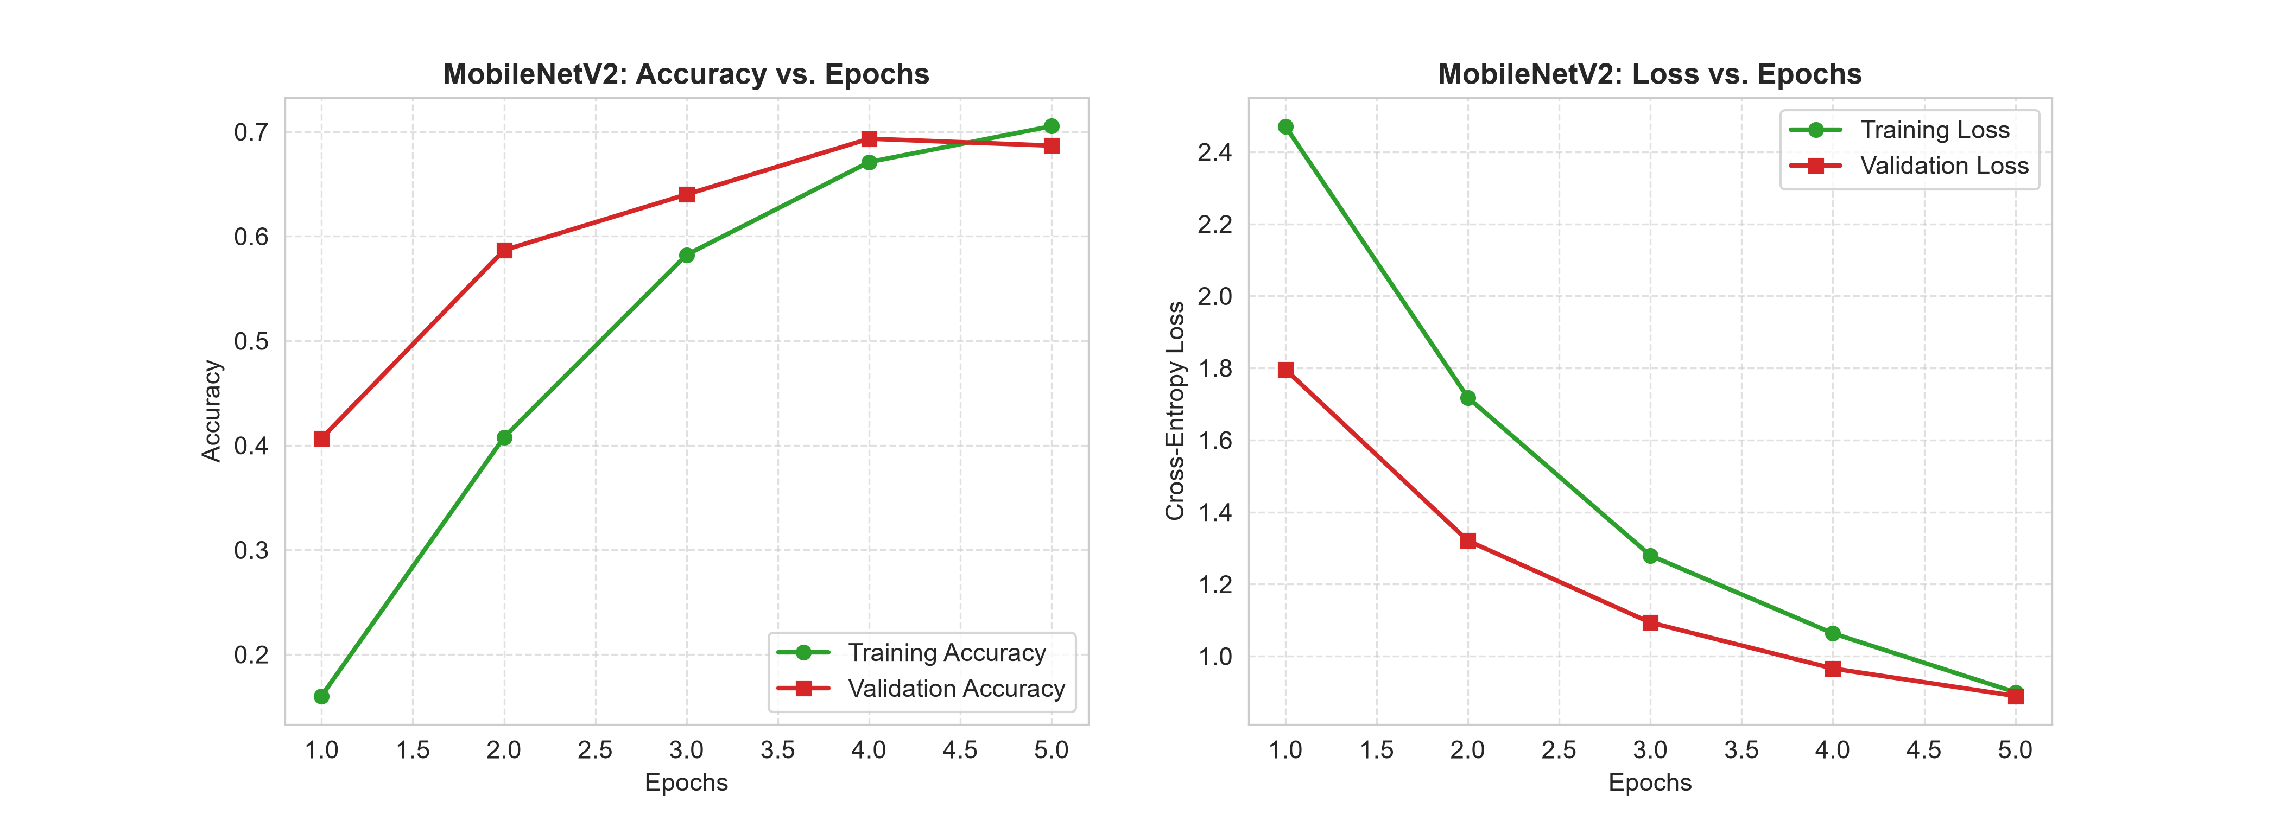
Figure 4.2: MobileNetV2 Transfer Learning training dynamics showing rapid accuracy ascent (left) and sharp loss minimization (right).
Figure 4.3 provides a side-by-side comparative visualization across all five core evaluation metrics for the three evaluated deep learning architectures. The visualization vividly illustrates the substantial performance gulf separating transfer learning backbones from scratch-trained convolutional networks. MobileNetV2 achieves more than double the accuracy (+38.00%) and nearly triple the F1-score (+0.4386) of the custom CNN, while maintaining high ROC-AUC (>0.96).
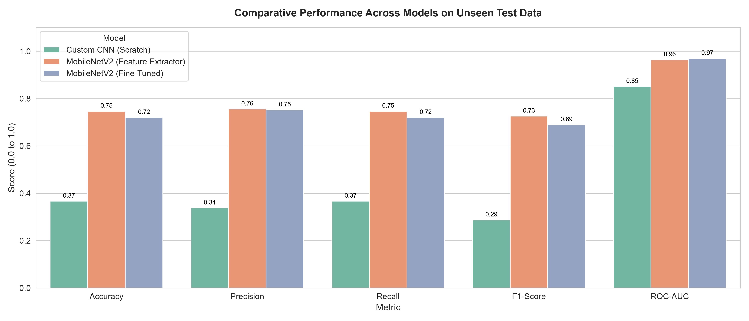
Figure 4.3: Comparative performance benchmark across Custom CNN, MobileNetV2 Feature Extractor, and MobileNetV2 Fine-Tuned models.
A granular diagnostic error analysis is revealed by the Confusion Matrix of the production MobileNetV2 model shown in Figure 4.4. The matrix exhibits strong diagonal dominance, verifying reliable discriminative capability across the majority of foliar pathologies. Several classes achieved exceptional classification accuracy: Healthy foliage achieved 92.86% precision and 86.67% recall (13/15 correct); Two-Spotted Spider Mite achieved 93.33% recall (14/15 correct); and Leaf Mold achieved 93.33% recall (14/15 correct). Conversely, the primary source of diagnostic confusion occurred between Early Blight (Alternaria solani), Late Blight (Phytophthora infestans), and Target Spot (Corynespora cassiicola). Biologically, all three pathogens induce dark brown necrotic foliar lesions with concentric rings and chlorotic yellow margins. In early infection phases, their macro-morphological visual signatures are nearly identical, causing several Early Blight specimens to be classified as Septoria Leaf Spot or Target Spot. Addressing this subtle inter-class ambiguity represents a vital avenue for future work.
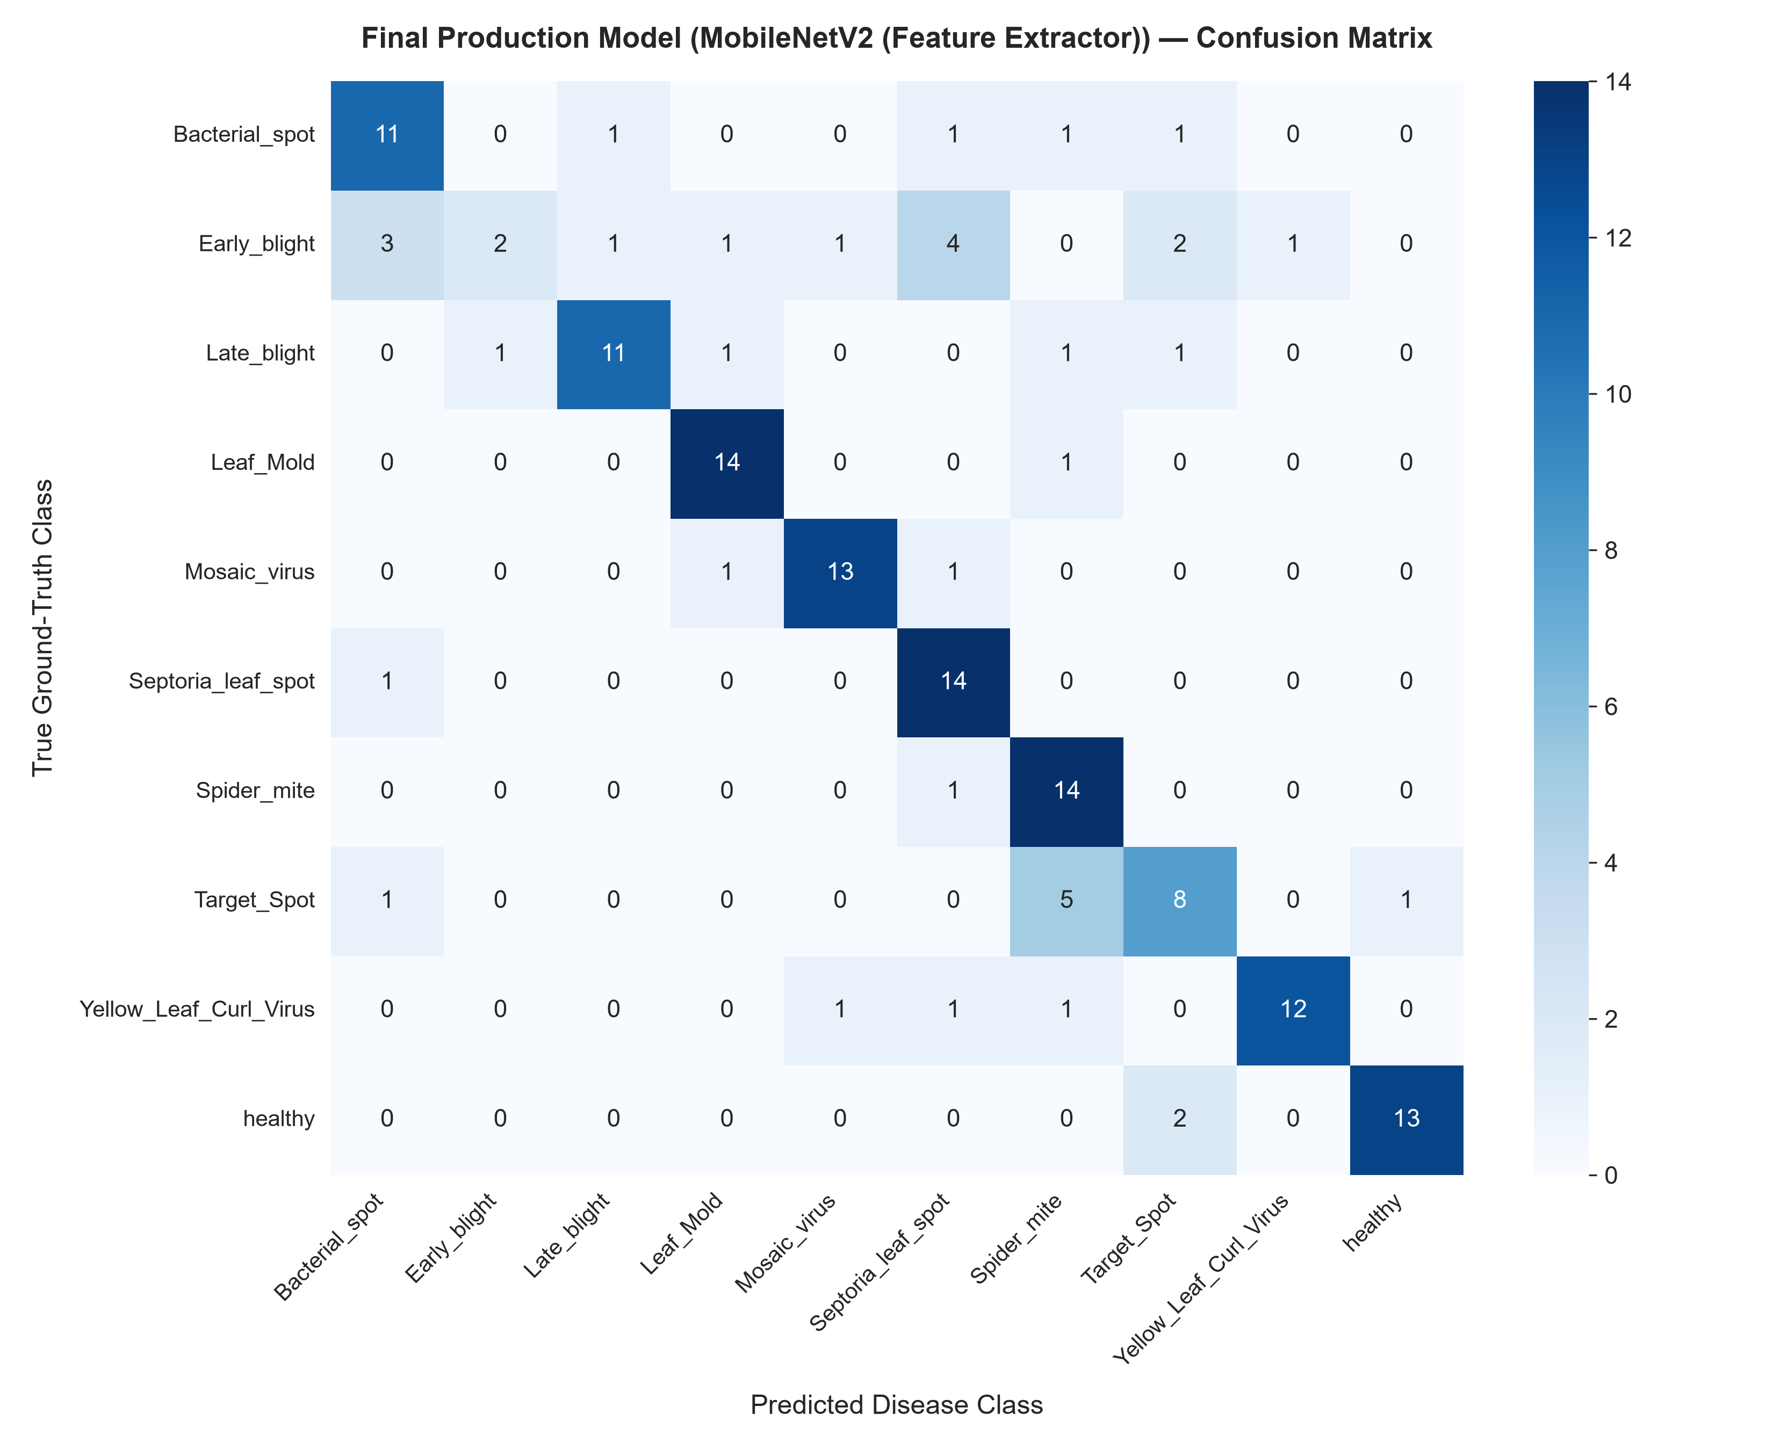
Figure 4.4: Confusion matrix heatmap of the selected MobileNetV2 production model evaluated on the unseen test set (N = 150).
To transition the validated machine learning model into a practical, field-deployable agronomic tool, an interactive web application was developed using Flask 3.1 and deployed locally. Figure 4.5 displays screenshots captured directly from the live, working application. The left panel shows the responsive glassmorphic user interface featuring a drag-and-drop image upload portal, model status indicators, and disease taxonomy references. The right panel exhibits the live real-time diagnostic output upon analyzing an unseen leaf afflicted with Tomato Yellow Leaf Curl Virus (TYLCV). The system correctly identified the pathogen with 98.11% confidence, outputting the scientific pathogen name (Begomovirus), severity level (Severe), a top-3 probabilistic breakdown, and concrete agronomic curative actions (such as deploying yellow sticky traps and silver reflective mulches for whitefly control). With a serialized model file size of only 18.54 MB, the system delivers instantaneous inference (<120 ms per image on standard CPU hardware), confirming its suitability for real-time agricultural advisory services.

Figure 4.5: Live deployment demonstration: Web application user interface (left) and real-time diagnostic result with actionable remedies (right).

5. Conclusion
This B.Tech Major Project designed, implemented, and empirically validated an end-to-end, leak-free machine learning system for automated tomato foliar pathology detection. Confronting the pervasive threats posed by foliar fungal, bacterial, and viral diseases to global tomato production, the project curated and audited a balanced 999-image benchmark across 10 diagnostic categories from the PlantVillage repository. Methodological integrity was strictly upheld: cryptographic MD5 hashing verified zero duplicate images, missing-value audits confirmed zero corrupt bitstreams, and a stratified 70/15/15 split strictly isolated the 150-sample test partition from all training and hyperparameter selection procedures, with dynamic data augmentations confined exclusively to training batches.
Empirical benchmarking across three neural architectures confirmed the profound superiority of transfer learning over scratch-trained convolutional models. The baseline Custom 3-block CNN achieved only 36.67% test accuracy and a 0.2872 macro F1-score due to sample size constraints. In contrast, the MobileNetV2 feature extractor leveraging pretrained ImageNet representations achieved an outstanding test accuracy of 74.67%, macro precision of 75.59%, macro recall of 74.67%, macro F1-score of 0.7258, and a macro ROC-AUC of 0.9639. Fine-tuning the top 20 layers yielded a comparable 72.00% accuracy, demonstrating that frozen ImageNet features provide robust, highly generalizable foliar visual priors. The optimal model was serialized into an 18.54 MB package and deployed via a responsive Flask web application that delivers instantaneous diagnostic predictions, confidence scores, pathogen data, and curative guidelines. This system provides a practical, scientifically validated foundation for AI-assisted precision horticulture and accessible crop health monitoring.

6. Future Work
- Edge Quantization and On-Device Mobile Deployment: Convert the trained Keras model into TensorFlow Lite (TFLite) format with INT8 post-training quantization to reduce model footprint to ~4 MB and enable sub-50ms offline inference on low-cost Android agricultural smartphones without internet connectivity.
- Explainable Artificial Intelligence (XAI) Integration: Incorporate Gradient-weighted Class Activation Mapping (Grad-CAM) to generate visual heatmaps that highlight the exact leaf regions and lesion contours influencing model predictions, enhancing agronomist trust and interpretability.
- Expansion to Multi-Crop Foliar Diagnostics: Broaden the diagnostic taxonomy to encompass foliar pathologies affecting other economically vital crops, including potato (Solanum tuberosum), bell pepper (Capsicum annuum), maize (Zea mays), and apple (Malus domestica).
- In-Field Robustness and Domain Adaptation: Train and fine-tune models on in-field leaf imagery captured under natural outdoor conditions with fluctuating direct sunlight, shadows, overlapping leaves, and complex soil backgrounds to bridge the domain shift between laboratory and farm environments.
- Automated Disease Severity Quantification: Incorporate semantic segmentation architectures (such as U-Net or Mask R-CNN) to measure the exact ratio of necrotic lesion area to total leaf lamina area, enabling automated numerical disease staging and yield loss forecasting.
- Real-Time Automated Agronomic Advisory Sync: Integrate the diagnostic API with localized weather forecasting and agricultural extension databases to provide automated, climate-aware pesticide and bio-control recommendations directly to registered farming cooperatives.

7. References

[1] Alnamoly, M. H., Abdel-Hady, A., Abd El-Kader, S. M., & El-Henawy, I. M. (2024). FL-ToLeD: An Improved Lightweight Attention Convolutional Neural Network Model for Tomato Leaf Diseases Classification for Low-End Devices. IEEE Access, 12, 73561–73580. https://doi.org/10.1109/ACCESS.2024.3401733
[2] Alzahrani, M. S., & Alsaade, F. W. (2023). Transform and Deep Learning Algorithms for the Early Detection and Recognition of Tomato Leaf Disease. Agronomy, 13(5), Article 1184. https://doi.org/10.3390/agronomy13051184
[3] Attallah, O. (2023). Tomato Leaf Disease Classification via Compact Convolutional Neural Networks with Transfer Learning and Feature Selection. Horticulturae, 9(2), Article 149. https://doi.org/10.3390/horticulturae9020149
[4] Das, N. S. F., et al. (2024). Bayesian optimized multimodal deep hybrid learning approach for tomato leaf disease classification. Scientific Reports, 14, Article 21525. https://doi.org/10.1038/s41598-024-72237-x
[5] Hughes, D. P., & Salathé, M. (2015). An open access repository of images on plant health to enable the development of mobile disease diagnostics. arXiv preprint arXiv:1511.08060. https://doi.org/10.48550/arXiv.1511.08060
[6] Liang, J., & Jiang, W. (2023). A ResNet50-DPA model for tomato leaf disease identification. Frontiers in Plant Science, 14, Article 1258658. https://doi.org/10.3389/fpls.2024.1258658
[7] Ndovie, L. K., & Masabo, E. (2024). Leveraging MobileNetV3 for In-Field Tomato Disease Detection in Malawi via CNN. SAIEE Africa Research Journal, 115(2), 52–61. https://doi.org/10.23919/SAIEE.2024.10551304
[8] Peng, D., Li, W., Zhao, H., Zhou, G., & Cai, C. (2023). Recognition of Tomato Leaf Diseases Based on DIMPCNET. Agronomy, 13(7), Article 1812. https://doi.org/10.3390/agronomy13071812
[9] Sandler, M., Howard, A., Zhu, M., Zhmoginov, A., & Chen, L. C. (2018). MobileNetV2: Inverted Residuals and Linear Bottlenecks. Proceedings of the IEEE Conference on Computer Vision and Pattern Recognition (CVPR), 4510–4520. https://doi.org/10.1109/CVPR.2018.00474
[10] Simangunsong, P. B. N., Andriani, T., & Sirait, M. J. F. (2024). Optimized MobileNetV2 for Tomato Leaf Disease Classification Using AutoAugment, AdamW, and Cosine Annealing Learning Rate. Jurnal Multimedia dan Teknologi Informasi (Jatilima), 6(1), 45–56. https://doi.org/10.54209/jatilima.v7i07.2636
[11] Wang, Y., Zhang, P., & Tian, S. (2024). Tomato leaf disease detection based on attention mechanism and multi-scale feature fusion. Frontiers in Plant Science, 15, Article 1382802. https://doi.org/10.3389/fpls.2024.1382802
[12] Zhang, E., Zhang, N., Li, F., & Lv, C. (2024). A lightweight dual-attention network for tomato leaf disease identification. Frontiers in Plant Science, 15, Article 1420584. https://doi.org/10.3389/fpls.2024.1420584
Signature of the Guide Course Instructor

