RCWL-056 Microwave Radar Motion Sensor Module

- 5-7m Detection Distance
- Through-Wall Human & Animal Movement Detector

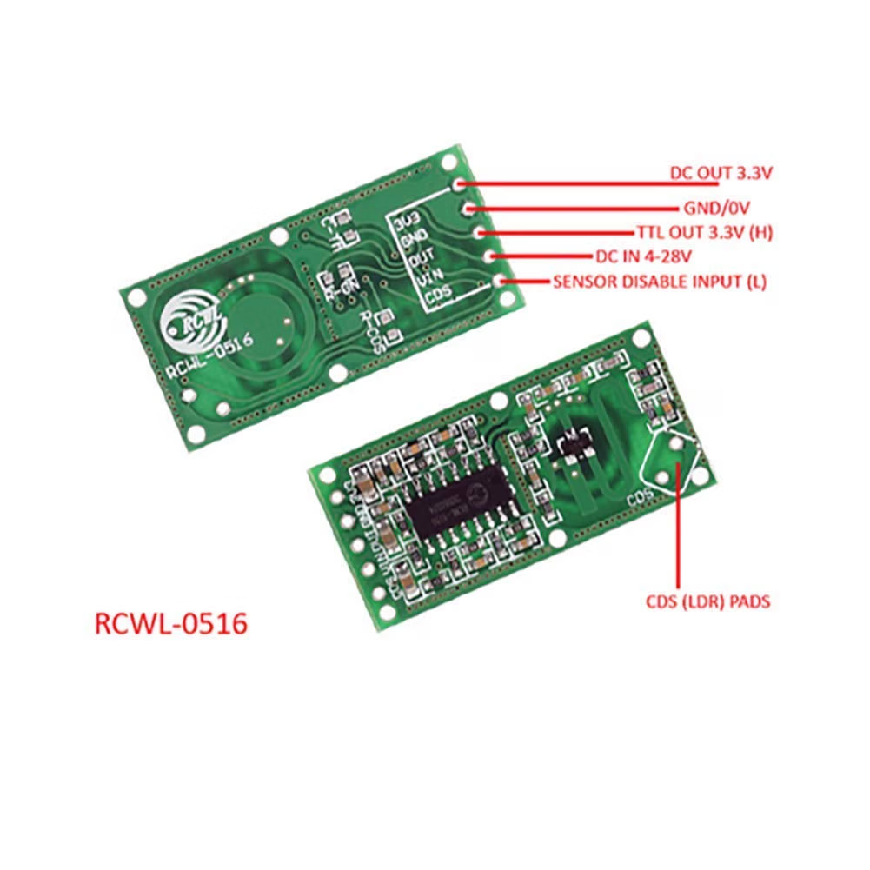

High Sensitivity & Wide Voltage – Detection range up to 5-7 meters with a large induction angle. Operates on 4-28V DC. Ideal for human motion sensing lighting, security alarms, smart home automation, and other presence detection projects
- 🚩 Through-Wall Detection Capability – Microwave radar signal penetrates glass, drywall, ceilings, and floors. Sensor can be triggered even when partially obscured. Note that more shielding reduces detection distance, but it still works reliably
- 🚩 Multi-Object Detection – Detects not only humans but also pets (cats/dogs), water-filled bottles, and other moving objects with sufficient density and volume. Perfect for pet monitoring or liquid presence sensing
- 🚩 Easy Integration with Dev Boards – Directly compatible with Arduino, ESP8266, NodeMCU, Wemos, and other 3.3V/5V logic boards. Outputs a clean 3.3V trigger signal – no level shifter required
- 🚩 Adjustable Settings for Custom Projects – On-board C-TM and R-GN adjustment points: add a capacitor to extend trigger hold time, or add a resistor to shorten detection distance (default 7m, ~5m with 1MΩ resistor). Ideal for applications requiring custom sensitivity and hold time

Features & Specs
Max Supply Voltage- 28VDC
Mount Type- weaver mount
Output- digital
Response Time- 2 sec.
Sensing Distance 7m(21.98 ft)
Use Cases- motion detection, security systems, automatic lighting, animal monitoring

