SENSOR GUIDE- OLED
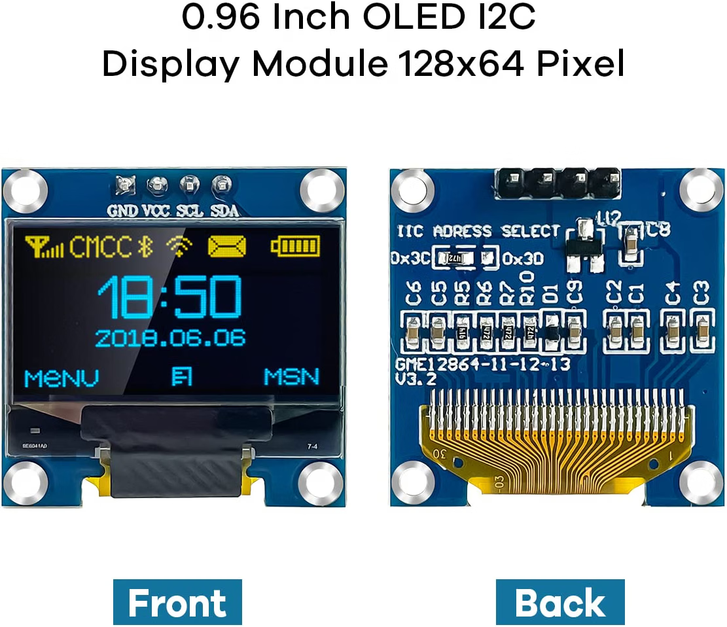

0.96 inch,Resolution: 128 x 64, View angle: > 160°, Support voltage: 3.3V-5V DC, Power consumption: 0.04W during normal operation, full screen lit 0.08W
- Embedded Driver IC: SSD1306. Communication: I2C/IIC Interface, only need two I / O ports
- It compatibles with R3 board and Mega, Raspberry pi, 51 MCU, STIM 32, etc.
- No backlight is required, and the display unit can be self-luminous. It has ultra-high contrast, bright and clear dots, and it is easy to read even small fonts
- There are no fonts embedded in the OLED controller, users can create fonts through font generation software.

