**Homework 01**

Mech307

Ekrem Yiğiter – 59721

**Problem 1:**

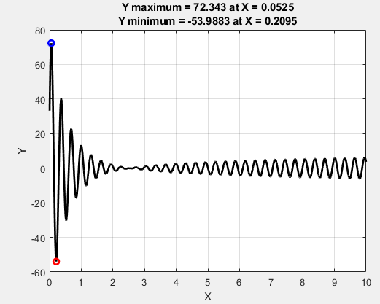



**Problem 2:**

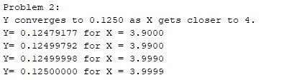

**Problem 3:**

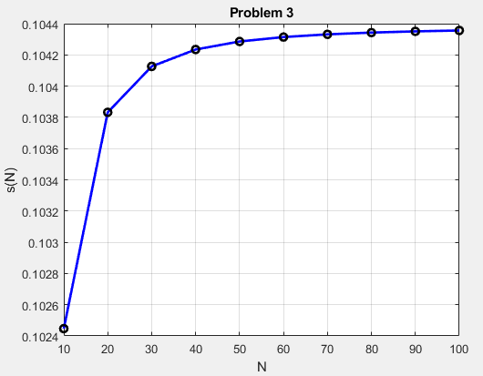

**Problem 4:**



**Problem 5:**

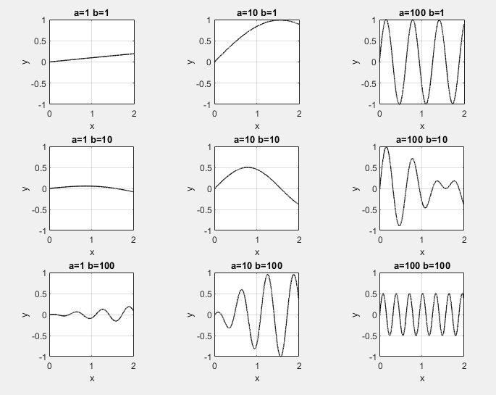

**Problem 6:**

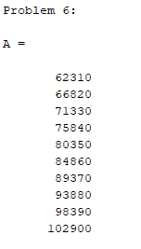

**Problem 7:**

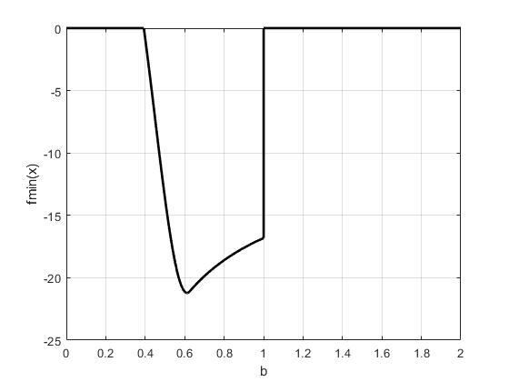

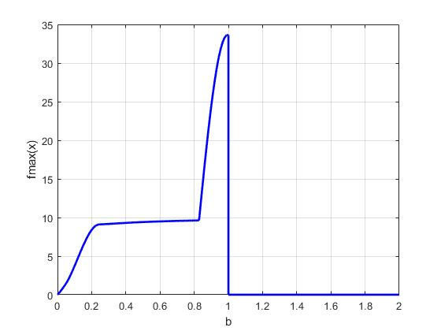

**Problem 8:**

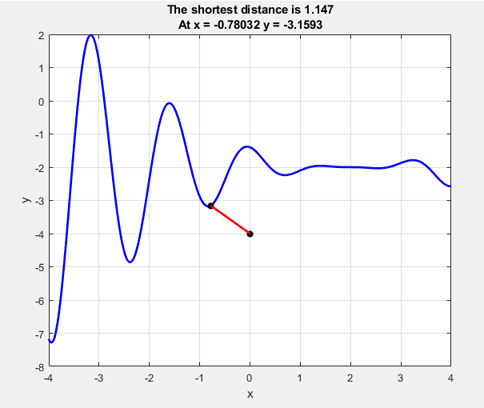

**Problem 9:**

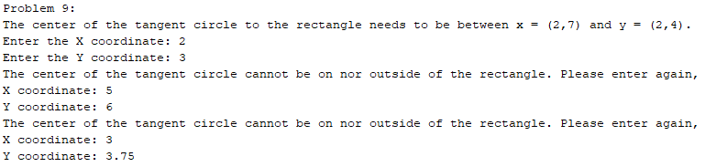

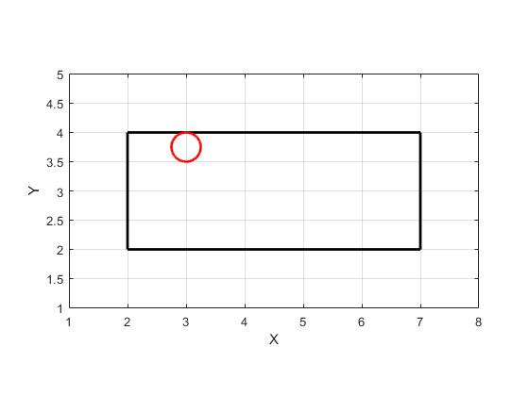

**MATLAB Codes:**

Problem 1:

clc;

clear all;

close all;

disp('Problem 1:');

x = 0:0.0001:10;

y = ((2*x.^3)+(4*x.^2)-7*x-40).*(cos(20*x+2)).*(1+exp(-x))./(sqrt(x+1).*(1+x+x.^2));

ymin = min(y);

ymax = max(y);

i = find(y == ymin);

j = find(y == ymax);

xmin = x(i);

xmax = x(j);

figure(1)

plot(x,y,'k-',xmin,ymin,'ro',xmax,ymax,'bo','linewidth',2)

grid on;

xlabel('X');

ylabel('Y');

title({['Y maximum = ',num2str(ymax),' at X = ',num2str(xmax)];['Y minimum = ',num2str(ymin),' at X = ',num2str(xmin)]});

fprintf('Ymax = %2.4f at X = %2.4f, with an accuracy of +/- 0.0001 in X.\n',ymax,xmax);

fprintf('Ymin = %2.4f at X = %2.4f, with an accuracy of +/- 0.0001 in X.\n',ymin,xmin);

Problem 2:

clc;

clear all;

close all;

disp('Problem 2:');

i = [0,0.09,0.099,0.0999];

x = 3.9 + i;

y = sqrt(4-x).*sin(4-x)./((16-4*x).^(3/2));

fprintf('Y converges to %.4f as X gets closer to 4.\n',y(4));

for j = 1:4

fprintf('Y= %.8f for X = %.4f\n',y(j),x(j));

end

Problem 3:

clc;

clear all;

close all;

disp('Problem 3:');

N = 2:2:100;

N1 = 10:10:100;

func = 1./(N.^3+N.^2);

sN=zeros(1,10);

for i = 1:10

sN(i)=sum(func(1:i*5));

end

figure(3)

plot(N1,sN,'b-',N1,sN,'ko','linewidth',2);

grid on

title('Problem 3');

xlabel('N');

ylabel('s(N)');

Problem 4:

clc;

clear all;

close all;

disp('Problem 4:');

sum = 0;

i=0;

while(sum<25000)

i = i + 1;

f = (i^2+4*i+1)/(i+1);

sum = sum + f;

end

N = i;

if (sum>25000)

N = N - 1;

end

fprintf('Maximum value of N = %d\n',N);

Problem 5:

clc;

clear all;

close all;

disp('Problem 5:');

a = [1, 10, 100];

x = 0:0.0001:2;

b = 0;

figure(5)

for i = 1:3

for j =1:3

b=b+1;

y = sin(a(j)*x/10).*cos(a(i)*x/10);

subplot(3,3,b);

plot(x,y,'k-','linewidth',1);

grid on;

title(['a=',num2str(a(j)),' b=',num2str(a(i))]);

xlabel('x');

ylabel('y');

axis equal;

axis([0 2 -1 1])

end

end

Problem 6:

clc;

clear all;

close all;

disp('Problem 6:');

i = 0:10:90;

b = (111:11:210)'+i;

c = (50:-2:32)';

A = b*c

Problem 7:

clc;

clear all;

close all;

disp('Problem 7:');

x = 0:0.0001:4;

b = 0:0.00005:2;

i = 0;

fmax = zeros(1,40001);

fmin = zeros(1,40001);

for b1 = 0:0.0001:2

i = i + 1;

f2 = (sin(b1*x)).*((b1*(x.^2))-(2*x)+10);

fmax(i) = max(f2);

fmin(i) = min(f2);

end

figure(7)

plot(b,fmin,'k-','linewidth',2);

grid on;

xlabel('b');

ylabel('fmin(x)');

figure(8)

plot(b,fmax,'b-','linewidth',2);

grid on;

xlabel('b');

ylabel('fmax(x)');

Problem 8:

clc;

clear all;

close all;

disp('Problem 8:');

x = -4:0.00001:4;

y = 0.15*cos(4*x).*((x-2).^2)-2;

Px=0;

Py=-4;

D = sqrt((x-Px).^2+(y-Py).^2);

Dmin = min(D);

Dmax = max(D);

i = find(D == Dmin);

figure(8)

plot(x,y,'b-',Px,Py,'k*',x(i),y(i),'k*',[Px x(i)],[Py y(i)],'r-','linewidth',2)

title({['The shortest distance is ',num2str(Dmin)];['At x = ', num2str(x(i)),' y = ',num2str(y(i))]})

grid on, xlabel('x'), ylabel('y')

Problem 9:

clc;

clear all;

close all;

disp('Problem 9:');

disp('The center of the tangent circle to the rectangle needs to be between x = (2,7) and y = (2,4).');

x = input('Enter the X coordinate: ');

y = input('Enter the Y coordinate: ');

a = true;

while(a==true)

if(x<=2 || x>=7 || y<=2 || y>=4)

disp('The center of the tangent circle cannot be on nor outside of the rectangle. Please enter again,');

x = input('X coordinate: ');

y = input('Y coordinate: ');

else

a=false;

end

end

d=min([abs(x-2) abs(x-7) abs(y-2) abs(y-4)]);

N = 1001;

t = linspace(0,2*pi,N);

Cx=x+d*cos(t);

Cy=y+d*sin(t);

figure(9)

plot([2 7],[2 2],'k-',[2 7],[4 4],'k-',[2 2],[2 4],'k-',[7 7],[2 4],'k-',Cx,Cy,'r-','linewidth',2);

grid on;

xlabel('X');

ylabel('Y');

axis equal;

axis([1 8 1 5]);