**Homework 01**

Mech307

Ekrem Yiğiter – 59721

1)

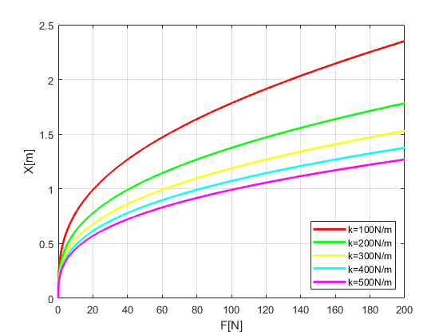

2)



**MATLAB Codes:**

Problem 1:

clc;

clear all;

close all;

x = 0:0.001:2.5;

colors = ['r','g','y','c','m'];

for k = 1:1:5

for f = 0:1:20000

kval = k*100;

fval(f+1) = f/100;

y = 4*kval*x.*(sqrt(9+x.^2)-3)-fval(f+1).*sqrt(9+x.^2);

yref = y(1);

for i = 2:length(x)

if ((y(i)*yref) <= 0 || (y(i)*yref) == 0)

xroot(k,f+1)=x(i);

break

end

end

end

figure(1)

plot(fval,xroot(k,:),colors(k),'linewidth',2);

hold on;

grid on;

xlabel('F[N]');

ylabel('X[m]');

legend('k=100N/m','k=200N/m','k=300N/m','k=400N/m','k=500N/m','Location','SouthEast');

end

hold off

Problem 2:

clc;

clear all;

close all;

t= 0:0.01:40;

vbval = 0:0.01:100;

vr=0:5:15;

colors = ['g-','y-','c-','m-'];

for i = 1:length(vr)

for j = 1:length(vbval)

y = (vbval(j)/cosd(60))*sind(t) - (vbval(j)/sind(60))*cosd(t) + (vr(i)/sind(60));

yref = y(1);

for z = 2:length(t)

if ((y(z)*yref) <= 0)

troot(i,j) = t(z);

break

end

end

end

figure(2)

plot(vbval,troot(i,:),colors(i),'linewidth',2);

hold on;

grid on;

xlabel('Vboat[km/hr]');

ylabel('Theta');

legend('Vriver = 0','Vriver = 5','Vriver = 10','Vriver = 15','Location','SouthEast');

end

hold off