Adaptive Traffic Signals Pilot
Camera-Based, Demand-Actuated Signal Control
Project Proposal

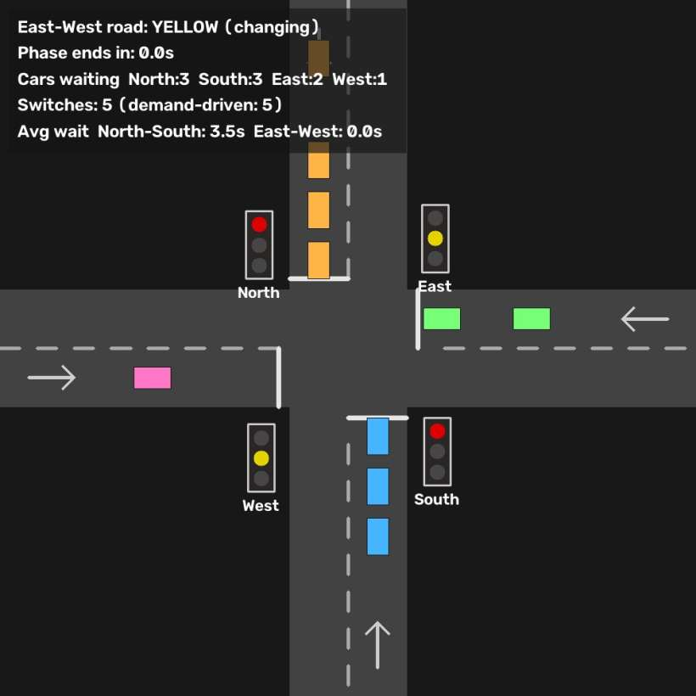

Prepared for: [Municipal Traffic Department]
Prepared by: Erenus Yildiz
Date: August 2026 | Repository: github.com/eyildiz-ugoe/smart-traffic

Executive Summary
Most traffic signals run on fixed timers. Drivers idle at red lights that protect empty roads, re-accelerate after stops that served no one, and pedestrians wait out long cycles whether or not any car is coming. Each of those moments wastes fuel, adds emissions, and erodes trust in the road network.
This proposal presents a working pilot system that replaces the timer with detection. Ordinary traffic cameras feed a YOLOv8 vision model; an adaptive controller holds a red light only when someone actually benefits from it. The system already exists as runnable software: three demonstration scenarios — a pedestrian crossing, a two-road junction, and a four-way intersection — each running both as an interactive simulation and in “shadow mode” on real camera footage, where genuine detections drive the signal plan the controller would issue for the observed traffic.
The engineering is deliberately conservative. Safety properties (no conflicting greens, mandatory yellow and all-red clearance intervals, guaranteed pedestrian service) are structural invariants of the controllers, verified by 74 automated tests and by adversarial fuzzing over millions of randomized inputs. Vehicles are tracked across frames so parked cars are recognized and excluded from demand — a classic failure mode of camera-based systems, solved and demonstrated on peer-reviewed research footage.
We propose a five-phase pilot, beginning with a software-only shadow deployment on existing city cameras that measures — with real numbers from real intersections — how much red-light time, how many stops, and how much waiting the adaptive plan would eliminate. Signal hardware is touched only after the evidence is on the table, and the existing fixed plan always remains as the supervised fallback.
The request of this proposal: approval and funding for Phase 1 (shadow deployment and measurement, software only) with an option on Phases 2–5 pending Phase 1 results.

1. The Problem: Signals That Cannot See
A fixed-time signal plan is a compromise frozen at the moment of its last retiming study. It cannot know that the cross street is empty at 22:40, that a pedestrian has been waiting ninety seconds in the rain, or that this morning's roadworks moved the queue two blocks. The consequences are well documented:
- Wasted fuel and emissions. Idling at unwarranted reds and re-accelerating after unnecessary stops are among the largest controllable sources of urban vehicle emissions. Published evaluations of camera-actuated signal control report measurable reductions in idle time and fuel consumption at equipped intersections (see References).
- Lost time, unfairly distributed. Fixed plans over-serve the movements the last study assumed and under-serve everyone else — side streets, off-peak drivers, and pedestrians bear the cost.
- Pedestrian non-compliance. Long, demand-blind waits train pedestrians to cross against the signal, converting a timing problem into a safety problem.
- Expensive retiming. Manual retiming studies are periodic, costly, and outdated the day traffic patterns shift.
Detector-actuated signals address this, but conventional actuation means cutting the road for inductive loops — expensive, disruptive, and per-lane. Cameras change the economics: one camera observes every approach of an intersection at once, and many intersections already have one installed.

2. The Proposed Solution
The pilot system pairs standard traffic cameras with modern computer vision and a family of small, verifiable signal controllers:
- See. A YOLOv8 neural network detects vehicles (cars, motorcycles, buses, trucks) and pedestrians in each frame, inside detection zones calibrated once per camera — the same zoning practice commercial video-detection products use.
- Understand. A tracking layer follows each vehicle across frames. A dwell-time filter distinguishes a car queued at the light from a car parked at the curb; debounced presence windows ensure a single missed frame never flickers the plan.
- Act. An adaptive controller grants green to measured demand: it rests in green when the cross road is empty, switches early when the served road clears, extends green under queue pressure, and guarantees service bounds so no approach or pedestrian is ever starved.

2.1 Two modes, one honest path to deployment
Every scenario runs in two modes. Simulation mode generates synthetic traffic with queueing physics — reproducible, seedable, ideal for live demonstration and for controller development. Real mode runs the identical controllers on prerecorded camera footage in shadow mode: the detections are real, and the display shows the decisions the adaptive controller would issue for that traffic.
Shadow evaluation is the industry-standard first stage of a signal-control pilot: it produces quantified evidence from real intersections at software-only cost, before any signal hardware is modified. This proposal is structured around that principle.

2.2 How this differs from off-the-shelf adaptive systems
Commercial adaptive platforms (SCOOT/SCATS-class) are proven but are network-scale commitments: proprietary, loop- or radar-instrumented, and priced accordingly. Conventional actuation via inductive loops requires cutting the pavement per lane. This pilot occupies a deliberately different niche:
- Reuses existing cameras. No civil works for Phase 1; one camera observes every approach at once.
- Fully transparent. The controllers are a few hundred lines of auditable, tested open code with explicit, documented safety constants — the department can read, question, and re-verify every rule it would be asked to trust.
- Incrementally fundable. Five phases with go/no-go gates; the first produces measured evidence for a software-only budget.
- A stepping stone, not a rival. If Phase 1 evidence justifies a commercial platform instead, the shadow logs and KPI methodology transfer directly to that procurement — nothing is wasted.

3. What Has Already Been Built
The system is not a concept: it is runnable today, from a single command, in all six scenario/mode combinations. All software, tests, and demonstration footage are in the project repository.

3.1 Case 1 — The pedestrian crossing
One road, one crosswalk. With no pedestrian present, the car light simply never turns red. When a pedestrian is detected waiting, the controller serves them after a minimum car-green time — at the next safe gap. A dilemma-zone guard refuses to begin the yellow while a fast vehicle is too close to stop comfortably; a fairness cap guarantees service within 45 seconds of accumulated waiting even under constant traffic, with a wait clock that survives detection dropouts and occlusions; and the all-red clearance holds while a vehicle is still physically on the crosswalk.
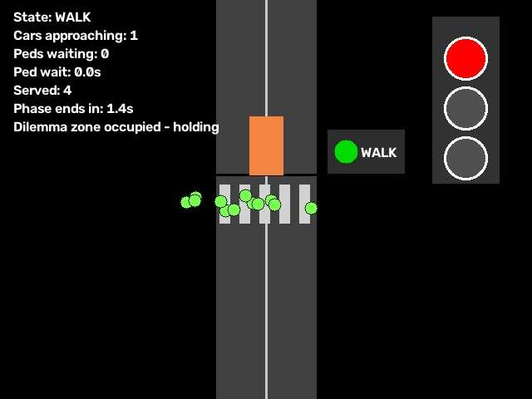
Case 1, simulation: WALK phase in progress, vehicle held behind the stop line.
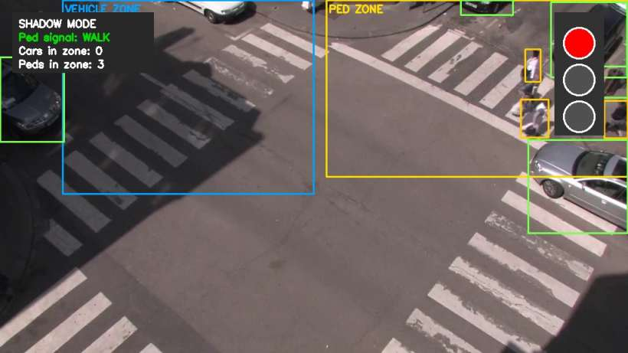
Case 1, real footage (Urban Tracker “Rouen”): pedestrians detected in the crossing zone, vehicle corridor clear, WALK granted — in shadow mode.

3.2 Case 2 — The two-road junction
Two one-way feeds. Vehicles are detected, ranked by distance to the stop line, and aggregated into a queue-pressure score that extends green time under load. The light rests in green when the cross road is empty and switches early when the served road clears. Every changeover runs green → yellow → all-red → cross green.
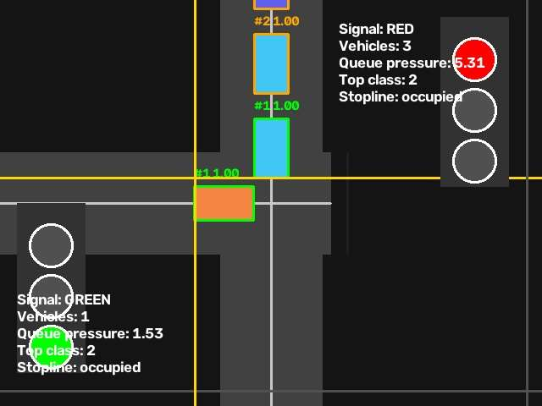
Case 2, simulation: per-vehicle queue ranking, live queue-pressure metric, and signal state for both roads.

3.3 Case 3 — The four-way intersection
Two crossing roads, four approaches, a standard two-phase plan made adaptive. An empty axis is skipped as soon as the cross axis has demand; detected demand is served within roughly 35 seconds worst-case; a slow fixed-time recall guards against detector failure so no approach can ever be starved. In a representative interactive run, the intersection performed 54 signal switches — every single one demand-driven, none by timer.
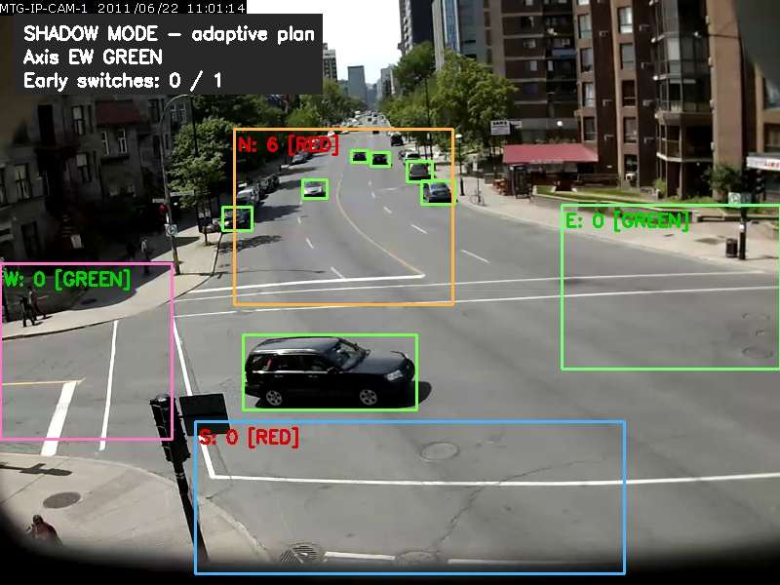
Case 3, real footage (Urban Tracker “Sherbrooke”): six vehicles queued on the North approach while the empty East–West axis is served briefly — each zone labelled with its live count and signal.

3.4 Parked-car immunity
A single camera frame cannot distinguish a parked car from one queued at a red light — both are stationary. The pilot solves this with motion history: every vehicle is tracked, and one that has never been seen moving, or has been stationary far longer than any signal cycle, is tagged PARKED on screen and excluded from demand — counting again the moment it moves. On the Sherbrooke footage the filter excluded three curbside cars while the moving queue was never mis-flagged across two minutes of signal cycles.
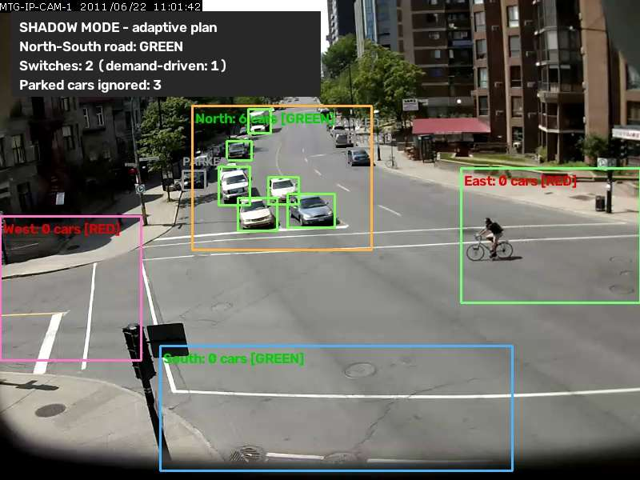
Parked-car immunity on real footage: three curbside vehicles excluded from demand (grey), moving traffic still counted (green).

3.5 Metrics observed in the demonstrations
Numbers recorded during the demonstration runs referenced throughout this proposal:
Observation | Value | Where
Signal switches in an interactive four-way session | 54 — all 54 demand-driven, none by timer | Case 3 simulation
Continuous green held for the main road while the cross axis was empty | ~36 seconds (then demand-driven cycling) | Case 3 real footage
Pedestrian walk phases served across looped playback | 2–3 per run, at detected safe gaps | Case 1 real footage
Parked vehicles excluded from demand | Up to 3 concurrently; moving queue never mis-flagged over 2 minutes of cycles | Case 3 real footage
Tracking stability after tuning | Track fragmentation halved (34.5 → 15.8 IDs per 1,000 frames) | Measured on Sherbrooke footage
Automated test suite | 74 tests, all passing; millions of fuzzed controller steps with zero invariant violations | Repository CI

4. Technology and Architecture
The software is a small, auditable Python codebase (~3,500 lines plus tests) built on industry-standard open components: OpenCV for video, Ultralytics YOLOv8 for detection, ByteTrack for multi-object tracking.
Layer | Component | Purpose
Detection | YOLOv8 (nano) | Vehicles and pedestrians per frame; GPU when available, automatic CPU fallback
Tracking | ByteTrack (tuned) | Persistent vehicle identities; configuration tuned for distant traffic-camera detections
Demand filtering | Dwell-time motion filter | Parked-vehicle exclusion; position-keyed history that survives tracker ID churn and looped playback
Sensing | Calibrated zones + debouncing | Per-camera detection zones; rolling presence windows so single-frame dropouts never flicker the plan
Control | Three signal controllers | Pedestrian crossing, two-road, four-way; injectable clocks; structural safety invariants
Presentation | Resolution-independent rendering | Identical behavior on a laptop and a 4K presentation wall; fullscreen demo mode

4.1 Safety by construction
Safety properties are not timing conventions — they are structural properties of the controller state machines. Conflicting greens are unrepresentable. Every changeover passes through a full yellow and an all-red clearance interval. The pedestrian walk phase exists only in a state where the car signal is red. Fairness bounds (maximum pedestrian wait, maximum cross-axis red under demand, detector-failure recall) are explicit constants with documented rationale.

5. Engineering Rigor and Validation
- 74 automated tests cover the controller state machines, simulation physics, zone logic, the motion filter, the video tooling, and the command-line interface.
- Adversarial fuzzing. Property-based tests drove the controllers through millions of randomized update sequences — clock jumps from 0.01 to 120 seconds, detection flapping at exact decision boundaries — asserting after every step that no conflicting greens, skipped safety phases, or starvation can occur. Two subtle defects found this way (a detector-flicker starvation pattern and a tracker configuration flaw) were fixed and converted into permanent regression tests.
- Independent multi-model review. The codebase passed repeated audit rounds by independent AI review pipelines (multiple model families cross-checking correctness, safety, security, and test coverage), with every substantiated finding fixed and regression-tested.
- Measured detection performance. Tracking stability was measured on the research footage and improved by 2× (track fragmentation halved) after tuning; published systems of the same architecture report up to ~95% vehicle detection accuracy in field conditions (References).
- Reproducibility. Simulations run on an injected simulated clock: seeded runs are bit-identical across machines, monitors, and frame rates — what is rehearsed is exactly what is presented.

6. Current Limitations — Stated Plainly
The credibility of a pilot rests on knowing precisely what it does not yet do. Each limitation below maps directly onto a phase of the roadmap in Section 7.
Limitation | Consequence today | Addressed in
No signal-hardware control | Shadow mode only; the system recommends, it does not yet actuate | Phase 4
Two-phase plans only | No protected left turns, no multi-phase rings, no corridor coordination | Phases 3 & 5
Detection envelope | YOLOv8-nano at 5–15 FPS on CPU; night, rain, and snow unvalidated; distant/occluded objects can be missed | Phase 2
Presence-based dilemma logic | No speed estimation; yellow-onset timing is conservative rather than speed-optimal | Phase 2
Simplified simulation physics | Straight-through traffic only; no turning movements or driver modelling | Phase 3 (SUMO coupling)
Uncalibrated fuel metrics | Wait times and stops are measured; litres and CO₂ require an accepted conversion methodology | Phase 3
Manual zone calibration | Each camera view is zoned by hand at setup | Phase 2
Minimal privacy posture | Frames are processed and discarded, nothing stored — but formal review, signage, and policy are required for deployment | Phase 5

7. Pilot Plan and Timeline
Five phases, each producing a decision point before the next is funded. Phase 1 is software-only and uses infrastructure the city already owns.
Phase | Scope | Duration | Key deliverable
1. Shadow deployment | Run this system against live feeds at 2–3 candidate intersections; log adaptive decisions vs. installed fixed plans | 2–3 months | Measured KPI report: avoidable red time, stop counts, pedestrian wait distributions
2. Detection hardening | Fine-tune the detector on local footage (night, rain, winter); track-based speed estimation; GPU edge device (Jetson-class) for 30+ FPS; semi-automatic zone calibration | 2–3 months | Detection validated across local conditions; real-time performance
3. Controller enrichment | Protected turn phases and ring-and-barrier plans; SUMO microsimulation coupling; calibrated fuel/CO₂ savings model | 3–4 months | Engineering-grade evaluation against recorded demand profiles
4. Hardware-in-the-loop | Integration with a signal controller via the locally used standard (NTCIP/OCIT); existing fixed plan retained as supervised fallback; certified fail-safe review | 4–6 months | One intersection under supervised adaptive control
5. Scale-out | Corridor coordination (green waves); central monitoring dashboard; privacy and compliance sign-off; operations handbook | 6+ months | Deployment blueprint and business case for network-wide rollout

Decision gates: each phase ends with a go/no-go review against pre-agreed KPI targets. The city can stop after any phase with the full evidence produced so far.

8. Expected Benefits and How They Will Be Measured
Phase 1 exists to replace expectations with measurements. The KPIs below are computed directly from the shadow logs — the same quantities the on-screen counters already display in the demonstrations:
KPI | Definition | Source
Avoidable red time | Vehicle-seconds spent at red while the conflicting movement had zero detected demand | Shadow log vs. fixed plan
Stops avoided | Signal changeovers the adaptive plan would have skipped (rest-in-green) or moved (early switch) | Shadow log
Pedestrian service time | Distribution of detected-wait to walk-granted intervals; share served within the fairness bound | Shadow log
Queue clearance | Time from green onset to detected queue clearance, per approach | Shadow log
Fuel / CO₂ estimate | Idle-time and stop counts converted via an accepted drive-cycle methodology (Phase 3) | Derived

Published evaluations of comparable YOLO-based adaptive signal systems report reduced intersection idle time and fuel consumption, with detection accuracy up to ~95% in field conditions (References). The pilot's own numbers, from the city's own intersections, will be the basis for the scale-out business case.

8.1 An illustrative calculation
To make the KPI concrete (illustrative arithmetic, not a promise): suppose a minor cross street at one intersection receives a fixed 20-second green every 90-second cycle, but has no waiting vehicle in 60% of night-time cycles. Every empty cycle forces main-road traffic to stop for roughly 25 seconds of yellow-plus-red. Over an 8-hour night that is ~190 unnecessary interruptions at a single intersection — each one idling several vehicles and forcing several stop-and-go accelerations. The adaptive plan simply skips those cycles (rest-in-green), which is precisely the quantity the Phase 1 shadow logs will measure per intersection, per hour, from real detections rather than assumptions.

9. Budget Framework
Amounts are intentionally left open pending scoping with the department; the structure below defines what a complete Phase 1–2 budget contains. Phase 1 requires no capital hardware if existing cameras are used.
Item | Phase | Notes | Amount
Engineering (integration, calibration, KPI reporting) | 1 | Primary Phase 1 cost; software exists | [to be scoped]
Camera access / IT coordination | 1 | Feeds from existing infrastructure; network and access arrangements with the city | [to be scoped]
GPU edge devices (per intersection) | 2 | Jetson-class unit, mount, power | [to be scoped]
Detector fine-tuning and data collection | 2 | Local footage capture and annotation, night/weather validation | [to be scoped]
Signal-controller interface and certification | 4 | NTCIP/OCIT integration, fail-safe review with the signals vendor | [to be scoped]
Contingency | all | Recommended 10–15% | [to be scoped]

10. Risk Management
Risk | Likelihood | Mitigation
Detection degrades at night / bad weather | Medium | Phase 2 fine-tuning on local footage; detector-failure recall already guarantees no approach is ever starved even with a blind camera
Camera outage or misdetection in operation | Medium | Fixed plan remains the supervised fallback at all times (Phase 4 design); fixed-time recall built into the controller
KPI results below expectations | Low–Medium | Phase-gate structure: decision after Phase 1 costs only the shadow study
Privacy concerns from the public | Medium | Nothing is stored by design; formal privacy review, signage, and policy in Phase 5; engagement material prepared from the demonstrations
Integration friction with signals vendor | Medium | Standard interfaces (NTCIP/OCIT); vendor engaged from Phase 3; supervised-fallback architecture

11. Team and Governance
Project lead: Erenus Yildiz — system design and implementation.
[Add: departmental sponsor, traffic-engineering counterpart, IT/camera-infrastructure contact, signals-vendor liaison.]
Governance: monthly steering review during each phase; phase-gate reviews with pre-agreed KPI targets; all code, logs, and reports delivered to the department in an auditable repository.

12. References
- Jodoin, Bilodeau, Saunier. Urban Tracker: Multiple Object Tracking in Urban Mixed Traffic. IEEE WACV 2014 — source of the peer-reviewed demonstration footage (“Rouen”, “Sherbrooke” sequences).
- IIETA Traitement du Signal (2024). Real-Time Vehicle Detection Using YOLOv8-Nano for Intelligent Transportation Systems.
- IJERT. Smart Traffic Surveillance System with Adaptive Traffic Control Signal using YOLO — reports reduced idle time and fuel consumption.
- IJRASET (2025). AI-Driven Emergency Vehicle Detection for Signal Optimization Using YOLOv8 — ~95% detection accuracy in field conditions.
- Project repository. github.com/eyildiz-ugoe/smart-traffic — all code, tests, demonstration footage, and documentation.

Appendix A — Running the Demonstration
The complete demonstration runs on a standard laptop (Windows/Linux/macOS, Python 3.10+). A GPU is optional; all scenarios run on CPU.
Installation: pip install -r requirements.txt
The three cases, live:
Command | Shows
python demo.py --case 1 --mode simulation --fullscreen | Pedestrian crossing: no pedestrian, no red
python demo.py --case 1 --mode real | Same controller on real crosswalk footage (shadow mode)
python demo.py --case 2 --mode simulation --seed 42 | Queue-pressure green extension, reproducible run
python demo.py --case 3 --mode simulation | Four-way intersection with live switch counters
python demo.py --case 3 --mode real | Adaptive plan + parked-car immunity on a real intersection

Controls: F toggles fullscreen; Q quits. All screenshots in this proposal were produced by these commands.
Verification: pytest tests/ runs the complete 74-test suite in under half a minute on a laptop; no videos or GPU are required for the core suites.

Appendix B — Glossary
Term | Meaning
Shadow mode | Running the adaptive controller on real camera input while displaying — not actuating — its decisions; the standard first stage of a signal-control pilot
Rest-in-green | Holding green on the served road indefinitely while the conflicting movement has no detected demand
Early switch | Ending a green before its nominal duration because the served road has emptied and the cross road is waiting
Dilemma zone | The stretch just before the stop line where an approaching vehicle can neither stop comfortably nor clear before red; the controller never starts a yellow while it is occupied
All-red clearance | A short interval with every signal red between conflicting greens, letting committed vehicles leave the conflict area
Queue pressure | A demand score that weights detected vehicles by their distance from the stop line, so long queues extend green time
Recall (detector-failure) | A slow fixed-time fallback that serves an approach even if its detector reports nothing, so a dead camera can never starve it
Dwell-time filter | Tracking-based logic that distinguishes parked vehicles from queued traffic by their motion history
KPI | Key performance indicator — the measured quantities (Section 8) that gate each pilot phase

— End of proposal —

