DLP Assessment Descriptive Results
School-level snapshot, compliance, proficiency, and geographic summaries
June 11, 2026

What is in the dataset
The final file uses the DLP randomized schools file as the base, so the dataset has 258 schools. Based on rev_status, 217 schools are coded as Control and 41 schools are coded as Treatment.
Across these schools, the DLP enrollment file has 313,009 junior high school students. The Beginning of School Year reading assessment has 295,755 assessed students, while the End of School Year reading assessment has 250,696. For mathematics, the Beginning of School Year assessment has 294,804 assessed students and the End of School Year assessment has 283,564.
Treatment status | Schools | Enrollment | Reading BoSY assessed | Reading EoSY assessed | Math BoSY assessed | Math EoSY assessed
Control | 217 | 265,493 | 251,653 | 211,678 | 250,252 | 240,372
Treatment | 41 | 47,516 | 44,102 | 39,018 | 44,552 | 43,192

Dataset snapshot by treatment status
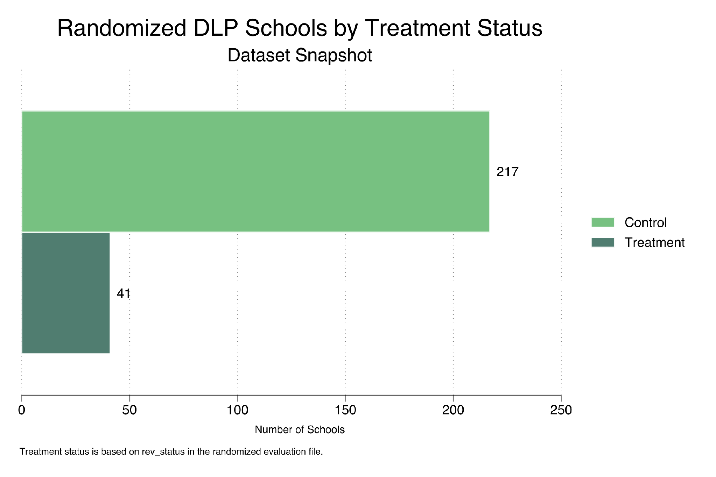

Compliance
Using the assignment flags and rev_status rule, 41 of 258 schools are compliant, or 15.9% overall. Compliance is highest in the emergency assignment group and lowest in the mainstream assignment group.
Assignment group | Schools | Compliant schools | Compliance rate
Emergency | 87 | 16 | 18.4%
Mainstream | 85 | 10 | 11.8%
Shifting | 86 | 15 | 17.4%

Compliance by assigned randomization group
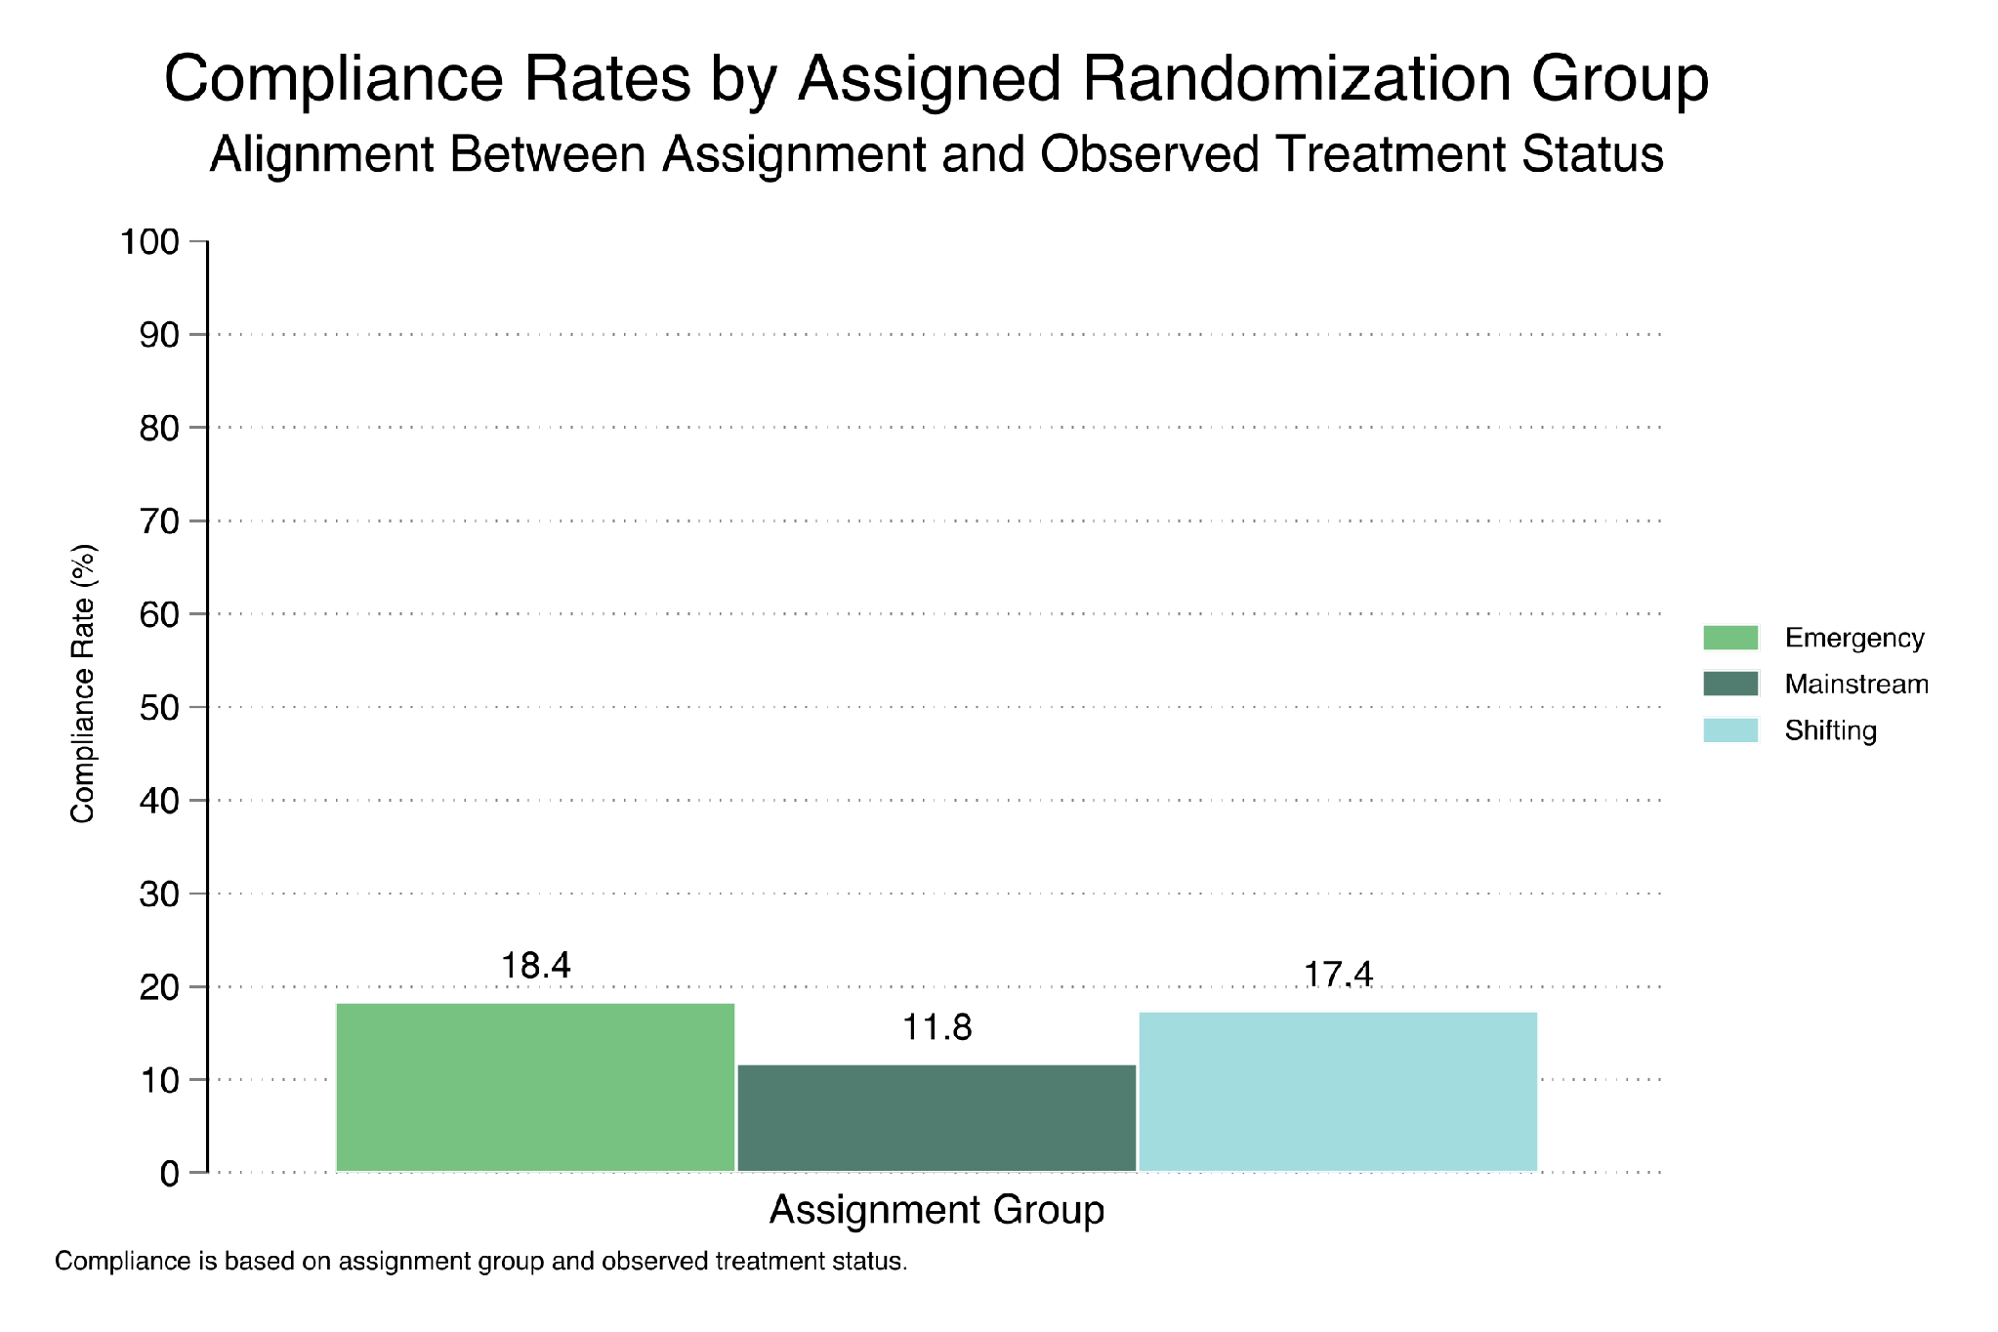

Proficiency and reading categories
Rapid Mathematics Assessment results are concentrated in the not proficient group in both the Beginning of School Year and End of School Year files. This pattern is visible across Grades 7 to 10.
Period | Group | Students | Share of assessed
BoSY | Not proficient | 257,630 | 87.4%
EoSY | Not proficient | 135,932 | 47.9%

For the Philippine Informal Reading Inventory, the Beginning of School Year file has separate 2-level and 3-level reading categories. The End of School Year file does not have the same 2-level and 3-level fields, so End of School Year independent is used as a proxy for grade ready in the comparison figures.
Reading measure | Category used | Share of classified students
Beginning of School Year 2-Level | Independent | 31.8%
Beginning of School Year 3-Level | Independent | 25.5%
End of School Year Proxy | Independent | 41.1%

Rapid Mathematics Assessment proficiency by grade
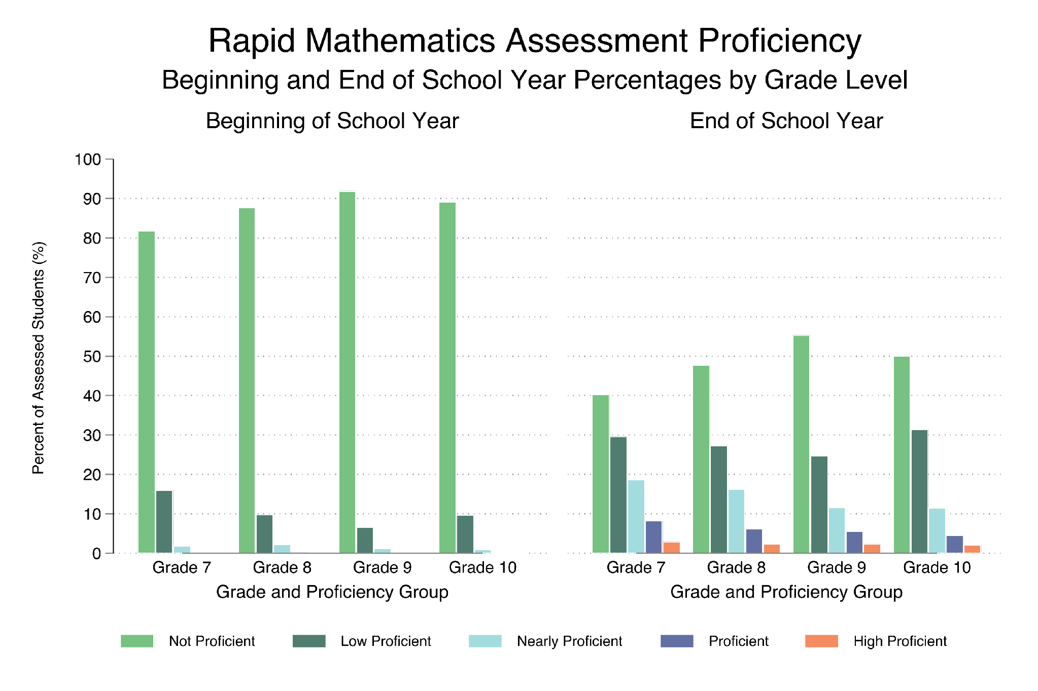

Philippine Informal Reading Inventory Beginning of School Year 2-Level and End of School Year Proxy
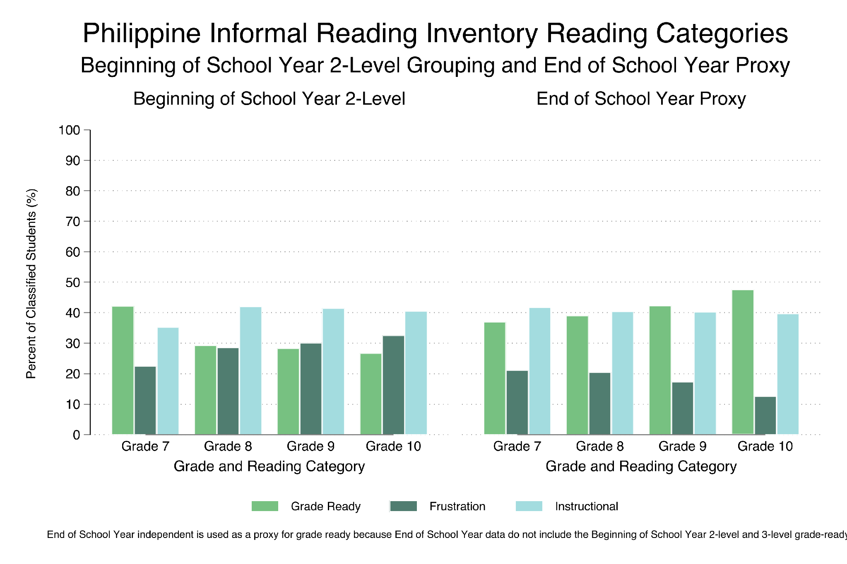

Philippine Informal Reading Inventory Beginning of School Year 3-Level and End of School Year Proxy
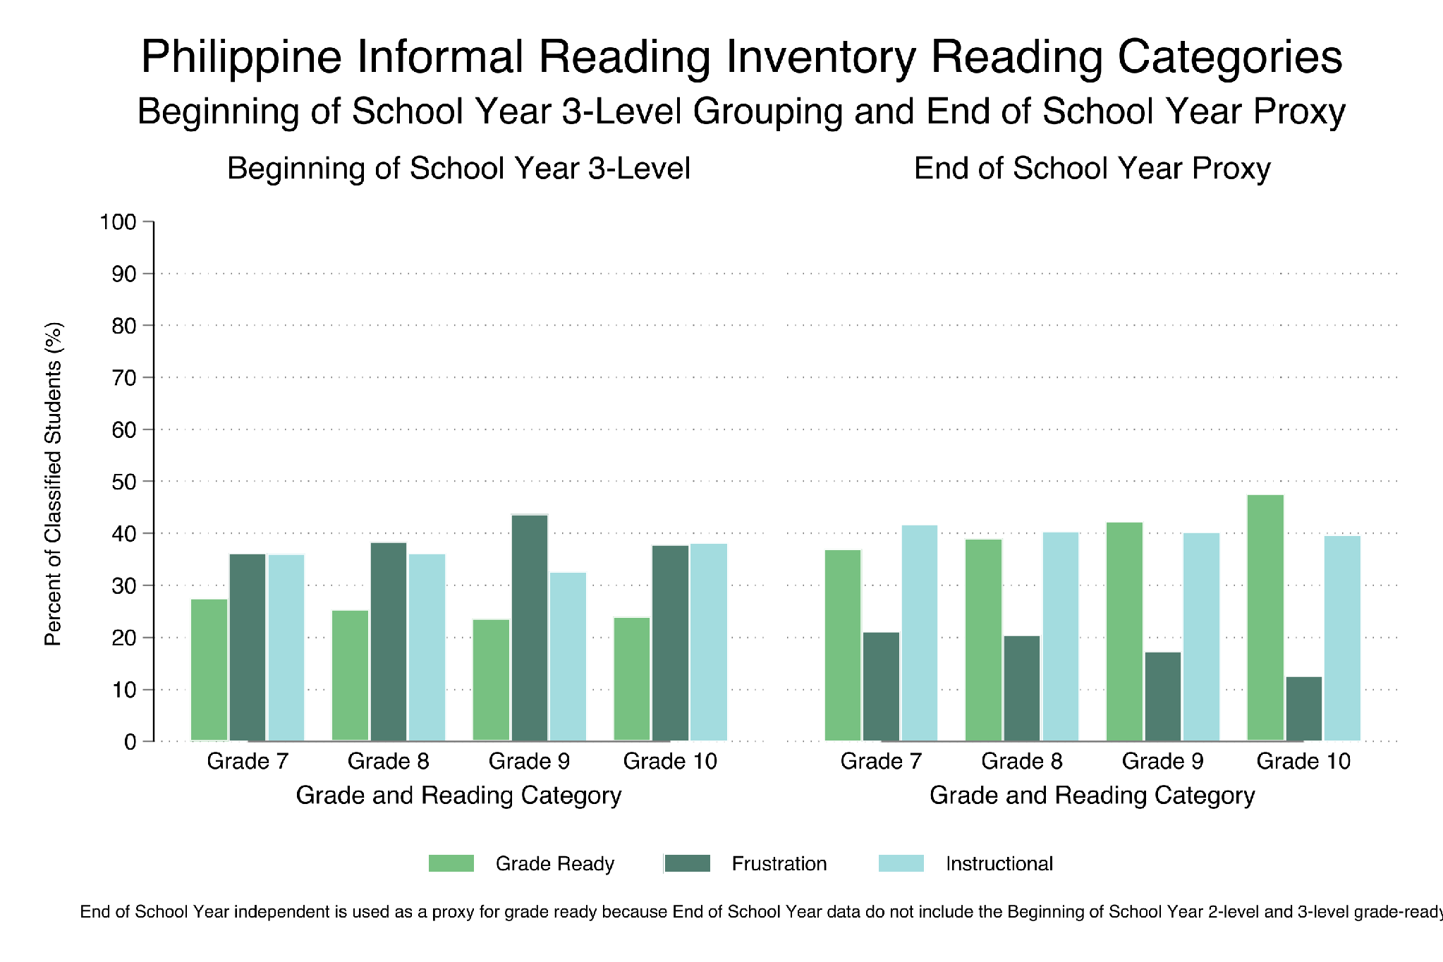

Subgroup patterns
The subgroup tables below compare the main math and reading indicators for Control and Treatment schools. The full grade-level subgroup tables are saved in the outputs/tables folder.

RMA not proficient share
Treatment status | Beginning of School Year | End of School Year
Control | 88.8% | 48.8%
Treatment | 79.6% | 42.9%

RMA not proficient share by treatment status
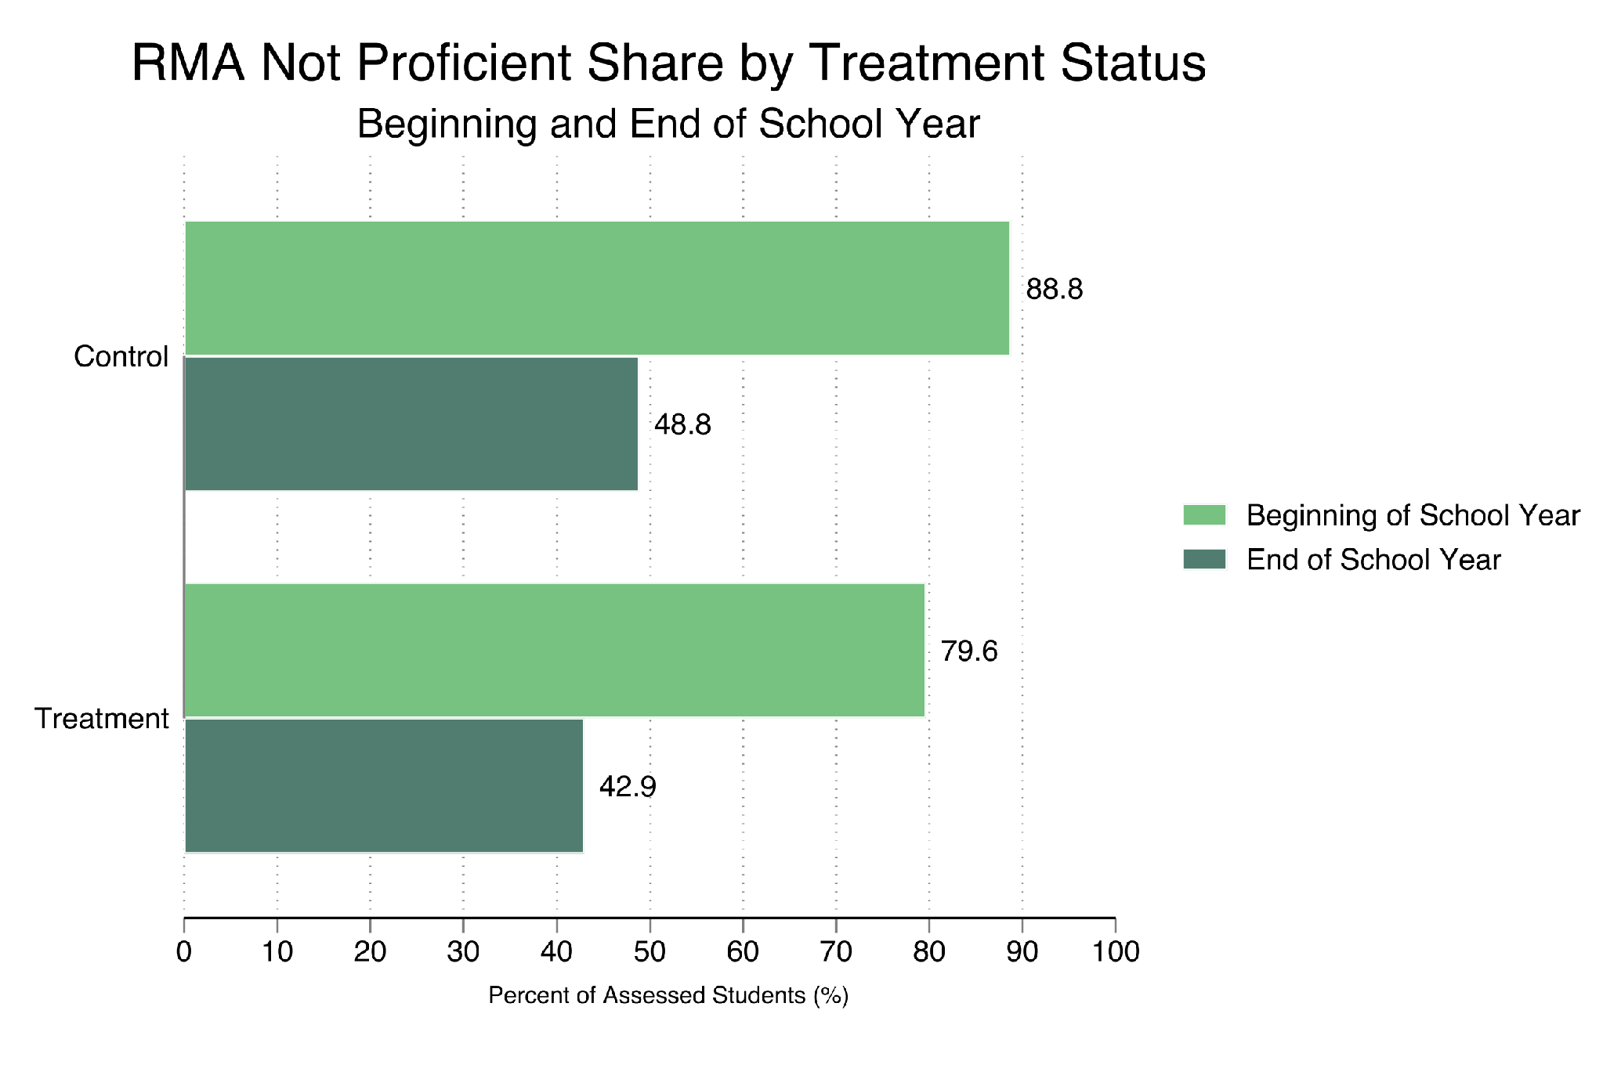

Phil-IRI grade ready and proxy share
For Phil-IRI, Beginning of School Year uses the 2-level and 3-level independent categories. End of School Year independent is shown as a proxy because the End of School Year file does not include the same 2-level and 3-level fields.
Treatment status | BoSY 2-Level | BoSY 3-Level | EoSY Proxy
Control | 32.4% | 26.3% | 42.2%
Treatment | 28.5% | 20.8% | 35.2%

Phil-IRI grade ready share by treatment status
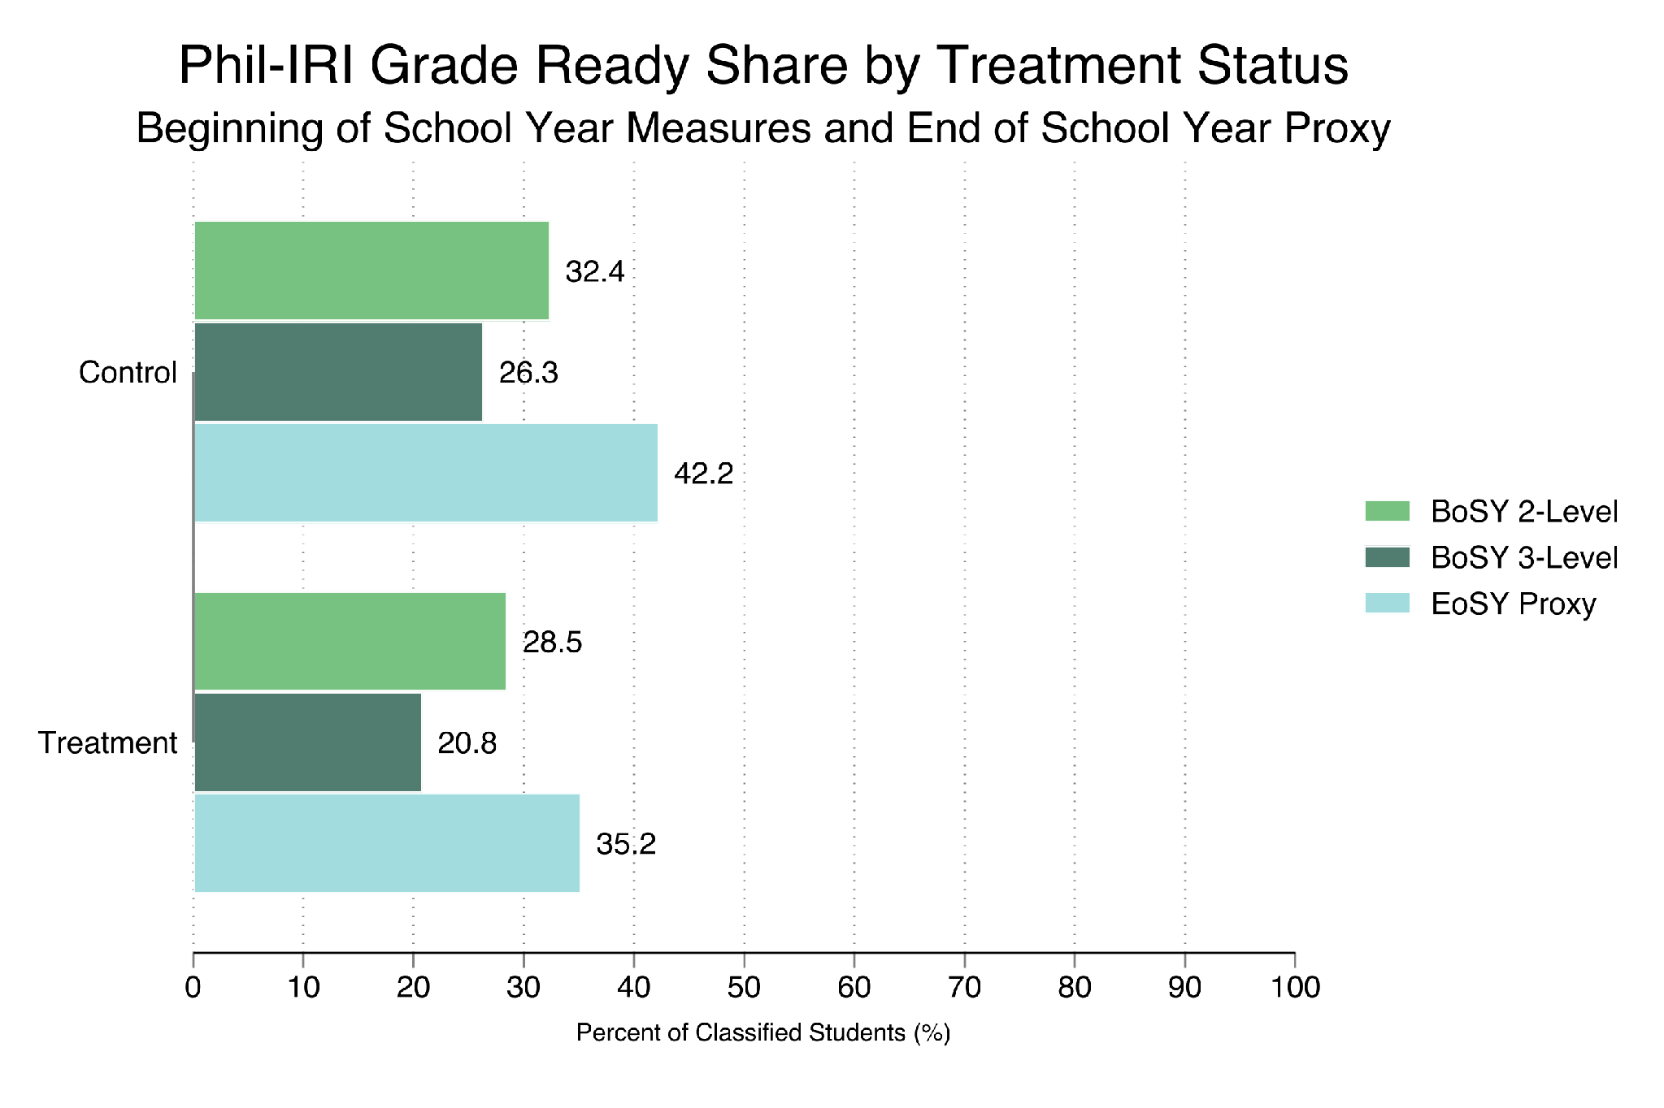

Geographic summaries
The randomized schools in this file are spread across five regions. Region 5 has the largest number of schools in the dataset. The coverage rates now use the enrollment denominators from the assessment dashboard files, so the regional rates stay below 100 percent.
Region | Schools | Reading BoSY coverage | Reading EoSY coverage | Math BoSY coverage | Math EoSY coverage | Compliance
Region 5 | 87 | 98.3% | 93.5% | 99.1% | 97.6% | 18.4%
Region 15 | 48 | 96.6% | 76.6% | 98.0% | 97.4% | 22.9%
Region 7 | 48 | 97.7% | 93.0% | 99.0% | 97.7% | 12.5%
Region 4 | 38 | 97.9% | 92.9% | 99.5% | 96.7% | 10.5%
Region 11 | 37 | 98.4% | 93.6% | 98.1% | 95.0% | 10.8%

Beginning and End of School Year regional assessment coverage
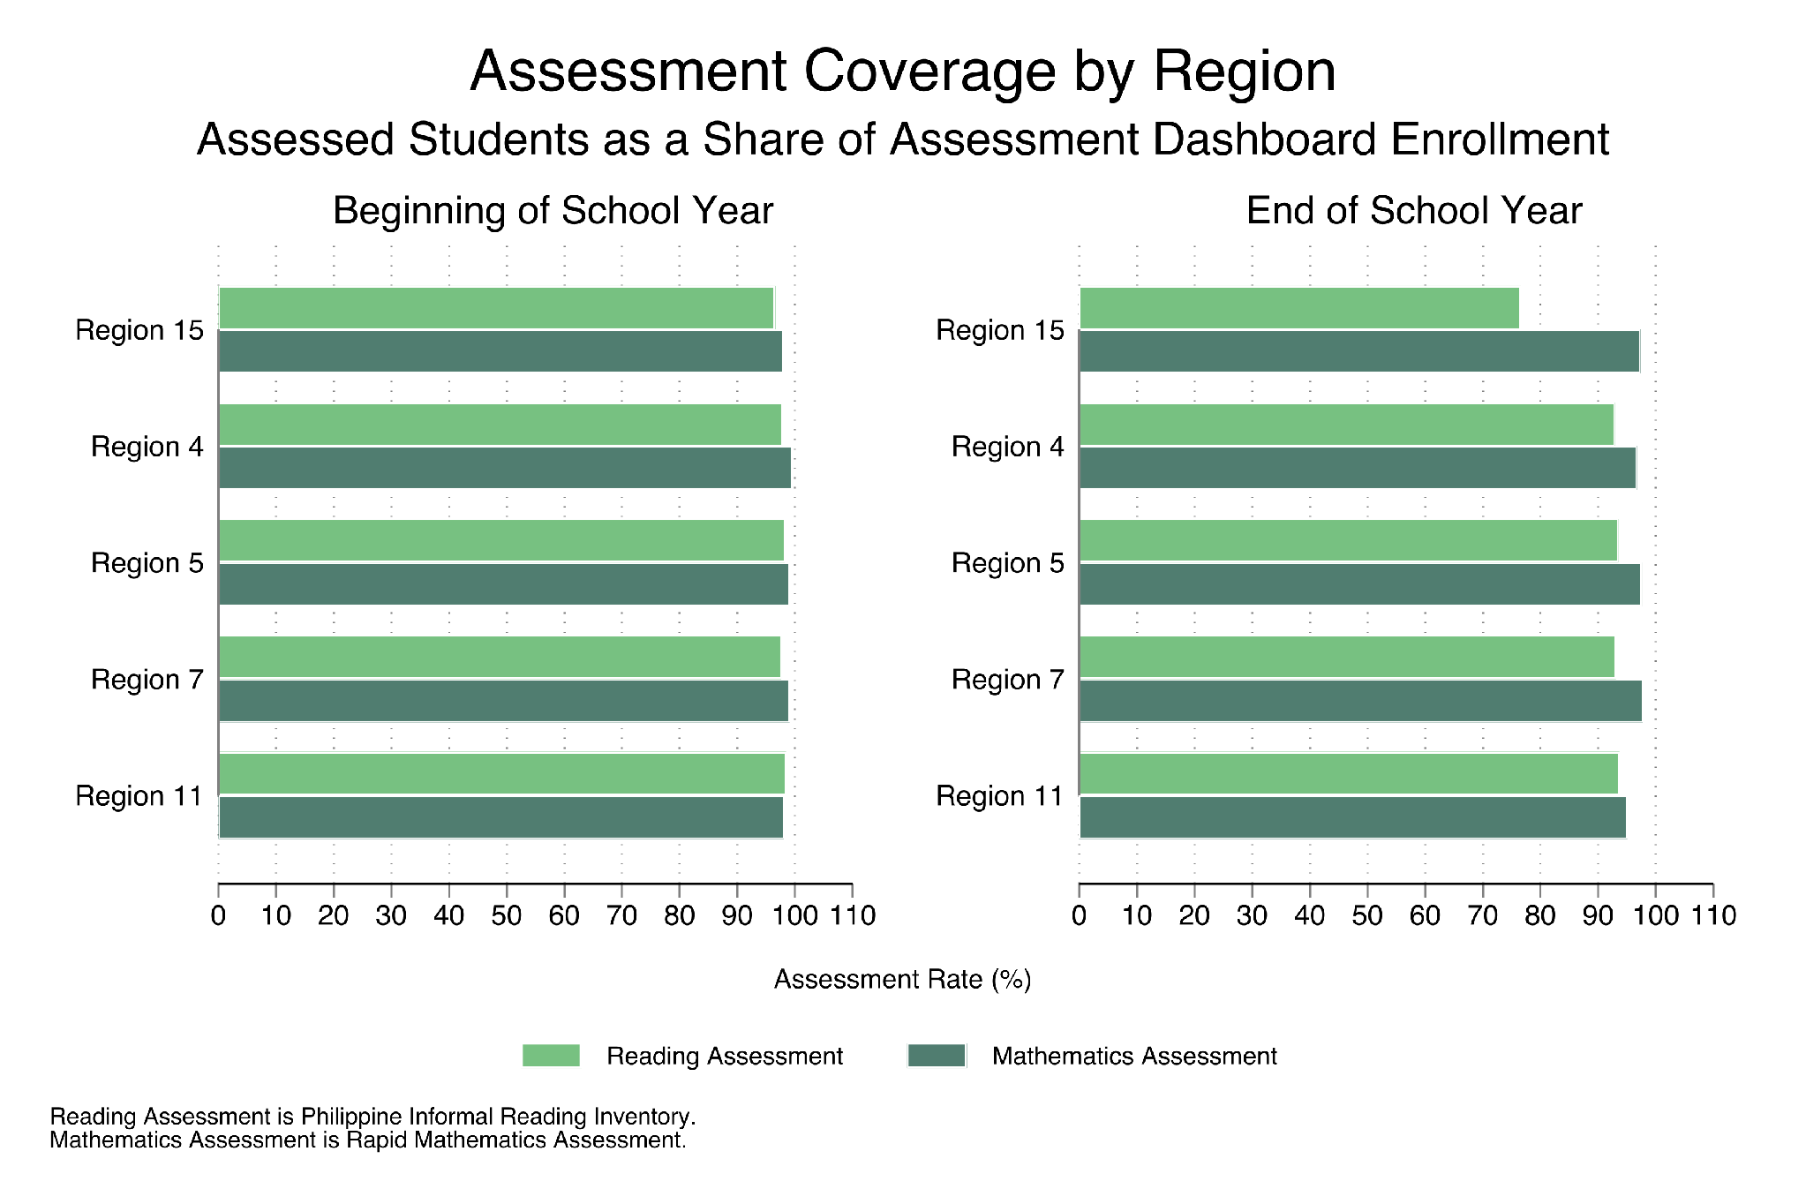

Regional compliance rate
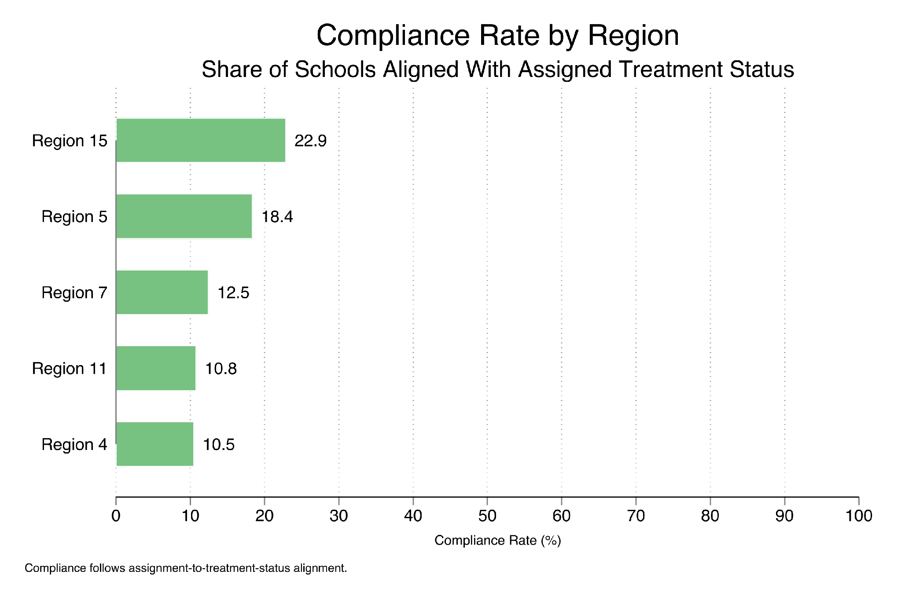

Files to share
The do-files are in scripts/. Cleaned data is in data/. Tables, logs, this brief, and individual PNG figures are in outputs/.

