|  |  |  |
| --- | --- | --- |
|  | p-2022-048 | **Project number:** |
|  | Raam Kavod - 205784218  Eylon Kapel - 207807025 | **Student:** |
|  | Dr. Ilan Shalish | **Supervisors:** |
|  | 24/07/2022 | **Submission date:** |

**Table of contents**

1. Abstract……………………………………………………………...……...…....…3  
 1.1 English abstract……………………………………….…………….…….3  
 1.2 Hebrew abstract……………………………………….…………….....….3  
2. Specification sheet………………………………...…………………...……....…4-6  
 2.1 Technology………………….……………………………………..…...…4  
 2.2 Applications of the product………………………………………….....…5  
 2.3 Performances specification………..………………………………....……5  
 2.4 Schematic of system………………………………………………....……5  
 2.5 Comparison to the original specification sheet …..………………………6  
3. Design approach & solution…...…………………………...……………………….6  
4. Final verifications……………...…………………………...………………………7  
5. Difficulties & Solutions......…...…………………………...………………….…....8  
 5.1 Dual supplier input problem...……………………………………..…..…8  
 5.2 Override switch and spare bus………………………………………....…8  
6. Conclusion & Suggestions.…....…………………………...……………………..8-9  
7. References………………..…....…………………………...………………...……10  
8. Appendix.…....…………………………...………………...………………….…..10

1. **Abstract**

**1.1 Abstract**

In the near future, we may not be able to solve any problem with Silicon, therefore the need to research alternative materials grows. Certain material characterization methods require conditions of a magnetic field in a Faraday cage. The purpose of this project is to enable computerized control of such measurement conditions.  
The innovation of this measurement tool is the first measurement tool that measures in conditions of a magnetic field in a Faraday cage that is controlled automatically from distance.  
The suggested method consists of an FPGA microprocessor, Step motor, LEDs, power supply, printed circuit boards, Interface, Infrared sensors, belt conveyor, Rare Earth Magnet, and a Shock Absorber which together should make up the required measurement tool.  
The expected result is a working system that can take precise measurements under the desirable controlled conditions.  
Keywords: Magnet, Rare Earth Magnet, FPGA Microprocessor, Step motor, Hall effect, LabView, Position Sensors.

* 1. **תקציר**

בעתיד לא בטוח שיהיה ניתן לפתור כל בעיה עם סיליקון ולכן הרצון לחקור חומרים ודגמים שונים תמיד יהיה קיים. לשם כך נדרשות מערכות מדידה שיכולות למדוד את הרכיבים בתנאים של שדה מגנטי ובתוך כלוב פאראדיי הנשלטים מרחוק בדיוק רב.   
בעקבות כך המטרה של מכשיר המדידה תהיה לדעת למדוד את התכונות הרצויות תוך מתן תנאים רצויים.   
החדשנות היא בכך שלא קיים כיום כלי מדידה המבצע את המדידות לצד שדה מגנטי בתוך כלוב פאראדיי המבודד ספקטרום של כל גלי האור הלא רצויים (מלבד אורך הגל הרצוי) שניתן לשלוט עליו מרחוק.  
המתודה המוצעת היא שילוב של הרכיבים הבאים: מיקרו בקר, מנוע צעד, כרטיס המיועד להתממשק עם המנוע ולהפעיל אותו, לדים להמחשת מיקום המודל, ספק מתח מתאים, חיישני אינפרא אדום, מעגל מודפס המחבר בין הבקר לחיישנים, למתחי הספק ולנגדים חיצוניים , בולם זעזועים, מסוע ודגם שנמצא במרכז המסוע. התוצאה שאנו מצפים לה היא מערכת עובדת שניתן לבצע באמצעותה מדידות בתנאים הרצויים הנשלטת על ידי תוכנת מדידה חיצונית.  
מילות מפתח: מגנט עופרת נדירה, מגנט, מיקרו-בקר, מנוע צעד, אפקט הול, חיישני מיקום, lab-view.

**2. Specification sheet**  
**Computerized drive for permanent magnets in a spectroscopic setup**

The purpose of this project is to create a system which can affect the magnetic field at a certain area in an on-off manner, this system will be part of a larger spectroscopic setup and as a result will have the constraints of things such as the need to be remotely controlled, feedback to the user etc.   
The reason for using Rare Earth Magnet and not the commonly used Electromagnet like Hall Effect measurement tools is that the Rare Earth Magnet is smaller and cheaper, so it is both space- and cost-effective for our circumstances. The disadvantage of Rare Earth Magnet is that we cannot control its magnetic field with electricity, and the solution is to build a belt conveyor system and control the distance from the sample because the magnetic field weakens as the distance grows, according to the measurements shown at Figure-1.

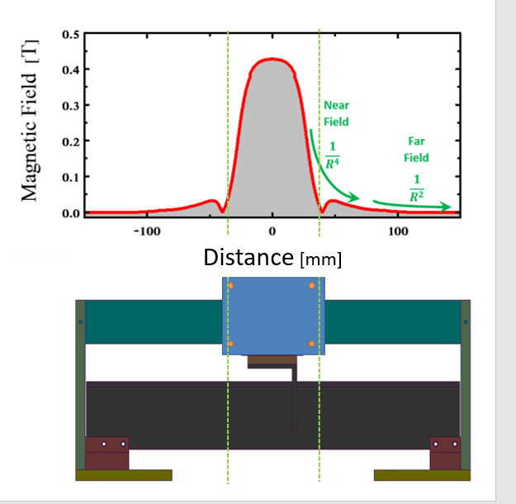

Figure 1  
Magnetic field as function of distance

Figure 2

**2.1 Technology**

The included technologies in our project are electrical devices that can drive the magnet on the belt conveyor (or devices that can support them) which also can be remotely controlled.

**2.2 Applications of the product**

The application of this product is to be a part of a system that can measure research samples under conditions of magnetic fields and isolation of light, by software or a physical switch which can override the software and move the magnet to both directions.

**2.3 Performances specification**

The system will take as input, power supply and a signal which specifies if the magnet need to be on the sample or far from it. The system’s output is the magnet’s location shown on the LED screen that is visible from outside the setup. It should operate in a way that wouldn’t make much physical disturbances and noise to the system (which is sensitive and needs to be reliable) and preferably with a fast response time.

**2.4 Schematic of system**

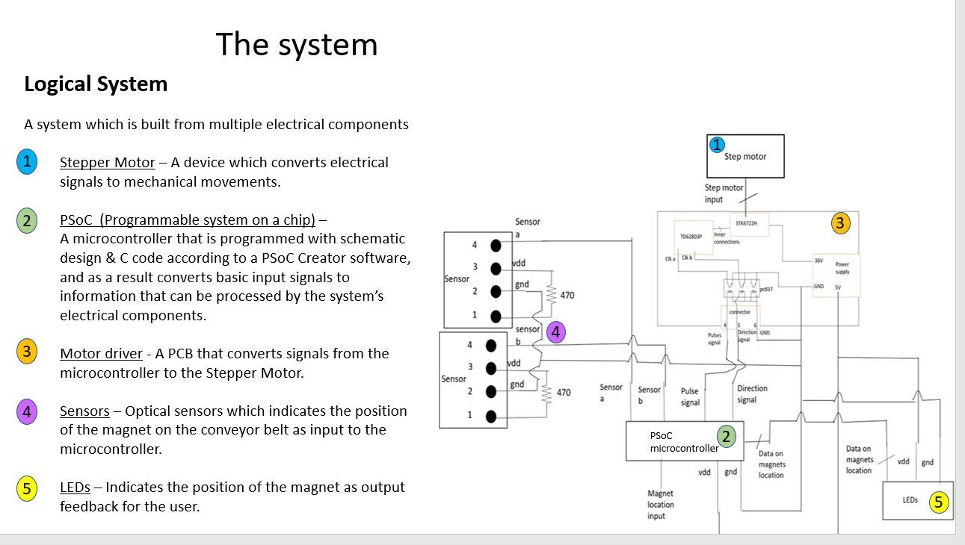

Figure 2  
Logical System

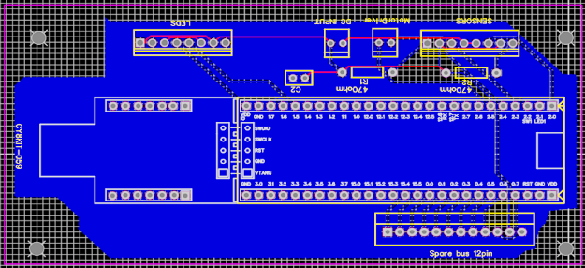

Figure 3  
PCB

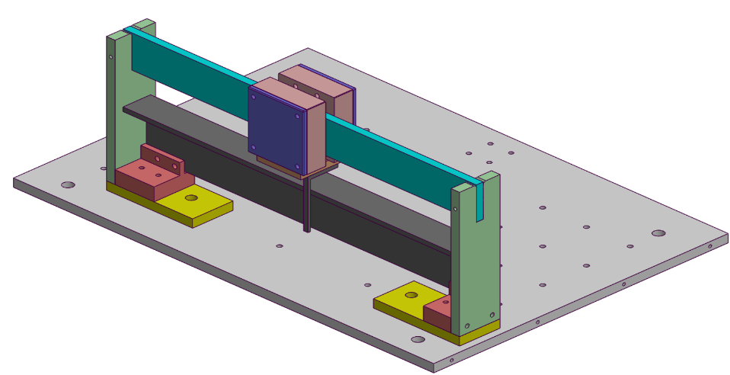

Figure 4  
Mechanical system

**2.5 Comparison to the original specification sheet**

1. We provided a measurement of the magnetic flux density’s (Tesla units) at the relevant range of the conveyor belt to support the assumption that it is negligible off the sample, relatively to when it is on it. In comparison to the original proposal which only theoretically addressed the behavior of the magnetic field (which also turned out to be different from what we anticipated)

2. At the beginning we had a partial schematic of the logical part of the system, since then we updated it, added schematics of the mechanical and the PCB that we implemented since then.

3. At the beginning we assumed that the control from the user will be only via software using lab-view, since then we also added a physical switch which can override the software and provide more options and possibilities.

**3. Design approach & solution**

The first approach we thought about was using an electromagnet[1] because it is the common solution for problems that require changing magnetic fields’ strengths. An electromagnet is a magnet that can be controlled by an electric current. However, we concluded that since the electromagnet heats up due to the power it consumes, it needs a cooling system that can satisfy those demands, and that in addition to its size, makes it expensive.  
Since we concluded that we won’t use a stationary magnet to change the magnetic field, we will use a moving mechanism in the system because the farther the sample will be from the magnet, the weaker the magnetic field will be.   
Therefore, the approach was to use a permanent magnet[2] in our system, supported by a system that drives it farther or closer to our measured sample, it solved the problems from the first approach since we don’t need a cooling system and we are using a Rare Earth Magnet material so that the size of the magnet is smaller than the electromagnet, this approach required more elements to the system like a step motor, sensors, etc. but we managed to solve those problems, therefore, this approach was the way we decided to solve the problem.

The FSM shown in Figure 5 describes the program of the microcontroller that is shown in Figure 2.

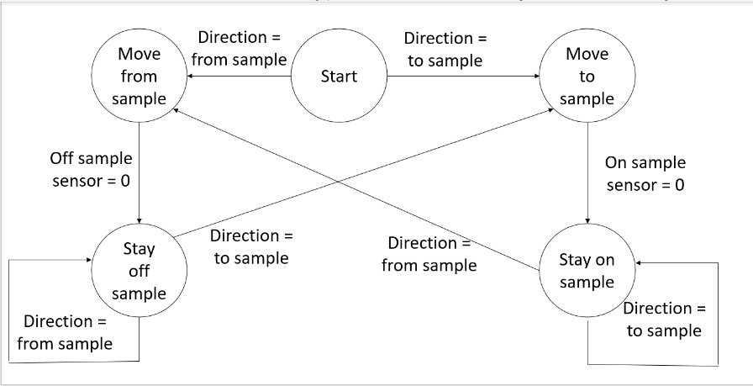

Figure 5  
FSM of the microcontroller

**4. Final verifications**

The main measurement appears in Figure 1, it consists of a measurement of the magnetic flux density in the range of the conveyor belt. We used the belt and the permanent magnets that are used in the system, along with a magnetometer – A device that can measure the magnetic flux density (Tesla units), relatively to a reference point. In addition to that, we also used a static stand for the magnetometer to prevent inaccuracies.

Since the stepper motor which moves the magnet is triggered by a PWM, i.e., signal pulses, the magnet moves incrementally at constant distances, therefore, we took the measurements at those points.

The measurement was made in such a way that we placed the magnetometer in the middle of the belt, where the sample will be, and the reference point is at the edge. We measured at every step of the magnet along the belt.

The behavior that we expected is:

We are interested only in the magnetic flux density at the center compared to the edges since the magnet will be only at those locations when taking measurements.  
We also wanted to see the general behavior and not specific values since we want to confirm that the magnetic field is negligible at the edges relative to the center, we didn’t expect to see specific values, but a difference of a few magnitudes of order.

The result of the measurement is that the magnetic field at the edge of the conveyor belt is negligible compared to the center as expected.

The behavior of the graph is such that when the magnetometer is between the magnet’s plates the magnetic field decreases like , and like otherwise, although we expected to have an inverse square behavior everywhere, the results were better than we anticipated.

**5. Difficulties & Solutions**

**5.1 Dual supplier input problem**

There are two ways to supply voltage to the microcontroller, through USB connection to a PC and through an external source, but not together, this is to prevent short circuit between two suppliers.

The external source is the preferred way to supply power to the microcontroller in order to avoid the need to keep the USB always connected, but we need the USB to program the microcontroller. This is a problem since the PCB we designed does not connect between the microcontroller DC input and the external source.

There is a chip that transfers DC supply from the USB (PC) through a diode (D1). To prevent short circuit and solve the design problem, we disconnected the diode and soldered VDD and GND underneath the PCB between the DC input of the board to the DC input of the microcontroller, so the microcontroller will only receive voltage from the external power supply even while programming the microcontroller through USB.

**5.2 Override switch and spare bus**

In the initial design of the PCB, we created a spare bus connection to the microcontroller GPIOs and DC input in case of possible changes.

After we designed and printed the PCB, we decided that another component is needed, a switch that can override the software and move the magnet on-off the sample.   
We used the spare bus GPIOs to integrate the override switch to the system.

**6. Conclusions & Suggestions**

In summary, the use of permanent magnets is reliable, robust, cheap, and sufficient for controlling on-off magnetic field compared to an electromagnet which can be robust and reliable but is more expensive and requires a cooling system in addition to the setup.

The anticipated behavior for the magnetic field’s flux density is to decrease like over distance as shown in Figure 1. The theory wasn’t that different from reality, the magnetic field far from the magnet was inverse squared to distance, but between the magnet’s plates behaved like .

The advantages of the product were as seem above, permanent magnets are cheaper and requires fewer peripheral components.  
The disadvantage of the permanent magnet compared to an electromagnet is the possible physical disturbances from the movement of the magnet on the conveyor belt.  
The absence of magnetic field that the electromagnet can provide is not a disadvantage because the magnetic field is negligible in the distances of the setup.  
The size of the setup is not an advantage as well. If the system was built based on an electromagnet, we wouldn’t have to use a conveyor built which increases the size of it, but it would require a cooling system that increases the size of the system as well.

The objective of the project accomplished, we have designed electromechanical system remotely controlled by software and physical switch. However, we didn’t link the system with a LabVIEW software.

In timeline manners, we stayed on schedule, we haven’t linked the LabVIEW, however, we have added an override switch.

In manners of cost, we used exactly the estimated budget.

|  |  |  |
| --- | --- | --- |
| **Product** | **Price** | **Source** |
| FPGA Cypress CY8CKIT-059 PSoC 5LP Prototyping Kit. sample: CY8C5888LTI-LP097 | 10$ | https://www.cypress.com/documentation/development-kitsboards/cy8ckit-059-psoc-5lp-prototyping-kit-onboard-programmer-and |
| Step Motor SST55D3C020 SHINANO KENSHI CO.LTS.JAPAN | 15$ | https://www.ebay.com/itm/265166457228 |
| Nikon 2s700-601 PCB Pulse Motor Drive | 440$ | https://www.ebay.com/p/1637081306 |
| Power Supplies 220V/36V TDK-Lambda SCB | 167$ | https://il.farnell.com/tdk-lambda/gws-250-36/psu-switch-mode-36v-250w/dp/1996025 |
| Power Supplies 220V/5V TDK-Lambda SCB | 45$ | https://il.farnell.com/tdk-lambda/ls150-5/psu-enclosed-5v-26a-150w/dp/1657459 |
| Infra-red Sensors Nikon J1 | 8$ |  |
| Rare Earth Magnet | 8$ | https://www.aliexpress.com/item/32824638879.html |
| Belt conveyor | 25$ |  |
| LEDS PCB | 12$ |  |
| PCB and breadboard | 6$ | https://www.amazon.com/4Pcs-MCIGICM-Point-Solderless-Breadboard/dp/B08115P2T4 |
| Total | 736$ | Signature: ________________ |

**To sum up, the estimated budget is 736$ (while the overhead is 25%) and including overhead is 920$**

**7. References**

*[1] “The National High Magnetic Field Laboratory”* <https://nationalmaglab.org/education/magnet-academy/learn-the-basics/stories/magnets-from-mini-to-mighty>

[2] Cullity, B. D., Graham, C. D. (2008). Introduction to Magnetic Materials. Wiley-IEEE. p. 489. ISBN 0-471-47741-9

**8. Appendix**