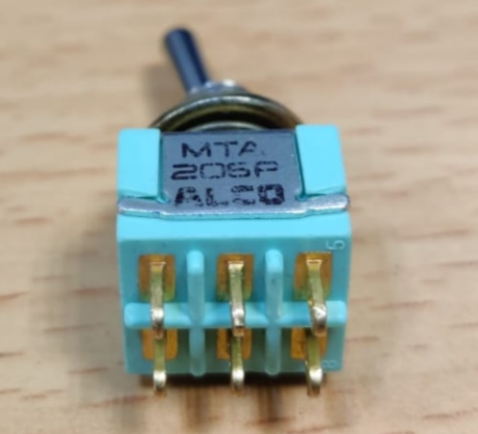

1 2 3

4 5 6

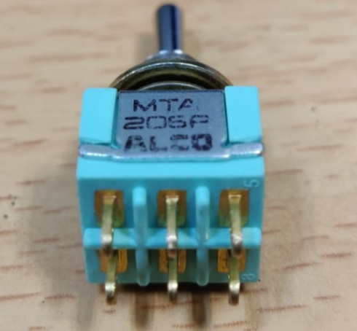

1 2 3

4 5 6

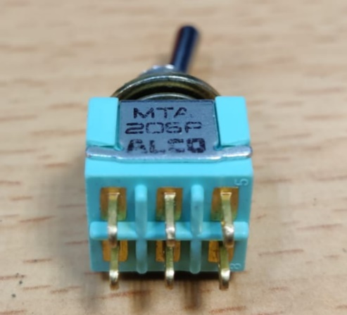

1 2 3

4 5 6

**On sample mode**

**USB mode**

**Off sample mode**

|  |  |
| --- | --- |
| **Pinout** | |
| **Switch** | **Spare Bus** |
| 1 | 9 |
| 2 | **11** (for 5V) OR **2** (for PWM) TODO |
| 3 | 10 |
| 4 | 12 |
| 5 | 12 |
| 6 | 12 |