Project description

TODO:

* Switch: The way that the microprocessor will receive power(5V) from the user will be the following:
  + 1st mode will be from the software i.e., the USB
  + 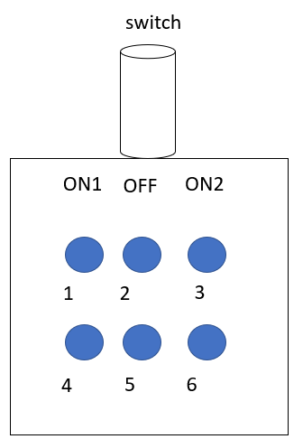2nd mode is from a switch, it has the following structure:

ON1 mode – 2,3 are connected, 5,6 are connected

ON2 mode – 1,2 are connected, 4,5 are connected

OFF mode – high Z

That means that for each mode we can give two signals, one of them will be an interrupt for the system to know that the switch needs to override the software signal, the second one will be the input (0 for one of them indicating one direction and 1 for the other indicating the 2nd direction)

* + **TODO:**
    - Learn how to work with information from the USB connection.
    - The switch will be connected to some entries on the spare bus, decide on which entries and see how to connect them
    - See what the voltage of the switch’s interrupt pin is when it’s in off mode (for example if it is 0 then we will set it to 1 to cause interrupt)
    - Learn how to cause an interrupt with the microprocessor
    - Check that everything works – switch gives interrupts and sets the direction
* Documentation: detail the final connections needed to make – what PCB connections need to be connected to where, for example match between the PCB “sensors” inputs to the actual sensors outputs (DB9)
* Supply voltages: currently the microprocessor can only receive voltages from the USB input, this is temporary and should not be this way in the final version.
  + **Done by Yuri:**
    - Remove the diode connecting the microprocessor voltages to the USB voltages.
    - Give the microprocessor the PCB voltages
  + **TODO:**
    - Check that everything works