Billie Mission 2120

Test Cases Documentation

**Summary**

This document contains test scenarios with descriptions for Billie Mission 2120 Project.

**Author**

Eylül akar

V1.0, 03.02.2021

**1. TEST CASES**

|  |  |  |  |  |  |
| --- | --- | --- | --- | --- | --- |
| **ID** | **TEST CASE** | **FEATURE** | **DATA** | **EXPECTED RESULT** | **RESULT** |
| 1 | Create booking | Create booking | Post /booking  Body: correct booking json object | - Request returns 200 OK.  - Response body object is equal to object in  request body.  - Response body object has ‘bookingid’ field with non-null value. | PASS |
| 2 | Create booking fails due to malformed total price (1) | Create booking | Post /booking  Body: booking json with negative totalprice (-50) | - Request returns 400 Bad Request. | FAIL  Booking still created. |
| 3 | Create booking fails due to malformed total price (2) | Create booking | PUT /booking/id  Body: booking json with string totalprice value(“ASD”) | - Request returns 400 Bad Request. | FAIL  Booking still created. |
| 4 | Update booking | Amendment of the created booking | PUT /booking/id  Body: correct booking json object | - Request returns 200 OK.  - Response body object is equal to object in  request body. | PASS |
| 5 | Update booking fails due to wrong date (1) | Amendment of the created booking | PUT /booking/id  Body: booking json with date values as text(checkin: ASD, checkout:BSD) | - Request returns 400 Bad Request.  -Should throw exception | PASS |
| 6 | Update booking fails due to wrong date (2) | Amendment of the created booking | PUT /booking/id  Body: booking json with date values as correct dates, checkout date is later than checkin (checkin: 2120-01-10, checkout:2120-01-01) | - Request returns 400 Bad Request.  -Should throw exception | FAIL  Booking still updated. |
| 7 | Update booking fails due to wrong date (3) | Amendment of the created booking | PUT /booking/id  Body: booking json with date values without days (checkin: 2120-01, checkout:2120-01) | - Request returns 400 Bad Request.  -Should throw exception | FAIL  Booking still updated. |
| 8 | Update booking fails due to wrong date (4) | Amendment of the created booking | PUT /booking/id  Body: booking json with null date values | - Request returns 400 Bad Request.  -Should throw exception | PASS |
| 9 | Getting booking | Getting booking | GET /booking/id | - Request returns 200 OK.  - Response body object is equal to object created previously. | PASS |
| 10 | Delete booking | Delete booking | DELETE /booking/id | - Request returns 201 Created. | PASS |

Example Executions:

* All scenarios execution:

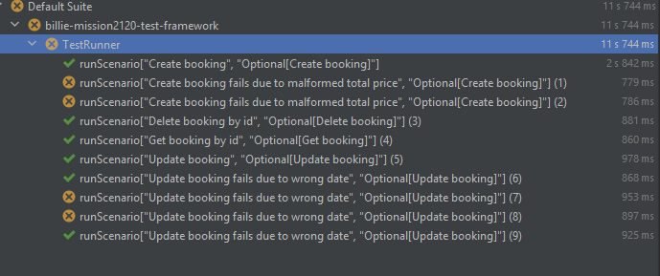

* Create booking feature execution:

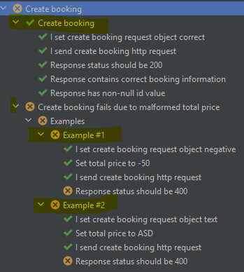

**2. FEATURES**

|  |  |  |
| --- | --- | --- |
| **ID** | **FEATURE NAME** | **EXPECTED RESULT** |
| 1 | Creation of a new booking | Request returns 200 OK.  Response body object is equal to object in  request body.  Response body object has ‘bookingid’ field with non-null value. (successful scenario) |
| 2 | Amendment of the created booking | PUT request to restful-booker returns 200 OK  The data given in response body is equal to the data in  request body . (successful scenario) |
| 3 | Getting booking | GET request to restful-booker returns 200 OK  The data given in response body is equal to the last actual  data (after creation or update events) . |
| 4 | Delete booking | DELETE request restful-booker returns 201 Created  GET request to restful-booker returns 404 Not Found |