FSA Design

Ali Omrani

FSA – Integers:

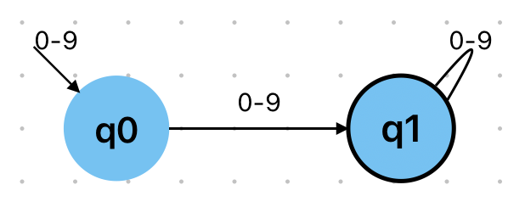

RE: [0-9]* (any number)

FSA – Identifiers

RE: [a-zA-Z_][a-zA-Z_0-9]* (any string that starts with a letter or _ and can contain any letter, _, and any number)