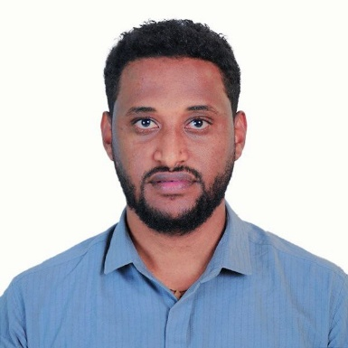❤️V­­

**Skills**

* **Legal Expertise**:
* **Making of Contract Documents**:
* **Legal Research**
* **Communication**:
* **Attention to Detail**
* **Time Management**
* **Ethics and Integrity**
* **Computer skill**

**Education**

* **Arbaminch University, Arbaminch***Bachelor of Laws (LL.B.)*  
  2015 – 2019
* **Debre Markos University, Debre Markos**  
  *Master of Laws (LL.M.) in Business and Investment Law*

Candidate; currently at the final stage of thesis defense.

* **Federal Justice and Legal Research and Training Institute, Bahir Dar**  
  *Certificate in Judicial and Prosecutorial Training*  
  October 15, 2019 – July 30, 2020

**v**

**Work Experience**

* Federal Justice and Legal Research and Training Institute, **Bahir Dar**

Assistant Judge & Public Prosecutor

October 15, 2019 – July 30, 2020

* ANRS Supreme Court, **Meket Woreda Court, Filakit**

Judge

August 1, 2020 – July 30, 2022

* **ANRS Supreme Court**, North Mecha Woreda Court, **Mehal Genet**

Judge

August 1, 2023 – January 8, 2024

* Abay Insurance S.C**., Addis Ababa**

Attorney II

February 7, 2024 – September 15, 2024

* Dashen Bank S.C**., Addis Ababa**

Attorney

August 22, 2024 – Present

**Profile**

I am **an experienced** Judge with a strong background in legal interpretation, judicial decision-making, and dispute resolution. Over the course of my career, I have presided over diverse cases, ensuring fairness, impartiality, and adherence to the rule of law.

**Marelign Teshome**

Judge

**Contact**

**Address**

Addis Abeba, ethiopia

**Phone**

+251 937413891

**Email : marelignteshome**@gmail.com

**Languages**

* English
* Amharic

**Hobbies**

* Football
* reading