Generating the code for bumblebee input

1) Open the .ioc file in STM32CubeMX

2) Open the Project Manager Tab

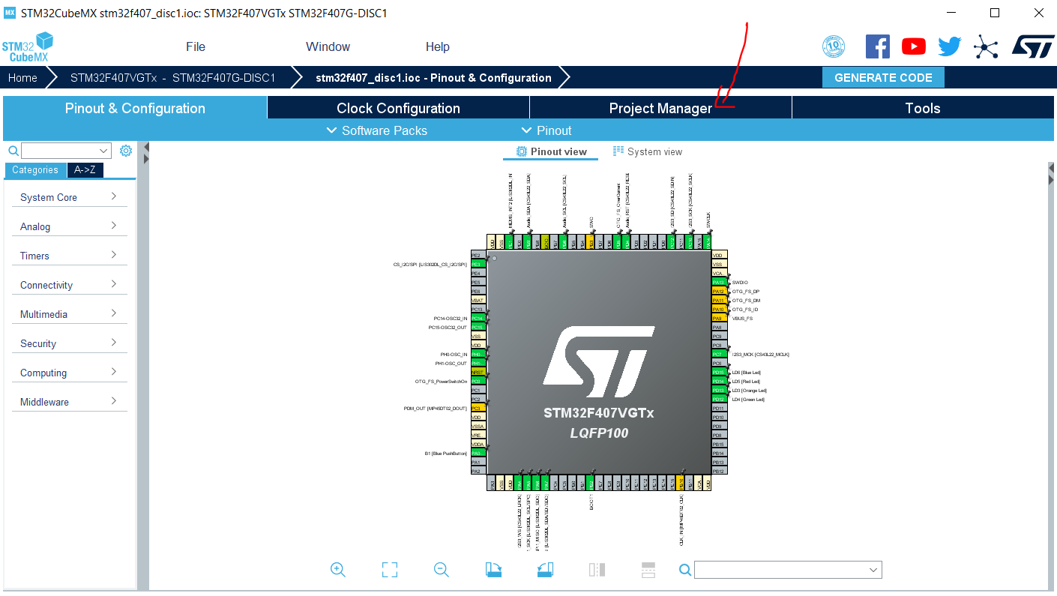
3) Generate the code
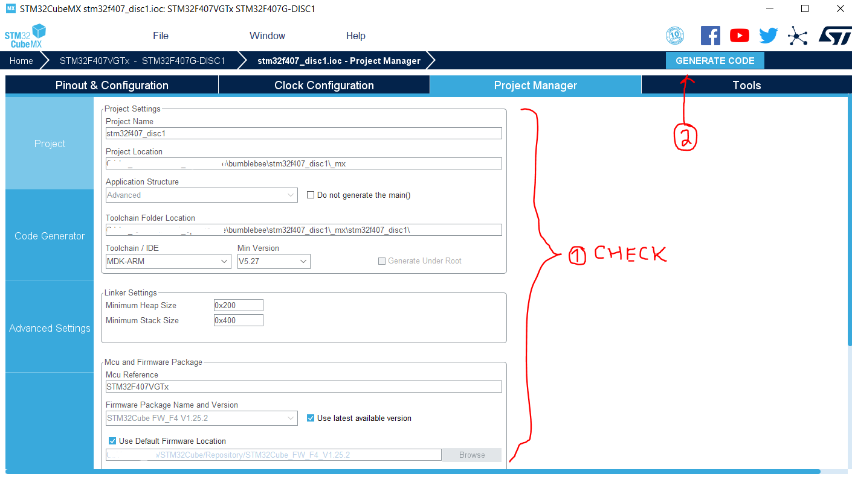
4) When it asks to open project – don’t

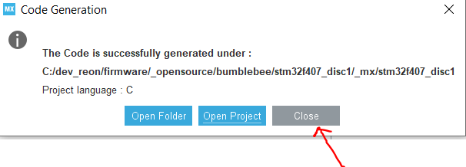
5) You get something like this
