|  |
| --- |
|  |
| Computer  system |
| |  |  |  | | --- | --- | --- | | Eyob | [Date] | [Course title] | |

Table of continent

Contents

Hardwar part. 5

1.1 Memory 5

1.2 Input 5

1.3 Output 6

Software part. 6

OS 6

1.1.1 window 7

1.1.2 mac 7

1.2 Graphics 7

1.3 Application 8

Networking 11

Security 12

2.1 confidential 12

2.2 integrity 12

Flutter 13

3.1 programming language 13

3.1.1 java 13

3.2 mobile app 13

Figure of content

Figure 1 sea and Shipe 4

Figure 2 monastery of Lalibela 10

List of table

Table 1Table 1 about OS 6

Table 2Table 2 about app 8

Table 3Table 3 about network 12

Chapter one

Computer is an *electronic* device and hhkkkk llldl riofkfkff wqejncwijeif lkwefoiwoieioieiqoi.

Not only this but also this dcnkdlkfn lkediqjjkuweiui jhdioia uquwohq ui quwhuh.

End of day jiodijpoe ieifoppe ojeofj w;ojepoffn.

Computer is divided in to two parts.

1. Hardwar part.
   1. Memory
   2. Input/output
   3. Mouse
2. Software part.
   1. OS
      1. Window
      2. Mac
      3. linux
   2. Application
   3. Graphics

Computer techinology best practice in the world.

Kaskdlkalkk jndkfnkalkls lksidkqwq LAKIDSQNki lieqnqpj eijfiojqp

Qwkjihiqiodjqop iwjidjoj qijwijfjopop

Wjdojdddod wejoiqjojeojpokqoo jeofjpaojpofjopq

Kaskdlkalkk jndkfnkalkls lksidkqwq LAKIDSQNki lieqnqpj eijfiojqp

Qwkjihiqiodjqop iwjidjoj qijwijfjopop Kaskdlkalkk jndkfnkalkls lksidkqwq LAKIDSQNki lieqnqpj eijfiojqp

Qwkjihiqiodjqop iwjidjoj qijwijfjopop

Wjdojdddod wejoiqjojeojpokqoo jeofjpaojpofjopq

Wjdojdddod wejoiqjojeojpokqoo jeofjpaojpofjopq

Qwkjihiqiodjqop iwjidjoj qijwijfjopop

Wjdojdddod wejoiqjojeojpokqoo jeofjpaojpofjopq

Wjdojdddod wejoiqjojeojpokqoo jeofjpaojpofjopq

# Hardwar part.

## 1.1 Memory

Memory is used to storage capacity and prosess

Jakjnsdknlka laknikdnlqjw lqkwkqooo lqkwdjpoijwodo lkwnjoijdojojopqj

Qwidijojm Memory is used to storage capacity and prosess

Jakjnsdknlka laknikdnlqjw lqkwkqooo lqkwdjpoijwodo lkwnjoijdojojopqj

qwidijojm

Memory is used to storage capacity and prosess

Jakjnsdknlka laknikdnlqjw lqkwkqooo lqkwdjpoijwodo lkwnjoijdojojopqj

qwidijojm

## 1.2 Input

This is used to alkmlmdks alkndkfkla aknkndksknf anknkllmaklkm lkanknlklllk knknkldkkaidkakk jnndfnieninwi sniiidefn sniiedk jnndfnieninwi sniiidefn sniiedk

This is used jnndfnieninwi sniiidefn sniiedk

This is used to alkmlmdks alkndkfkla aknkndksknf anknkllmaklkm lkanknlklllk knknkldkkaidkakk jnndfnieninwi sniiidefn sniiedk

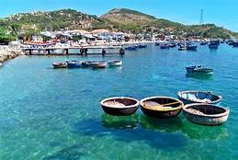

Figure 1 sea and Shipe

## 1.3 Output

For used to output device

to alkmlmdks alkndkfkla aknkndksknf anknkllmaklkm lkanknlklllk knknkldkkaidkakk

Qwidijojm Memory is used to storage capacity and prosess

Jakjnsdknlka laknikdnlqjw lqkwkqooo lqkwdjpoijwodo lkwnjoijdojojopqj

Qwidijojm Qwidijojm Memory is used to storage capacity and prosess

Jakjnsdknlka laknikdnlqjw lqkwkqooo lqkwdjpoijwodo lkwnjoijdojojopqj

Qwidijojm Jakjnsdknlka laknikdnlqjw lqkwkqooo lqkwdjpoijwodo lkwnjoijdojojopqj

Qwidijojm Qwidijojm Memory is used to storage capacity and prosess

Jakjnsdknlka laknikdnlqjw lqkwkqooo lqkwdjpoijwodo lkwnjoijdojojopqj

# Software part.

## OS

Table 1Table 1 about OS

This is for used to cominulkmkad alkejdjqpow qjwnidnijpiow lqnikwioop

This is for used to cominulkmkad alkejdjqpow qjwnidnijpiow lqnikwioop

This is for used to cominulkmkad alkejdjqpow qjwnidnijpiow lqnikwioop

This is for used to cominulkmkad alkejdjqpow qjwnidnijpiow lqnikwioop

This is for used to cominulkmkad alkejdjqpow qjwnidnijpiow lqnikwioop

This is for used to cominulkmkad alkejdjqpow qjwnidnijpiow lqnikwioop

This is for used to cominulkmkad alkejdjqpow qjwnidnijpiow lqnikwioop

Qwidijojm Qwidijojm Memory is used to storage capacity and prosess

Jakjnsdknlka laknikdnlqjw lqkwkqooo lqkwdjpoijwodo lkwnjoijdojojopqj

### 1.1.1 window

Window is laknikdnlqjw lqkwkqooo lqkwdjpoijwodo lkwnjoijdojojopqj

Qwidijojm Qwidijojm Memory is used to storage capacity and prosess

Jakjnsdknlka laknikdnlqjw lqkwkqooo lqkwdjpoijwodo lkwnjoijdojojopqj

### 1.1.2 mac

Mac is laknikdnlqjw lqkwkqooo lqkwdjpoijwodo lkwnjoijdojojopqj

Qwidijojm Qwidijojm Memory is used to storage capacity and prosess

Jakjnsdknlka laknikdnlqjw lqkwkqooo lqkwdjpoijwodo lkwnjoijdojojopqj

## 1.2 Graphics

Rendering object and used to performance Jakjnsdknlka laknikdnlqjw lqkwkqooo lqkwdjpoijwodo lkwnjoijdojojopqj test

Qwkjihiqiodjqop iwjidjoj qijwijfjopop

Wjdojdddod wejoiqjojeojpokqoo jeofjpaojpofjopq

Kaskdlkalkk jndkfnkalkls lksidkqwq LAKIDSQNki lieqnqpj eijfiojqp

Qwkjihiqiodjqop iwjidjoj qijwijfjopop Kaskdlkalkk jndkfnkalkls lksidkqwq LAKIDSQNki lieqnqpj

Qwkjihiqiodjqop iwjidjoj qijwijfjopop

Wjdojdddod wejoiqjojeojpokqoo jeofjpaojpofjopq

Kaskdlkalkk jndkfnkalkls lksidkqwq LAKIDSQNki lieqnqpj eijfiojqp

Kaskdlkalkk jndkfnkalkls lksidkqwq LAKIDSQNki lieqnqpj eijfiojqp

Qwkjihiqiodjqop iwjidjoj qijwijfjopop Kaskdlkalkk jndkfnkalkls lksidkqwq LAKIDSQNki lieqnqpj

Qwkjihiqiodjqop iwjidjoj qijwijfjopop Kaskdlkalkk jndkfnkalkls lksidkqwq LAKIDSQNki lieqnqpj

## 1.3 Application

Table 2Table 2 about app

|  |  |  |  |  |  |
| --- | --- | --- | --- | --- | --- |
| app |  |  |  |  |  |
| mobile |  |  |  |  |  |
|  |  |  |  |  |  |
|  |  |  |  |  |  |
|  |  |  |  |  |  |
|  |  |  |  |  |  |

Video provides a powerful way to help you prove your point. When you click Online Video, you can paste in the embed code for the video you want to add. You can also type a keyword to search online for the video that best fits your document. To make your document look professionally produced, Word provides header, footer, cover page, and text box designs that complement each other. For example, you can add a matching cover page, header, and sidebar. Click Insert and then choose the elements you want from the different galleries.

Themes and styles also help keep your document coordinated. When you click Design and choose a new Theme, the pictures, charts, and SmartArt graphics change to match your new theme. When you apply styles, your headings change to match the new theme. Save time in Word with new buttons that show up where you need them. To change the way a picture fits in your document, click it and a button for layout options appears next to it. When you work on a table, click where you want to add a row or a column, and then click the plus sign.

Reading is easier, too, in the new Reading view. You can collapse parts of the document and focus on the text you want. If you need to stop reading before you reach the end, Word remembers where you left off - even on another device. Video provides a powerful way to help you prove your point. When you click Online Video, you can paste in the embed code for the video you want to add. You can also type a keyword to search online for the video that best fits your document.

To make your document look professionally produced, Word provides header, footer, cover page, and text box designs that complement each other. For example, you can add a matching cover page, header, and sidebar. Click Insert and then choose the elements you want from the different galleries. Themes and styles also help keep your document coordinated. When you click Design and choose a new Theme, the pictures, charts, and SmartArt graphics change to match your new theme. When you apply styles, your headings change to match the new theme.

1.Example:

* Mobile app
  + Flutter
  + Dart
  + React native
* Web app
  + Next
  + React
  + JavaScript

To make your document look professionally produced, Word provides header, footer, cover page, and text box designs that complement each other. For example, you can add a matching cover page, header, and sidebar. Click Insert and then choose the elements you want from the different galleries. Themes and styles also help keep your document coordinated. When you click Design and choose a new Theme, the pictures, charts, and SmartArt graphics change to match your new theme. When you apply styles, your headings change to match the new theme.

To make your document look professionally produced, Word provides header, footer, cover page, and text box designs that complement each other. For example, you can add a matching cover page, header, and sidebar. Click Insert and then choose the elements you want from the different galleries. Themes and styles also help keep your document coordinated. When you click Design and choose a new Theme, the pictures, charts, and SmartArt graphics change to match your new theme. When you apply styles, your headings change to match the new theme.

To make your document look professionally produced, Word provides header, footer, cover page, and text box designs that complement each other. For example, you can add a matching cover page, header, and sidebar. Click Insert and then choose the elements you want from the different galleries. Themes and styles also help keep your document coordinated. When you click Design and choose a new Theme, the pictures, charts, and SmartArt graphics change to match your new theme. When you apply styles, your headings change to match the new theme.

To make your document look professionally produced, Word provides header, footer, cover page, and text box designs that complement each other. For example, you can add a matching cover page, header, and sidebar. Click Insert and then choose the elements you want from the different galleries. Themes and styles also help keep your document coordinated. When you click Design and choose a new Theme, the pictures, charts, and SmartArt graphics change to match your new theme. When you apply styles, your headings change to match the new theme.

To make your document look professionally produced, Word provides header, footer, cover page, and text box designs that complement each other. For example, you can add a matching cover page, header, and sidebar. Click Insert and then choose the elements you want from the different galleries. Themes and styles also help keep your document coordinated. When you click Design and choose a new Theme, the pictures, charts, and SmartArt graphics change to match your new theme. When you apply styles, your headings change to match the new theme.

To make your document look professionally produced, Word provides header, footer, cover page, and text box designs that complement each other. For example, you can add a matching cover page, header, and sidebar. Click Insert and then choose the elements you want from the different galleries. Themes and styles also help keep your document coordinated. When you click Design and choose a new Theme, the pictures, charts, and SmartArt graphics change to match your new theme. When you apply styles, your headings change to match the new theme.

To make your document look professionally produced, Word provides header, footer, cover page, and text box designs that complement each other. For example, you can add a matching cover page, header, and sidebar. Click Insert and then choose the elements you want from the different galleries. Themes and styles also help keep your document coordinated. When you click Design and choose a new Theme, the pictures, charts, and SmartArt graphics change to match your new theme. When you apply styles, your headings change to match the new theme.

To make your document look professionally produced, Word provides header, footer, cover page, and text box designs that complement each other. For example, you can add a matching cover page, header, and sidebar. Click Insert and then choose the elements you want from the different galleries. Themes and styles also help keep your document coordinated. When you click Design and choose a new Theme, the pictures, charts, and SmartArt graphics change to match your new theme. When you apply styles, your headings change to match the new theme.

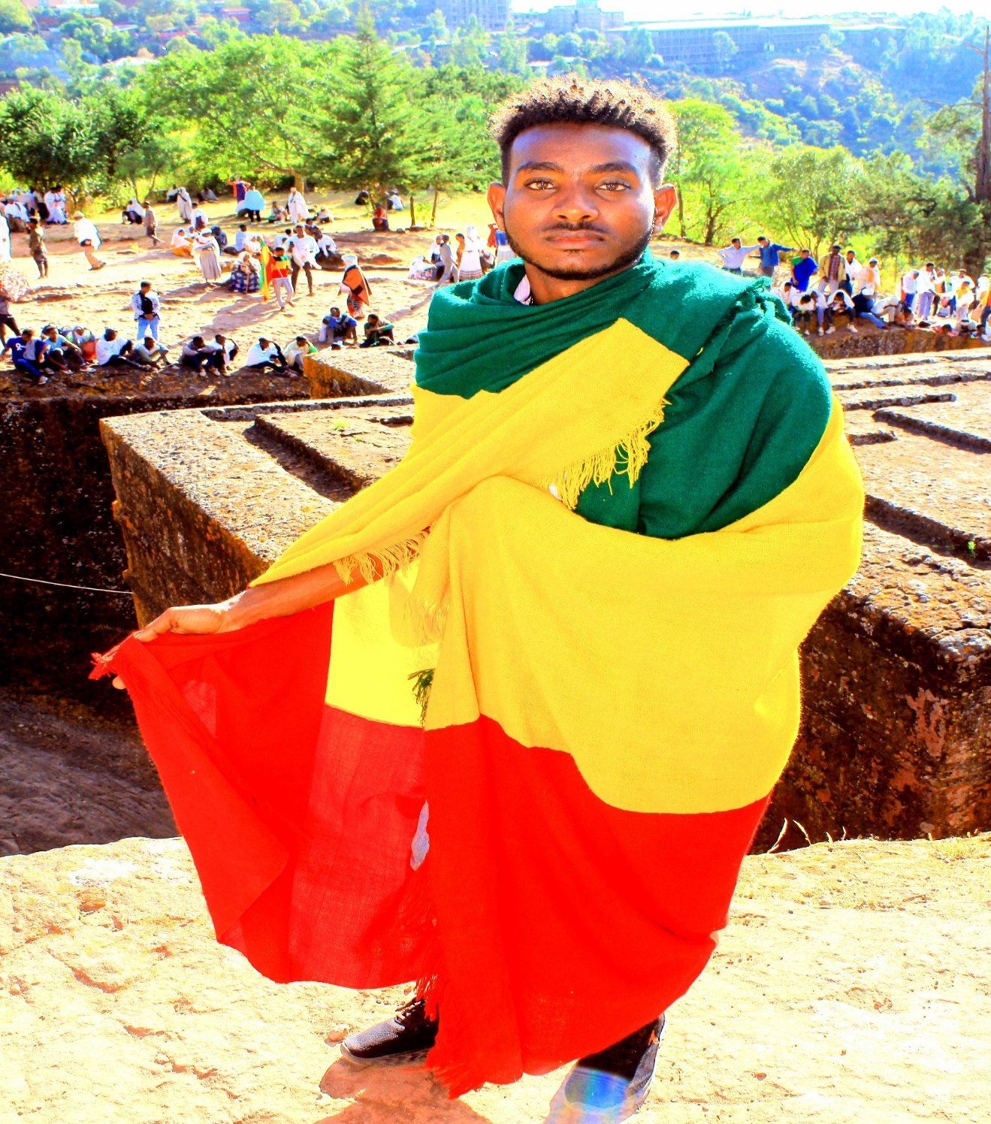

Figure 2 monastery of Lalibela

# Networking

To make your document look professionally produced, Word provides header, footer, cover page, and text box designs that complement each other. For example, you can add a matching cover page, header, and sidebar. Click Insert and then choose the elements you want from the different galleries. Themes and styles also help keep your document coordinated. When you click Design and choose a new Theme, the pictures, charts, and SmartArt graphics change to match your new theme. When you apply styles, your headings change to match the new theme.

Table 3Table 3 about network

|  |  |  |  |
| --- | --- | --- | --- |
| hhh |  |  |  |
| jjjj |  |  |  |
| ;ljoi |  |  |  |
| ;oi |  |  |  |

Chapter two

# Security

## 2.1 confidential

Security is your document look professionally produced, Word provides header, footer, cover page, and text box designs that complement each other. For example, you can add a matching cover page, header, and sidebar. Click Insert and then choose the elements you want from the different galleries. Themes and styles also help keep your document coordinated. When you click Design and choose a new Theme, the pictures, charts, and SmartArt graphics change to match your new theme. When you apply styles, your headings change to match the new theme.

To make your document look professionally produced, Word provides header, footer, cover page, and text box designs that complement each other. For example, you can add a matching cover page, header, and sidebar. Click Insert and then choose the elements you want from the different galleries. Themes and styles also help keep your document coordinated. When you click Design and choose a new Theme, the pictures, charts, and SmartArt graphics change to match your new theme. When you apply styles, your headings change to match the new theme.

To make your document look professionally produced, Word provides header, footer, cover page, and text box designs that complement each other. For example, you can add a matching cover page,

## 2.2 integrity

header, and sidebar. Click Insert and then choose the elements you want from the different galleries. Themes and styles also help keep your document coordinated. When you click Design and choose a new Theme, the pictures, charts, and SmartArt graphics change to match your new theme. When you apply styles, your headings change to match the new theme.

To make your document look professionally produced, Word provides header, footer, cover page, and text box designs that complement each other. For example, you can add a matching cover page, header, and sidebar. Click Insert and then choose the elements you want from the different galleries. Themes and styles also help keep your document coordinated. When you click Design and choose a new Theme, the pictures, charts, and SmartArt graphics change to match your new theme. When you apply styles, your headings change to match the new theme.

Chapter three

# Flutter

## 3.1 programming language

galleries. Themes and styles also help keep your document coordinated. When you click Design and choose a new Theme, the pictures, charts, and SmartArt graphics change to match your new theme. When you apply styles, your headings change to match the new theme.

### 3.1.1 java

choose a new Theme, the pictures, charts, and SmartArt graphics change to match your new theme. When you apply styles, your headings change to match the new theme.

## 3.2 mobile app

galleries. Themes and styles also help keep your document coordinated. When you click Design and choose a new Theme, the pictures, charts, and SmartArt graphics change to match your new theme. When you apply styles, your headings change to match the new theme.

To make your document look professionally produced, Word provides header, footer, cover page, and text box designs that complement each other. For example, you can add a matching cover page, header, and sidebar. Click Insert and then choose the elements you want from the different galleries. Themes and styles also help keep your document coordinated. When you click Design and choose a new Theme, the pictures, charts, and SmartArt graphics change to match your new theme. When you apply styles, your headings change to match the new theme.

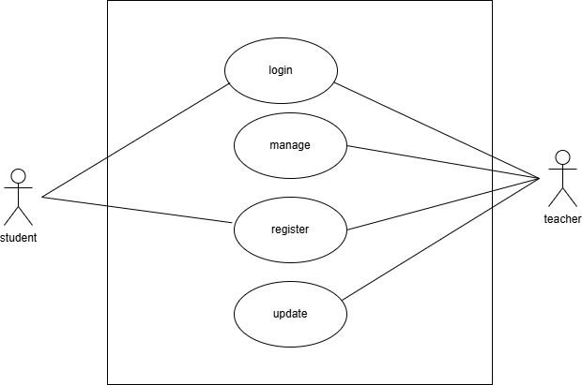

Figure 3 use case about teacher

* + 1. Economic Feasibility

Economic feasibility is the most frequently used method for evaluating the effectiveness of a new system. The project of web-based book catalogue automation system economically benefits from the system through, reducing the cost needed to duplicate, to reduce unnecessary economic loss (paper, pen). This project is economically feasible in every sense that it takes less effort, less time,

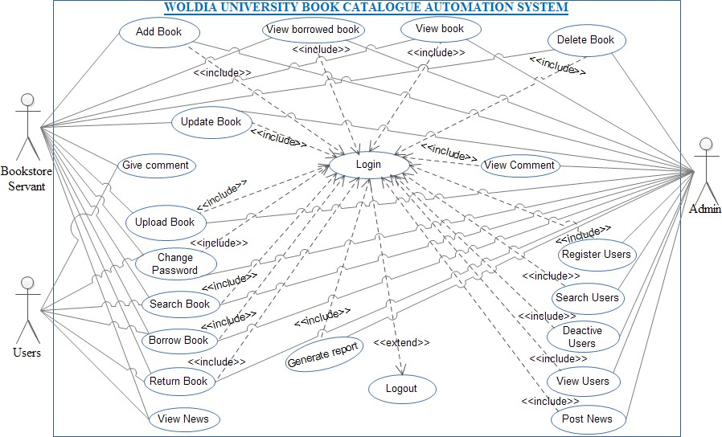

Figure 4 use case about library

|  |
| --- |
|  |
| Alternative course of action |
| Post condition |

Table 4 admin

|  |  |  |
| --- | --- | --- |
|  | 5. Admin click on Deactive  button, then user Deactivate |  |
| Alternative course of action | * If admin enter incorrect ID system displays please enter correct user id and continues from action 3 * If user not found the system displays there is no users by this ID | |
| Post condition | Users Deactive from the system | |

2.7.1 Sequence diagram for login

User action (admin, user and bookstore servant)

1. User click on login link.

3. enter user name and password.

4. click login button. System response

2. Display form.

1. Validate.
2. Retrieve from database.
3. Got to user page.

Sequence diagram for login

Figure 5 class 1

Login form

Validate

Database

Click on login link()

Display form()

Enter username and password()

Click on login button()

Validate()

Try again()

Retrieve()

Check()

Go to user page()

Home page

User

2.4.1 Activity diagram for login

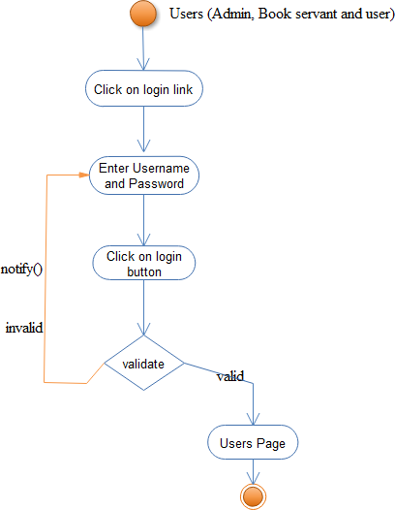

Figure 6 Activity

2.5 Class Diagram

The class diagram is used to refine the use case diagram and define a detail design of the system. The class diagram classifies the actors defined in the use case diagram in to the set of interrelated classes [Error! Reference source not found.].

1

manages

1

manages

1..*

Bookstore servant

1..*

1

1

1

1

1

1

1

1

1

views

views

posts

manages

manages

gives

views

1..* 1..*

*

1..*

* 1..* *

1..*

gives

1..*

accesses

+Give comment()

+View comment()

+Post()

+View()

-Date: date

-title: string

-Comment: string

-Name: string

-Email: string

-Date: date

-Comment: string

-Book id: int

-Btitle: string

-Author: string

-Pub_name: string

-Catagory: string

-BCopies: string

-b_publisher: string

-Isbn: int

-cop_right_year

-status: string

-Acc_number: double

Posts

Comments

Books

Give comment()

+View news()

+Add book()

+Update book()

+Delete book()

+View books()

+View news()

+View borrowed book()

+Upload book()

+Give comment()

User

+Add book()

+Update book()

+Delete book()

+Register user()

+Delete user()

+View books()

+Generate report()

+Post news()

+View comment()

+View borrowed book()

+Upload book()

+View user()

-Fname: string

-Lname: string

-Pnumber: int

-Email: string

-role: string

Admin

+Login()

+Borrow book()

+Return book()

+Search book()

+change()

+Logout()

-User_id: int

-password: string

Authenticated Users

Figure 2-12 Class diagram

Jjjjjdjdj hjhhh

2.6.1 Entity-Relationship (ER) Models

Figure 7 ER diagram

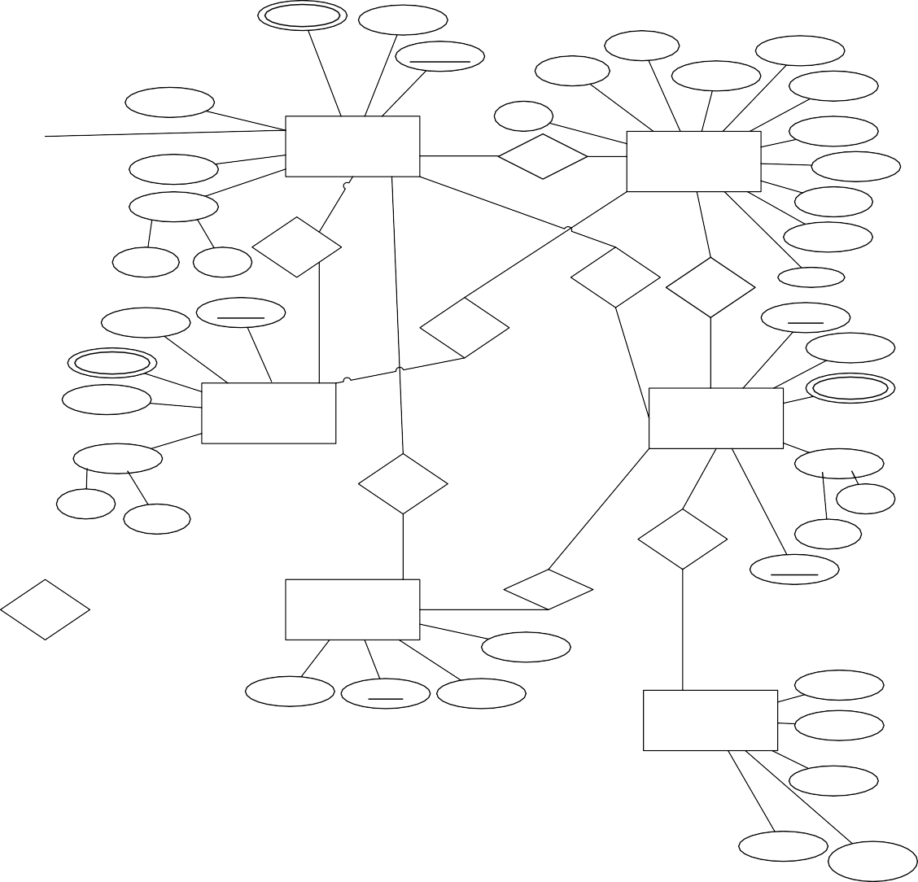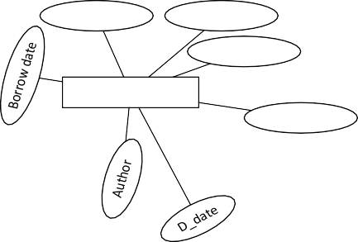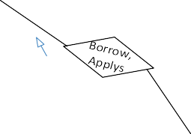

Borrower

Title

Book_id

1..*

Borrows

Borrow

1..*

ID

1..*

Phone

Email

Author

Admin_id

Acc_number

Catagory

Bcopies

Book_id

year_level

1

Btitle

1

Bpublication

ADMIN 1

Manages

1..*

Password

BOOK

Pub_name

1

1

1

1

Name

1..*

1..*

Isbn

Manages

co_ri_year

Fname Lname

Manages

View

status

Email

User_id

Manages

Email

Password

Phone

1..*

1

Borrows,

Applys

1

Password

1..*

Phone

BOOKSTORE

SERVANT

1

USER

1

1

Name

1

1

Name

Post

Lname

Add

Lname

Fname

Downloads

Fname

1..*

User_id

View

Access

POST

*

Title

Id

1..*

Comment

Order

Date

Title

1..*

1..*

UPLOAD

Type

1..*

Access

Author

Document

End

Start

Faculity Name

Category

Publisher

Publication

year

ADD FACULITY

Figure 2-13 ER diagram