

Addis Ababa Science and Technology University

**College of Engineering**

**Department of Software Engineering**



Software component design

Figma based project



***Group Members***

1. Eyouel Melkamu – ETS0479/13
2. Eshetu Tessema – ETS0435/13
3. Fannuel Gulelat – ETS0488/13
4. Eyob Betemariam – ETS0462/13
5. Fikre Tadesse – ETS0505/13
6. Lealem Meseret - ETS1552/13

***Date of Submission***

Wednesday, Dec 18, 2024

**Table of content**

What is Figma? 1

Why Use Figma? 1

Key Features of Figma 2

Benefits of Figma 2

Project – High-Fidelity Design Overview 3

Summary 11

Reference 11

**Images**

1 . Sign up and Log in page 4

2 . Job listing page 5

3 . Search and filter page 5

4 . Job description page 6

5 . Application page 7

6 . Job post page 8

7 . Application dashboard page 9

8 . Profile page 10

# What is Figma?

Figma is a powerful design tool that lets you create and collaborate on user interfaces and prototypes for websites, apps, and much more.[1] Unlike traditional design software that requires installation, Figma runs entirely in web browser, making it accessible on any platform, whether you're using Windows, Mac, or Linux. This platform independence allows everyone to access and use it easily.

# Why Use Figma?

Figma offers a wide range of features and benefits, making it an essential tool for designers. Here are some reasons why Figma stands out:

* **Real-Time Collaboration:** As a cloud-based tool, Figma allows multiple users to work on the same design in real-time. This means designers, developers, and stakeholders can view and edit designs simultaneously, speeding up the workflow and ensuring everyone is on the same page.
* **Platform Independence:** Figma is available directly from your web browser, so it works seamlessly across all devices, whether you're using Windows, Mac, or even Linux.
* **Responsive Design:** Figma makes it easy to create designs that look great on all devices. Its auto-layout and constraint features help in building responsive designs that adapt to different screen sizes.

## Example of Collaborative Design:

Suppose you’re working on a mobile app design with a team of designers and developers. With Figma, all of you can work on the same design file simultaneously, making changes, adding feedback, and testing features in real time. This collaborative environment makes the design process more efficient and helps create a high-quality product faster.

# Key Features of Figma

* **Collaborative Environment:** Figma’s real-time collaboration feature allows multiple team members to work together on the same design. Changes are instantly visible to everyone, and team members can leave comments directly on the design to provide feedback or suggest improvements.
* **Prototyping Tools:** Figma goes beyond static design by offering powerful prototyping tools. User can create interactive prototypes with animations, transitions, and gestures, allowing stakeholders to experience how the final product will feel and function.
* **Vector Editing:** Figma provides advanced vector editing capabilities, enabling designers to create and modify shapes, paths, and text with ease. This is particularly useful for creating scalable graphics that look great on any screen size.
* **Component Libraries:** With Figma’s component libraries, you can create reusable elements like buttons, icons, and UI kits. Any changes made to a component are automatically updated across all instances, ensuring design consistency and saving time.
* **Plugins:** Figma offers a wide variety of plugins to enhance your design workflow. For example, some plugins can turn your design into a working website without any coding knowledge. There are plugins for color management, accessibility checks, and much more to help streamline your design process.

# Benefits of Figma

* **Accessible from Anywhere:** As a cloud-based tool, you can access your design projects from any device with internet access.
* **Design Feedback:** Stakeholders and team members can leave comments directly on the design, making it easier to gather and implement feedback.
* **Real-Time Feedback and Updates:** Since Figma is cloud-based, team members and stakeholders can leave comments and feedback directly on the designs. This streamlines communication and helps implement changes quickly.

* **Cross-Platform Accessibility:** Figma works on any platform with an internet connection, making it accessible for designers using different operating systems like Windows, Mac, or Linux.
* **Plugin Integration:** Figma offers numerous plugins to enhance the design process, such as tools for color management, accessibility checks, and exporting designs into code. These plugins save time and increase efficiency.
* **Version Control:** Figma automatically saves your progress and maintains a history of changes, allowing you to easily revert to previous versions if needed.

Figma is a versatile and user-friendly design tool that simplifies the design process, encourages teamwork, and offers powerful features for creating high-quality digital products.

# Project – High-Fidelity Design Overview

**The Job Portal Application** design focuses on connecting job seekers with employers through a clean and intuitive user interface. The high-fidelity designs were developed using Figma with an emphasis on:

* **Visual Clarity**: Creating a professional and clean layout for user-friendly navigation.
* **Modular Design**: Utilizing reusable components to streamline development and ensure design consistency.
* **UI Consistency**: Maintaining uniform colors, fonts, and spacing to enhance the user experience.
* **Responsive Structure**: Designing layouts adaptable to various screen sizes.

## Key Features of the Design

### 1. Sign-Up and Login Pages

* **Sign-Up Page**:
  + Enables users to create a new account by providing their name, email, password, and user type (job seeker or employer).
* **Login Page**:
  + Allows existing users to log in with their email and password.
  + Includes "Forgot Password" and "Sign Up" links for easy navigation.

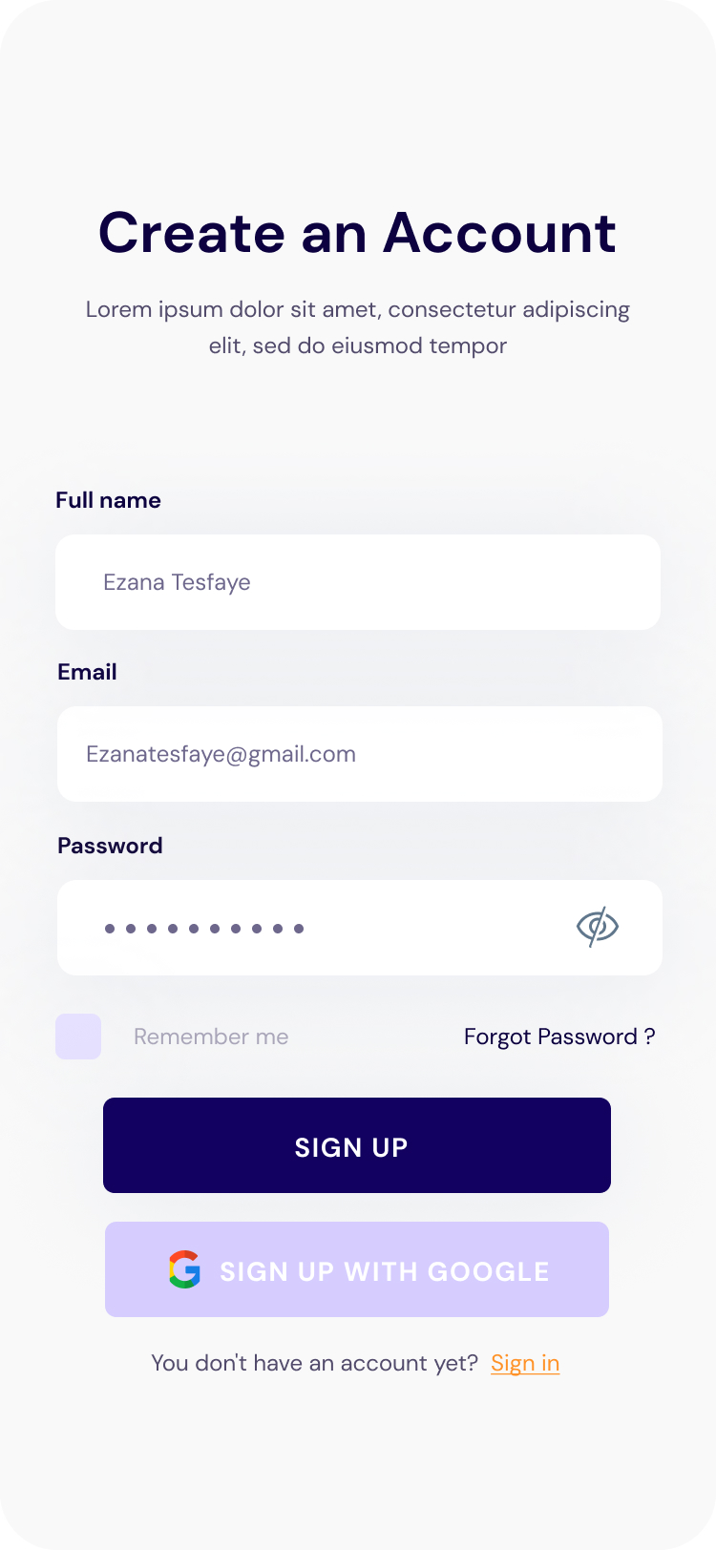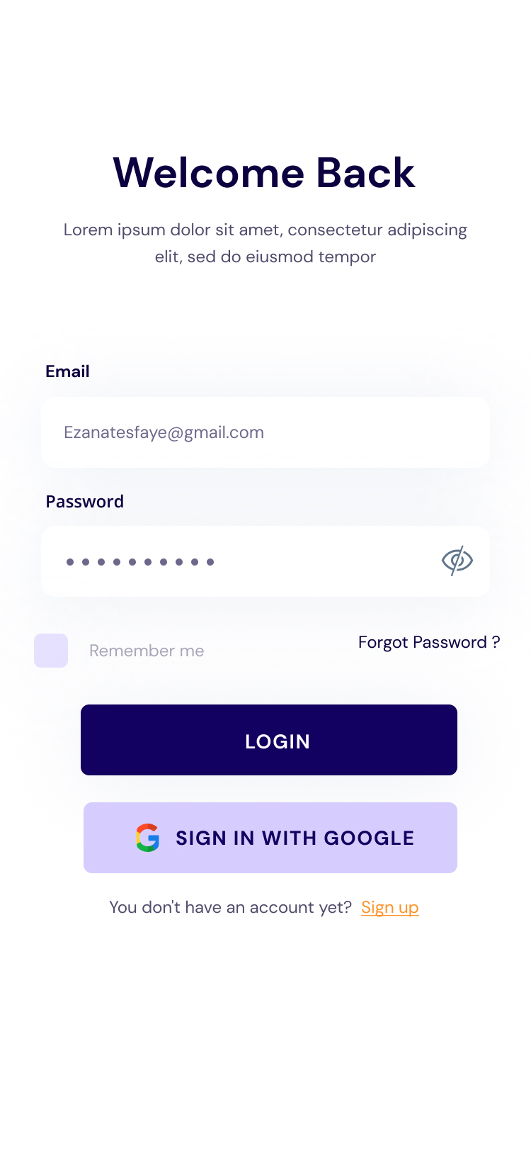

1. Sign up and Log in page

### 2. Job Listings Page

* Displays a list of available job opportunities in a card-based layout.
* Each card includes key job details such as job title, company name, location, and a brief description.
* Provides clear buttons for users to view more details or save a job.

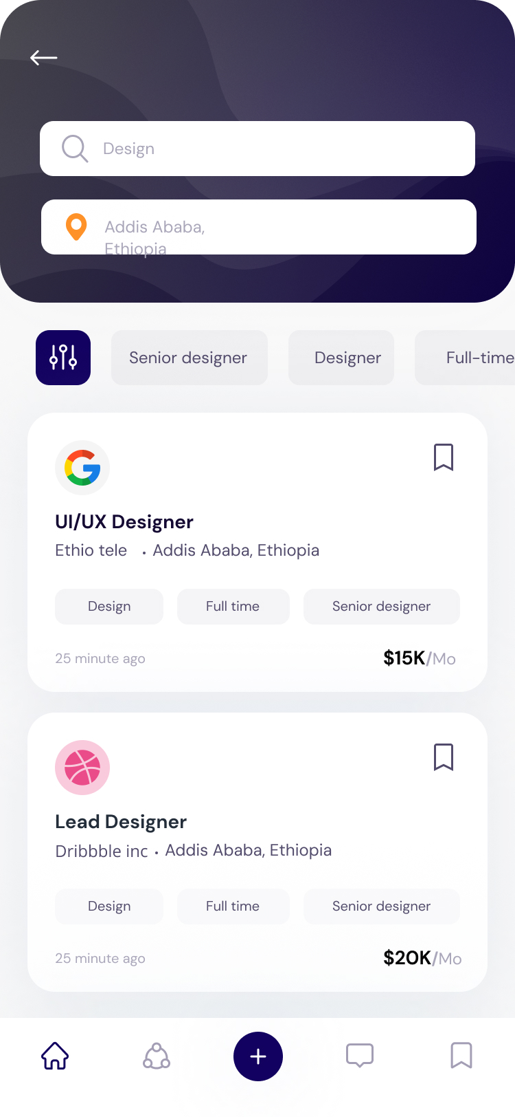

2. Job listing page

### 3. Search and Search Filter Page

* Includes a prominent search bar for users to look up jobs by keywords.
* Offers filters to refine job searches based on criteria like location, salary range, job type, and industry.
* Improves user experience by narrowing down search results effectively.

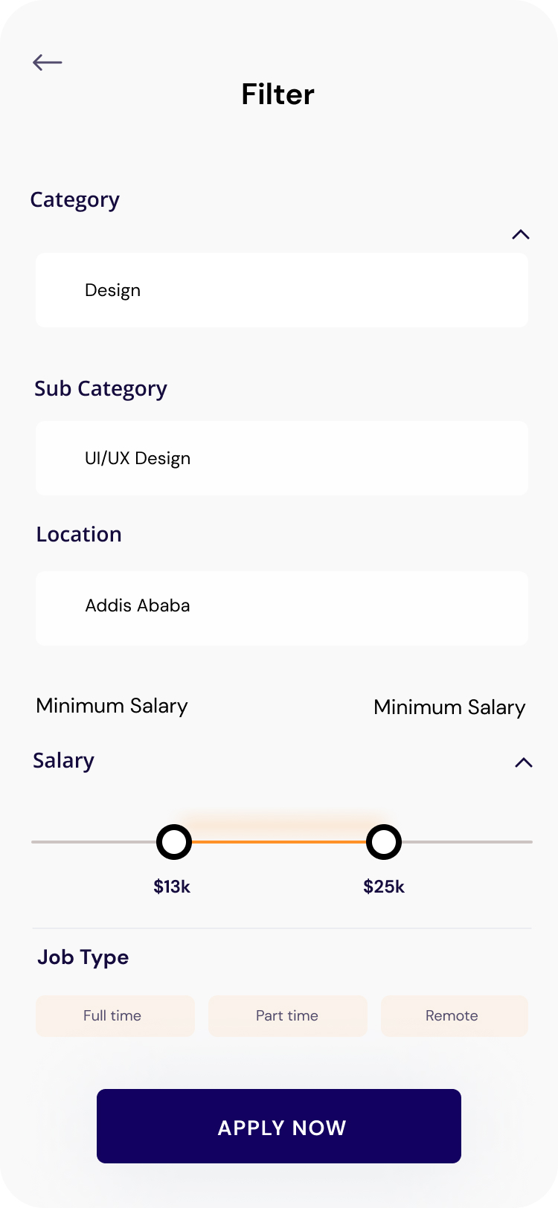

3. Search and filter page

### 4. Job Description Page

* Provides detailed information about a selected job, including responsibilities, qualifications, and company details.
* Features a large, visible "Apply Now" button to encourage immediate action.

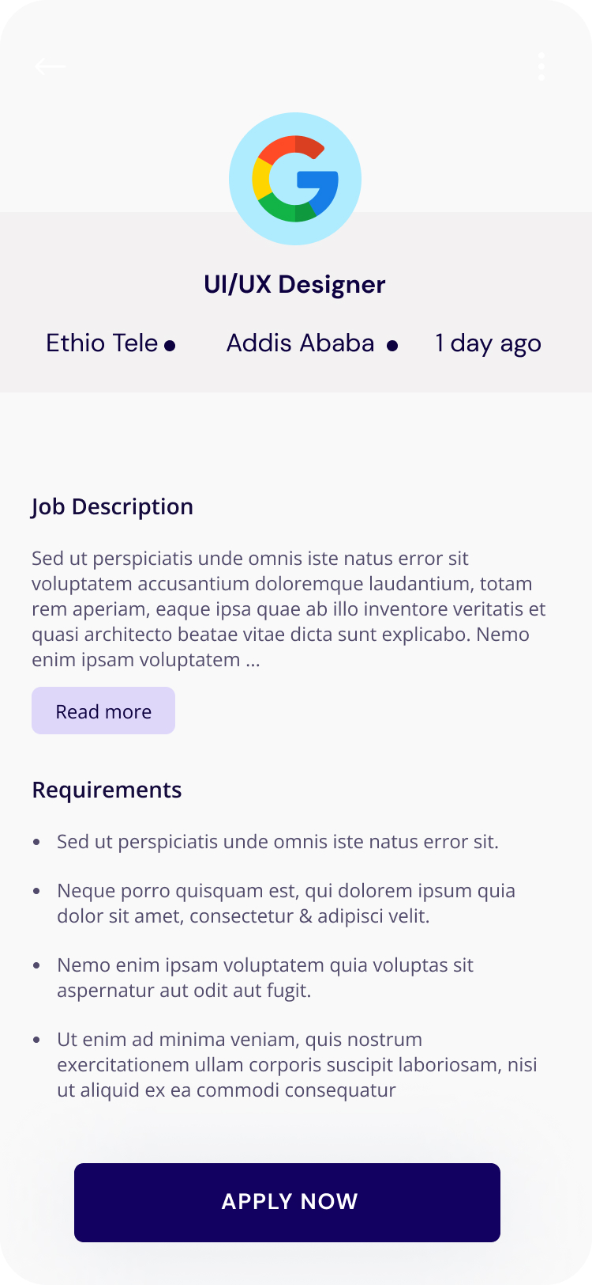

4. Job description page

### 5. Application Page

* A form where users can submit applications by providing necessary details like contact information and uploading a resume.

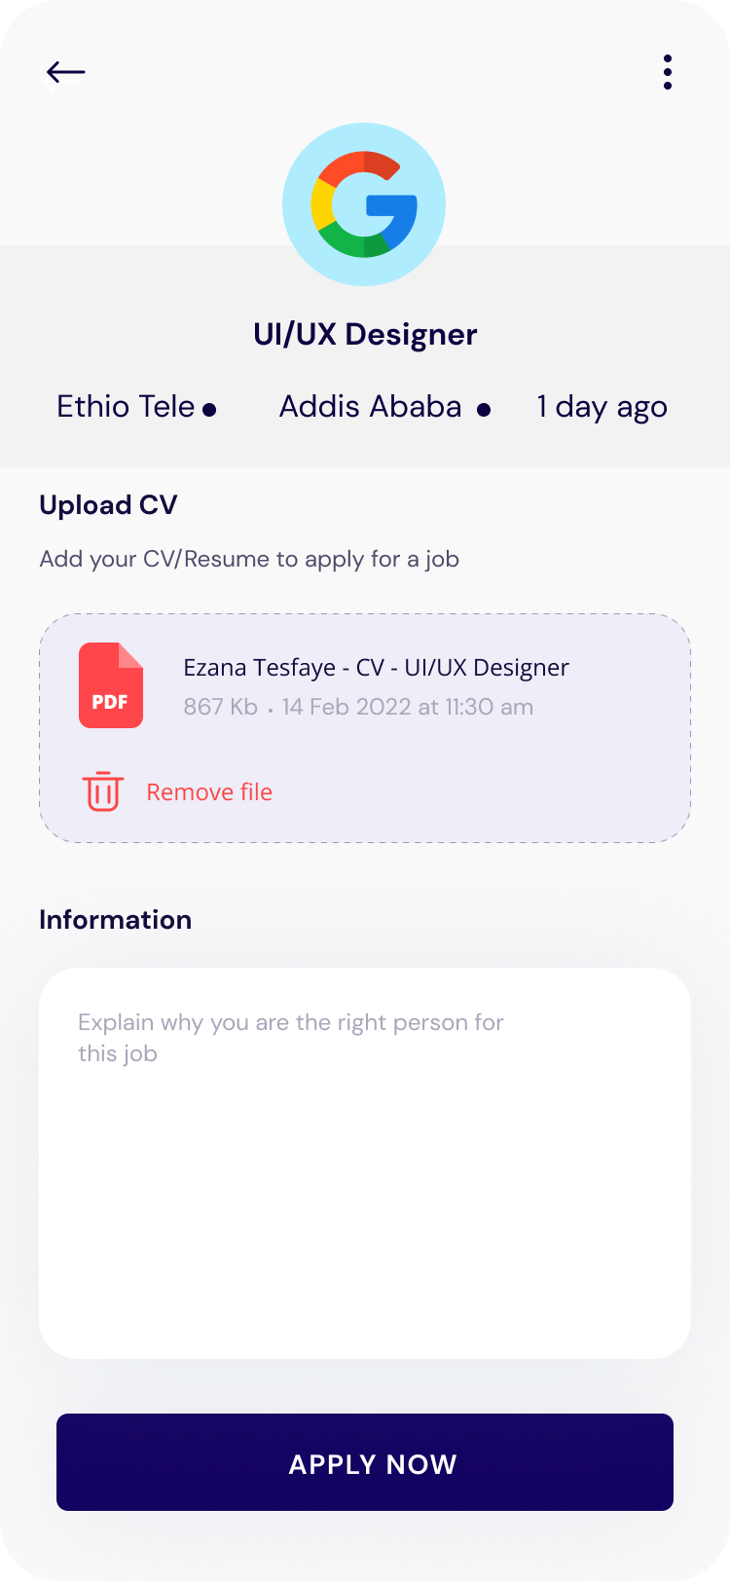

5. Application page

### 6. Post Job Page

* Enables employers to post job openings by filling in fields such as job title, description, requirements, location, and salary.

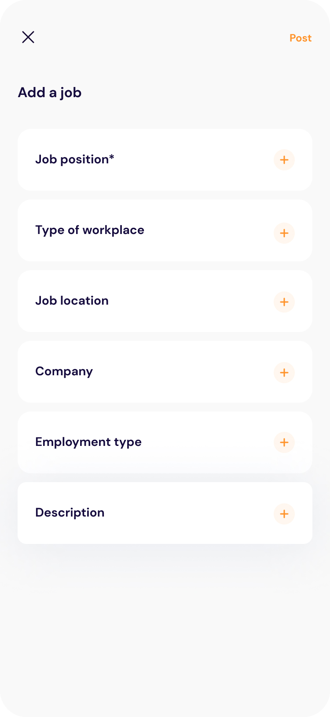

6. Job post page

### 7. Application Dashboard Page

* For job seekers: Displays the status of their submitted applications (e.g., pending, accepted, or rejected).
* For employers: Shows a list of applicants for their posted jobs, with options to view, accept, or reject applications.

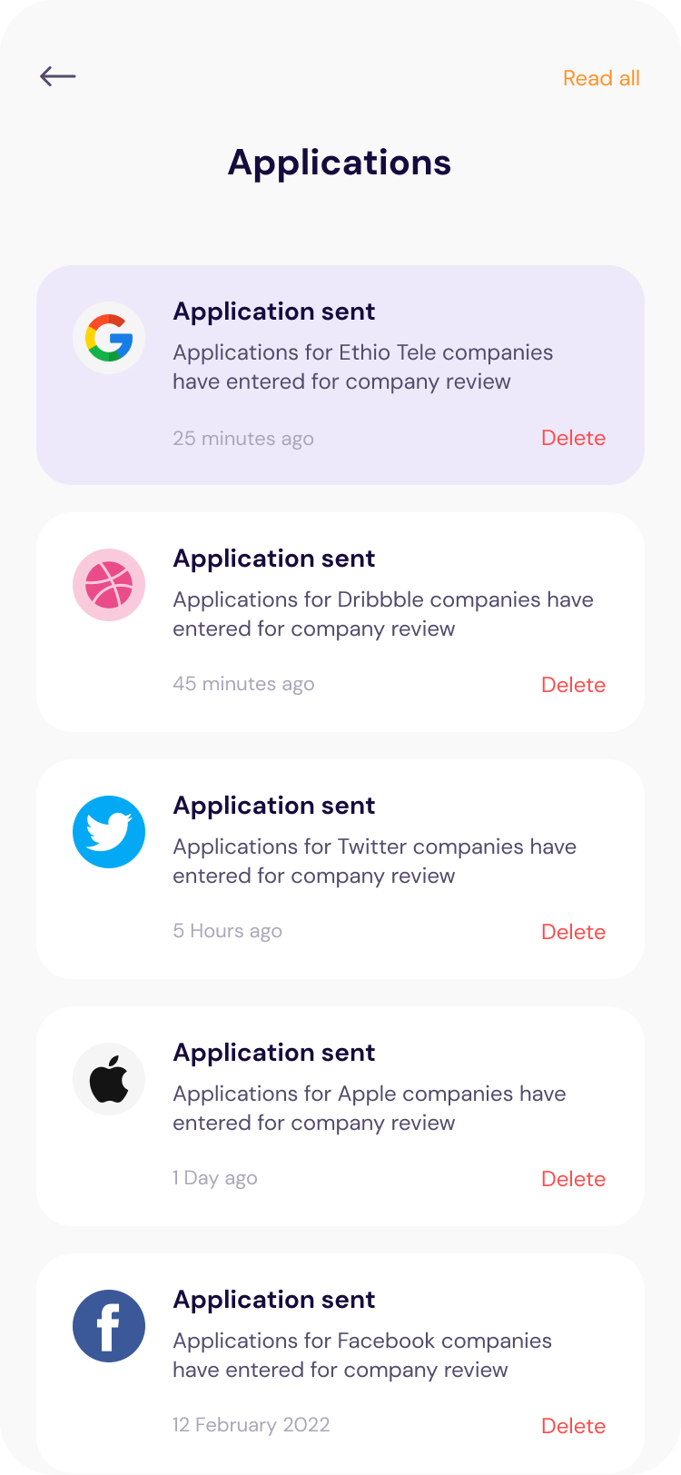

7. Application dashboard page

### 8. Profile Page

* Allows users to view and update their personal or professional information.
* Job seekers can manage details like name, email, skills, and uploaded resumes.
* Employers can edit company information and manage their profile details.

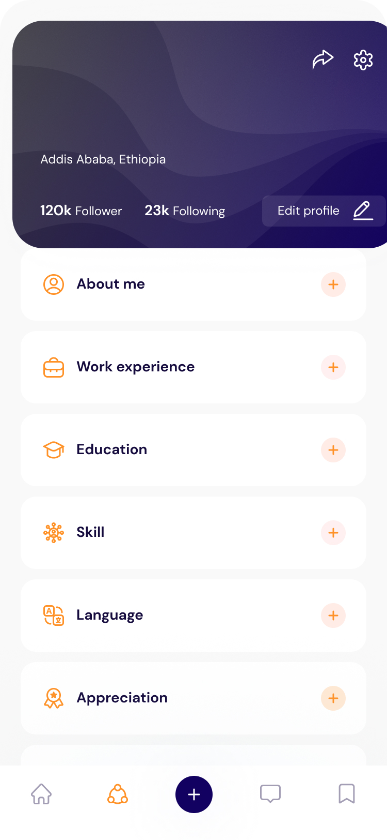

8. Profile page

## Design Principles Applied

### UI/UX Principles

The high-fidelity designs were built based on the following UI/UX principles:

* **Consistency**: Standardized components (buttons, input fields, cards) ensure a uniform look and feel.
* **Hierarchy**: Use of headings, subheadings, and visual contrast to guide users’ attention to key actions.
* **Accessibility**: High-contrast colors and readable fonts improve usability for all user groups.
* **Clarity**: Simple, intuitive layouts minimize user confusion and improve navigation.
* **Minimalism**: A clean design with no unnecessary clutter ensures smooth user interaction.

# Summary

The high-fidelity design of the **Job Portal Application** in Figma focuses on delivering a visually appealing, modular, and user-friendly experience. By leveraging reusable components such as **buttons**, **job cards**, and **input fields**, the design ensures **consistency** across all screens while maintaining scalability for future enhancements.

This design reflects careful attention to user needs, simplicity, and visual aesthetics, making it intuitive for **job seekers** and **employers** alike.

# Reference

1. What is figma?, <https://www.nobledesktop.com/learn/figma/what-is-figma>