DESIGN SYSTEM
You Are In Good Company
Foundations v0
The visual language, made literal.

Document version 1.0 (draft for review)
Companion artefact: patterns.html (the rendered pattern catalogue)
May 2026

You are in good company.

Contents
Right-click the field below and update to refresh after edits.

1. Overview
This document is the design system for You Are In Good Company. It is deliberately small. We have one product, one engineer, and one designer (when one is engaged). A system any bigger than this would be premature.

1.1 What this is
Three artefacts work together:
- This document. The strategic frame: principles, governance, naming conventions, what to build first, when to add new things, when not to.
- packages/design-tokens. The runtime source of truth for colours, typography, spacing, radii, shadows, and motion. Consumed by Tailwind, the application code, and (later) by Figma.
- apps/web/src/app/styleguide/page.tsx (and the standalone patterns.html that mirrors it). The browsable pattern catalogue. Every token rendered, every component rendered with code samples and states, every pattern documented in full.

1.2 What this is not
- Not a Figma file. We will create one when a designer is engaged. The naming conventions in this document are deliberately Figma-friendly so the translation is trivial when it happens.
- Not Storybook. We will introduce Storybook in Sprint 2 or 3 once there are 10+ components in production. Today, the patterns.html does the same job at a tenth of the setup cost.
- Not a brand identity document. Visual identity (logo system, brand guidelines, voice rules) lives elsewhere. The design system consumes the brand; it does not define it.
- Not finished. v0 is the foundation. v1 follows when we have run through Sprints 1 to 4 and can see which patterns we actually used.

1.3 Who this is for
Audience | What they read first
Lead engineer (Sprint 0 onward) | Sections 4 (tokens), 5 (components), 6 (naming), 7 (governance). Then patterns.html.
Designer (when engaged) | Sections 2 (principles), 4 (tokens), 6 (naming). Then patterns.html. Then Figma library setup.
Bassey / founder | Sections 2 (principles) and 3 (audit). Then skim the rest.
Advisor / investor | Section 2 (principles). The patterns.html is the actual proof point.

1.4 Status
v0 = minimum viable design system
Eight components, five patterns, six token categories. Documented, named with Figma alignment, status-pilled, governance-ruled.
This is not a complete system. It is the smallest possible system that protects the brand from drift in Sprints 1 to 4, and unblocks a designer joining in Phase 2 without rework.

2. Principles
Six principles that govern every decision in this system.

2.1 Tokens are the source of truth
Every colour, font size, spacing value, radius, shadow, and motion duration lives in packages/design-tokens. If a value appears anywhere else in the codebase as a hex code or a hard-coded pixel value, that is a bug.
This rule is enforced by ESLint. Hex codes are blocked in TSX files outside the tokens package. Hard-coded font families are blocked everywhere.

2.2 The brand voice is part of the design system
Components do not just have visual properties. They have copy properties. A Button has copy. An Eyebrow has copy. A FAQ Item has a question. That copy is governed by the brand voice rules: no "care" outside allow-list compounds, no "elderly", no "loneliness", no em dash. The brand voice guard CI rule is part of the design system as much as the colour token file is.

2.3 Accessibility is the floor
WCAG 2.2 AA is not aspirational. It is the minimum acceptable bar for any component to ship. Every component in this system has been verified for keyboard navigation, focus visibility, colour contrast, and screen-reader compatibility before being marked Stable.
Where AA is achievable, it is non-negotiable. Where AAA is reasonably achievable, we go for it.

2.4 Restraint over completeness
It is easier to add a component when we genuinely need it than to remove one we built speculatively. The starter set is eight components. Every new component must justify itself: real production use, repeated pattern, not a one-off.
The corollary: if the codebase has a one-off custom layout that does not belong in this system, that is fine. Not everything belongs in the design system. The system holds the patterns that are repeated.

2.5 Figma alignment from the start
Component names use the Figma-friendly Component/Variant/State convention from day one. Button/Primary/Default, Card/Highlighted, Hero/WithPortrait. Even without a Figma file in place, this convention pays back the day a designer opens Figma and mirrors what is in code.
The cost of this discipline now is essentially zero. The cost of renaming the entire component library to match Figma naming later is several days of refactor and broken commits.

2.6 Drift is the enemy
Design systems decay in three ways. First, when a developer creates a custom variant of a component instead of extending the system. Second, when a designer introduces a new colour or type ramp in Figma that does not match the tokens. Third, when the documentation stops being updated and the code becomes the only source of truth.
Section 7 (Governance) names the rituals that prevent these drifts. The rituals are deliberately lightweight at this scale, but they exist from day one.

3. Audit: what we already have
Before formalising the system, an honest stock-take. Across the work to date (PRD, kickoff pack, content strings, landing page, four website pages), the following patterns are already established. v0 captures these. Sprint 1+ extends.

3.1 What is established
Element | Source | Status
Colour palette (10 brand + 3 functional) | Brand guidelines, landing page CSS | Stable. Used consistently across all artefacts.
Typography (Fraunces + Inter) | Brand guidelines, landing page CSS | Stable. Self-hosted fonts planned in Sprint 0 (IGC-S0-010).
Spacing scale (4-px base) | Implied by landing page | Implicit. v0 makes it explicit.
Border radii ladder | Implied by landing page | Implicit. v0 makes it explicit.
Shadow ladder | Implied by landing page | Implicit. v0 makes it explicit.
Motion durations | Implied by landing page | Implicit. v0 makes it explicit.
Button (3 variants, 3 sizes) | Landing page | Stable.
Eyebrow label | Landing page, all marketing pages | Stable. Two variants (default, on-dark).
Pull quote (italic Fraunces, terracotta border) | Landing page, content strings file header | Stable.
Card (default, highlighted) | Landing page (visit cards) | Stable. May expand variants later.
Pillar (numbered trust pillar) | Landing page | Stable.
FAQ Item accordion | Landing page | Stable. Pure CSS, no JS.
Founder note treatment | Landing page, /about | Stable.
Closing line signature | All pages | Stable. The brand signature.
Section background variants | Landing page | Stable. Three variants (cream, moss, cream-deep).
Trust strip pattern | Landing page | Stable.
Hero composition (asymmetric two-col) | Landing page | Stable for marketing hero. Other hero variants come later.

3.2 What we know we will need but is not yet built
- Form field components (label, hint, input, error, disabled) - drafted in patterns.html, ready to lift into code in Sprint 1.
- Banner / notice component - drafted in patterns.html, ready to lift into code.
- Navigation components (top nav, side nav, footer) - landing page has implementations; lift into a component in Sprint 1.
- Modal / dialog - not needed in Sprint 1 to 3. Add when first booking confirmation prompt is built.
- Toast notifications - not needed in Sprint 1 to 3. Add when self-serve actions need confirmation feedback.
- Data tables - the operator console (Phase 2) needs these. Out of scope for v0.
- Avatar / portrait component - in patterns.html the hero portrait is illustrated; when real photography is available, this becomes a proper Avatar component.
- Calendar / date picker - companion availability calendar (Phase 2). Out of scope for v0.
- Empty states - drafted as strings in the content pack; render component pending Sprint 2.

3.3 What does not yet exist anywhere
- A real logo file. The wordmark + terracotta dot lockup is rendered in HTML/SVG but there is no SVG / PNG asset. Commission this as part of brand identity finalisation, separate from the design system.
- Photography or commissioned illustration. The hero portrait is a placeholder silhouette. The Landing Page Design Brief specifies what to commission.
- Icon set. We have deliberately not introduced one yet. Where icons would normally appear (in cards, in nav), we use typographic glyphs or omit entirely. Revisit in Sprint 4.

4. Tokens
The atoms of the system. All token values render in patterns.html. This section documents the categories, the naming convention, and where each lives in code.

4.1 Token categories
Category | Naming convention | What lives in it
Colour | color.<name> | Brand (10), functional (3). No raw hex codes outside this file.
Typography | type.<semantic-name> | display.xl/lg/md/sm, body.lg/md/sm/xs, caption. Fluid sizing via clamp().
Font families | font.<role> | display (Fraunces), body (Inter), mono (JetBrains Mono).
Spacing | space.<step> | 4 / 8 / 12 / 16 / 24 / 32 / 48 / 64 / 96 / 128 px.
Radii | radius.<size> | none, sm (4), md (8), lg (16), xl (24), full (pill).
Shadows | shadow.<level> | none, sm, md, lg, portrait. Tinted with moss for warmth.
Motion | duration.<speed> / easing.<curve> | instant 100ms / quick 200ms / standard 300ms / slow 600ms / hero 800ms. easing.standard, easing.ease.
Breakpoints | bp.<size> | sm 600 / md 760 / lg 1000 / xl 1240.

4.2 Token file location
Tokens live in packages/design-tokens/src/. Each category is one file:
packages/design-tokens/
├── src/
│ ├── colors.ts # all color tokens
│ ├── typography.ts # type scale + font families
│ ├── spacing.ts # 4-px scale
│ ├── radii.ts # border radii
│ ├── shadows.ts # shadow ladder
│ ├── motion.ts # durations + easing
│ ├── breakpoints.ts # responsive breakpoints
│ └── index.ts # re-exports everything
└── package.json

4.3 How tokens are consumed
- Tailwind config reads from the tokens package and exposes them as utility classes (e.g. text-moss, p-6, rounded-lg).
- Application code never imports raw hex codes. ESLint rule blocks hex codes in apps/web/src/**/*.{ts,tsx}.
- CSS variables are defined at :root in the global stylesheet so they are also reachable from inline styles where needed (rare).
- When a Figma file is created, the same token names appear as Figma styles. Plugin Tokens Studio is the bridge.

4.4 The discipline
If a value is not in the tokens, it should not exist
If you need a colour that is not in colors.ts, you have two options: (a) use the nearest existing token, or (b) add a new token to the package with a name and a documented usage. Never inline a one-off hex code.
The same rule applies to spacing, type sizes, radii, and shadows. Drift starts with one inline value.

5. Components
The starter set. Eight components, all marked Stable in v0. Each has a Figma-aligned name, a clear purpose, documented variants, and a code location.

5.1 The starter set
Component | Figma name | Purpose
Button | Button/Primary, Button/Secondary, Button/Ghost | Actions: book a call, sign in, submit form. Three variants, three sizes.
Eyebrow | Eyebrow/Default, Eyebrow/OnDark | The small uppercase label above headings. Audience signal.
Card | Card/Default, Card/Highlighted | Visit cards, feature cards, content blocks.
Pillar | Pillar/Default | Numbered trust-pillar block with top border. Sets of three or four parallel arguments.
PullQuote | PullQuote/Default | Italic Fraunces in moss with terracotta border. Emphasis moments.
FAQItem | FAQItem/Default | Native HTML accordion with + that rotates to ×.
FormField | FormField/Default, FormField/Error, FormField/Disabled | Label, hint, input, error. The form-building primitive.
Banner | Banner/Info, Banner/Success, Banner/Warning, Banner/Alert | Bordered notice. Four variants tied to functional colour tokens.

5.2 Component file structure
Each component lives in apps/web/src/components/ui/<Component>.tsx. Co-located with its tests and (when present) Storybook story.
apps/web/src/components/ui/
├── Button/
│ ├── Button.tsx # component implementation
│ ├── Button.test.tsx # Vitest unit + a11y tests
│ ├── Button.stories.tsx # Sprint 3+ once Storybook is in
│ └── index.ts # re-export
├── Card/
├── Eyebrow/
├── FAQItem/
├── FormField/
├── Pillar/
├── PullQuote/
├── Banner/
└── index.ts # barrel export for convenient imports

5.3 Status taxonomy
Every component carries one of these statuses, shown as a pill on the pattern catalogue:
Status | Visual | Meaning
Stable | Green pill | Production-ready. Used in shipped code. API is firm; breaking changes need a deprecation notice.
Draft | Amber pill | Designed and documented but not yet shipped in production. API may change.
Planned | Stone pill | Identified as needed but not yet built. Lives on the backlog.
Deprecated | Strike-through | Component is being phased out. Replacement is named. Removal date is set.

5.4 Acceptance criteria for marking Stable
A component is Stable when all of these are true:
- It has been used in production code for at least one full sprint.
- Its TypeScript props are documented with JSDoc comments visible in IDE tooltips.
- All variants and states are rendered in patterns.html.
- Unit tests cover the variants and a11y behaviour.
- It has been keyboard-tested and screen-reader-tested at least once on NVDA or VoiceOver.
- Its Figma name follows the Component/Variant/State convention.
- It uses tokens only - no inline hex codes, no hard-coded font families, no magic pixel values.
- It does not violate the brand voice (no forbidden words in default copy).

6. Naming conventions
Naming is the foundation of a design system. Consistent names mean designers and engineers can talk about the same thing without translation.

6.1 The Figma-aligned format
Component / Variant / State
Three slash-separated levels. Each level is PascalCase. The slash is meaningful: Figma uses it as a hierarchy separator, automatically creating component variants in the Figma component library. Code uses it conceptually.

6.2 The levels
Level | Example | Notes
Component | Button | The thing itself. Always required. PascalCase.
Variant | Primary, Secondary, Ghost | Different visual or semantic versions of the same component. Optional. When present, PascalCase.
State | Default, Hover, Focus, Disabled, Error | Interaction or status. Optional. When present, PascalCase. Often omitted in code (states are handled by CSS pseudo-classes).
In code, the slash convention maps to component props:
// In code, slashes become props
<Button variant="primary" size="large">Book a call</Button>
<Card variant="highlighted">...</Card>
<Banner variant="warning">...</Banner>

// In Figma, the same component is named:
// Button / Primary / Default
// Button / Primary / Hover
// Button / Secondary / Default
// Button / Ghost / Default

6.3 Sizes as a separate prop
Sizes (sm, md, lg, xl) are not variants. They are sizes. Always lowercase. Always a separate prop in code (size="sm") and a separate Figma property.

6.4 Anti-patterns
- Do not concatenate (PrimaryButton, SmallSecondaryButton). The whole point of the variant system is to keep the component name stable and let props express the variation.
- Do not use abstract names (BlueButton, BigButton). The token system already encodes the visual; the component name should describe the role, not the appearance.
- Do not invent a new component when an existing one with a new variant would do the job. Three Buttons with variant="primary|secondary|ghost" is better than three components.
- Do not use kebab-case or snake_case in component names. PascalCase only.

6.5 Special-case names
A handful of components have unusual names that need explanation:
Component | Why this name
Eyebrow | Editorial / publishing term for the small label above a headline. The brand voice is editorial; this name preserves that. Not Label, not Tag.
Pillar | The numbered trust-pillar pattern. Named for the rhetorical structure ("three pillars of trust") rather than the visual ("top-bordered card"). The structure is what matters.
PullQuote | Editorial term for a highlighted quote pulled from longer text. Distinguishes from a plain blockquote.
FounderNote | A specific composition with the founder's voice. Not a generic "testimonial" because the brand uses founder voice intentionally and uniquely.
ClosingLine | The brand signature. Not Footer because it appears in places other than the footer (post-visit reports, emails).
TrustStrip | A specific composition that signals trust between hero and the first long-form beat. Not a generic Banner because its content and placement are unique.

7. Governance
Lightweight, but real. The rituals below prevent drift without adding ceremony.

7.1 Who owns the system
- Bassey is the owner of the brand and voice.
- The lead engineer is the owner of the tokens, components, and the pattern catalogue code.
- The designer (when engaged) is the owner of the Figma library and the visual evolution.
- Decisions that affect any of: a token value, a Stable component's API, a brand voice rule, require all three owners to agree. Until the designer is engaged, Bassey and the lead engineer suffice.

7.2 Adding a new token
- Identify the need. "I am about to write an inline value" or "I am about to use the nearest existing token but it does not feel right".
- Propose the new token in a PR that updates packages/design-tokens. Include the rationale in the commit message.
- Update patterns.html to render the new token.
- Update this document if the new token introduces a new category.
- Bassey and the lead engineer review.

7.3 Adding a new component
- Check whether an existing component with a new variant would do. If yes, add the variant instead. If no, proceed.
- Draft the component in code. Mark it Draft in the pattern catalogue.
- Use it in real production code for at least one sprint.
- After one sprint of production use, if the API has not changed, promote it to Stable in a PR that updates the patterns.html status pill.
- Add Storybook story (from Sprint 3+ when Storybook is in).

7.4 Changing a Stable component
- Visual changes (colour, spacing, type): no deprecation needed, but call it out in the PR.
- API changes (renamed props, removed props): require a deprecation notice, a deprecation comment in code, and a migration note in this document. The old API is supported for at least one sprint after deprecation before removal.
- Breaking changes to behaviour (focus order, accessibility) require an ADR (Architectural Decision Record) in docs/adr/.

7.5 Deprecating a component
- Mark it Deprecated in the pattern catalogue (strike-through).
- Name the replacement component in this document.
- Set a removal date at least one sprint in the future.
- Replace all production usages by the removal date.
- Remove the component.

7.6 The drift review
Once a month, the lead engineer (or Bassey, in the absence of a lead engineer) does a 30-minute drift review:
- Grep the codebase for inline hex codes. There should be none outside the tokens package.
- Grep for hard-coded pixel values that should use a spacing token. Fix or justify.
- Grep for custom font-family declarations outside the tokens package. There should be none.
- Scan production pages for visual patterns that look custom but should be system components.
- Update patterns.html with anything new that has emerged.
The drift review takes 30 minutes a month
Skipping it for three months is the difference between a system that holds together and a system that quietly stops working.
It is the lightest possible ceremony that prevents the heaviest possible problem. Do not skip it.

8. Roadmap
How the system grows, sprint by sprint. Aligned with the engineering kickoff pack.

8.1 Sprint 0 (foundations, in flight)
- packages/design-tokens implemented with all token categories (this document is the spec).
- Self-hosted Fraunces and Inter.
- /styleguide route in the application that renders the same content as patterns.html.
- ESLint rule blocks hex codes in TSX files outside the tokens package.
- Brand voice guard lint rule enforces forbidden words in content packages and marketing routes.

8.2 Sprint 1 (marketing site)
- Lift the landing page CSS into proper components: Button, Eyebrow, Card, Pillar, PullQuote, FAQItem, Banner, FounderNote, ClosingLine, TrustStrip, Section, Hero.
- Implement marketing pages on top of the components (home, how it works, pricing, safeguarding, about, FAQ, join Companion Club, contact).
- All components marked Stable as they reach production use.
- Each component gets unit tests and accessibility tests.

8.3 Sprint 2 (portal-shaped components)
- FormField with all states (default, error, disabled, focused).
- Dropdown / Select component (used in pricing tier selection, household management).
- Checkbox and Radio components.
- Toast / Notification component for success states after actions.
- Modal / Dialog component for confirmation flows.
- DataList / DescriptionList for displaying recipient and visit detail.

8.4 Sprint 3 (Storybook + designer onboarding)
- Storybook setup. Every Stable component gets a story.
- If a designer joins around now, the Figma library mirrors the Storybook components 1:1.
- Tokens Studio plugin connects packages/design-tokens to Figma styles.

8.5 Sprint 4+ (operator console patterns)
- Table component with sorting, filtering, pagination.
- Search input with autocomplete.
- DateRangePicker for booking calendars.
- Badge / Pill for status indicators across the operator console.
- Avatar component once real photography is commissioned.
- Icon set introduced if needed by the operator console (only if needed, not as a default).

8.6 Phase 2 (companion-side and complex flows)
- Calendar component for companion availability.
- Multi-step form / Wizard pattern for sign-up flows.
- Empty-state component standardised across portals.
- Skeleton-loading patterns where genuine network delays exist.

8.7 What we will not build
Some things the wider design-system industry treats as standard, that we are deliberately not adopting:
- A full icon library. We do not need one. Where icons are required, we use sparingly and from a single small set.
- Illustrations as a system. Illustrations are commissioned one-off, not systematised.
- Heavy animation system (Framer Motion, Lottie, etc.). The motion principles (restrained, hero load, hover lifts, FAQ accordion) cover all our motion needs in v0 and v1.
- Dark mode. The brand has one mode: the warm cream-and-moss palette. We do not invert it.
- RTL support. English UK only in v1. RTL support is not on the roadmap until we have a real localisation requirement.

9. Component reference (short form)
The full specification, including every state and the actual code, lives in patterns.html (and the in-app /styleguide route). The table below is a quick lookup.
Component | Status | Props (summary)
Button | Stable | variant: 'primary' | 'secondary' | 'ghost'; size: 'sm' | 'md' | 'lg'; href?: string; onClick?: () => void; disabled?: boolean; children: ReactNode
Eyebrow | Stable | variant?: 'default' | 'onDark'; children: string
Card | Stable | variant?: 'default' | 'highlighted'; children: ReactNode. Card.Mark, Card.Title, Card.Body as compound children.
Pillar | Stable | number: string (e.g. '01'); label: string; children: ReactNode. Pillar.Title, Pillar.Body as compound children.
PullQuote | Stable | attribution?: string; children: ReactNode
FAQItem | Stable | question: string; defaultOpen?: boolean; children: ReactNode
FormField | Stable | label: string; hint?: string; error?: string; disabled?: boolean; children: ReactNode (the input)
Banner | Stable | variant: 'info' | 'success' | 'warning' | 'alert'; children: ReactNode
Section | Stable | background: 'cream' | 'moss' | 'cream-deep'; children: ReactNode
Hero | Stable | variant: 'withPortrait' | 'textOnly'; eyebrow?, headline, body, primaryCta, secondaryCta?, reassurance?, portrait?
TrustStrip | Stable | items: string[]
FounderNote | Stable | attribution: string; children: ReactNode (with <em> for emphasis)
ClosingLine | Stable | variant?: 'onMoss' | 'onCream' (auto-detected from parent section background)

10. Pattern catalogue preview
The patterns.html file (and the /styleguide route in production) is the visual source of truth. The screenshots below are a static preview. The live file is interactive and always reflects current tokens.

10.1 The full catalogue
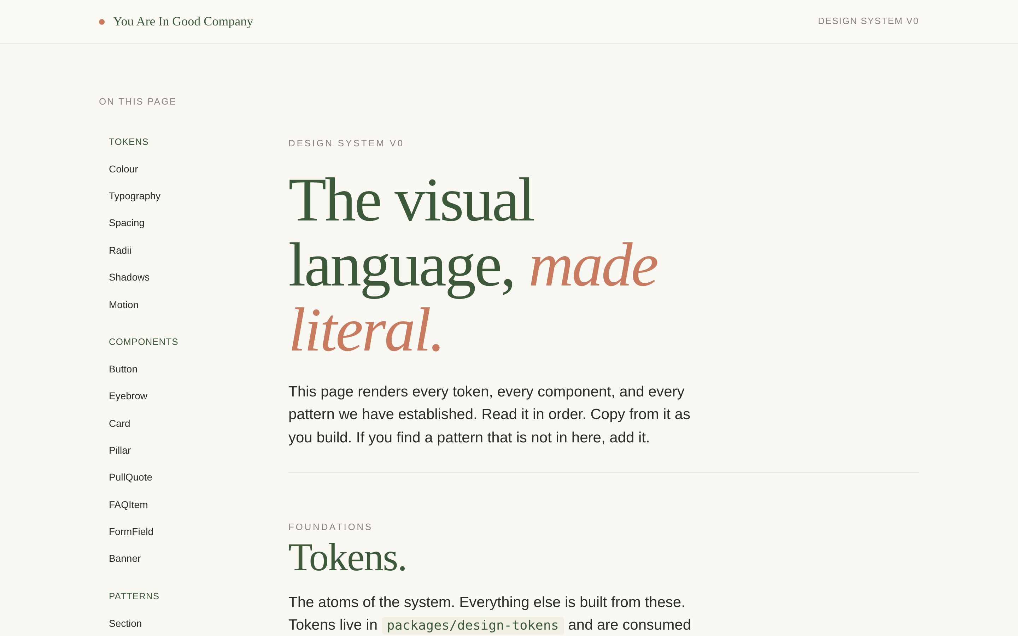

The patterns.html opens with a header introducing the system, a side navigation listing all tokens / components / patterns, and a hero that uses the system's own typography to demonstrate the visual voice.

10.2 Tokens section
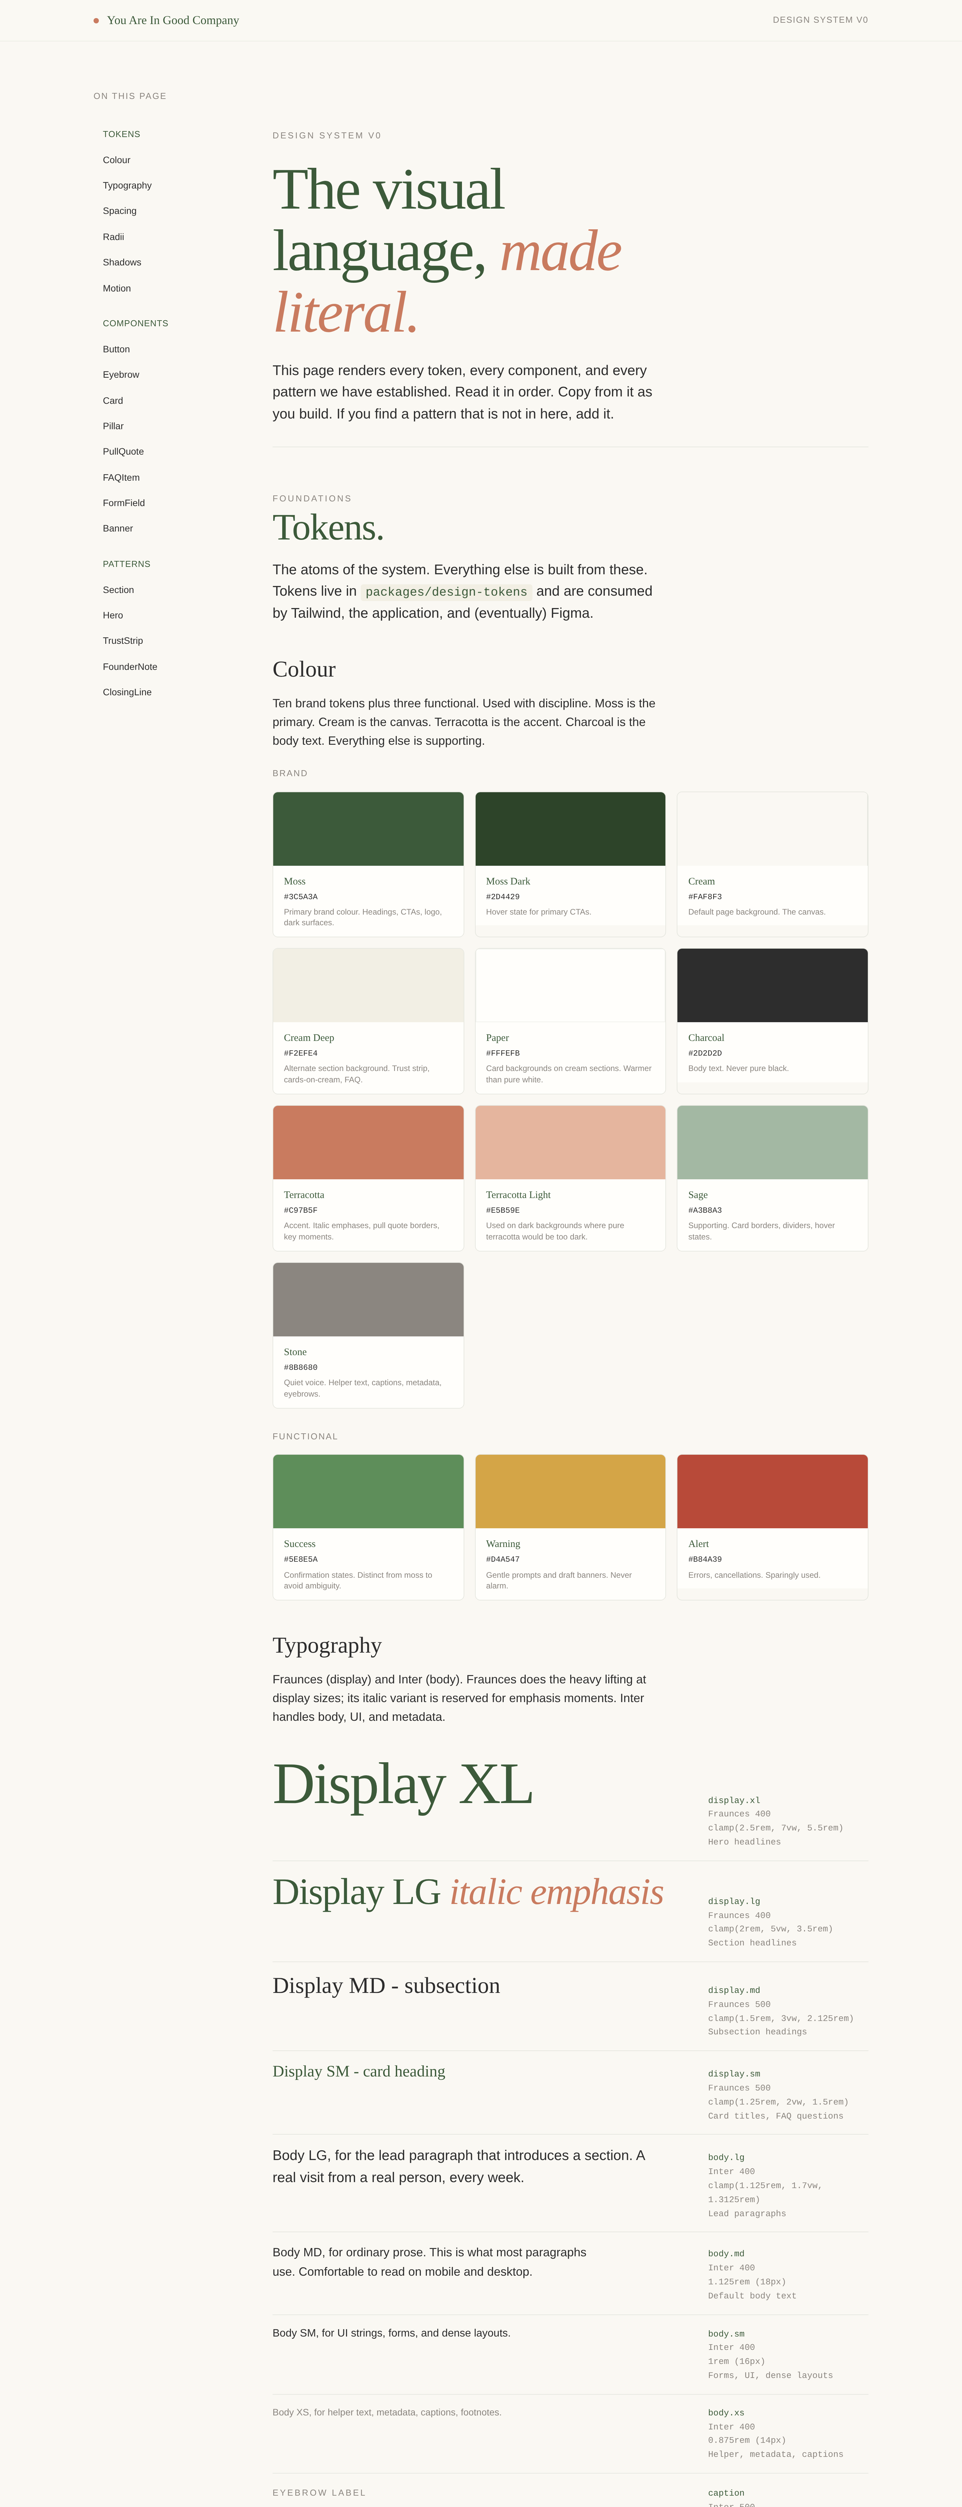
The tokens section renders every colour swatch with its name, hex code, and usage notes. Typography specimens are paired with mono-font metadata (semantic name, family, weight, clamp values, intended use).

10.3 Components section
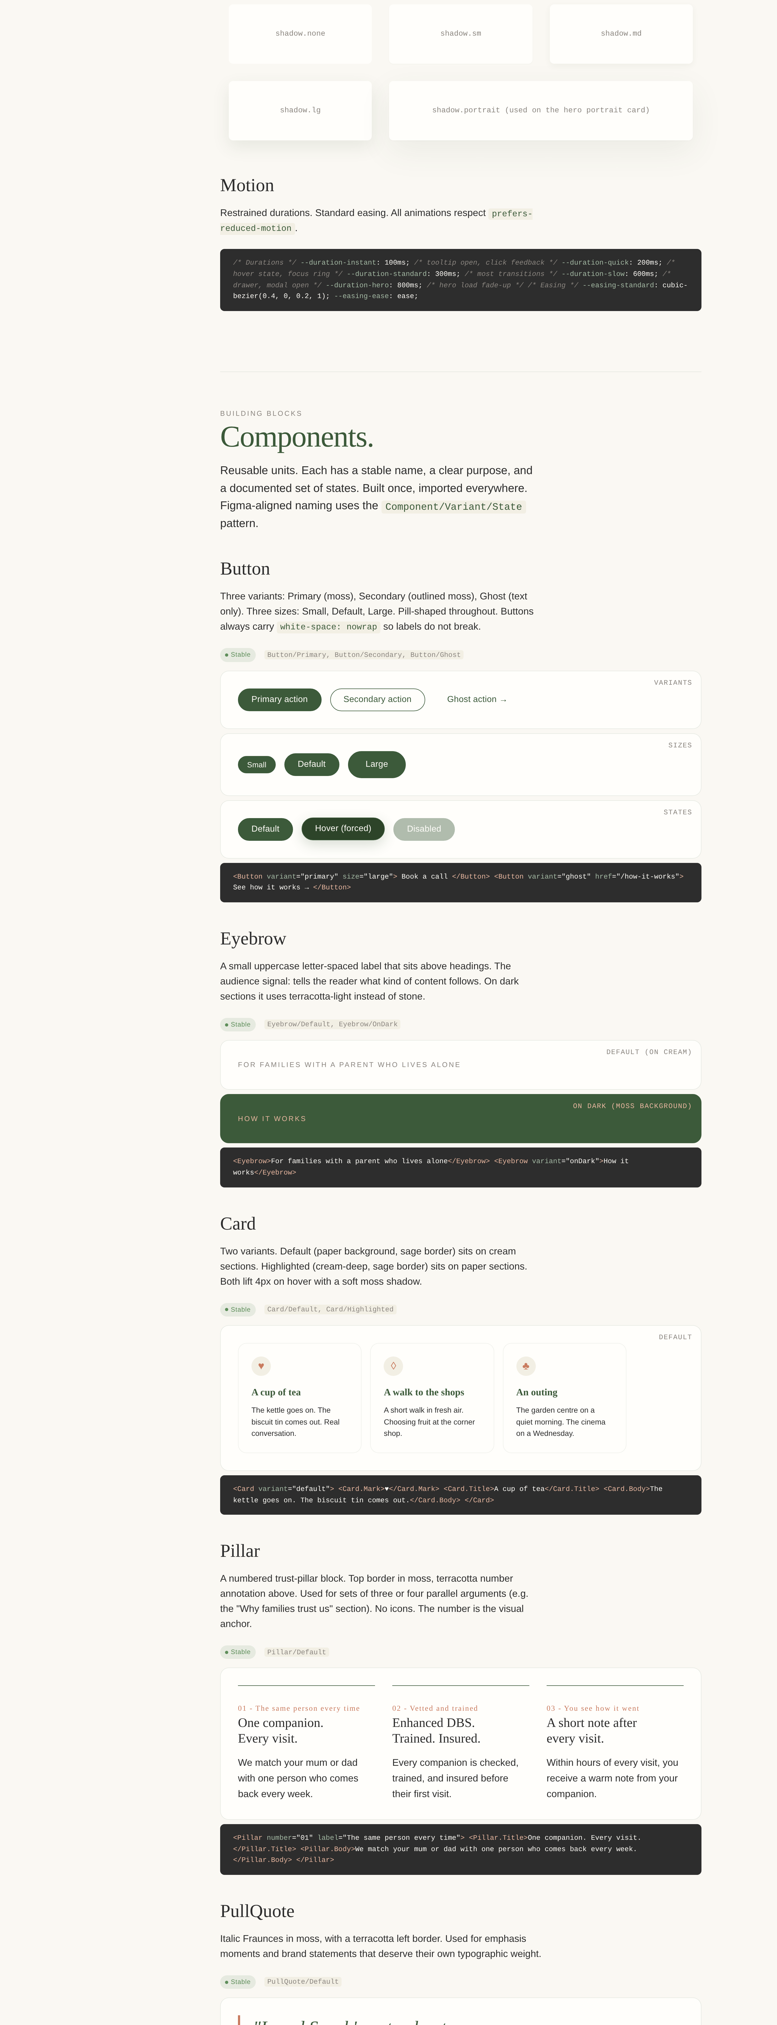
Each component shows variants, sizes, and states in a specimen frame, followed by a syntax-highlighted code sample using the JSX the engineer will actually write.

10.4 Patterns section
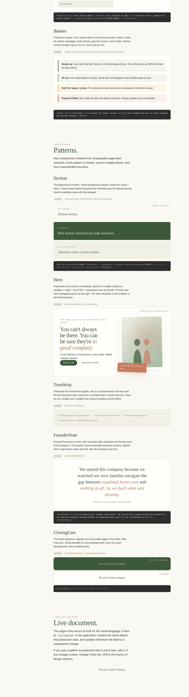
Patterns show the compositions: how components combine into page-level moments. The Hero pattern includes a working scaled-down render of the actual landing page hero, with portrait card and overlapping quote bubble. The ClosingLine appears in both on-moss and on-cream variants.

11. Open questions
Things deliberately undecided. Each needs an owner and a decision date.
Question | Working position
When do we engage a designer? | Sprint 3 to 4, after the marketing site is in production and the first portal screens are taking shape. Earlier engagement is possible if budget allows.
Do we need an icon set? | Not yet. Default position is no. Revisit when the operator console (Phase 2) needs status indicators, sort arrows, or table actions. If introduced, Lucide is the working candidate (single small set, consistent stroke weight, free).
Storybook or no Storybook? | Yes, but not yet. Sprint 3+. Adds value when there are 10+ Stable components and more than one engineer.
Tokens Studio (Figma plugin) or hand-mirroring? | Tokens Studio once a designer is engaged. Trying to keep Figma and code in sync manually is the most common cause of drift.
Dark mode? | No. The brand has one mode. Revisit only if a strong recipient-side reason emerges (some older users prefer dark mode for visual comfort).
A11y certification (e.g. axe-mark, third-party audit)? | First independent audit within four weeks of public launch. Annual thereafter. Accessibility statement at /accessibility commits us to this.
Component-level versioning (semver in package.json)? | No. v0 is monolithic with the application. Versioning becomes useful when there is an external consumer; v0 is internal-only.
Visual regression testing (Chromatic, Percy, etc.)? | Phase 2. Useful but adds cost; the visual stability of v0 is enforced by the discipline of using tokens and the manual drift review.

12. A note on this document
This document is alive. If a pattern emerges in production that is not in here, add it. If a component is deprecated, mark it. If a token changes, update the rationale.
The drift review (section 7.6) catches what passive maintenance misses. Do it monthly. Thirty minutes. Pay the cost, keep the system.

End of document
You are in good company.

