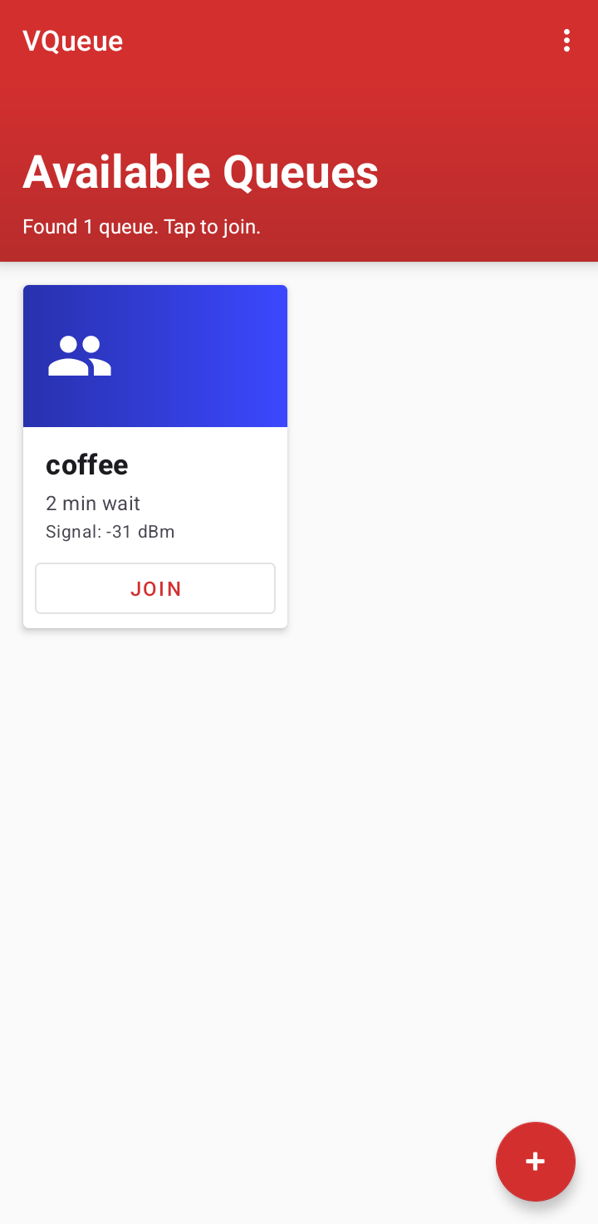
Vqueue Guide

- Ideally you need two android phones to test it
- UI can be tested with just one though
- prerequisite : turn on Bluetooth

on the first device :

1. Tap on the FAB and create a queue : give it a name and estimated wait time and press create button

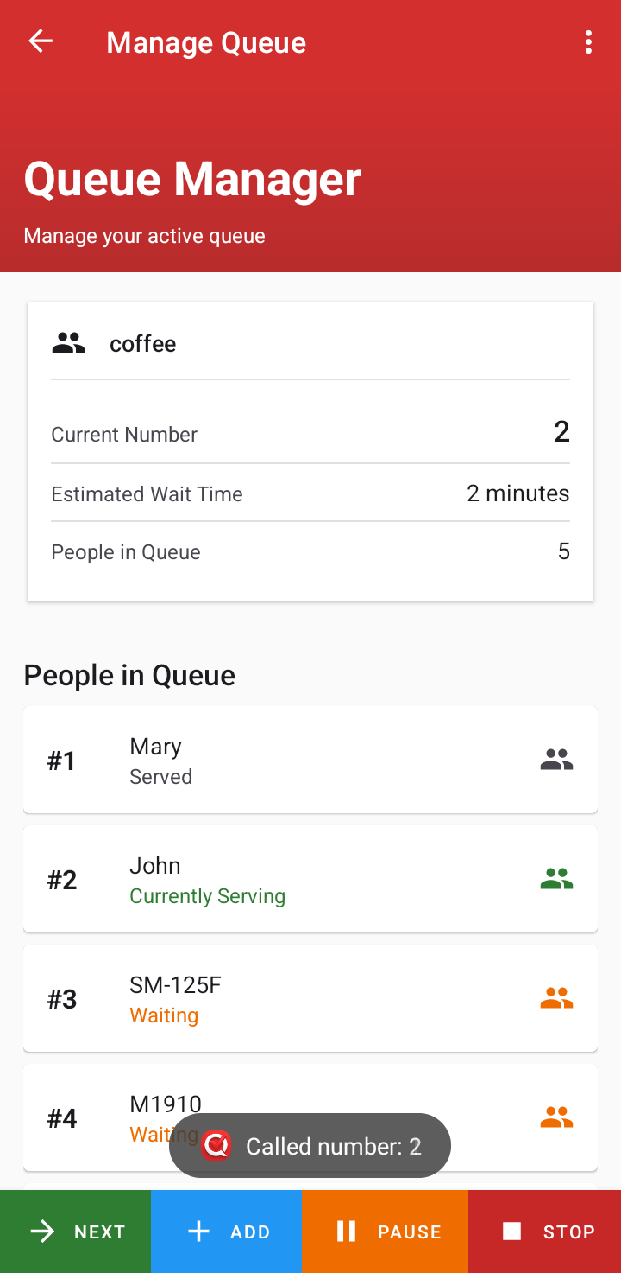
2. Manage It here :

next : to get the next person’s phone ring.
Add : add a person manually
pause : stop more people joining
stop : close the queue

on the second device:

The queue created by the first device will be displayed. Refresh if needed. Tap on it and confirm.
You will enter waiting screen. You can leave the app at this point.

Press next on the first device.
When its your turn ( in case you have added people manually or have more devices queuing, you will receive a notification)

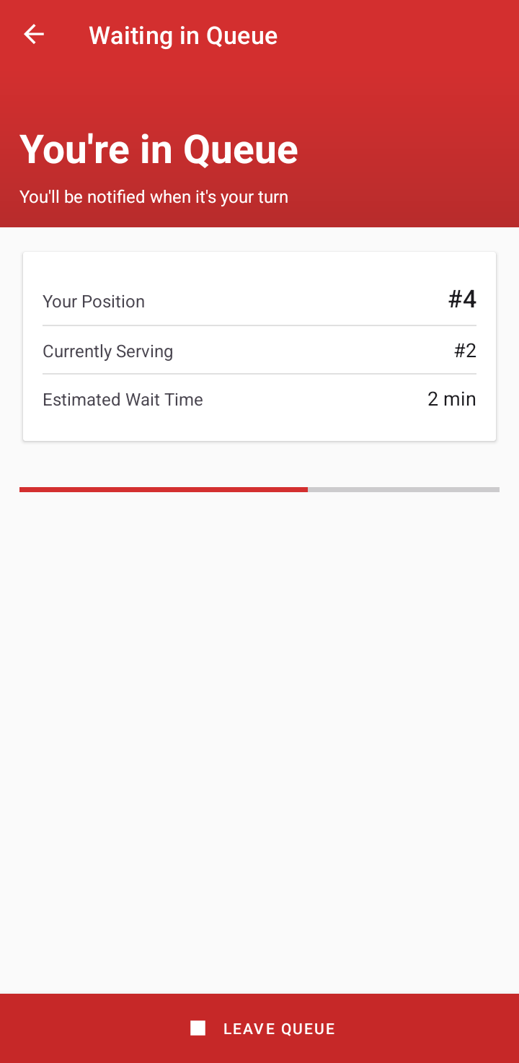
from the first screen
Tap on three dot menu to see about info or go to some settings(change theme)

