SWDD- 001

PANTHER CONSULTING
Employee Management System for Company 'Z'

Software Design Document

Name(s): Ikechukwu Anyanwu, Yogesh Patel, Eyobed Gebregziabher, Kenny Bui, Pruthvi Rajaghatta, Marc Chishibanji
Section: 004

Date: 12/02/2025

TABLE OF CONTENTS
1.0 INTRODUCTION 3
1.1 Purpose 3
1.2 Scope 3
1.3 Overview 3
1.4 Reference Material 4
1.5 Definitions and Acronyms 4
2.0 SYSTEM OVERVIEW 4
3.0 SYSTEM ARCHITECTURE 5
3.1 Architectural Design 5
3.2 Decomposition Description 5
3.3 Design Rationale 7
4.0 DATA DESIGN 8
4.1 Data Description 8
4.2 Data Dictionary 9
5.0 COMPONENT DESIGN 11
6.0 HUMAN INTERFACE DESIGN 12
6.1 Overview of User Interface 12
6.2 Screen Images 13
6.3 Screen Objects and Actions 15
7.0 REQUIREMENTS MATRIX 15

INTRODUCTION

Purpose

This Software Design Document (SWDD) describes the architecture, system design, and detailed component specifications for the Employee Management System for Company 'Z'. This document translates the preliminary software requirements into a comprehensive design blueprint, serving as the primary reference for code development and implementation. The intended audience includes the development team, project manager, and stakeholders interested in the system's structure and functionality.

Scope

The scope of this software system is to provide a minimal working backend and console-based User EXperience (UX) for managing essential employee data and generating specific reports for Company 'Z'.
The system's primary goals and objectives are:
- Manage Core Employee Data: Allow for the insertion, searching, and updating of employee records, including a new requirement for storing the SSN (Social Security Number).
- Implement Business Logic: Facilitate the bulk update of employee salaries based on specific percentage and salary range criteria.
- Generate Required Reports: Produce three specific reports: Full-time employee information with pay statement history, Total pay for the month by job title, and Total pay for the month by Division.
- Technology Stack: The implementation will utilize Java for the application logic and MySQL for persistent data storage, accessed via JDBC. A console-based UX will be used to satisfy the minimal working UX requirement.

Overview

This document is organized into several sections to guide the reader through the system's design:
- Section 1.0 provides the context, scope, and organization of the document.
- Section 2.0 presents a high-level overview of the system's functionality and context.
- Section 3.0 details the architectural design, decomposition, and design rationale.
- Section 4.0 defines the data design, including the data structures and dictionary.
- Section 5.0 specifies the component-level design using pseudocode for critical operations.
- Section 6.0 describes the console-based user interface.
- Section 7.0 provides a Requirements Matrix linking features to components.

Reference Material
- IEEE Std 1016, Recommended Practice for Software Design Descriptions.
- Project Requirements/User Story Document (provided by Company 'Z').
- UML Diagrams (Use Case, Class, Sequence) for the Employee Management System.

Definitions and Acronyms
Acronym/Term | Definition
SWDD | Software Design Document
UML | Unified Modeling Language
UX | User EXperience
UI | User Interface
DAO | Data Access Object.  A design pattern used to abstract and encapsulate access to a data source (e.g., PayStatementDAO, EmployeeDAO).
DB | Database. Refers to the MySQL data store.
JDBC | Java Database Connectivity. API for Java to connect to and execute queries against a database.
SSN | Social Security Number

SYSTEM OVERVIEW
The Employee Management System for Company 'Z' is a backend-focused application designed to manage and report on employee payroll and biographical data. The system is architected as a layered application with a clear separation of concerns, adhering to Object-Oriented principles as depicted in the Class Diagram.
Functionality
The core functionality falls into two main categories:
1. Data Management (CRUD-like operations): Handled primarily by the Admin actor, this involves:
  - Inserting new employee records. [note sequence diagram]
  - Searching for employees by name, SSN, or employee ID.
  - Updating all employee data fields.
  - Updating Salary for a range of employees by a specific percentage.
2. Reporting: Handled by the Payroll Staff actor (and indirectly the Admin), this involves generating complex reports:
  - Full-time employee info with pay statement history.
  - Total pay for the month by Job Title.
  - Total pay for the month by Division (as required by Use Case and Class Diagrams).
Context and Design
The system uses a MySQL Database (DB) as the persistent storage layer. The application is built in Java, utilizing Data Access Objects (DAOs) like EmployeeRepository and PayStatementDAO to communicate with the DB. Business logic and transaction management are centralized in Service classes like EmployeeService and ReportService. The user interacts with the system via a ConsoleUI, which is responsible for gathering input and displaying formatted output (note sequence diagram). This layered approach enhances modularity, maintainability, and testability.

SYSTEM ARCHITECTURE

Architectural Design

The Employee Management System employs a Three-Tier/Layered Architecture to enforce a separation of concerns, enhance modularity, and facilitate maintenance.
Layer | Responsibility | Components (Java Classes)
Presentation Tier (UX) | Handles all user interaction, input collection, and display of formatted results. | ConsoleUI
Business/Service Tier | Contains all the business rules and logic. It orchestrates the flow of data between the UX and the Data Tier. | EmployeeService, ReportService
Data Access Tier (DAO/Repository) | Provides an abstract interface to the persistent data. Handles connection management and executes database queries (CRUD operations). | EmployeeRepository, PayStatementDAO, DBConnection

The Class Diagram illustrates the relationships between these components, showing the Service tier depending on the Repository/DAO tier, which in turn manages access to the database. The Sequence Diagrams (e.g., for reporting and insertion) further show the communication flow between these layers: UX → Service →DAO → DB.

Decomposition Description
The system is decomposed using an Object-Oriented (OO) approach, where responsibilities are partitioned into collaborating objects.
A. Subsystem Model and Collaboration
The system's core functional components and their collaborations are primarily defined by the Service and Repository classes:
EmployeeService: Handles administrative functions. It utilizes the EmployeeRepository for basic operations (insert, search, update) and contains the complex logic for salary adjustments (applyRaiseByRange).
ReportService: Handles all reporting functions. It relies heavily on specialized DAOs like PayStatementDAO to perform aggregate queries necessary for the three required reports (Pay by Job Title, Pay by Division, Full-time history).
Data Entities: The DTOs (Employee, PayrollRecord, Division, JobTitle) encapsulate the data and are passed between the layers.
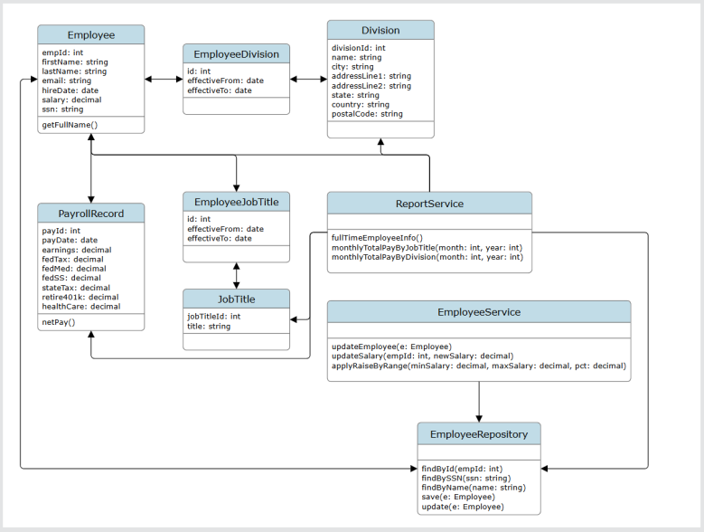
B. Sequence Diagrams

The following sequence diagrams illustrate the functional flow for two critical use cases:
1. Report Generation (Total Pay by Job Title): Shows the flow from the Admin initiating the request via ConsoleUI, which calls the ReportService, which queries the PayStatementDAO, leading to an SQL aggregate query on the DB.
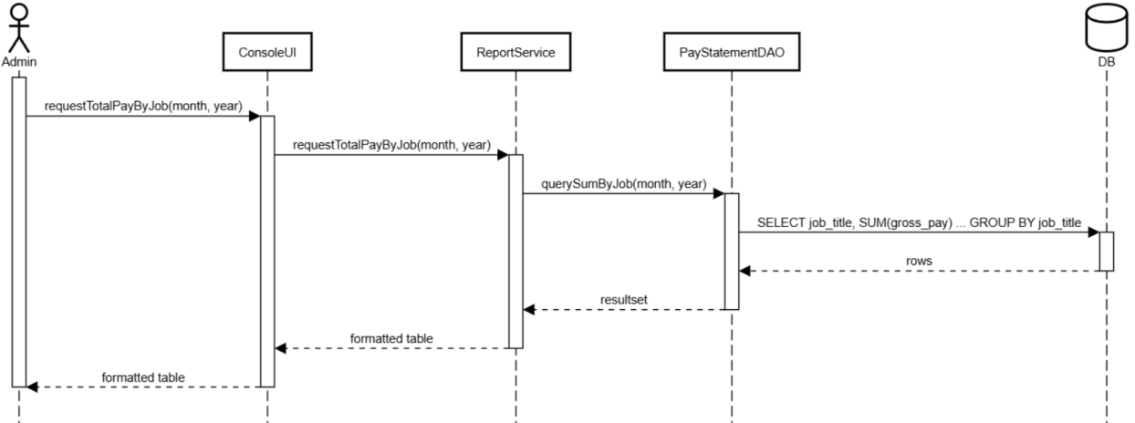

2. Employee Insertion: Shows the Admin inputting data, which the ConsoleUI packages and sends to EmployeeService, which inserts the data using EmployeeDAO into the DB. The DB returns the generated employee ID (empid).
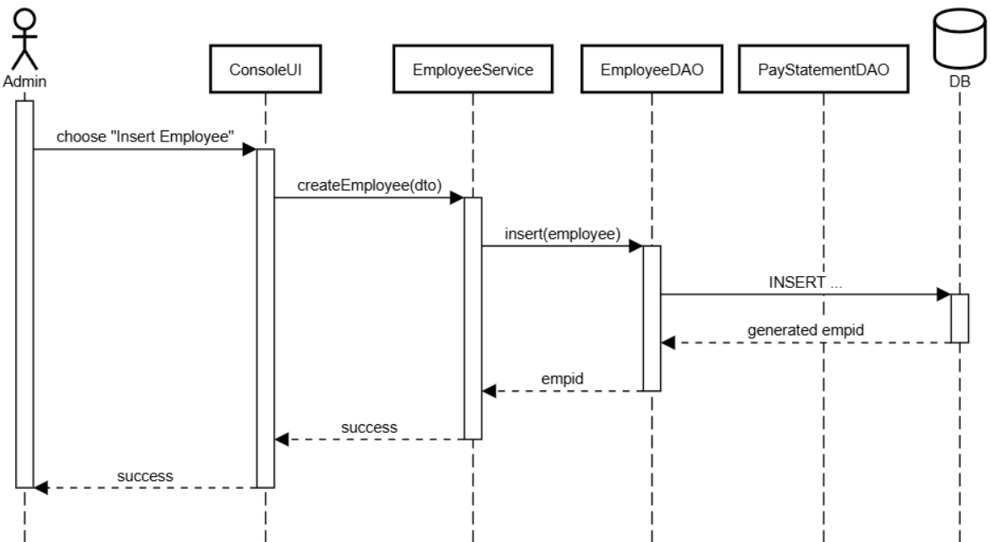

Design Rationale
The Layered Architecture was chosen primarily for the following reasons:

1. Maintainability and Testability: Isolating the business logic (Service Layer) from the data access details (DAO Layer) ensures that changes to the database (e.g., migrating from MySQL to PostgreSQL) only require modifications to the DAO layer, minimizing ripple effects. This makes unit testing the business logic straightforward.
2. Compliance with Requirements: The approach directly supports the separation needed for the required functions, such as implementing the complex salary increase logic within a dedicated EmployeeService method, and isolating complex aggregate reporting logic within the ReportService.
3. Simplicity: Given the project's scale (minimal UX, less than twenty employees), this architecture provides a robust structure without the overhead of more complex patterns (like microservices), aligning with the minimal working system goal.

DATA DESIGN

Data Description
The information domain is structured around a Relational Database Management System (RDBMS), specifically MySQL. The data model is derived from the entities defined in the Class Diagram and the ER Diagram. Key system entities are stored in the database and linked via primary and foreign keys.
The major data entities and storage items include:
Employee Table: Stores all biographical and employment information, including the new required SSN field.
PayrollRecord Table: Stores historical pay statements, including gross and net pay calculations.
Relationship Tables: Tables like EmployeeDivision and EmployeeJobTitle manage the many-to-many relationships between the core entities and their respective assignments, maintaining an effective date range (effectiveFrom, effectiveTo).
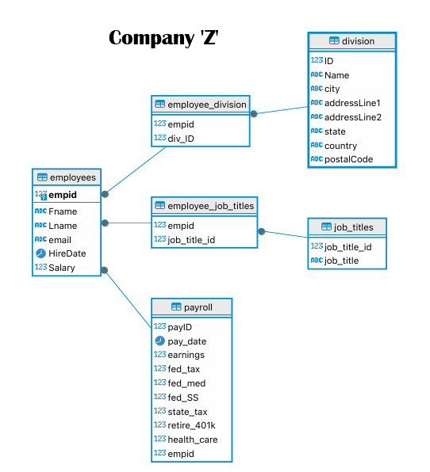

Data Dictionary
Entity (Class) | Attribute/Field Name | Data Type (Java/DB) | Description
Division | divisionId | int | Primary Key
Division | name | string | Division name
Division | city | string | Division city
Division | addressLine1 | string | Division address
Employee | empId | int | Primary Key
Employee | firstName | string | Employee firstname
Employee | lastName | string | Employee firstname
Employee | email | string | Employee email
Employee | hireDate | date | Employee hireDate
Employee | salary | decimal | Annual salary
Employee | ssn | string | Social Security Number (no dashes)
Employee | getFullName() | string | Returns concatenation of first and last name.
EmployeeService | updateEmployee(e) | Employee | Updates all employee data fields.
EmployeeService | updateSalary(empId, newSalary) | int, decimal | Updates only the salary field.
EmployeeService | applyRaiseByRange(min, max, pct) | decimal, decimal, decimal | Applies percentage raise to salaries within the defined range.
JobTitle | jobTitleId | int | Primary Key
JobTitle | title | string | Job title
PayrollRecord | payId | int | Primary Key
PayrollRecord | payDate | date | Date of payroll execution
PayrollRecord | netPay() | decimal | Calculates net pay after taxes and deductions.
ReportService | monthlyTotalPayByJobTitle(m, y) | int, int | Generates report: Total pay by job title for month/year.
ReportService | monthlyTotalPayByDivision(m, y) | int, int | Generates report: Total pay by division for month/year.

COMPONENT DESIGN
P1: Insert New Employee (Feature: Insert Employee)
ConsoleUI: insertEmployee()
1. CREATE new Employee object e.
2. PROMPT user for all employee attributes (name, title, salary, SSN, etc.).
3. IF dao.insertEmployee(e) is TRUE, DISPLAY "Employee inserted."
ELSE DISPLAY "Error."
EmployeeDAOImpl: insertEmployee(Employee e)
1. SQL: INSERT INTO employees (...) VALUES (?, ..., ?)
2. BIND e attributes to the prepared statement.
3. EXECUTE ps.executeUpdate().
4. RETURN TRUE if rows updated > 0.

P2: Update Employee Data (Feature: Update Employee)
ConsoleUI: updateEmployee()
1. PROMPT user for empid.
2. CALL dao.getEmployeeById(id) to retrieve Employee object e.
3. IF found: PROMPT user for new values (title, salary, etc.).
4. SET new values on e.
5. CALL dao.updateEmployee(e).
6. DISPLAY status.
EmployeeDAOImpl: updateEmployee(Employee e)
1. SQL: UPDATE employees SET first_name=?, ..., is_full_time=? WHERE empid=?
2. BIND e attributes and the empid for the WHERE clause.
3. EXECUTE ps.executeUpdate().
4. RETURN TRUE if rows updated > 0.
P3: Search Employee by Criteria (Feature: Search Employee)
ConsoleUI: searchEmployee()
1. PROMPT user to select search type (ID, Name, or SSN).
2. CASE SSN: PROMPT for SSN, CALL dao.getEmployeeBySSN(ssn).
3. DISPLAY the resulting Employee object or "Not found."
EmployeeDAOImpl: getEmployeeBySSN(String ssn)
1. SQL: SELECT * FROM employees WHERE ssn=?
2. PREPARE statement, BIND ssn.
3. EXECUTE query and RETURN the mapped Employee object.
P4: Apply Salary Increase by Range (Feature: Update Salary)
Utilizes the EmployeeService to implement the required business logic.

ConsoleUI: applySalaryIncrease
1. PROMPT user for minSalary, maxSalary, and percentage.
2. CALL service.applySalaryIncrease(min, max, percent).
3. DISPLAY "Updated [count] employees."
EmployeeService: applySalaryIncrease(min, max, percentage)
1. GET employees list: dao.getEmployeesBySalaryRange(min, max).
2. INITIALIZE count = 0.
3. FOR EACH Employee e in employees:
4. CALCULATE newSalary = e.getSalary() * (1 + percentage / 100).
5. ROUND newSalary to two decimal places.
6. SET e.setSalary(newSalary).
7. IF dao.updateEmployee(e) is TRUE, INCREMENT count.
8. RETURN count.
EmployeeDAOImpl: getEmployeesBySalaryRange(min, max)
1. SQL: SELECT * FROM employees WHERE salary >= ? AND salary < ?
2. PREPARE statement, BIND min and max.
3. EXECUTE query and RETURN list of mapped Employee objects.
P5: Generate Total Pay by Job Title Report (Report: Total Pay by Job Title)
This task uses the ReportService to generate one of the three required reports.
ConsoleUI: showReports()
1. PROMPT for report type (2) and month (YYYY-MM).
2. CALL reports.totalPayByJobTitle(month).
ReportService: totalPayByJobTitle(String month)
1. SQL: SELECT job_title, SUM(p.pay_amount) AS total FROM employees e JOIN pay_statements p ON e.empid = p.empid WHERE DATE_FORMAT(p.pay_date, '%Y-%m') = ? GROUP BY e.job_title
2. PREPARE statement, BIND month.
3. EXECUTE query.
4. WHILE ResultSet.next(): DISPLAY job_title and total pay.

HUMAN INTERFACE DESIGN

Overview of User Interface
The system utilizes a Console-based User Interface (ConsoleUI) to meet the requirement for a "minimum working UX." The interface is menu-driven, simple, and text-based, providing an administrative portal to the underlying database and business logic.

The user flow starts with the main menu, which is executed via Main.java. The user interacts by entering numerical choices and text inputs.
User Interaction Model:

Menu Selection: The user selects a function (Insert, Update, Search, Reports) from a numerical menu.

Input Gathering: The system sequentially prompts the user for necessary data fields (e.g., employee details, salary range, month for report).

Feedback/Display: The system displays immediate feedback (success/error messages) or the requested report/search results in a formatted text output.
Feature | User Action | System Feedback (Dispalyed)
Insert Employee | Selects menu option 1. Enters all required employee data (Name, Salary, SSN, Hire Date, etc.) when prompted sequentially. | Success: "Employee inserted." Failure: "Insert error: Employee data could not be saved."
Update Employee | Selects menu option 2. Enters the Employee ID (empid) to modify, then enters the new values for fields like Salary, Job Title, or Division. | Success: "Employee updated successfully." Failure: "Update error: Employee ID not found or data save failed."
Search Employee | Selects menu option 4. Chooses search type (ID, Name, or SSN). Enters the search query. | Success: Displays a formatted toString() representation of the Employee object. Failure: "Not found" or "No employees matching that criteria."
Apply Salary Increase | Selects menu option 5. Enters the minimum salary, the maximum salary, and the percentage to raise. | Success: "Updated [X] employees." Failure: "Invalid input or update operation failed."
Generate Reports | Selects menu option 6. Chooses the report type. Enters the required parameter. | Success: Displays the aggregated data in a readable console format. Failure: "Report generation error."

Screen Images
Main Menu:
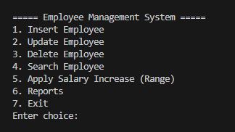
Insert Employee:
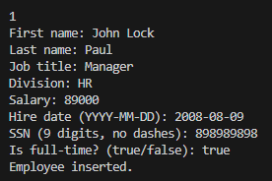

Search Employee by SSN:
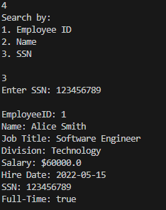
Generate report: total pay by job title (monthly)
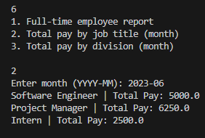

Screen Objects and Actions
Screen Object | Action/Input | Corresponding System Function
Main Menu Prompt | Handles all user interaction, input collection, and display of formatted results. | Routes to the corresponding private method in ConsoleUI.
Data Prompt (e.g., "First name:") | Text/Numeric input | Captured by Scanner and used to build an Employee object.
"Enter choice: 5" | Numeric choice 5 | Initiates applySalaryIncrease().
Search Sub-Menu | Numeric choice (1, 2, or 3) | Directs to methods in EmployeeDAOImpl via ConsoleUI.searchEmployee().

REQUIREMENTS MATRIX
This matrix traces the primary functional requirements to the components that satisfy them.
Functional Requirement (FR) | Source | Component(s) Satisfying the FR
FR1: Add column SSN (no dashes). | User Story 1 (Change Table) | Employee.java (Field: ssn), EmployeeDAOImpl (SQL Schema update).
FR2: Search for an employee (name, SSN, empid). | User Story 2 (Search) | ConsoleUI.searchEmployee(), EmployeeDAOImpl.getEmployeeBySSN(), getEmployeeById(), getEmployeesByName().
FR3: Update an employee's data. | User Story 3 (Update) | ConsoleUI.updateEmployee(), EmployeeDAOImpl.updateEmployee().
FR4: Update salary for an increase of a particular percentage only for a salary range (e.g. 3.2% for salary ≥ 58k but < 105k | User Story 4 (Complex Update) | ConsoleUI.applySalaryIncrease(), EmployeeService.applySalaryIncrease(), EmployeeDAOImpl.getEmployeesBySalaryRange().
FR5: Report: Full-time employee information with pay statement history. | Report 1 | ReportService.fullTimeWithHistory().
FR6: Report: Total pay for month by job title. | Report 2 | ReportService.totalPayByJobTitle(month).
FR7: Report: Total pay for month by Division. | Report 3
  ReportService.totalPayByDivision(month).

