

**WOLKITE UNIVERSITY**

**College of Computing and informatics**

**Department Of Software Engineering**

**Course Title :** Fundamental of Database System

**Course Code :** Seng5021

**Group Two**

**Name Id**

1. BEHAILU BEDADA NSR/0362/13
2. BEREKET TESFAYE NSR/0388/13
3. EYOB WORKU NSR/0800/13
4. FITSUM BELAYNEH NSR/0900/13
5. HAYDER ABDELA NSR/1112/13
6. WAKUMA HAILU NSR/2121/13

**Submission date :** 29/06/2014 E.C

**Submitted to :** Mr.SIME A.

**Hotel room rent database**

*Purpose*

As the number of hotels and reservations is increasing the hotel groups wanted to get rid of the tedious paper work of reserving a room and payment records and customer stay records, as a result, hotels needed to go digital and for that they need a centralized database system for reserving so that manhours will be reduced and complete the same work and to reduce human errors as data is easily available to the customers the business also will efficiently increase.

*Description*

For guests, a hotel keeps track of the rent of its rooms. There is only one room in each rent. A guest must fill out a registration form that includes his or her name, gender, phone number, and city. If a guest has any family, they must also register. A guest rents a room for a few days. For each guest, the check-in and check-out dates for rent must be tracked. A guest can pay their rent in a variety of ways, and the transaction can be completed whole or partially. A guest has the option of reserving a room for future usage. A room can be reserved just once per day.

**Entities**

Guest

Family

Room

Rent

Payment

**Attributes of Entities**

Guest (Guest_id, Phone_No, Fname, Sname, Sex, City)

Family (Fname, Lname, Sex, PhoneNo, City)

Room (Room_No, price, Bed_No, Name)

Rent (RentId, CheckInDate, CheckOutDate)

Payment (payt_id, Amount, Payement_method, Date)

**Relations**

Guest has families

Guest makes payment

Guest Allocates room

Rent books room

Rent Payment paid

**ER DIAGRAM**

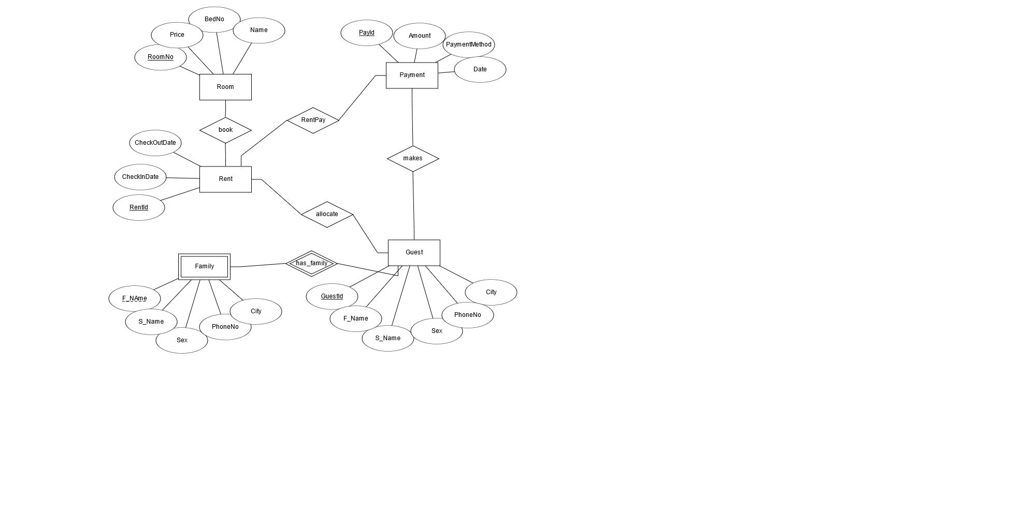

**Cardinality of The Relationship**

1. Guest 1: N Family
2. Guest 1: N Rent
3. Guest 1: N Transaction
4. Room 1: N Rent
5. Transaction 1: N Rent

**ER To Relational Mapping**

|  |  |  |  |
| --- | --- | --- | --- |
| RoomNo | Price | BedNo | Name |

Room

Guest

|  |  |  |  |  |  |
| --- | --- | --- | --- | --- | --- |
| GuestId | FirstName | SecondName | Sex | PhoneNo | City |

Family

|  |  |  |  |  |  |
| --- | --- | --- | --- | --- | --- |
| FName | SName | Sex | PhoneNo | City | GuestId |

|  |  |  |  |  |
| --- | --- | --- | --- | --- |
| RentId | CheckInDate | CheckOutDate | RoomNo | GuestId |

Rent

|  |  |  |  |  |  |
| --- | --- | --- | --- | --- | --- |
| PayId | Amount | PaymentMethod | Date | GuestId | RentId |

Payment

**Normalization**

**Third Normal Form**

|  |  |  |  |
| --- | --- | --- | --- |
| RoomNo | Price | BedNo | Name |
| 01 | 500 | 1 | standard |
| 02 | 500 | 1 | standard |
| 03 | 650 | 1 | **Presidential** |
| 04 | 650 | 1 | **Presidential** |

The Normal form will be:

Split the above table into Room and RoomType.

|  |  |
| --- | --- |
| RoomNo | RoomTypeId |
| 01 | 1 |
| 02 | 2 |

|  |  |  |  |
| --- | --- | --- | --- |
| RoomTypeId | Price | BedNo | Name |
| 1 | 500 | 1 | standard |
| 2 | 650 | 1 | **Presidential** |

**Queries**

* Query to create database and its table

CREATE DATABASE ROOMRENT;

USE ROOMRENT;

CREATE TABLE RoomType(

RoomTypeId INT PRIMARY KEY,

Price MONEY,

BedNo INT,

NameOfRoom VARCHAR(20)

);

CREATE TABLE Room(

RoomNo INT PRIMARY KEY,

RoomTypeID INT FOREIGN KEY REFERENCES RoomType(RoomTypeId)

);

CREATE TABLE Guest(

GuestId INT PRIMARY KEY IDENTITY(1,1),

FirstName VARCHAR(20) NOT NULL,

SecondName VARCHAR(20) NOT NULL,

Sex VARCHAR(1),

PhoneNo INT,

City VARCHAR(20)

);

CREATE TABLE Family(

FirstName VARCHAR(20) NOT NULL,

SecondName VARCHAR(20) NOT NULL,

Sex VARCHAR(1),

PhoneNo INT,

City VARCHAR(20),

GuestId INT,

CONSTRAINT PK_Family PRIMARY KEY(GuestId, FirstName),

CONSTRAINT FK_Family FOREIGN KEY(GuestId) REFERENCES Guest(GuestId)

);

CREATE TABLE Rent(

RentId INT PRIMARY KEY IDENTITY(1,1),

CheckInDate DATE NOT NULL,

CheckOutDate DATE NOT NULL,

RoomNo INT FOREIGN KEY REFERENCES Room(RoomNo) NOT NULL,

GuestId INT FOREIGN KEY REFERENCES Guest(GuestId) NOT NULL

);

CREATE TABLE Payment(

PayId INT PRIMARY KEY IDENTITY(1,1),

Amount MONEY NOT NULL,

PaymentMethod VARCHAR(20),

PaymentDate DATE,

GuestId INT FOREIGN KEY REFERENCES Guest(GuestId) NOT NULL,

RentId INT FOREIGN KEY REFERENCES Rent(RentId) NOT NULL

);

**Value Insert into Tables**

--value insert to RoomType tables

INSERT INTO RoomType VALUES(1,500,1,'Standard'),(2,650,1,'Presidential'),(3,800,1,'Double Bed'),(4,1000,1,'Double Room'),(5,1300,1,'Family');

--Value insert roomNo into room

INSERT INTO Room VALUES(01,1),(02,1),(03,1),(04,2),(05,2),(06,3),(07,3),(08,5),(09,5);

--first the guest arrive and he/she register--

INSERT INTO Guest VALUES('Eyob','Worku','M',0945026712,'Adama');

INSERT INTO Guest VALUES('Alazar','Derege','M',0905026712,'Addis Abeba');

INSERT INTO Guest VALUES('Hanan','Bahr','F',0978026712,'Kefa');

INSERT INTO Guest VALUES('Tayu','Teshe','M',0921026712,'Wikro');

INSERT INTO Guest VALUES('Bezu','Geremew','F',0942198950,'Jima');

select * from Guest

--register if they have any family--

INSERT INTO Family VALUES('Ribka','worku','f',0932456787,'Addis',1)

INSERT INTO Family VALUES('Ermiyas','worku','m',0982454780,'Addis',1)

INSERT INTO Family VALUES('Maruf','worku','f',0900456787,'Addis',3)

INSERT INTO Family VALUES('Adane','Dereje','f',0972456787,'Addis',2)

INSERT INTO Family VALUES('Tigist','Dereje','f',0912456787,'Addis',2)

--Assign a room for guest--

INSERT INTO Rent VALUES('2022-03-16','2022-03-18',1,1);

INSERT INTO Rent VALUES('2022-03-19','2022-03-22',2,2);

INSERT INTO Rent VALUES('2022-03-22','2022-03-25',9,1);

INSERT INTO Rent VALUES('2022-03-22','2022-03-24',4,2);

INSERT INTO Rent VALUES('2022-03-23','2022-03-24',6,3);

INSERT INTO Rent VALUES('2022-03-23','2022-03-25',1,4);

--let say guest comes at 23/03 and he want a room type 1, so we can check by this query

SELECT RoomNo FROM Room WHERE NOT EXISTS (SELECT RoomNo FROM Rent WHERE

Rent.RoomNo = Room.RoomNo AND (CheckOutDate>'2022-03-23')) AND RoomTypeID = 1