CREATIVE BRIEF

Project Title: Liverpool FC 2019-2020 season

1. **Project Overview**

Liverpool has had a great year and their success needs a place on the internet to live. This space is for the team’s wins and great players, and will have lots of pictures from the season. It’s kind of like a snapshot of this year’s games and great plays

1. **Resources**

<https://en.wikipedia.org/wiki/2019%E2%80%9320_Liverpool_F.C._season>

This is where I got most of my information, although there are lots of very technical things such as transfers and stuff that doesn’t need to be included in the page (those are for the hardcore fans in the UK). There are also LOTS of pictures on google images in high res

1. **Audience**

I’m thinking the main audience of this website will be people who are familiar with Liverpool and the Premier League and can check the roster and this year’s stats and game times. Ideally, if this project was really going out into the world, then each team would have a page like this

1. **Message**

The message is basically to celebrate this team and inform on the roster and game times

1. **Tone**

Fun! Casual, I imagine this is something you would look up before watching a game with family or buddies.

1. **Visual Style**

Something with lots of red and white, easy to use, more for people who have heard about Liverpool and want to know more. Kind of a middle ground of sports pages

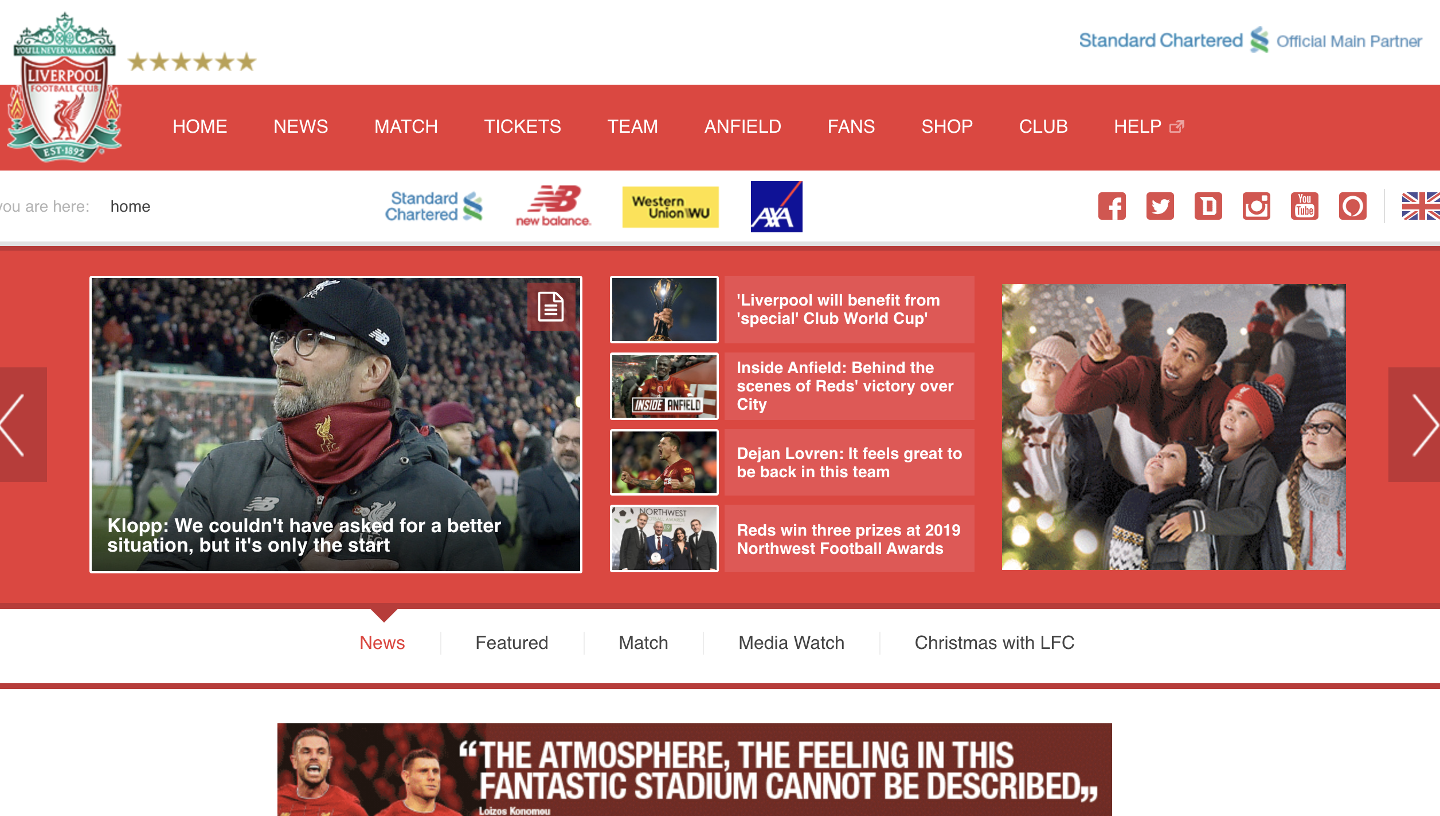

Something like this but not as complicated, needs to be more streamlined

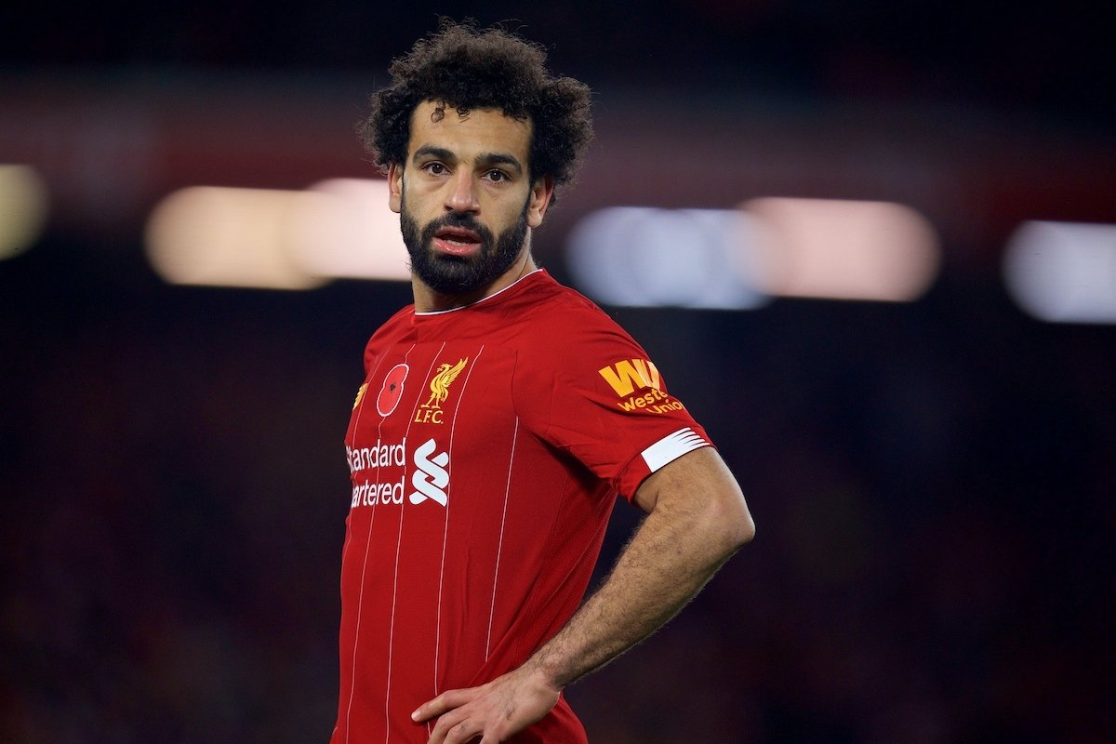

Mo Salah being sassy



Color scheme and feel of the website should be kind of like this